Friends Women’s Association

JULY 2022 Report

Table of Contents
Friends Women’s Association 1
JUly 2022 Report 1
ACTIVITIES 2
Caring for HIV Positive People (CHIVPP) 2
Improving Women’s Reproductive Health (IWRH) 4
Rape Survivors’ Support (RSS) 4
MEDICAL TEAM 11
CONSULTATIONS 11
LABORATORY 11
FAMILY PLANNING 12
PRENATAL CONSULTATION (PNC) 12
ANTI-RETROVIRAL SITE 12
PHARMACY 12
PSYCHOSOCIAL TEAM 12

COVID-19 AND NTASEKA CLINIC
In the month of July, Friends Women’s Association has continued to apply covid restrictions restrictions at Ntaseka Clinic for both the staff and the beneficiaries’ protection.

ACTIVITIES

Caring for HIV Positive People (CHIVPP)
In the month of July, medical follow-up and home visits were done for our HIV positive people.
On July 22, 2022, a group of people living with HIV was held in the Ntaseka health center. Among the 20 participants, there were five sex workers and three breastfeeding women.
Three goals:
- Reinforcement of compliance for those on ARVs treatment
- Supply of ARVs in distribution points (PODI)
- Viral load sampling for those who have not yet taken this test for the year 2022
-Proposal of a social fund
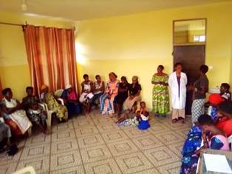
Regarding compliance, we found that many of them do not respect the appointments and schedule for taking medication. We advised them to do everything possible to be observant. Otherwise, it will affect their health. The mediator is at their disposal as a coach to properly organize the schedule for taking medication.
Concerning the points of distribution of medicaments in the communities, all the participants refused this strategy for question of discretion.
Regarding the viral load, three samples were taken. Concerning the social fund, the participants agreed to contribute BIF300 per month.
On July 27, 2022, there was a visit to the Ntaseka clinic by an FHI360 executive, Doctor Felicite, in charge of quality improvement in the HIV program in the province of Bujumbura Mairie. She was with Mr. Elie the focal point in the North Health District of Bujumbura Mairie. The main focus was coaching about three 95s and different treatments.
- For the first 95, 95% of people living with HIV know their HIV status. Here we use target screening, self-testing in the community and indexing
- Second 95: 95% of people who are tested HIV positive for HIV are on ARVs treatement
- Third 95: 95% of people living with HIV who are on ARV treatment have suppressed viral load
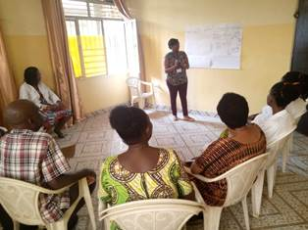
For the second point, we were reminded that we must continue to apply the different treatments which are:
1. GAC (Community Adherence Group). It is the team leader who goes to the structure for the transport of medicines. Once every three months, there is a meeting place HIV positive people members of a PODI to meet together and stock up on medicines.
2. The observer club which takes place in the structure once every three or six months
3. Outreach: is done by the provider who transports the drugs to the homes of patients who have particularities
4. Fast-track: This is for patients who refuse PODIs. They continue to stock up in health facilities
The observation was that there must be another team in charge of quality improvement in our structure. It must be made up of people from different departments following the patient circuit. This team is in charge of studying case by case the different clouds or challenges in the care service for people living with HIV. Then, she will suggest how to improve our services by putting in place strategies in place to offer quality services.

Maternity Ward Building
In the month of July, under the support of the African Great Lakes Initiative (AGLI), both the placenta and ash pits were built. The pillars of the water tank were also built. j
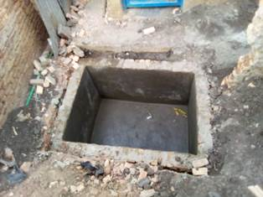 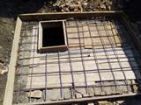. 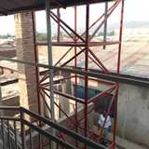

Improving Women’s Reproductive Health (IWRH)
FWA community health workers and FWA staff have continued to educate men, women and young people on the importance of birth control.
On July 31st, 2022, a discussion group for 30 Young Women who are in three young girls' self-help groups, was organized to discuss about sexual and reproductive health. The theme of the day was Intimate Hygiene and Infections as planned since May 2022
Facilitators were Midwife Augustin HARUSHIMANA, Dr NIBONA Alexia and Dr Marie Salomé CISHAHAYO.
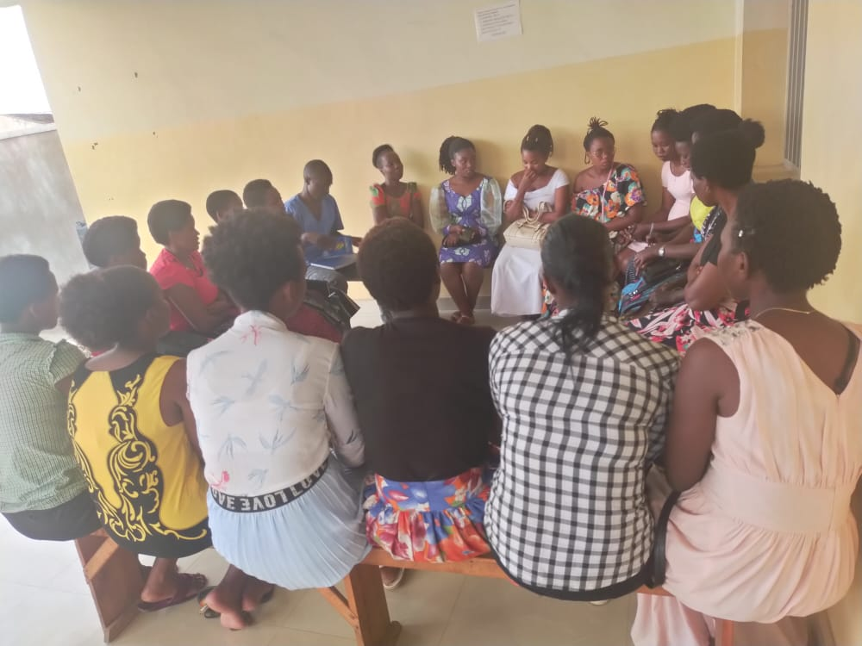
It is a group of young girls who are leaders of three self-help groups (SHGs). They are there every last Sunday of the month to discuss and share ideas and experiences around a theme according to the theme plan already established in the framework for the promotion of sexual and reproductive health.We started with the continuation of the previous theme on the choice of career and choice of spouse that we had not finished. The facilitators was Augustin HARUSHIMA.Dr Alexia should talk about Intimate Hygiene but she was not available for personal reasons.Dr. Salomé spoke extensively about infections:

She talked about 4 kinds of infections

1) Infection in general

2) Urinary tract infection

3) Vaginal infection

4) Sexually transmitted infection

Everywhere she explained the signs, causes, treatment and prevention

Since sexually transmitted infections and urinary tract infections were of much more concern to the participants, it was found that our young girls were unaware of their female genitalia and the menstrual cycle. We found that certain physiological signs of their body are considered as infections when it is normal. This is why we agreed that during the meeting of August 28, 2022, we will talk about the Female Genital System and the menstrual cycle.

At the end of the session, a participant insisted on inviting her friends during the next sessions. In fact, these kinds of themes are beneficial for their sexual and reproductive health. The answer is that these sessions are reserved for young girl leaders of FWA SHGs. FWA will prepare sessions on sexual and reproductive health for other young girls (friends or sisters of current focus groups, young girls children of women members of FWA SHGs, as well as other young girls members self-help groups of mixed women and girls of FWA). The said sessions will be organized after consultation with the FWA Coordination.
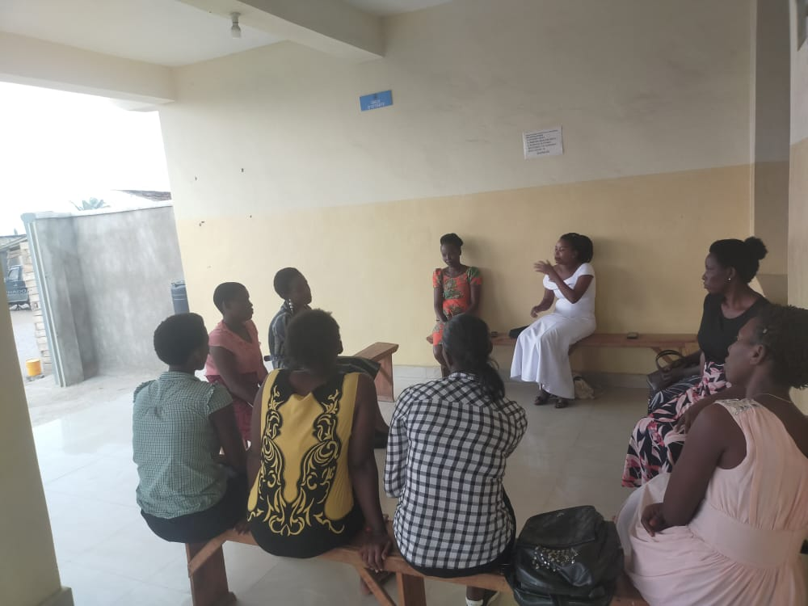
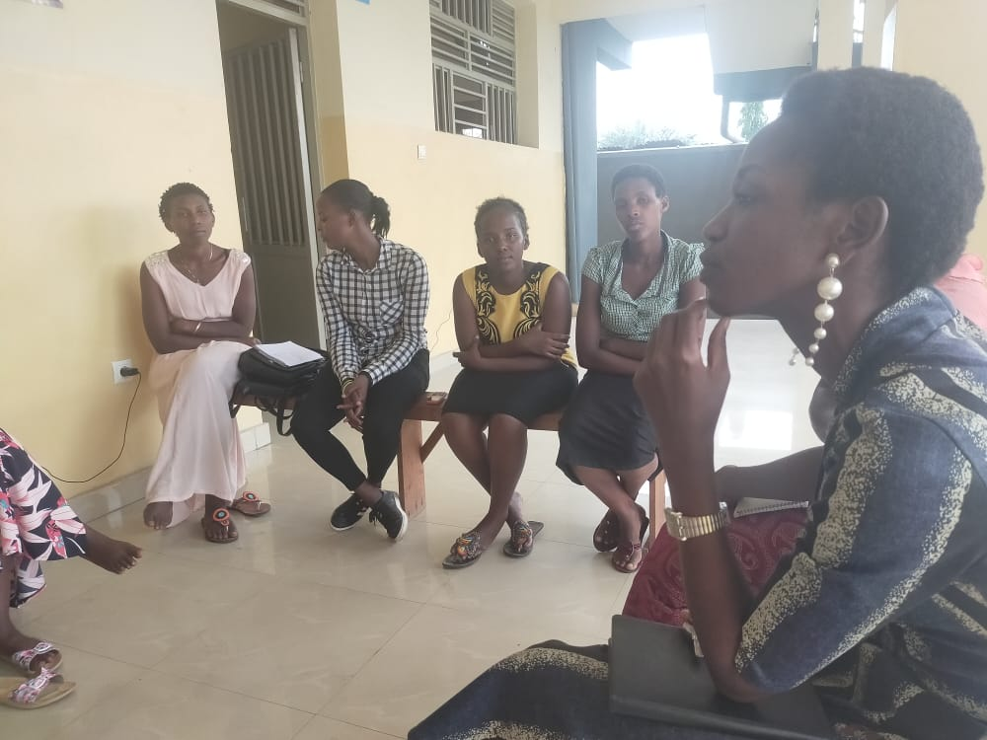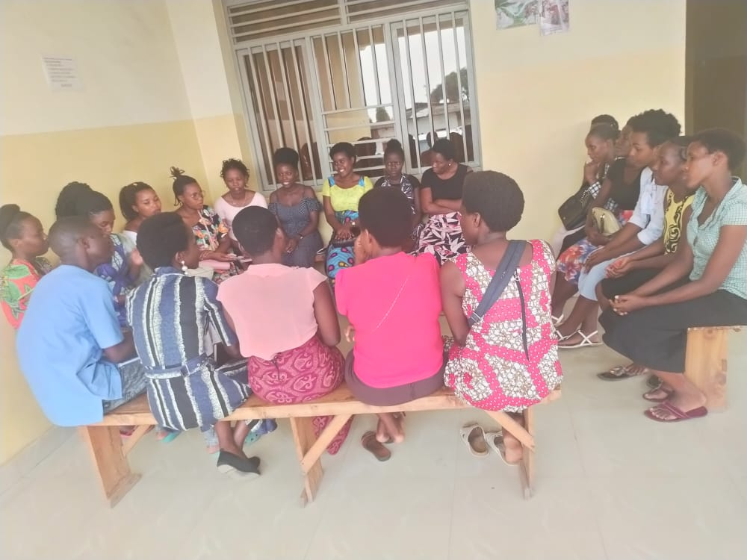

Rape Survivors’ Support (RSS)
In the month of July, the Rape Survivors Support program had different activities: the supervision of Self-Help Groups (SHGs) and evaluation, one trauma healing workshop, and the Street Business School (SBS) fourth promotion first session. At the end of July 2022, we had a total of 153 SHGs in Kamenge, Bujumbura Mairie province for a total of 3613 women and 35 SHGs for 863 women in Nyabiraba commune, Bujumbura province.
- SHGs
ABOUT NEW SHG
No | Name of SHG | Month of creation | Member Number | Created by

SHG Total Number: | 153
Evaluation
As the table shows, in the month of July 6 SHGs made a sharing and the results are as follows;
No | About sharing | Number of SHG | Total
1 | Total money saved | 6 | 27,845,900
2 | Total Credit granted | 6 | 23,179,200
3 | Total interest | 6 | 22,810,500
4 | People who didn’t paid | 6 | 16
5 | Total money not refunded | 6 | 1,685,700

Classification of SHG
After evaluation it was found that;
Active | Less Active | Sick | Total
5 | 1 | 0 | 6

SHG Success story

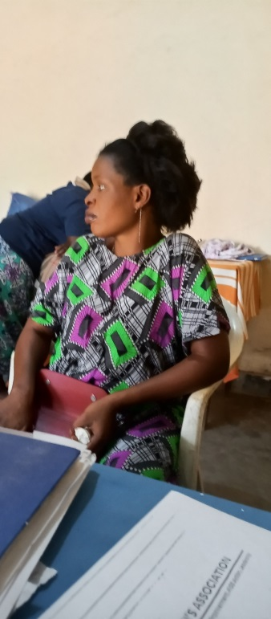
Now I received a word; my name is Aisha. I have been here at FWA for 3 years. Before, I was mistreated by my husband. He sometimes told me that I am worthless.
I joined the SHGs and at the end of the year, I showed him the money I saved and my interest. From that moment, he began to support me in saving. Due to savings and credit, now we achieved many things; we have built a house, we have water and electricity in our house and we have bought another plot of land. I'm pregnant and I'm coming very far from here (Gatunguru). But, he encourages me to come to save money. Before, my husband received money but he wasted it in beer but today see our achievement! We are proud of ourselves! Now I have a word in my family, my husband loves me and we work together.

2.SBS
Two training sessions on SBS were held where we discussed about Module 1 (Getting Out of your Comfort Zone) and module 2 which is about Business Opportunity Identification.
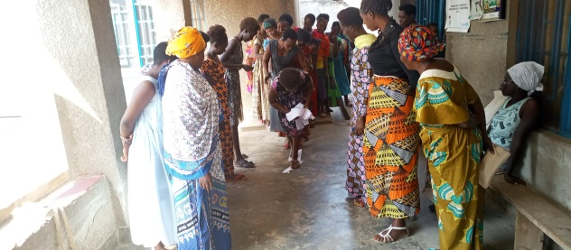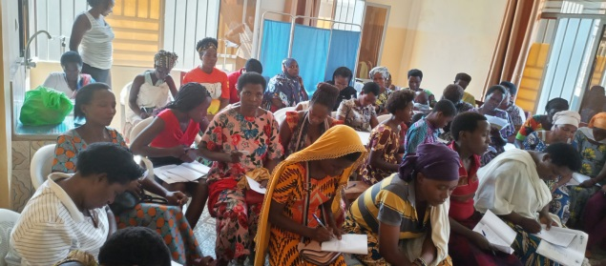
Illustrating game of getting out of comfort zone
3.Trauma Healing Workshop
On July 17-19 2022, there was a three-day trauma healing workshop for 20 GBV survivors.
I am a woman who is married by force. My husband was a violent man He destroyed my life in a period of 14 years.
I was going to visit him with my friend. My friend went to the toilet, then he closed the door that time, I knew that my friend sold me. I tried to defend myself but in vain, He locked me in his house for a week and convinced me to stay with him. Covered with shame, I could not even come out and look my mother in her face. Then I decided to stay and live with my husband whom I never loved.
My man was a drug addicted; He used to beat me, he burned all my clothes, He can beat me naked in public. In addition to this, he took a knife and put it under our bed and told me that one day he will kill me. After that, I decided to be separated with him although it was too late (after 14 years). I have always hoped that he will at least help me to raise my three children but in vain. In these 14 years, I got HIV and heart disease because of my husband. I'm depressed. My thoughts are always bad. I have no hope, my husband stole my future.

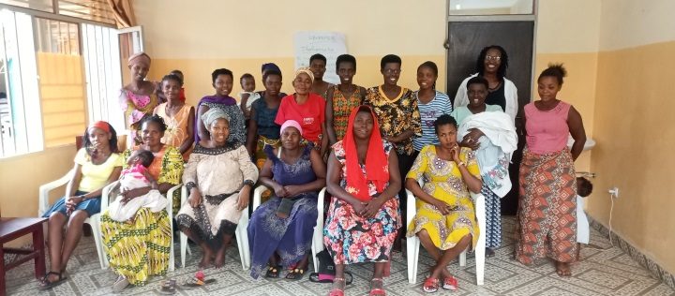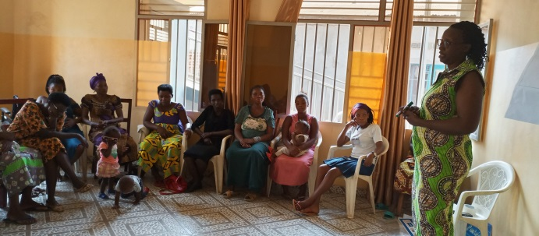

ACTION ON GENDER-BASED VIOLENCE (AGBV)
In the month of July 2022 under the support of the Canadian Friends Service Committee (CFSC) there were three workshops on the national rules on people and families in Nyabiraba commune, Bujumbura province. A total of 59 participants was reached including 30 community elected leaders and 29 religious leaders.
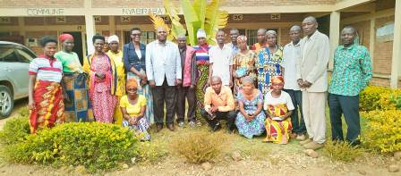
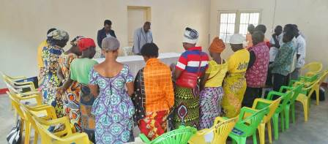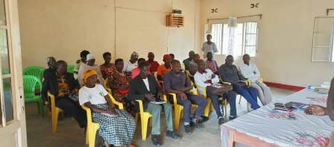

MEDICAL TEAM

CONSULTATIONS
Our medical doctors consulted with 178 cases, including 92 adults (44 men and 48 women), 35 children (18 boys and 17 girls), 22 HIV positive people and 29 pregnant women for ultrasound. The nurse received 247 patients including 176 adults and 71 children.

LABORATORY
In the month of July, apart from HIV voluntary testing, there were a total of 255 tests.
Test | Test completed | Positive | Negative
G.E.  Malaria test | 62 | 25 | 37
Quick malaria test | 28 | 6 | 22
ECBU  Urine test | 18 | 13 | 5
Selles  Stool test | 18 | 17 | 1
Pregnancy | 49 | 9 | 40
Sero-widal  Typhoïd fever | 18 | 15 | 3
Glycémie  Diabetes | 14 | 4 | 9
RPR VDRL  (Syphilis) | 30 | 1 | 29
Complete Blood Count | 14 | 10 | 4
Hepatitis B | 2 | 0 | 2
Hepatitis C | 2 | 0 | 2
Viral Load | 0 | 0 | 0
Total Tests: 255

FAMILY PLANNING
397 people received contraceptives from FWA’s nurse, including 218 old cases and 179 new ones. 284 received the contraceptive injection, 65 were given contraceptive pills, 42 received male condoms, 1 received UID and 5 received implants.

PRENATAL CONSULTATION (PNC)
In July, 53 women came for prenatal consultation (PNC), including 25 who came for PNC 1, 12 for PNC 2, 9 for PNC 3 and 7 for PNC 4.
29 pregnant women came for the ultrasound test.

ANTI-RETROVIRAL SITE
At the end of July, we had 330 patients under retro drugs followed at NTASEKA clinic, including 267 women and 63 men.

PHARMACY
Regarding medications, FWA was able to purchase the minimum needed medicine.

PSYCHOSOCIAL TEAM
In the month of July, 84 people were tested for HIV and received pre and post HIV test counselling. Out of the three people detected HIV positive, two were women with 4% of seropositivity.
Total Number of People Tested: | 84
Total Number of Women Tested: | 56
% of People Tested Who Are Women: | 67%
Average Age: | 28
Median Age: | 27
Total HIV+ : | 3
Total HIV- : | 81
Number of Women HIV+ : | 2
Total % Seropositivity: | 4%
% of Women Tested Who Are HIV+: | 4%

