Friends Women’s Association

FEBRUARY 2024 Report

Table of Content
Friends Women’s Association 1
FEBRUARY 2024 Report 1
ACTIVITIES 2
Caring for HIV Positive People (CHIVPP) 2
Improving Women’s Reproductive Health (IWRH) 4
Rape Survivors’ Support (RSS) 4
MEDICAL TEAM 11
CONSULTATIONS 13
LABORATORY 13
FAMILY PLANNING 13
PRENATAL CONSULTATION (PNC) 13
ANTI-RETROVIRAL SITE 14
PHARMACY 14
PSYCHOSOCIAL TEAM 14

ACTIVITIES

Caring for HIV Positive People (CHIVPP)
In the month of February, medical follow-up and home visits were done for our HIV positive people.
Two discussion groups were done respectively on March 5, 2024 and on March 7 2024.
- The First Discussion group
On March 5, 2024 at the Friends Women's Association, we organized a discussion group in favor of women undergoing PMTCT (Prevention of Mother-to-Child Transmission of HIV/AIDS). 20
The items on the agenda were:
- Schedule for prenatal consultation and viral load
- Schedule for monitoring the pregnancy and child
- Family planning
20 women were present. The objective was to encourage them to do the prenatal consultation on time and to explain to them the importance of monitoring the pregnancy. Actually, these past months, we ended up with pregnant women who did not do the prenatal consultation. This has caused failure in viral load because the prenatal consultation goes hand in hand with the viral load. For pregnant women it is recommended to do the first viral load in the first trimester and the 2nd viral load in the 3rd trimester.
After delivery, the child must benefit from preventive treatment with ARVs, with early screening between 4 and 6 weeks. After birth at 1 1/2 months give cotrimoxazole, at 9 months do serology. After weaning, do the Polymerase Chain Reaction (PCR). The PCR is done after delivery to see the concentration of the HIV AIDS virus in the plasma to check if the baby doesn’t have traces of the HIV AIDS. at 18 months do the serology. If the serology is negative, the child will be removed from follow-up cases. If the result is positive, give ARV treatment.
Testimony
My name is Françoise. I thank FWA for its efforts in organizing the discussion groups because it is thanks to them that I feel at ease. Previously I was in isolation; I didn't know I could have children; I didn't want to communicate. But now I participate in different activities that allow me to have money such as small business and also participate in FWA Self-Help groups. In addition, I have two healthy children without HIV even though I and my husband are HIV positive. I thank the FWA service providers very much. It is thanks to them that my children are healthy.

Recommendations from the Participants
* Increase the number of discussion groups
* Free medication for opportunistic infections
* Free care for children who are under PMTCT.
*Continue with nutritional support

- The Second Discussion Group
The second discussion group was done on March 7, 2024
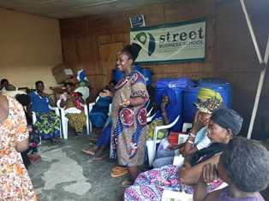
On March 7 at 10:00 a.m. at the Friends Women's Association, we organized a discussion group in favor of young girls who are sex workers, 20 people were present.
The discussion was about the following points:
- The different means of transmission of HIV/AIDS
- Strengthen compliance. Indeed, to stay healthy, the person infected with HIV must take ARVS as prescribed by the provider.
- The different methods of family planning
The objectives were:
- Show them how one can live positively with HIV/AIDS;
- Preventing the transmission of the virus to people around them and their children;
- Show them the benefits of taking ARVs correctly;
- Encourage them to take medication correctly and adhere to the family planning program.
Testimony
My name is Smith. When I learned that I was HIV positive, I tried to take the retro drugs correctly. But, after few months, I stopped my medication. Afterwards I started having opportunistic infections all the time and it was after taking again the retro drugs that my health improved. I thank the Ntaseka clinic providers who advised me to take again the ARVs treatment and give up taking drugs. Indeed, the drugs had influenced me to abandon ARVs.
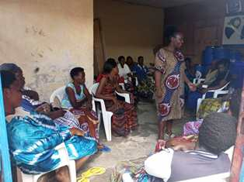
Recommendations:
- Increase discussion groups
- Create the detox center
- Helps the sex workers find other jobs to do
- Free medication for opportunistic infections

Maternity Ward Building
Although Ntaseka maternity ward still needs some medical equipment; both the delivery and the hospitalization services are currently functional.

Improving Women’s Reproductive Health (IWRH)
FWA community health workers and FWA staff have continued to educate men, women and young people on the importance of birth control. ​

Awareness raising among women of childbearing age who live around FWA on Sexual and Reproductive Health(SRH)
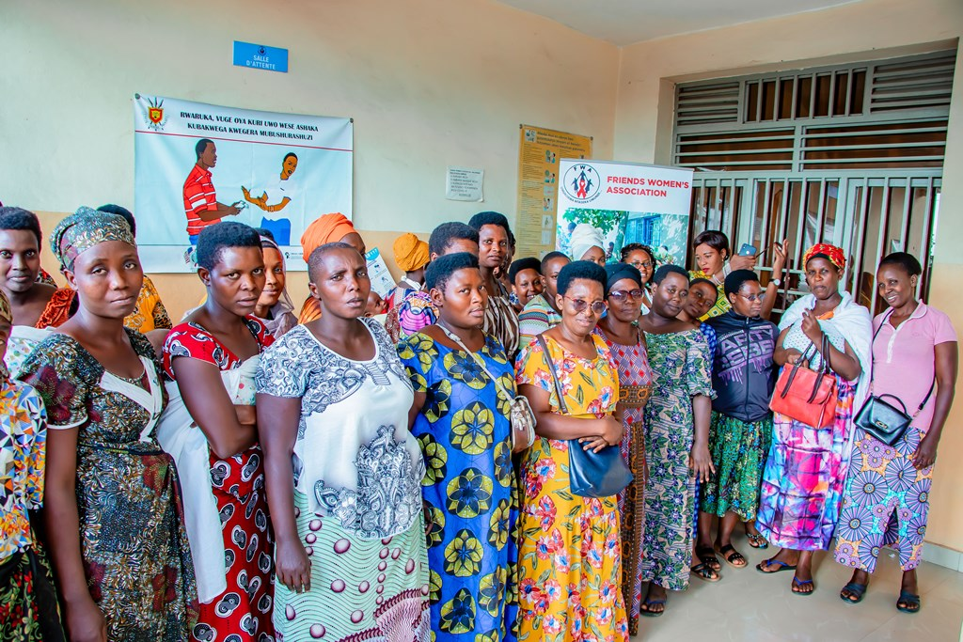
With the general objective of contributing to the increase in Sexual and Reproductive Health (SRH) indicators which are lacking in the Bujumbura North Health District, Ntaseka clinic organized an awareness workshop for women of reproductive age who live around FWA on Sexual and reproductive health.
Dates: March 7&8, 2024.
The specific objectives of these workshops were:
1. Inform women of childbearing age surrounding FWA about the Mission, Vision and Objectives of FWA
2. Raise awareness among women of childbearing age surrounding FWA to use the Health Services Available at NTASEKA clinic
3. Raise awareness among women of childbearing age about Sexual and Reproductive Health
4. Strengthen Collaboration between Women of childbearing age surrounding FWA and FWA staff in general and Medical staff in particular.
The Expected Results were
1. The Mission, Vision and Objectives of FWA are informed to the 80 Women of childbearing age surrounding FWA
2. 80 Women of childbearing age surrounding FWA are made aware of how to use the Health Services Available at NTASEKA clinic
3. 80 Women of childbearing age are made aware of Sexual and Reproductive Health
4. Collaboration between 80 women of childbearing age surrounding FWA and FWA staff in general and Medical staff in particular is strengthened
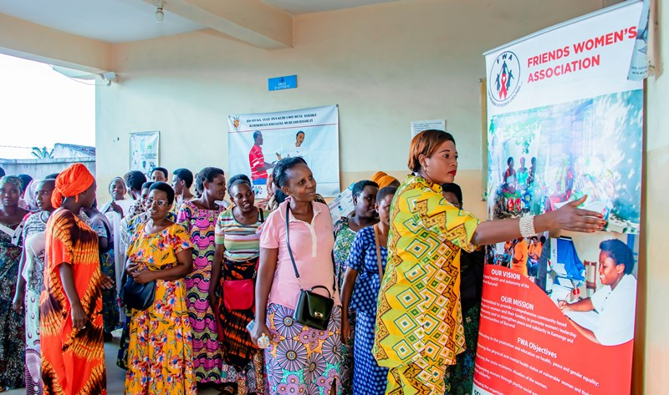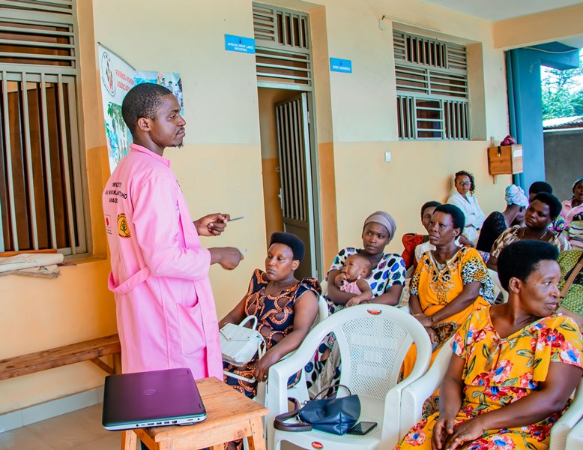

The Activity Description
80 Women of childbearing age surrounding FWA in two groups, 40 Women of childbearing age surrounding FWA came on March 7 and and another 40 women came on March 8, 2024 from 2:00 p.m. Facilitators were the two midwives and one lab technician from Ntaseka clinic.
The discussion was about:
Many are among our clients and beneficiaries of more than one FWA program. They appreciated the idea behind all these activities and especially the autonomy of women which was for these participants the pillar of solution for many of the challenges that women encounter. Next comes health. With the economic autonomy especially of the woman, she can provide health care for her family.
These 80 women of childbearing age surrounding FWA were made aware of how to use the health services available at NTASEKA clinic. The latter include the minimum package of Health Center services, namely curative and preventive including curative consultation, prenatal consultation, family planning, HIV screening and HIV management, laboratory, pharmacy, minor surgery, Hospitalization and maternity. Each of the services has been explained in detail regarding its activities and services.
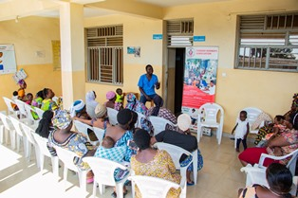

Then we discussed the different high-risk pregnancies to encourage women of childbearing age to come for early prenatal consultations and keep appointments. We have talked about family planning after childbirth and this will be discussed in depth in the next sessions.
Among the risk factors that lead to high-risk pregnancies, we talked about, among others:
- Pregnancy before age 18
- A pregnancy after 35 years
- Scarred uterus
- Diabetes during pregnancy
- Hypertension during pregnancy
- A big baby
- Bleeding during pregnancy
- Fevers during pregnancy
- Multiple pregnancies
- History of subsequent pregnancies
- Cardiovascular illnesses
- Chronic diseases
After discussing these risk factors, the 40 women of childbearing age appreciated this type of discussions and pleaded for the continuity of sessions on mother-child health.
Afterwards the Laboratory Assistant explained the biomedical examinations during pregnancy and these examinations are necessary to properly monitor the pregnancy
These examinations reveal different diseases such as anemic diabetes, hypertension during pregnancy, sexually transmitted infections, urinary infections, blood grouping, toxoplasmosis and others depending on the state of health of each person.
Then, there were discussions with these women of childbearing age regarding their commitment to respecting appointments for the prenatal consultation and doing medical examinations. All the women raised the issue of financial resources and the men’s incomprehension of the importance of these examinations and family planning.

Testimonies
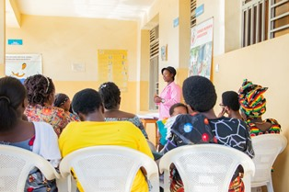
1) My name is Cécile. I appreciate NTASEKA for these sessions. This is not the first time that I have participated in these kinds of sessions but for today it is the first time that I have heard about prenatal examinations one by one and their importance. I realize that it is us who are the sources of the misfortunes that happen when we are pregnant. Many things can be avoided if we do the medical consultation on time and keep appointments as well.
2) My name is Mariam. I'm glad to learn these things. All my daughters will come for a blood group test and I will in turn educate and give this information to my friends, families and colleagues to have timely medical monitoring during the pregnancy. Sometimes we think that health centers and providers want to eat our money but I understand why you insist. So men are obstacles out of ignorance. Please raise their awareness to them as you often do for us. Thank you Ntaseka for this privilege and these sessions.

Rape Survivors’ Support (RSS)
In the month of February, the Rape Survivors Support program had different activities: the supervision of Self-Help Groups (SHGs) evaluation. FWA has started the process for the SHGs to comply of the new law of the central Bank of Burundi. At the same time, the FWA has encouraged those groups to initiate together small projects for income generating activities. That is why a group of women from the Batwa ethnic group has now initiated the Growing Onions Project together at Bubaji hill in Nyabiraba commune.
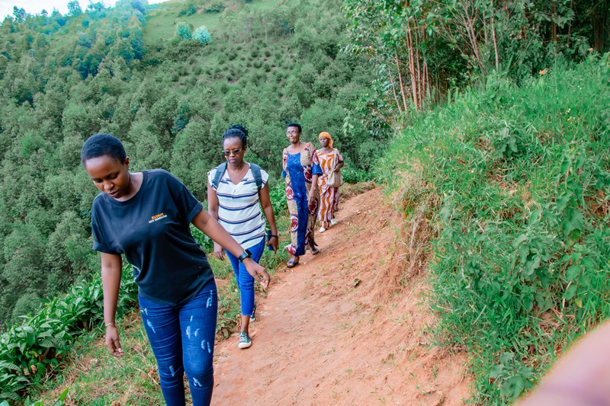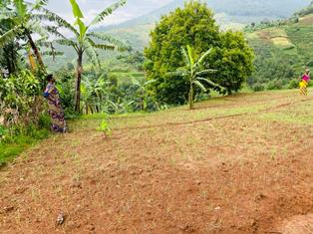
The FWA national coordinator with two staff visiting the field of onions at Bubaji hill in Nyabiraba commune, Bujumbura province.
At the same time a group of young girls who were not able to be graduated from secondary school are being trained on sewing in one of the Nyabiraba commune training rooms
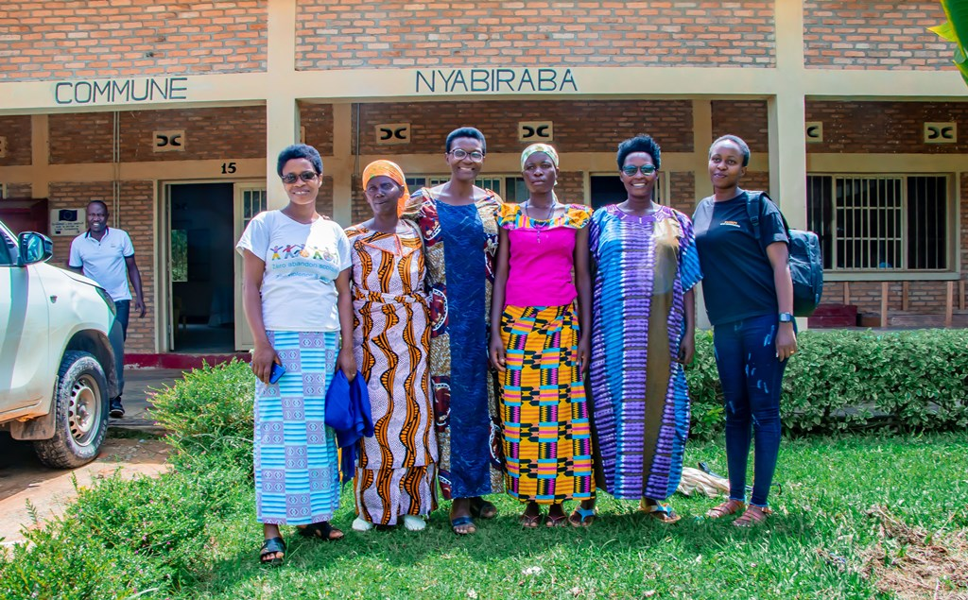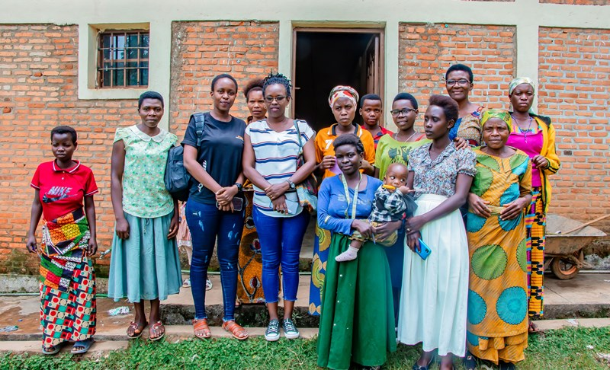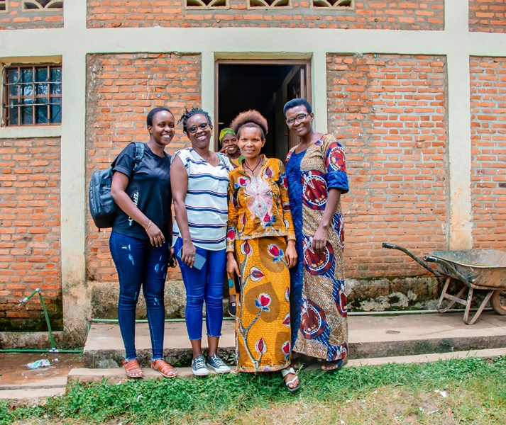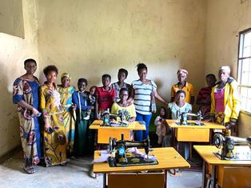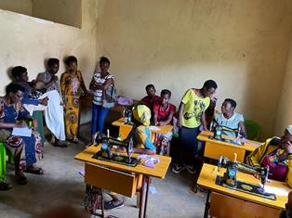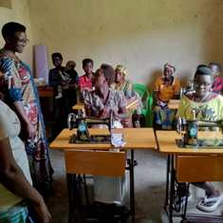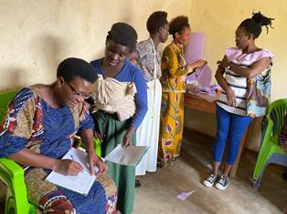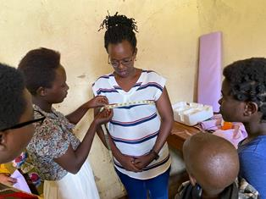

Evaluation
As the table shows, in the month February 6 SHGs made a sharing and the result are as follows;
No | About sharing | Number of SHG | Total
1 | Total money saved | 6 | 12,548,300
2 | Total Credit granted | 6 | 9,870,900
3 | Total interest | 6 | 4,500,000
4 | People who didn’t paid | 6 | 9
5 | Total money not refunded | 6 | 653,800

Classification of SHG
After evaluation it was found that;
Active | Less Active | Sick | Total
2 | 3 | 1 | 6

ACTION ON GENDER-BASED VIOLENCE (AGBV)
In the month of January, in the context of the project "Connecting the Global to the Local: Strengthening Women's Leadership for the Localization of the United Nations Security Council Resolution 1325 (2000) on "Women, Peace and Security", seven psychologists and 132 psychologists’ assistants have been receiving gender-based violence survivors for both listening and counselling. There was a coordination meeting with the seven psychologists see together how far we are meeting our project indicators. The meeting was held in the American friends Service Committee meeting room.
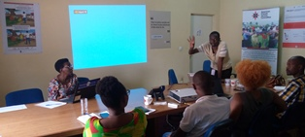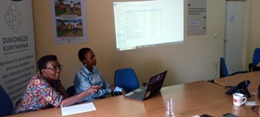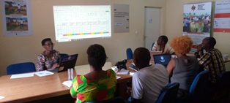
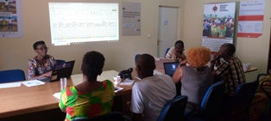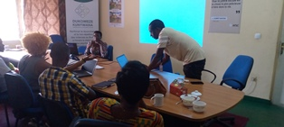
After the training of trainers (ToT) by the Society for Women and AIDS in Africa (SWAA) Burundi, one training against GBV was organized by the two people from FWA staff who had attended the ToT. Participants were young boys who are jobless.
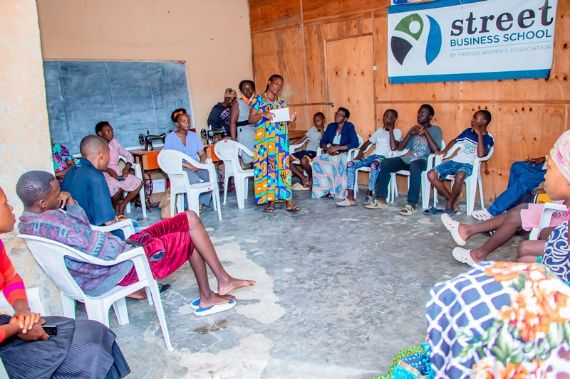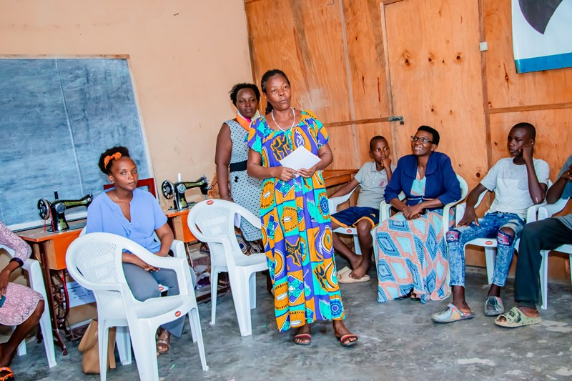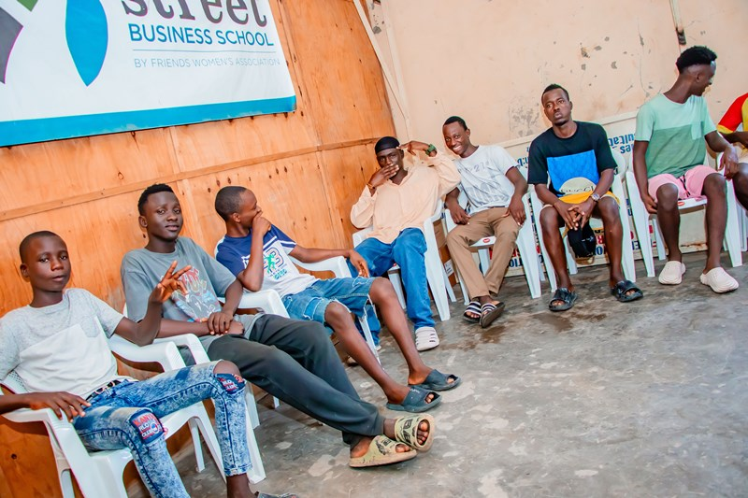

MEDICAL TEAM

CONSULTATIONS
Our medical doctors consulted with 151 cases, including 51 adults (19 men and 32 women), 11 children (2 boys and 9 girls), 36 HIV positive people and 53 pregnant women for ultrasound. The nurse received 184 patients including 143 adults and 41 children.

LABORATORY
In the month of February, apart from HIV voluntary testing, there were a total of 358 tests.

Test | Test completed | Positive | Negative
G.E.  Malaria test | 65 | 27 | 38
Quick malaria test | 45 | 16 | 29
ECBU  Urine test | 24 | 15 | 9
Selles  Stool test | 13 | 13 | 0
Pregnancy | 32 | 7 | 25
Sero-widal  Typhoïd fever | 59 | 18 | 41
Glycémie  Diabetes | 18 | 7 | 11
RPR VDRL  (Syphilis) | 33 | 1 | 32
Complete Blood Count | 45 | 14 | 31
Hepatitis B | 10 | 0 | 10
Hepatitis C | 8 | 0 | 8
Viral Load | 6 | 2 | 4
Total Tests: 358

FAMILY PLANNING
448 people received contraceptives from FWA’s nurse, including 64 old cases and 384 new ones. 400 received the contraceptive injection, 2 were given contraceptive pills, 23 received male condoms at Ntaseka clinic, 3 received UID and 20 received implants

PRENATAL CONSULTATION (PNC)
In February, 60 women came for prenatal consultation (PNC), including 23 who came for PNC 1, 18 for PNC 2, 14 for PNC 3 and 5 for PNC 4.
53 pregnant women came for the ultrasound test.

ANTI-RETROVIRAL SITE
At the end of February, we had 330 patients under retro drugs followed at NTASEKA clinic, including 267 women and 63 men.

PHARMACY
Regarding medications, FWA was able to purchase the minimum needed medicine.

PSYCHOSOCIAL TEAM
In the month of February, 77 people were tested for HIV and received pre and post HIV test counselling. Out of seven people who were detected HIV positive, six women were women with 9% of seropositivity.
Total Number of People Tested: | 77
Total Number of Women Tested: | 60
% of People Tested Who Are Women: | 78%
Average Age: | 28
Median Age: | 26
Total HIV+ : | 7
Total HIV- : | 70
Number of Women HIV+ : | 6
Total % Seropositivity: | 9%
% of Women Tested Who Are HIV+: | 10%

