Friends Women’s Association

FEBRUARY 2022 Report

Table of Contents
Friends Women’s Association 1
FEBRUARY 2022 Report 1
ACTIVITIES 2
Caring for HIV Positive People (CHIVPP) 2
Improving Women’s Reproductive Health (IWRH) 3
Rape Survivors’ Support (RSS) 5
MEDICAL TEAM 10
CONSULTATIONS 10
LABORATORY 10
FAMILY PLANNING 11
PRENATAL CONSULTATION (PNC) 11
ANTI-RETROVIRAL SITE 11
PHARMACY 11
PSYCHOSOCIAL TEAM 11

COVID-19 AND NTASEKA CLINIC
In the month of January, Friends Women’s Association has continued to apply covid restrictions restrictions at Ntaseka Clinic for both the staff and the beneficiaries’ protection.

The Burundian Alliance for the Family Welfare made a donation to the Ntaseka Clinic. This donation consisted of drugs generally used by pregnant women in case of illness or certain complications.

ACTIVITIES

Caring for HIV Positive People (CHIVPP)
In the month of February, medical follow-up and home visits were done for our HIV positive people.
Maternity Ward Building
In the month of February, under the support of the Global Giving Foundation, wooden doors were put inside the second floor of our maternity ward. More work was done for the maternity ward completion
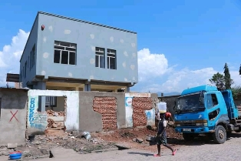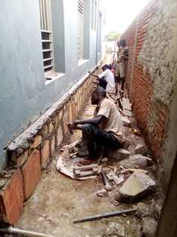.

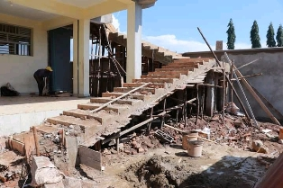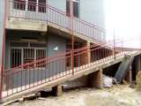
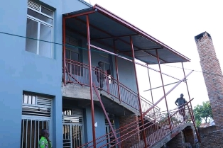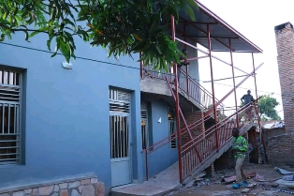

Improving Women’s Reproductive Health (IWRH)
FWA community health workers and FWA staff have continued to educate men, women on the importance of birth control. One discussion groups was done for breastfeeding women under one year.

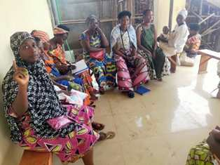
As of February 28, 2022, a discussion group of 20 women who are breastfeeding kids under one year was organized to discuss on sexual and reproductive health in general and family planning in particular.
Augustin HARUSHIMANA, the Ntaseka clinic midwife was a facilitator!
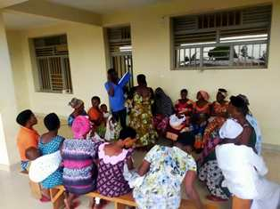
The discussion group began with a survey regarding the participants’ lifestyle as women breastfeeding a child less than one year. The results were:
- All 20 participants are members in FWA Self Help Groups
- 12/20 are legally married
- 4/20 are illegally married with many partners
- 4/20 do not know where their husbands are
- 20/20 are less than 35 years old
- 13/20 have more than 4 children
- 20/20 do not know their menstrual cycle
- 12/20 had sex as soon as the husband asked without protection or family planning, the earliest possible was a week and the latest was a month of childbirth
We discussed sexual and reproductive health after childbirth and the couple's sex life after childbirth, and information related to free care and some necessary information about the Ntaseka Clinic service.
Testimony :
My name is Anniella. I am 28 years old. I have 3 children. The first is 2 years 6 months old. The second is 1 year 6 months old and the last is 3 months old. My husband abandoned me for no reason after 2 weeks of giving birth to the 2nd child. Because of these close pregnancies, I lost my job in one of the companies in Bujumbura because with prenatal leave and work without a contract, I could not honor my specifications. When I learned that there are Self-Help Groups at Ntaseka clinic, I joined one of them. I participated in a workshop on Family Planning when my second child was 9 months old. I refused to join contraceptive methods because of three reasons: the first was that I was not with my husband. The second was that my religious beliefs did not allow adherence to family planning. The third was the side effects of contraceptives. Suddenly I received a visit from my husband who immediately impregnated me with a third child and continued on his way as usual. My husband is now out of my discussions. I decided not to continue living the ordeal. I am currently on family planning. I preferred the long-acting 5-year method and vow not to have another child if nothing changes.
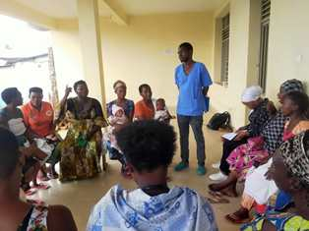

Rape Survivors’ Support (RSS)
In the month of Februart, the Rape Survivors Support program had different activities: one trauma healing workshop for GBV survivors on February 23-25, the evaluation of Self-Help Groups (SHGs) and field visits for both the Growing Rice Project and the Growing Corns Project.
I was born in a Christian family with a strict education. I grew up ignoring the wickedness of men. I was a church lady. I never knew the man sexually, I even didn’t understand a girl who can have sex before marriage; I did not even believe that it exists.
I married an HIV-positive man without knowing it, but He knew it. I got this bad news when I was pregnant. My heart was shattered into a thousand pieces; I felt the pain I had never felt before. It took me time to accept that my husband who is a practicing Christianity could do such a thing to me. With time, I found who really my husband is; a man who loves many women, who sleeps in hotels with other women, irresponsible man, angry man who beats me, and a man who is different than who I dreamed for. I fell into endless mourning in these 8 years. Sometimes I ask God why I harvested a life like life of a sex worker while I abstained for the glory of God.
I mourn my youth sometimes it's hard to leave the house I stay in my room because I think everyone knows that I’m HIV positive. I cry for my children because I'm going to die soon, who will raise my children? I no longer have strength to live. I sometimes desire death. This workshop has been meaningful to me. I feel I’m also human. Thanks a lot to the FWA
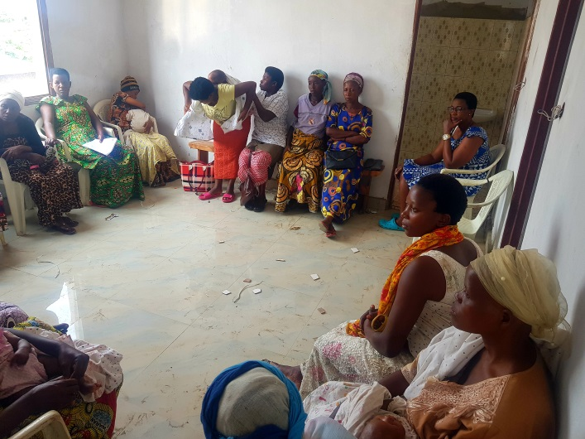

The Self-Help Groups have continued to meet once a week. At the end of February 2022, we had a total of 149 SHGs in Kamenge, Bujumbura Mairie province for a total of 3538 women and 30 SHGs for 738 women in Nyabiraba commune, Bujumbura province.

Self Help Groups Evaluation
No | About sharing | Number of SHG | Total
1 | Total money saved | 4 | 15,910,000
2 | Total Credit granted | 4 | 12,041,000
3 | Total interest | 4 | 11,655,000
4 | People who didn’t paid | 4 | 4
5 | Total money not refunded | 4 | 193,000

As the table above shows, in the month of February 4 SHGs made a sharing and the results are as follows;
- Savings made by the 4 SHGs were: 15,910,000 BIF
- Credits granted by the 4 SHGs were: 12,041,000 BIF
- Interest generated by 4 SHGs credits : 11,655,000 BIF
- People who have not paid back : 4
- Total money not refunded : 193,000 BIF

Classification of SHG
Active | Less Active | Sick | Total
1 | 3 | 0 | 4

After evaluation it was found that 1 SHGs are active and 3 SHGs are less active
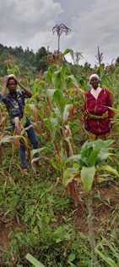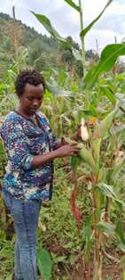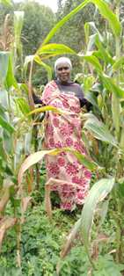
The Growing Corns Project in Nyabiraba commune, Bujumbura province
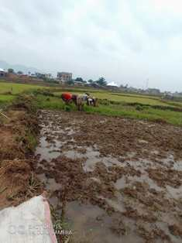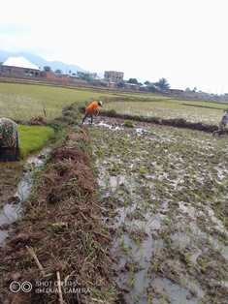
The Growing Rice Project in Bujumbura Mairie

ACTION ON GENDER-BASED VIOLENCE (AGBV)
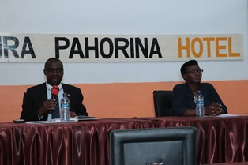
From left to right; The governor of Bujumbura, FWA National Coordinator
In the month of February 2022, FWA started to implement a new project sponsored by the United Nations Peace Building Fund. The title of the project is "Connecting the Global to the Local: Strengthening Women's Leadership for the Localization of the United Nations Security Council Resolution 1325 (2000) on "Women, Peace and Security". FWA is an implementing partner of the American Friends Service Committee (AFSC). This project will cover seven provinces of Burundi, including Bubanza, Bujumbura Mairie, Bujumbura, Cibitoke, Gitega, Makamba and Rumonge.
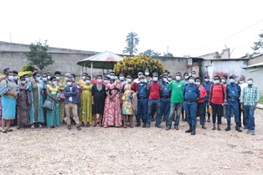
Bubanza Group Photo
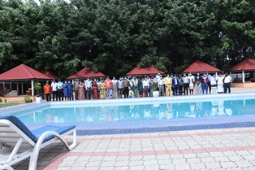
Bujumbura group photo

MEDICAL TEAM

CONSULTATIONS
Our medical doctor consulted with 46 cases, including 12 adults (1 man and 11women), four children (2 boys and 2 girls), 21 HIV positive people and 9 pregnant women for ultrasound. The nurse received 223 patients including 151 adults and 72 children.

LABORATORY
In the month of February, apart from HIV voluntary testing, there were a total of 240 tests.
Test | Test completed | Positive | Negative
G.E.  Malaria test | 52 | 19 | 33
Quick malaria test | 59 | 26 | 33
ECBU  Urine test | 7 | 6 | 1
Selles  Stool test | 9 | 9 | 0
Pregnancy | 37 | 14 | 23
Sero-widal  Typhoïd fever | 31 | 18 | 13
Glycémie  Diabetes | 8 | 2 | 6
RPR VDRL  (Syphilis) | 18 | 2 | 16
Complete Blood Count | 4 | 3 | 1
Hepatitis B | 2 | 0 | 2
Hepatitis C | 2 | 0 | 2
Viral Load | 11 | 0 | 11
Total Tests: 240

FAMILY PLANNING
571 people received contraceptives from FWA’s nurse, including 369 old cases and 202 new ones. 385 received the contraceptive injection, 116 were given contraceptive pills, 68 received male condoms, and 2 received implants.

PRENATAL CONSULTATION (PNC)
In January, 41 women came for prenatal consultation (PNC), including 14 who came for PNC 1, 10 for PNC 2, 9 for PNC 3 and 8 for PNC 4.
9 pregnant women came for the ultrasound test.

ANTI-RETROVIRAL SITE
At the end of February, we had 330 patients under retro drugs followed at NTASEKA clinic, including 267 women and 63 men.

PHARMACY
Regarding medications, FWA was able to purchase the minimum needed medicine.

PSYCHOSOCIAL TEAM
In the month of February, 63 people were tested for HIV and received pre and post HIV test counselling. Out of the four people detected HIV positive, three were women with 6% of seropositivity.
Total Number of People Tested: | 63
Total Number of Women Tested: | 51
% of People Tested Who Are Women: | 80%
Average Age: | 26
Median Age: | 23
Total HIV+ : | 4
Total HIV- : | 59
Number of Women HIV+ : | 3
Total % Seropositivity: | 6%
% of Women Tested Who Are HIV+: | 6%

