Friends Women’s Association

FEBRUARY 2025 Report

Table of Content
Friends Women’s Association 1
FEBRUARY 2025 Report 1
ACTIVITIES 2
Caring for HIV Positive People (CHIVPP) 2
Improving Women’s Reproductive Health (IWRH) 2
Rape Survivors’ Support (RSS) 2
MEDICAL TEAM 3
CONSULTATIONS 6
LABORATORY 6
FAMILY PLANNING 7
PRENATAL CONSULTATION (PNC) 7
ANTI-RETROVIRAL SITE 7
PHARMACY 7
PSYCHOSOCIAL TEAM 7

ACTIVITIES

Caring for HIV Positive People (CHIVPP)
In the month of February, medical follow-up and home visits were done for our HIV positive people.

Maternity Ward Building
Although Ntaseka maternity ward still needs some medical equipment; both the delivery and them, hospitalization services are currently functional.

Improving Women’s Reproductive Health (IWRH)
FWA staff and FWA community health workers have continued to educate both men and women on the importance of family planning.

RAPE SURVIVORS’ SUPPORT (RSS)
- SELF HELP GROUPS (SHGS)

ABOUT NEW SHG
No | Name of SHG | Month of creation | Member Number | Created by

SHG Total Number: | 63

THE WOMEN’S SOCIO-ECONOMIC EMPOWERMENT CENTER
The FWA has continued the construction of the Women’s Socio Economic Empowement Center (WSEEC). The aim of this project is to avail training rooms and a temporary safe shelter for gender-based violence survivors at the FWA headquarters. This project will cost $200,000. We have so far mobilized $39,100 including $16,600 from The African Great Lakes Initiative of the Friends Peace Teams, $10,000 from the CFSC and $12,500 from the Segal Family Foundation (SFF).
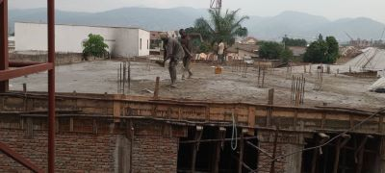

ACTION ON GENDER-BASED VIOLENCE (AGBV)
In the month of February, there was support of small projects initiated by Gender-based violence survivors. This comes from the project "Connecting the Global to the Local: Strengthening Women's Leadership for the Localization of the United Nations Security Council Resolution 1325 (2000) on "Women, Peace and Security".
In partnership with the American Friends Service Committee, Small projects intitiated by gender-based violence survivors from Bujumbura, Bubanza, Gitega, Makamba, Cibitoke and Rumonge were supported under the support of United Nations Peace Building Fund.
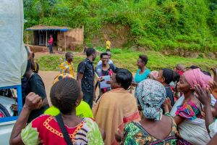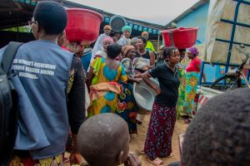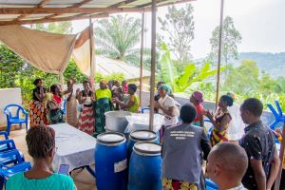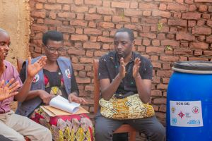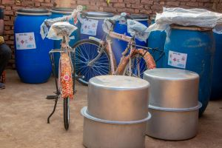
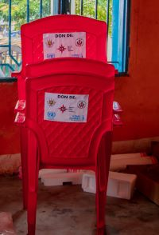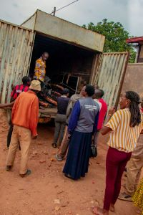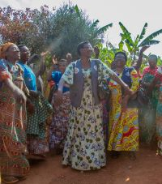
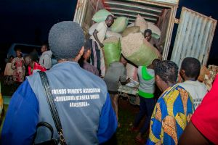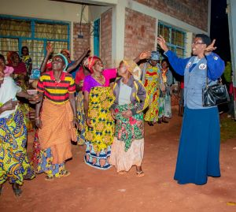
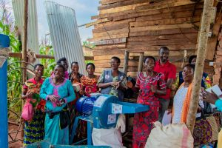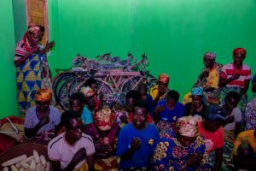
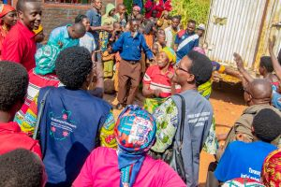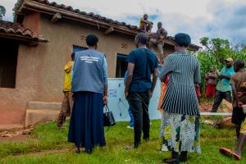
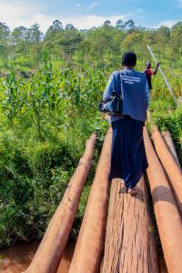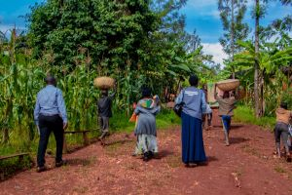

MEDICAL TEAM

CONSULTATIONS
Our medical doctor consulted with 88 cases, including 24 adults (3 men and 26 women), 8 children (2 boys and 5 girls), 12 HIV positive people and 44 pregnant women for ultrasound. The nurse received 268 patients including 171 adults and 97 children.

LABORATORY
In the month of February, apart from HIV voluntary testing, there were a total of 343 tests.

Test | Test completed | Positive | Negative
G.E.  Malaria test | 30 | 18 | 12
Quick malaria test | 94 | 30 | 64
ECBU  Urine test | 19 | 19 | 0
Selles  Stool test | 6 | 5 | 1
Pregnancy | 38 | 7 | 29
Sero-widal  Typhoïd fever | 58 | 9 | 49
Glycémie  Diabetes | 15 | 8 | 7
RPR VDRL  (Syphilis) | 16 | 0 | 16
Complete Blood Count | 43 | 20 | 23
Hepatitis B | 13 | 0 | 13
Hepatitis C | 11 | 0 | 11
Viral Load | 0 | 0 | 0
Total Tests: 343

FAMILY PLANNING
526 People received contraceptives from FWA’s nurse, including 283 old cases and 243 new ones. 427 received the contraceptive injection, 30 received pills, 54 received male condoms at Ntaseka clinic, 2 received UID and 13 received implants

PRENATAL CONSULTATION (PNC)
In February, 35 women came for prenatal consultation (PNC), including 10 who came for PNC 1, 9 for PNC 2, 7 for PNC 3 and 9 for PNC 4.
44 pregnant women came for the ultrasound test.

ANTI-RETROVIRAL SITE
At the end of February, we had 330 patients under retro drugs followed at NTASEKA clinic, including 267 women and 63 men.

PHARMACY
Regarding medications, FWA was able to purchase the minimum needed medicine.

PSYCHOSOCIAL TEAM
In the month of February, 42 people were tested for HIV and received pre and post HIV test counselling. All the 2 people detected HIV positive were women with 5% of seropositivity.
Total Number of People Tested: | 42
Total Number of Women Tested: | 33
% of People Tested Who Are Women: | 79%
Average Age: | 31
Median Age: | 30
Total HIV+ : | 2
Total HIV- : | 40
Number of Women HIV+ : | 2
Total % Seropositivity: | 5%
% of Women Tested Who Are HIV+: | 6%

