Friends Women’s Association

DECEMBER 2022 Report

Table of Contents
Friends Women’s Association 1
DECEMBER 2022 Report 1
ACTIVITIES 3
Caring for HIV Positive People (CHIVPP) 3
Improving Women’s Reproductive Health (IWRH) 3
Rape Survivors’ Support (RSS) 3
MEDICAL TEAM 10
CONSULTATIONS 10
LABORATORY 10
FAMILY PLANNING 11
PRENATAL CONSULTATION (PNC) 11
ANTI-RETROVIRAL SITE 12
PHARMACY 12
PSYCHOSOCIAL TEAM 12

COVID-19 AND NTASEKA CLINIC
In the month of December 2022, Friends Women’s Association has continued to apply covid restrictions restrictions at Ntaseka Clinic for both the staff and the beneficiaries’ protection.
On December 3, 2022, there was the general assembly of the FWA members in Kibimba, Gitega province.
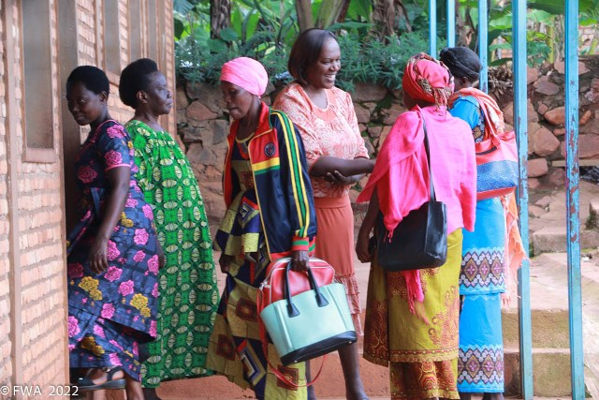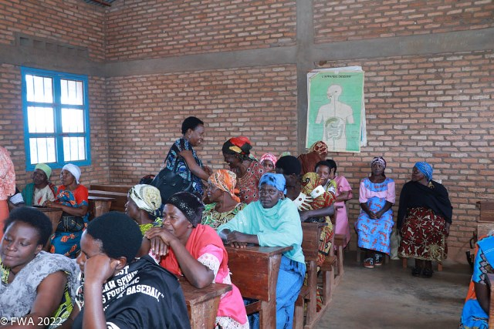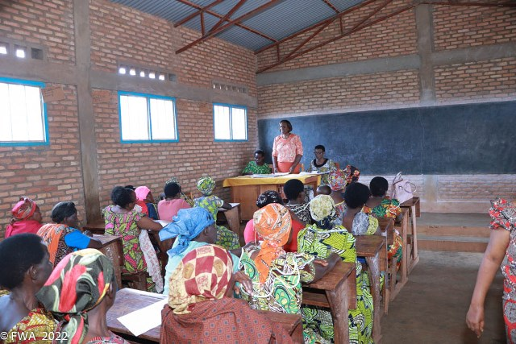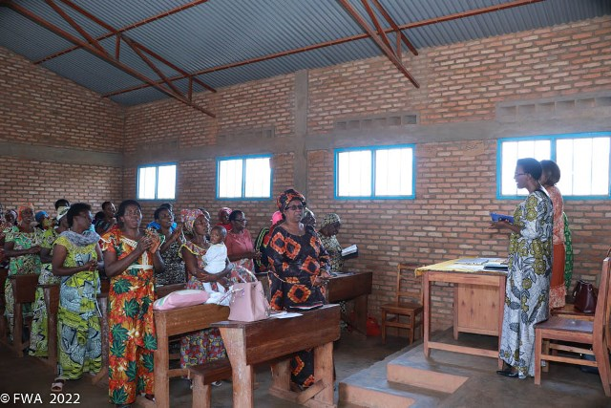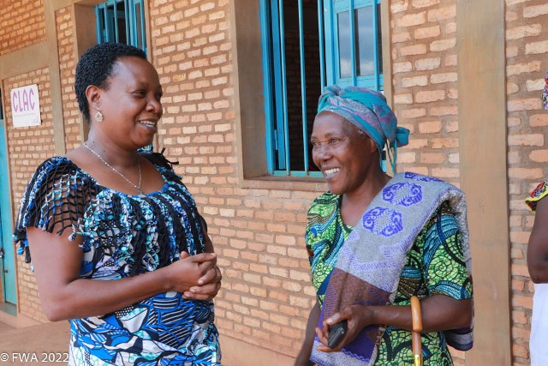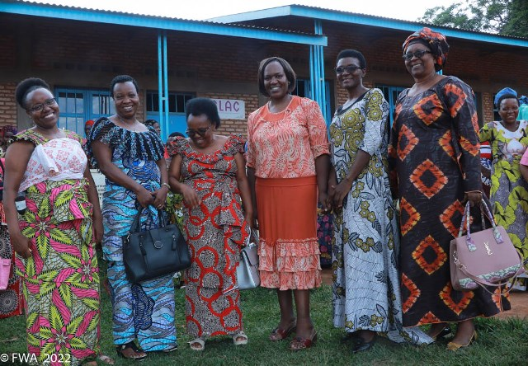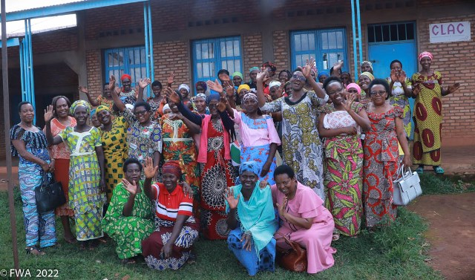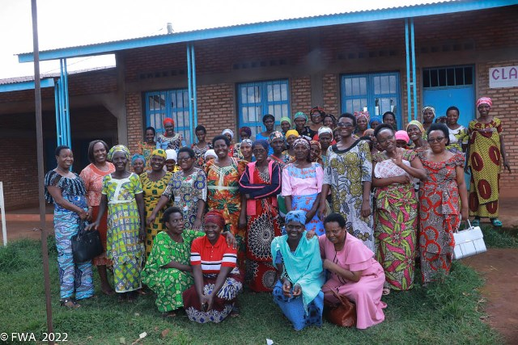

ACTIVITIES

Caring for HIV Positive People (CHIVPP)
In the month of December, medical follow-up and home visits were done for our HIV positive people.
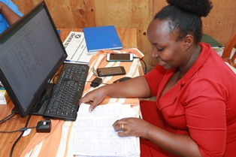

Maternity Ward Building
Ntaseka maternity ward still needs some medical equipment.

Improving Women’s Reproductive Health (IWRH)
FWA community health workers and FWA staff have continued to educate men, women and young people on the importance of birth control.

Rape Survivors’ Support (RSS)
In the month of December, the Rape Survivors Support program had different activities: the supervision of Self-Help Groups (SHGs) and evaluation and one trauma healing workshop. At the end of August 2022, we had a total of 154 SHGs in Kamenge, Bujumbura Mairie province for a total of 3638 women and 35 SHGs for 863 women in Nyabiraba commune, Bujumbura province.
- SHGs
ABOUT NEW SHG
No | Name of SHG | Month of creation | Member Number | Created by

SHG Total Number: | 154
SHGs Evaluation
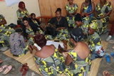 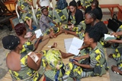 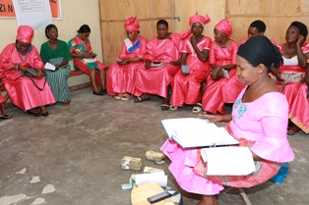 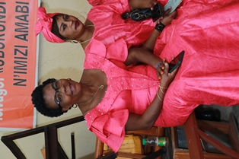 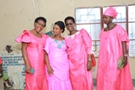 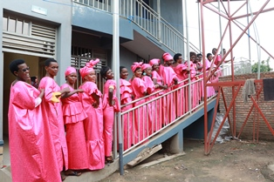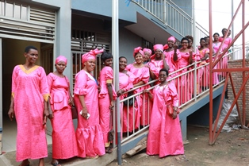 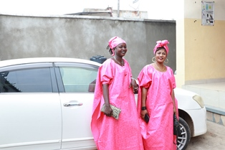 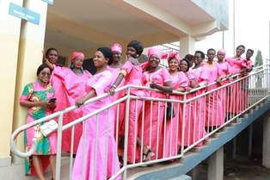 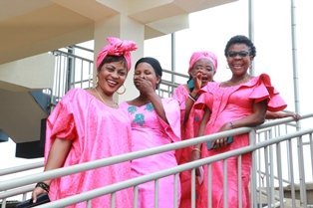 m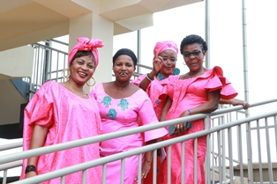.
As the table shows, in the month December 33 SHGs made a sharing and the result are as follows;
No | About sharing | Number of SHG | Total
1 | Total money saved | 33 | 120,674,700
2 | Total Credit granted | 33 | 97,430,100
3 | Total interest | 33 | 90,674,700
4 | People who didn’t paid | 33 | 26
5 | Total money not refunded | 33 | 3,243,100

Classification of SHG
After evaluation it was found that;
Active | Less Active | Sick | Total
28 | 4 | 1 | 33

- HROC Workshop ( December 24- 26)

Testimony
My name is Desiderate; I got married at 17 in the village. After a few months my husband left me. I was pregnant and I gave birth to my baby when the husband had not yet returned home.
My in-laws started mistreating me and pushed me to leave the house. I headed towards Bujumbura; I didn't know where I was going; I just took the bus. Arrived in Bujumbura I sat down at the edge of the road.
At sunset a woman approached me and proposed me to go to her home. I spent months with her, and she proposed me to marry a man illegally and I accepted. I lived with this man; unfortunately he died after a few months.

I decided to return to the village and my child fall seriously ill. That is how I learned that I and my child have HIV/AIDS because I continued to breastfeed my child. I understood that my second husband died because of HIV AIDS.

I returned to Bujumbura. I had a husband. He has just left me with my three children. Now I am alone without any activity I suffer a lot. Thank you for inviting me to this workshop.

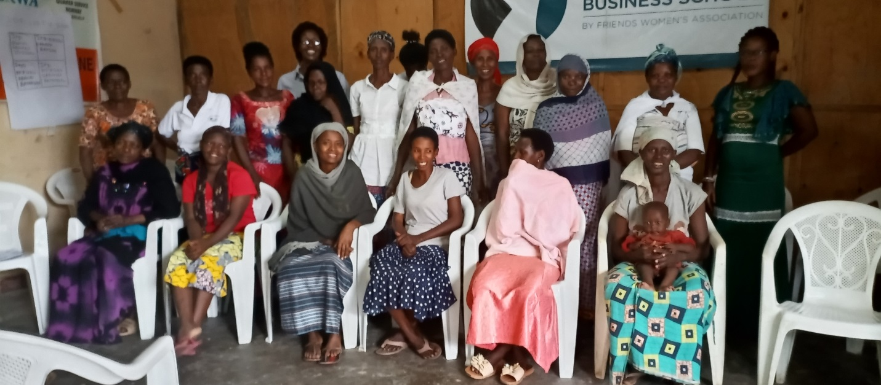
A group photo after the tree-day trauma healing workshop
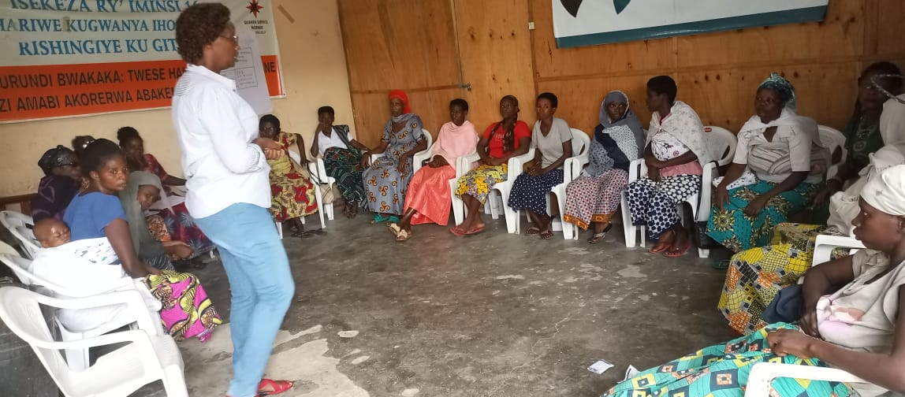

- Income Generating Activities
Income generating activities have continued. The handmade bas/mkets project by young girls has continued at our FWA office. In the month of November 2022, two SHGs from Nyabiraba commune have started to grow potatoes.
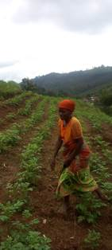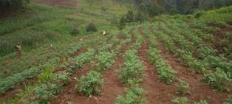
The Growing Potatoes Project at Mwumba hill, Nyabiraba commune, Bujumbura province
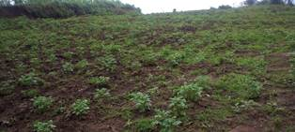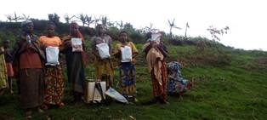
A group of beneficiaries (From Bubaji hill, Nyabiraba commune, Bujumbura province) with the potatoes fertilizer

ACTION ON GENDER-BASED VIOLENCE (AGBV)
In the month of December 2022, under the support of Canadian Friends Service Committee (CFSC), The FWA organization has joined the Burundi State and other NGOs during the 16 days-campaign of activism against GBV.
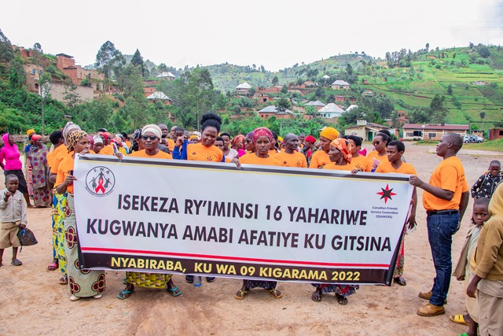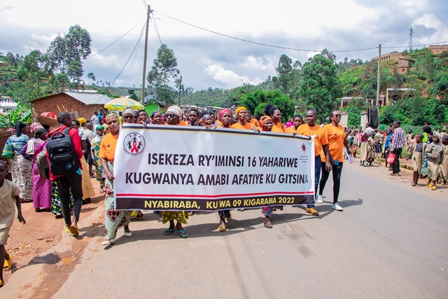
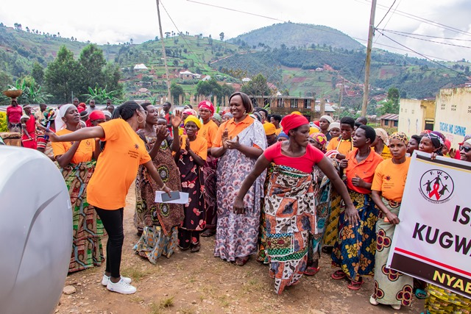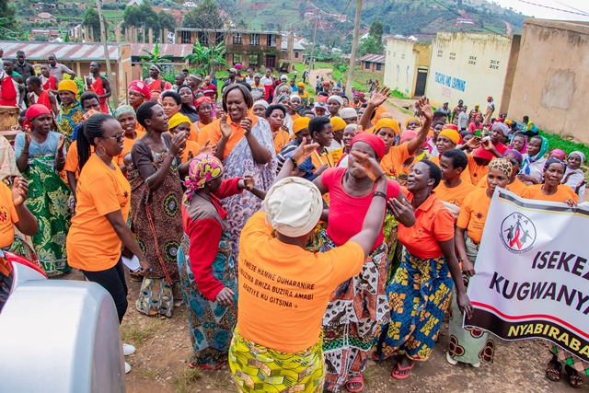
The national theme in 2022 was “Together let's work for a world without gender-based violence”. The ceremonies were rich in an orange color with a long peaceful walk on the Nyabiraba road. Local Authorities of Nyabiraba commune, various associations of women activists in the fight against violence against women in Nyabiraba commune, FWA accompanists, members of FWA’s savings groups and the population of Nyabiraba in general were present to celebrate that day. The event was characterized by: Traditional dances, sketches, drums, speeches and testimonies.

MEDICAL TEAM

CONSULTATIONS
Our medical doctors consulted with 166 cases, including 77 adults (31 men and 46 women), 21 children (8 boys and 13 girls), 19 HIV positive people and 49 pregnant women for ultrasound. The nurse received 273 patients including 201 adults and 72 children.

LABORATORY
In the month of December, apart from HIV voluntary testing, there were a total of 318 tests.
Test | Test completed | Positive | Negative
G.E.  Malaria test | 70 | 31 | 39
Quick malaria test | 56 | 20 | 36
ECBU  Urine test | 21 | 19 | 2
Selles  Stool test | 19 | 14 | 4
Pregnancy | 33 | 14 | 19
Sero-widal  Typhoïd fever | 54 | 21 | 33
Glycémie  Diabetes | 21 | 13 | 8
RPR VDRL  (Syphilis) | 16 | 0 | 16
Complete Blood Count | 11 | 3 | 8
Hepatitis B | 4 | 0 | 4
Hepatitis C | 4 | 0 | 4
Viral Load | 9 | 3 | 6
Total Tests: 318

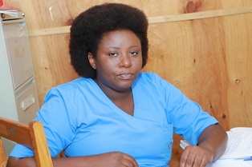
Aline, Ntaseka clinic Lab technician

FAMILY PLANNING
572 people received contraceptives from FWA’s nurse, including 282 old cases and 290 new ones. 387 received the contraceptive injection, 69 were given contraceptive pills, 93 received male condoms, 3 received UID and 20 received implants.

PRENATAL CONSULTATION (PNC)
In December, 71 women came for prenatal consultation (PNC), including 12 who came for PNC 1, 24 for PNC 2, 26 for PNC 3 and 9 for PNC 4.
49 pregnant women came for the ultrasound test.

ANTI-RETROVIRAL SITE
At the end of December, we had 330 patients under retro drugs followed at NTASEKA clinic, including 267 women and 63 men.

PHARMACY
Regarding medications, FWA was able to purchase the minimum needed medicine.

PSYCHOSOCIAL TEAM
In the month of December, 71 people were tested for HIV and received pre and post HIV test counselling. Out of them, two women were detected HIV positive with 3% of seropositivity.

Total Number of People Tested: | 71
Total Number of Women Tested: | 56
% of People Tested Who Are Women: | 79%
Average Age: | 30
Median Age: | 28
Total HIV+ : | 2
Total HIV- : | 69
Number of Women HIV+ : | 2
Total % Seropositivity: | 3%
% of Women Tested Who Are HIV+: | 4%

