Friends Women’s Association

AUGUST 2023 Report

Table of Content
Friends Women’s Association 1
AUGUST 2023 Report 1
ACTIVITIES 2
Caring for HIV Positive People (CHIVPP) 2
Improving Women’s Reproductive Health (IWRH) 3
Rape Survivors’ Support (RSS) 3
MEDICAL TEAM 5
CONSULTATIONS 5
LABORATORY 5
FAMILY PLANNING 6
PRENATAL CONSULTATION (PNC) 6
ANTI-RETROVIRAL SITE 6
PHARMACY 7
PSYCHOSOCIAL TEAM 7

COVID-19 AND NTASEKA CLINIC
In the month of August 2023, Friends Women’s Association has continued to apply covid restrictions at Ntaseka Clinic for both the staff and the beneficiaries’ protection.
On August 22-24, 2023 FWA National coordinator attended the Africa Hub workshop on Supporting Collective Action and Solidarity Building in Africa. This workshop was organized by Innovation for Change-Africa Hub. It took place in Entebbe, Uganda. 12 Participants were there, and they were coming from three different countries, including Burundi, the Democratic Republic of Congo (DRC) and Nigeria. The objectives of the convening were to bring together CSO members to deliberate and identify collective action efforts in closed countries in Africa and increase solidarity for advocacy by creating spaces for peer to peer learning and sharing.
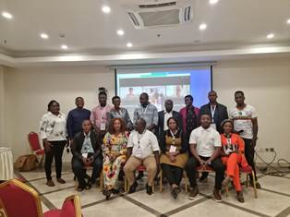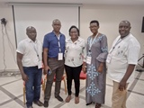
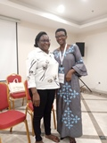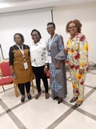

ACTIVITIES

Caring for HIV Positive People (CHIVPP)
In the month of August, medical follow-up and home visits were done for our HIV positive people.
Nutritional support was given to Ntaseka clinic HIV positive beneficiaries.
On August 29, 2023, a discussion group for HIV positive people was organized at Ntaseka clinic. 55 HIV positive people responded to our invitation,
The theme was: Importance of the Undetectable Viral Load and respecting appointments to obtain ARV supplies
The Health mediator NDAYISHIMIYE ESPERANCE who led the group explained the two types of results for the Viral Load “Undetectable viral load and detectable viral load”
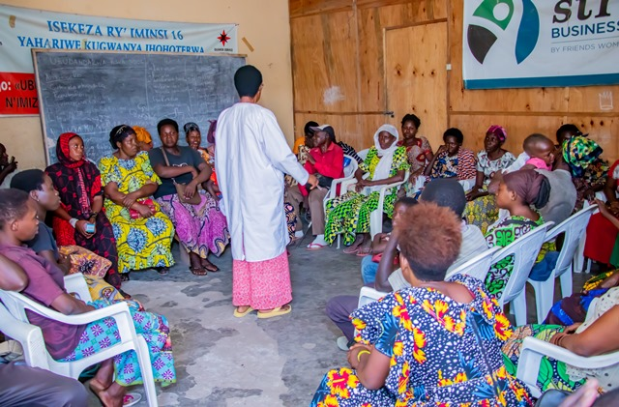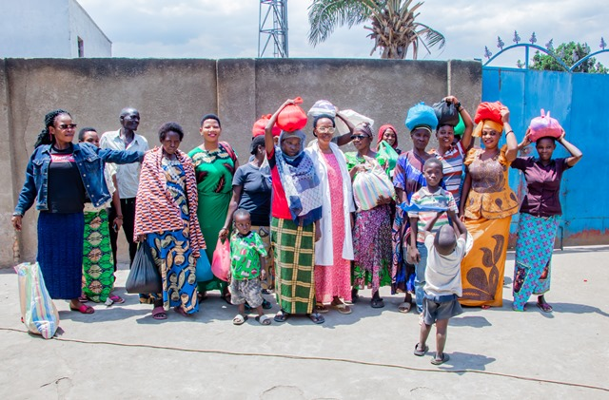
And then she reminded that for the moment the current protocol is “Test and Treat”. Thus, a 3-month supply of ARV is required. Many of those who were present are coming late to get supplies. The facilitator encouraged them by telling them that with the correct taking of the medications which are now combined in one and only one tablet per day; it is easy to have an undetectable viral load. And if you have an undetectable viral load, opportunistic diseases will not attack you. On the other hand, if you have a detectable viral load, this can lead you to the AIDS Disease Stage and with this stage dying quickly becomes easy. This can be prevented by taking medications correctly and respecting supply appointments.
We closed the discussion group with the distribution of rice and beans as nutritional support for our beneficiaries.
The beneficiaries warmly thank FWA for the nutritional support.
Testimonies
My name is Floribert. I’m 21 years old: I don't have a job and sometimes I get busy with work called "mason's helper" which requires too much effort. At the moment I haven't had a job for two weeks. Life is really too hard. But I just had 2kg of rice and 2kg of beans. With this I will spend the whole week looking for work as usual but this time with a good heart because I had something to eat. I thank FWA very much who is close to our hearts and who cares about our health holistically: psychologically through these discussion groups, medically and nutritionally. I will remember all this all my life. May the good Lord continue the work he has begun in you
I’m FURAHA: I'm too sick. I even think it's Cancer in my arm. Because of this, I don't do anything. I depend on other people medically and nutritionally, especially FWA and its Staff. With everything you do for me it's really very good. With this rice and these beans, I will spend my days in beauty with the strength to continue medical consultations, taking ARVs with joy and Courage. May God bless you abundantly.
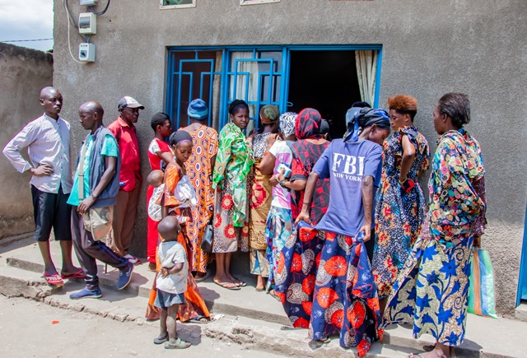
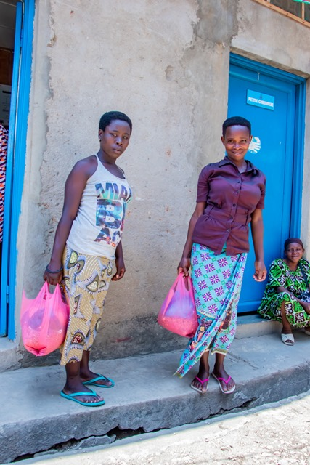

Meeting with parents whose children are being Supported by FWA to go to school
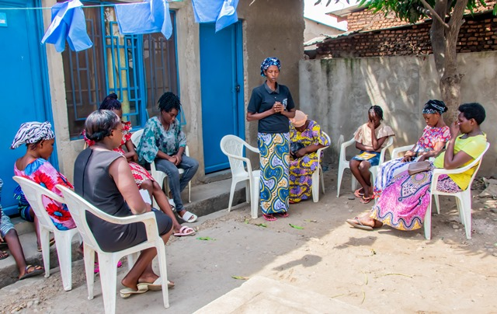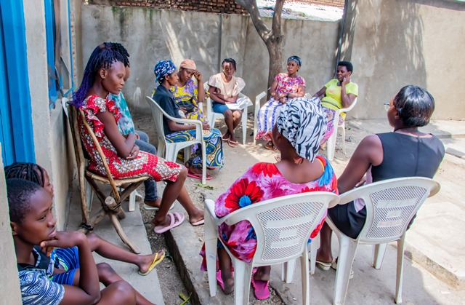
Maternity Ward Building
Although Ntaseka maternity ward still needs some medical equipment; both the delivery and the hospitalization services are currently functional. John Gould family Foundation has supported Ntaseka clinic with one SD3 Plus Foetal Doppler and one YX-24LM Dual Fuel Steam
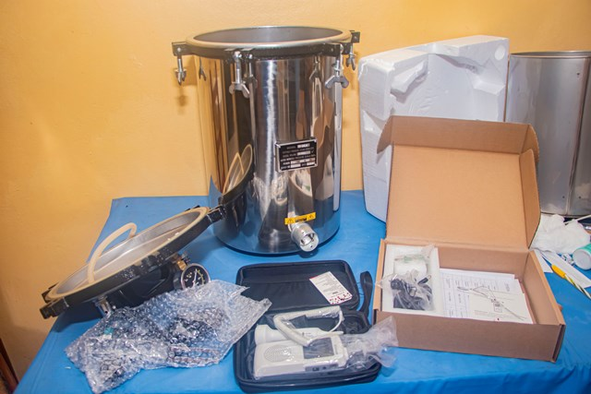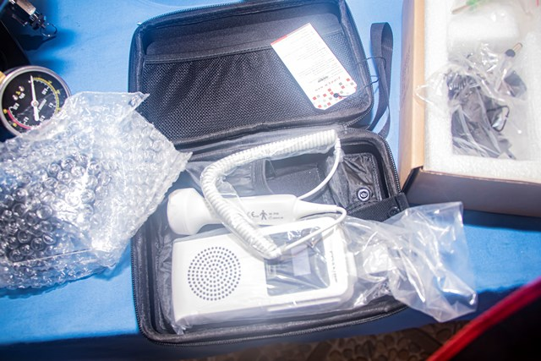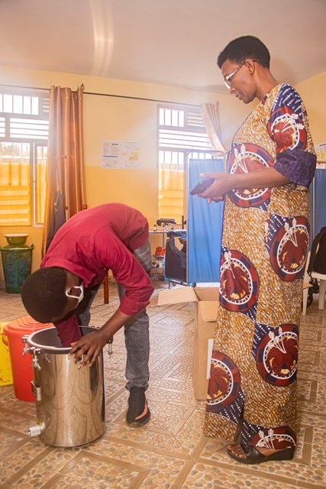

Improving Women’s Reproductive Health (IWRH)
FWA community health workers and FWA staff have continued to educate men, women and young people on the importance of birth control. ​

Rape Survivors’ Support (RSS)
In the month of August, the Rape Survivors Support program had different activities: the supervision of Self-Help Groups (SHGs) and one trauma healing workshop at Randa in Bubanza province. At the end of August 2023, we had a total of 159 SHGs in Kamenge, Bujumbura Mairie province for a total of 3763 women and 43 SHGs for 1063 women in Nyabiraba commune, Bujumbura province.
- SHGS
TOTAL SHGs
No | Name of SHG | Month of creation | Member Number | Created by

SHG Total Number: | 159+43=202
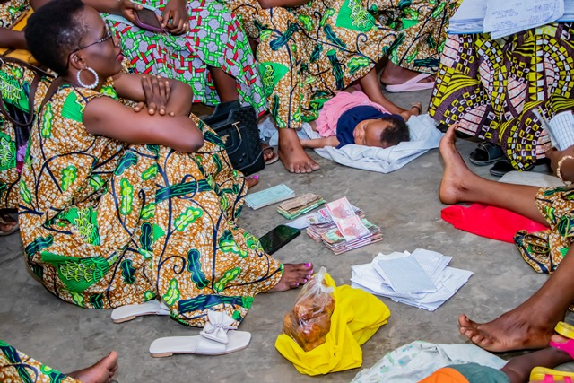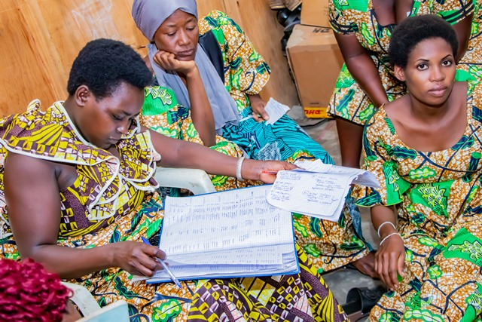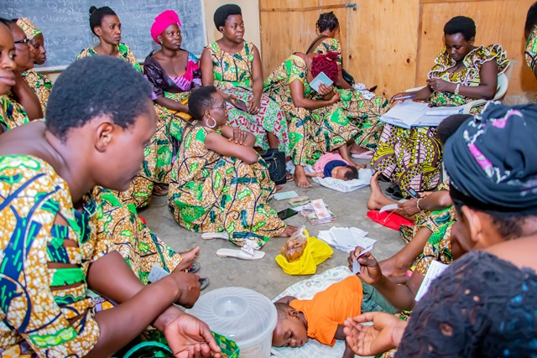
Evaluation
As the table shows, in the month August 2 SHGs made a sharing and the result are as follows;
No | About sharing | Number of SHG | Total
1 | Total money saved | 2 | 19,238,800
2 | Total Credit granted | 2 | 19,298,000
3 | Total interest | 2 | 10,600,600
4 | People who didn’t paid | 2 | 5
5 | Total money not refunded | 2 | 999,800

Classification of SHG
After evaluation it was found that;
Active | Less Active | Sick | Total
2 | 0 | 0 | 2

- SBS
In the month of August 2023, we discuss about “Business Opportunity Identification”. Participants were able to understand about; what is a business idea, what are the most common places where you get business ideas, why evaluate the viability of a potential business, the factors used when evaluating a potential business and When is the right time to start a business.
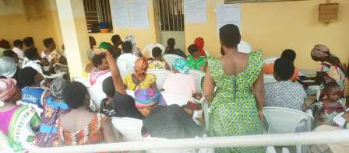
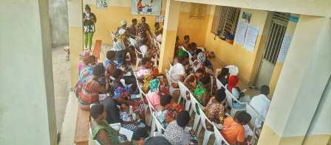

- HROC follow up ( August 28)

In August FWA organized a follow-up session with the aim of evaluating the impact of trauma healing training in Bubanza for 2 groups. After recycling HROC module there was a testimonial session on what was changed after the training.
Here are some testimonies:
“I am that woman victim of GBV who wanted and planned to kill my husband. I wasn't lying because I had already tried it for my first husband; it was even said on the radio: I threw hot water on his body and I fled to the DRC country. I spent 2 years there. They searched me in vain.
This training had a powerful impact in my life. I no longer recognize myself. It was hard to say that I was planning to kill my husband in front of the participants but it freed me. I felt light; little by little I felt the anxiety decreasing.
In front of a painful situation I am surprised to see myself calm and having a sleep. I said to my soul “be calm”; I leaned to talk with my soul. I am surprised that I forgive easily and that bad thoughts are gone.
I won't know how to say thank you because it's a miracle for me I was a Christian but I could not change. I tried to change, I used to give prayer requests but no change happened. The force of evil was too strong than me. Now I face every difficult situation with joy and hope.”
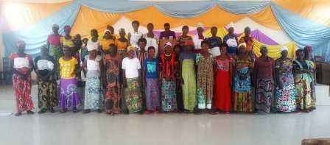
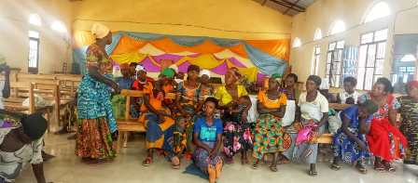

“This training helped me a lot. In the training I told you that I reached a stage of walking without knowing where I was going and that I was thinking about burning the houses of my community to have peace in my heart but now if you watch me you can see the change without saying anything. Before the HROC workshop, I could not wash myself and wash the clothes you saw it yourself. Now you can see that I am clean.
I didn't know what a sleep was but today it's very difficult for me to wake up. I was always worried and I didn't know peace of heart but now I have peace.
I hated my children I beat them seriously so that I can be imprisoned. I wanted to be imprisoned because I was hated by my husband until I hated myself.
Sincerely I tell you thank you, I had the courage to build a small house where I and my children will live. This will help me to reduce the stress of paying the rent each month.”

ACTION ON GENDER-BASED VIOLENCE (AGBV)
In the month of August 2023, in the context of the project "Connecting the Global to the Local: Strengthening Women's Leadership for the Localization of the United Nations Security Council Resolution 1325 (2000) on "Women, Peace and Security", seven psychologists and 132 psychologists’ assistants have been receiving gender-based violence survivors for both listening and counselling.

MEDICAL TEAM

CONSULTATIONS
Our medical doctors consulted with 156 cases, including 55 adults (23 men and 32 women), 14 children (8 boys and 6 girls), 38 HIV positive people and 49 pregnant women for ultrasound. The nurse received 222 patients including 157 adults and 65 children.

LABORATORY
In the month of August, apart from HIV voluntary testing, there were a total of 317 tests.

Test | Test completed | Positive | Negative
G.E.  Malaria test | 43 | 13 | 20
Quick malaria test | 26 | 5 | 21
ECBU  Urine test | 29 | 22 | 7
Selles  Stool test | 17 | 16 | 1
Pregnancy | 34 | 7 | 27
Sero-widal  Typhoïd fever | 42 | 15 | 27
Glycémie  Diabetes | 21 | 11 | 10
RPR VDRL  (Syphilis) | 34 | 5 | 29
Complete Blood Count | 37 | 17 | 20
Hepatitis B | 3 | 0 | 3
Hepatitis C | 6 | 2 | 4
Viral Load | 25 | 1 | 24
Total Tests: 317

FAMILY PLANNING
973 people received contraceptives from FWA’s nurse, including 244 old cases and 729 new ones. 493 received the contraceptive injection, 61 were given contraceptive pills, 35 received male condoms at Ntaseka clinic while 364 received condoms in the community (These were distributed by Ntaseka clinic community health workers), 2 received UID and 18 received implants.

PRENATAL CONSULTATION (PNC)
In August, 72 women came for prenatal consultation (PNC), including 26 who came for PNC 1, 14 for PNC 2, 22 for PNC 3 and 10 for PNC 4.
49 pregnant women came for the ultrasound test.

ANTI-RETROVIRAL SITE
At the end of August, we had 330 patients under retro drugs followed at NTASEKA clinic, including 267 women and 63 men.

PHARMACY
Regarding medications, FWA was able to purchase the minimum needed medicine.

PSYCHOSOCIAL TEAM
In the month of August, 118 people were tested for HIV and received pre and post HIV test counselling. Out of them, four people including three women were detected HIV positive with 3% of seropositivity.

Total Number of People Tested: | 118
Total Number of Women Tested: | 72
% of People Tested Who Are Women: | 61%
Average Age: | 28
Median Age: | 27
Total HIV+ : | 4
Total HIV- : | 114
Number of Women HIV+ : | 3
Total % Seropositivity: | 3%
% of Women Tested Who Are HIV+: | 4%

