Friends Women’s Association

APRIL 2022 Report

Table of Contents
Friends Women’s Association 1
april 2022 Report 1
ACTIVITIES 2
Caring for HIV Positive People (CHIVPP) 2
Improving Women’s Reproductive Health (IWRH) 3
Rape Survivors’ Support (RSS) 4
MEDICAL TEAM 6
CONSULTATIONS 6
LABORATORY 6
FAMILY PLANNING 7
PRENATAL CONSULTATION (PNC) 7
ANTI-RETROVIRAL SITE 7
PHARMACY 7
PSYCHOSOCIAL TEAM 7

COVID-19 AND NTASEKA CLINIC
In the month of April, Friends Women’s Association has continued to apply covid restrictions restrictions at Ntaseka Clinic for both the staff and the beneficiaries’ protection.

ACTIVITIES

Caring for HIV Positive People (CHIVPP)
In the month of April, medical follow-up and home visits were done for our HIV positive people.
Maternity Ward Building
In the month of April, the finishing works for Ntaseka clinic maternity ward were completed. On April, 8, 2022, under the high patronage of the Ministry of Solidarity, Social Affairs, Human Rights and Gender, there was official inauguration of the Ntaseka clinic maternity ward. Some participants were present physically, others were there virtually.
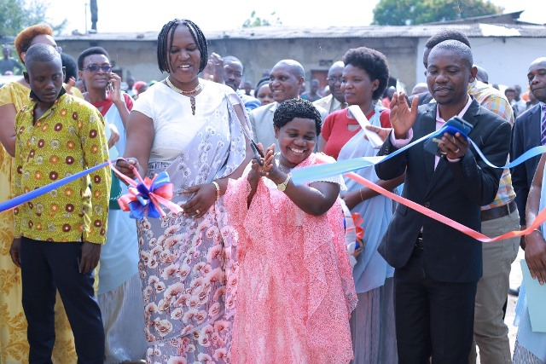
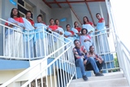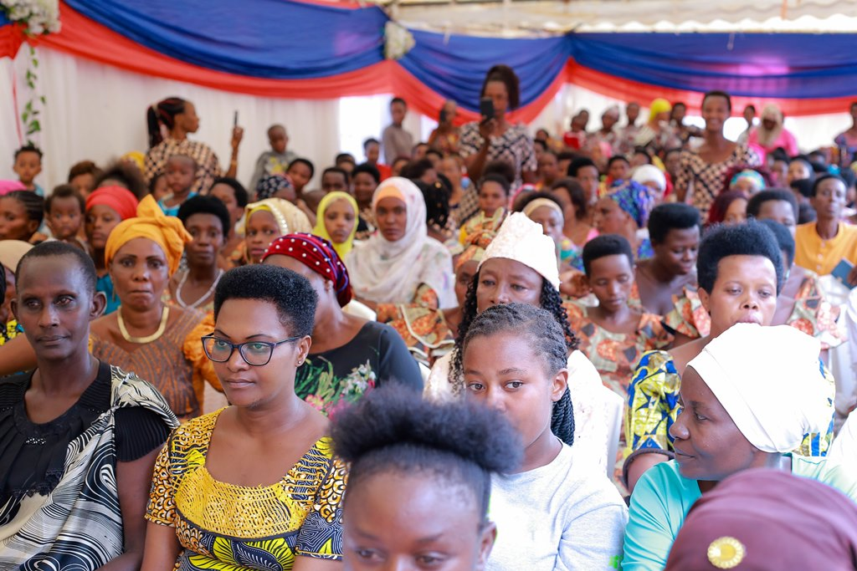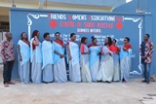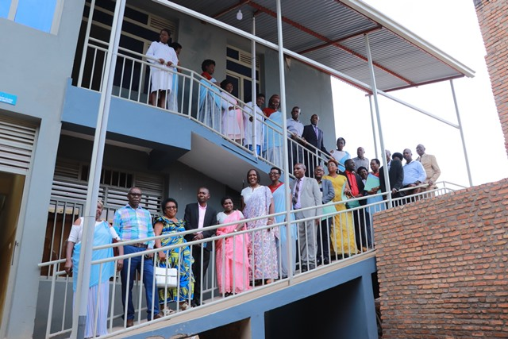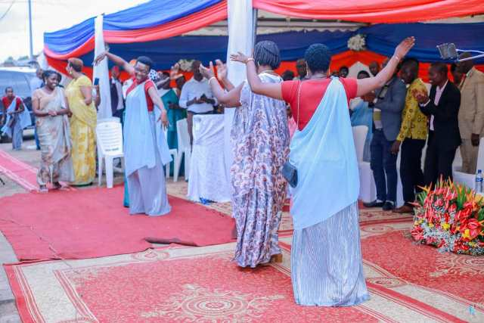
Joy and dancing after the Ntaseka clinic maternity ward official inauguration
https://www.youtube.com/watch?v=RQzgGnDNXr4&authuser=0

On April 24, 2022, there was a zoom meeting with Stony Run Friends Meeting to find together ways they can continue supporting Ntaseka clinic. Below are pictures of some people who were on the call.
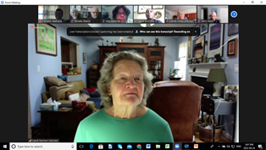
Sandi Morton, the organizer of the zoom call from Stony Run Friends Meeting
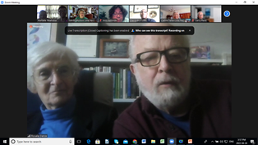
Rosalie Dance and Adrian Bishop, members of Stony Run Friends Meeting and promoters of the partnership between FWA and Stony Run Friends Meeting
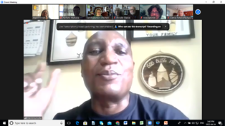
David Bucura, the coordinator of the African Great Lakes Initiative of the Friends Peace Teams
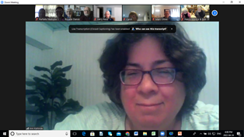
A member of Stony Run Friends Meeting
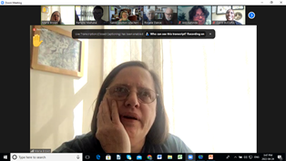
A member of Stony Run Friends Meeting

Improving Women’s Reproductive Health (IWRH)
FWA community health workers and FWA staff have continued to educate men, women and young people on the importance of birth control.
In partnership with Tabitha Community in Action, FWA ran a dialogue session with young people sexual responsibility on April 24, 2022 at Sentinella conference room in Kanyosha, Bujumbura Mairie. FWA was represented by Ntahuba Parfaite, the national coordinator and Augustin Harushimana, the Ntaseka clinic midwife and president of VYARUHEKE association (An association of Midwives in Burundi).
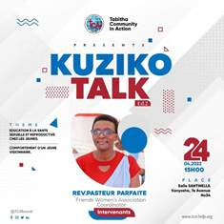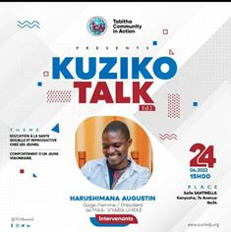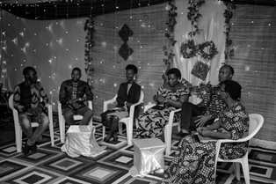
The picture above shows the team of speakers receiving questions from the participants
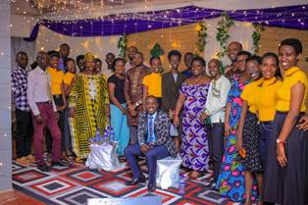

Rape Survivors’ Support (RSS)
In the month of April, the Rape Survivors Support program had different activities: the supervision of Self-Help Groups (SHGs) and field visits for both the Growing Rice Project. At the end of April 2022, we had a total of 149 SHGs in Kamenge, Bujumbura Mairie province for a total of 3538 women and 30 SHGs for 738 women in Nyabiraba commune, Bujumbura province.

ACTION ON GENDER-BASED VIOLENCE (AGBV)
In the month of April, the FWA has been discussing with Quaker Service Norway (QSN) to renew our partnership. The result is that we will have a two-year Memorundum of Understanding for this particular project implementation in Giheta commune, Gitega province. The same project will be implemented in Nyabiraba, Bujumbura province under the Canadian Friends Service Committee (CFSC).
In the same month of April, FWA has continued to implement the project sponsored by the United Nations Peace Building Fund "Connecting the Global to the Local: Strengthening Women's Leadership for the Localization of the United Nations Security Council Resolution 1325 (2000) on "Women, Peace and Security". During the month of April, FWA did three trauma healing workshops in three provinces: Bujumbura, Gitega and Rumonge. Participants were women mediators and one psychologist recently recruted per province. It was also an opportunity for women mediators to get connected to the psychologist for collaboration and networking.
“What traumatized me was the death of my husband in 1993. My husband went to work as usual but he did not return. We searched everywhere but in vain. What hurt me in the search for my husband was the Administrator of the commune at the time. I called him on a public telephone and he cut the telephone. I asked the army commander, and he replied: “stop confusing me; don't you know that there is war in our country?”.
We mourned in silence because no one was allowed to come to our house because it was said that my husband was a malefactor (Umumenja) because of the ethnic conflicts.
I had a letter from my friend informing me that she had seen my husband. Afterwards we went looking for him again but we did not find any trace. So we decided to do the final mourning. Finally, we saw my husband come back, and he told us that he had been hiding at his friend's house all these three months. But he was traumatized he continued hiding so that he canot be killed.
One day I had gone to ou rparish for prayer and when I came back I found him dead: He was not sick; he fell down, and he gave up his soul.
It was a big shock for me. Until now accepting his death is very difficult for me. I still mourn my husband, I am very sad as you said because in my head I wonder why God can accept all this. Doing the final mourning for someone twice was very hard for me. When I remember this I have a feeling of shame and I even want to stay at home.”
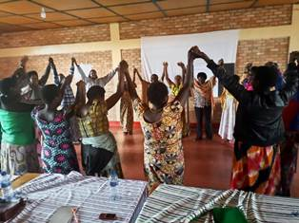
This picture above shows participants who were attending a three-day trauma healing workshop in Jenda, Bujumbura province. They were holding each other hands as a sign of support and unity after sharing their sad stories.

MEDICAL TEAM

CONSULTATIONS
Our medical doctors consulted with 48 cases, including 8 adults (4 men and 4 women), 3 children (all of them were girls), 10 HIV positive people and 27 pregnant women for ultrasound. The nurse received 221 patients including 157 adults and 64 children.

LABORATORY
In the month of April, apart from HIV voluntary testing, there were a total of 247 tests.
Test | Test completed | Positive | Negative
G.E.  Malaria test | 62 | 41 | 21
Quick malaria test | 47 | 10 | 37
ECBU  Urine test | 12 | 2 | 10
Selles  Stool test | 14 | 3 | 11
Pregnancy | 27 | 9 | 18
Sero-widal  Typhoïd fever | 19 | 7 | 12
Glycémie  Diabetes | 9 | 3 | 6
RPR VDRL  (Syphilis) | 23 | 0 | 23
Complete Blood Count | 21 | 8 | 13
Hepatitis B | 3 | 1 | 2
Hepatitis C | 1 | 0 | 1
Viral Load | 9 | 1 | 8
Total Tests: 247

FAMILY PLANNING
486 people received contraceptives from FWA’s nurse, including 246 old cases and 240 new ones. 380 received the contraceptive injection, 39 were given contraceptive pills, 51 received male condoms, 1 received UID and 15 received implants.

PRENATAL CONSULTATION (PNC)
In April, 46 women came for prenatal consultation (PNC), including 23 who came for PNC 1, 10 for PNC 2, 4 for PNC 3 and 9 for PNC 4.
27 pregnant women came for the ultrasound test.

ANTI-RETROVIRAL SITE
At the end of April, we had 330 patients under retro drugs followed at NTASEKA clinic, including 267 women and 63 men.

PHARMACY
Regarding medications, FWA was able to purchase the minimum needed medicine.

PSYCHOSOCIAL TEAM
In the month of April, 66 people were tested for HIV and received pre and post HIV test counselling. Both the two people detected HIV positive were women with 3% of seropositivity.
Total Number of People Tested: | 66
Total Number of Women Tested: | 58
% of People Tested Who Are Women: | 88%
Average Age: | 28
Median Age: | 27
Total HIV+ : | 2
Total HIV- : | 64
Number of Women HIV+ : | 2
Total % Seropositivity: | 3%
% of Women Tested Who Are HIV+: | 3%

