Friends Women’s Association

AUGUST 2022 Report

Table of Contents
Friends Women’s Association 1
AUGUST 2022 Report 1
ACTIVITIES 2
Caring for HIV Positive People (CHIVPP) 2
Improving Women’s Reproductive Health (IWRH) 2
Rape Survivors’ Support (RSS) 2
MEDICAL TEAM 9
CONSULTATIONS 9
LABORATORY 9
FAMILY PLANNING 10
PRENATAL CONSULTATION (PNC) 10
ANTI-RETROVIRAL SITE 10
PHARMACY 10
PSYCHOSOCIAL TEAM 10

COVID-19 AND NTASEKA CLINIC
In the month of August 2022, Friends Women’s Association has continued to apply covid restrictions restrictions at Ntaseka Clinic for both the staff and the beneficiaries’ protection.

ACTIVITIES

Caring for HIV Positive People (CHIVPP)
In the month of August, medical follow-up and home visits were done for our HIV positive people.

Maternity Ward Building
Under the support of the African Great Lakes Initiative (AGLI), there was recruitment of a full time medical doctor in the month of July 2022. In the month of August 2022, under the same support from AGLI, as we have frequent water shortages, there was the installation of Ntaseka clinic water tank
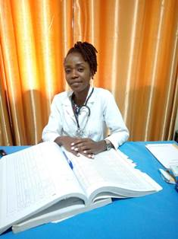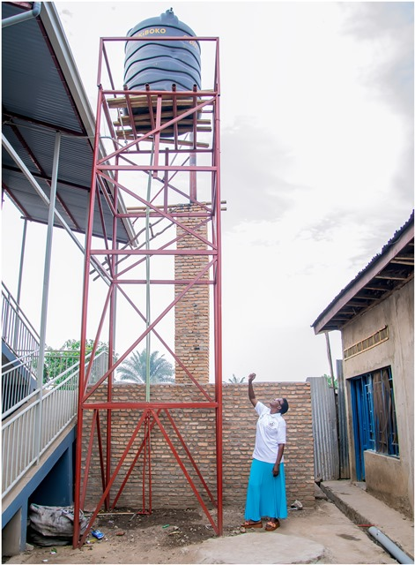
Doctor CISHAHAYO Marie Salome Pastor Parfaite next to the new water tank

Improving Women’s Reproductive Health (IWRH)
FWA community health workers and FWA staff have continued to educate men, women and young people on the importance of birth control.
On August 28th, 2022, a discussion group for 30 Young Women who are in three young girls' self-help groups, was organized to discuss about sexual and reproductive health. The theme of the day was “Menstrual cycle” as planned since May 2022.
Facilitators were Midwife Augustin HARUSHIMANA, Dr NIBONA Alexia and Dr Marie Salomé CISHAHAYO.

It is a group of young girls who are leaders of three self-help groups (SHGs). They are there every last Sunday of the month to discuss and share ideas and experiences around a theme according to the theme plan already established in the framework for the promotion of sexual and reproductive health.
We have seen in depth and breadth the menstrual cycle summarized as follows:
1. Definition
The menstrual cycle is the set of periodic genital and hormonal manifestations occurring in women from puberty to menopause and interrupted by pregnancy and lactation. The menstrual cycle goes from the 1st day of menstruation until the last day before the next menstrual period.
It can vary between 21 to 35 days. We took 28 days as the standard for the documents. Any woman who has a regular cycle whether it is 21, 28 or 35 days has a normal cycle. Ovulation always takes place 14 days before the 1st day of the next period. Periods last an average of 3 to 7 days.
2. Different phases of the menstrual cycle
The 1st phase: goes from the 1st day of menstruation to the day of ovulation
The 2nd phase: ovulation period: occurs 14 days before the end of the cycle.
The 3rd phase: 14 days for everyone ends the day before your period

3. The fertile period
• On average, ovulation occurs 14 days before the start of the next period.
• The spermatozoa retain their ability to fertilize for a period ranging from 2 to 3 days).
• The egg only retains the ability to be fertilized for 24 hours after ovulation.

This is the testimony of one young girl who will get married very soon:

My name is Elvine. I thank Ntaseka Clinic for having organized these sessions which will be beneficial in both my sexual and marital life. For this moment I have plenty information on the menstrual cycle and especially from this safe center as a source of information in sexual and reproductive health. I recommend to organize more sessions for young girls who are preparing for marriage in order to have much more clarification. Indeed, this is one of the most neglected areas by the girls themselves in Burundi while they are among the development pillars.

As the time was running very fast, the next session will be dedicated to questions and answers on the menstrual cycle and the sharing of experiences among the young girls and this will be facilitated by the Midwife Augustin and the two medical doctors of Ntaseka Clinic.

Among challenges, we have noticed that some sessions need both a projector and a laptop.

Rape Survivors’ Support (RSS)
In the month of August, the Rape Survivors Support program had different activities: the supervision of Self-Help Groups (SHGs) and evaluation, one trauma healing workshop, and the Street Business School (SBS) fourth promotion first session. At the end of August 2022, we had a total of 153 SHGs in Kamenge, Bujumbura Mairie province for a total of 3613 women and 35 SHGs for 863 women in Nyabiraba commune, Bujumbura province.
- SHGs
ABOUT NEW SHG
No | Name of SHG | Month of creation | Member Number | Created by

SHG Total Number: | 153
SHG Evaluation
As the table shows, in the month August 1 SHG was evaluated and the result are as follows;
No | Description | Number of SHG | Total
1 | Total money saved | 2 | 1,450,600
2 | Total Credit granted | 2 | 1,580,000
3 | Total interest | 2 | 0
4 | People who didn’t paid | 2 | 20
5 | Total money not refunded | 2 | 2,384,000

Classification of SHG
After evaluation it was found that;
Active | Less Active | Sick | Total
0 | 0 | 2 | 2

2. SBS
Two training sessions on SBS were held where we discussed about Module 3 (Getting Out of your Comfort Zone) and module 2 which is about Business Opportunity Identification

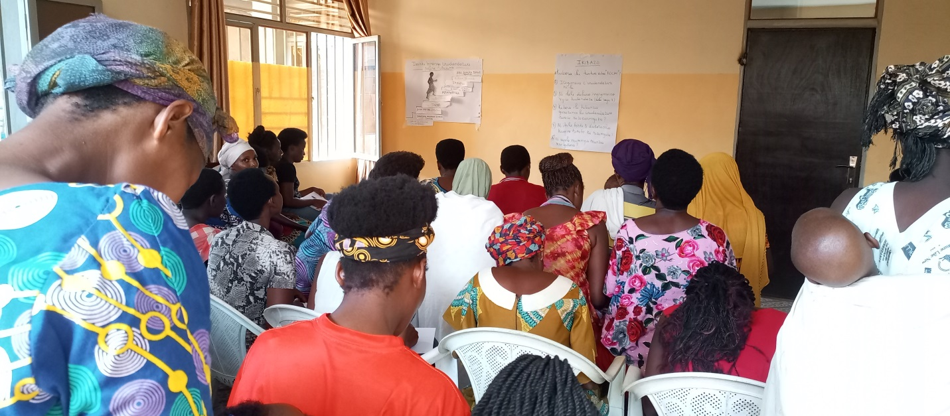

- Trauma healing workshop (August,17-19)

I married an orphan husband. He promised me to live happily and He used to say that I am all He has. After 4 year, he started dating other women. I lived in the village and He was in Bujumbura.
One day I asked him money to buy a cow in order to have manure. He answered me: "I bought one cow, it's a cow with two legs, (she talk about me and dowry) I can't buy another “Then He asked me for the money and I gave it to him. After I found that He had a premature child with another woman and the money was to pay for his hospitalization.
After that he called me and told me to come and live with him in Bujumbura. When I was hesitating, he told me that if I don't com, dangerous things could happen to me and I made the decision to go to live with him here in Bujumbura. It was afterwards that I discovered that this woman wanted to live with my husband by force and that my husband did not want it.
In that house I was victim of psychological violence; my husband gave me the order to prepare and serve food to his wife and my husband at the table while I and my children ate outside. I was preparing meals and serving them but my heart was bleeding.
One day I felt that I could not take it anymore; I told him that if this woman will come back again in my house I will throw hot water on them. He was scared and he made the decision to sleep in the house of his second wife or to come home late.
One day he came home around 2 a.m. and I refused to open until 8 a.m. I wanted everyone to see the bad husband he is. When I opened the door, he took everything in our house and wanted to leave us and I refused, explaining to him that he was not going to run away from his responsibilities. So, He took a rebar and beat me until I fainted. You could even see the scars.
Until now I'm in this situation but God gave me the courage to work to support my children He's there. When he wants, he comes back home; when He doesn't want he doesn't come home.

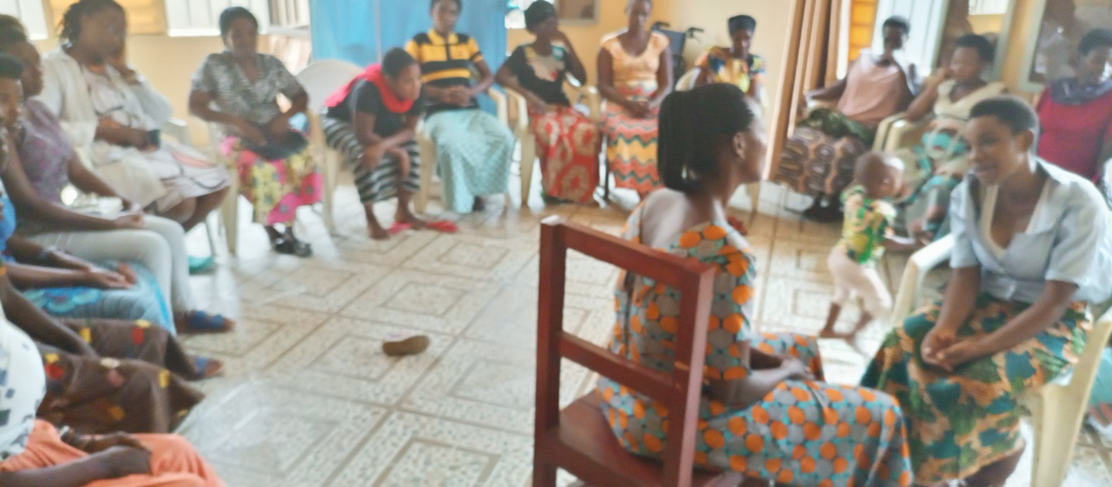
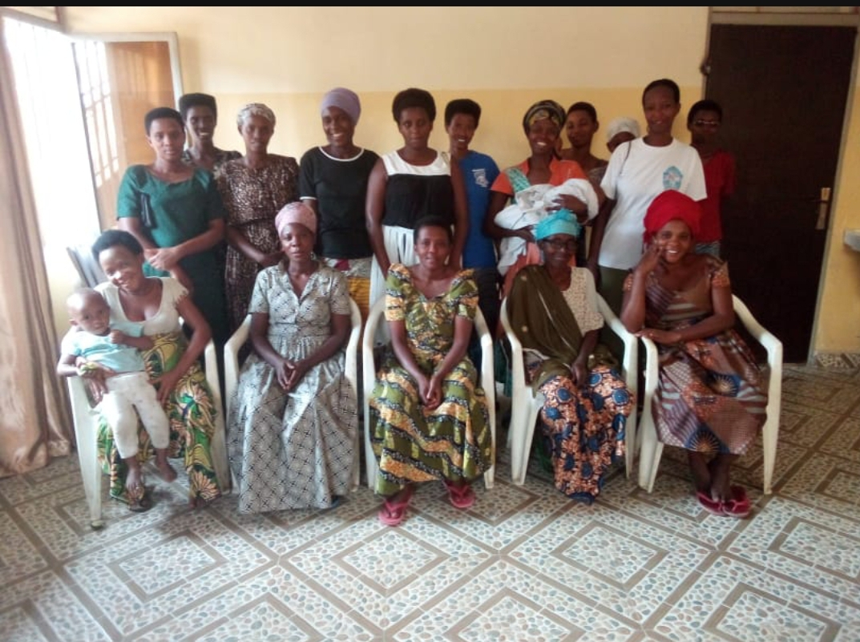

ACTION ON GENDER-BASED VIOLENCE (AGBV)
In the month of August 2022 (August 24-26, 2022), under the support of Quaker Service Norway (QSN), there was a three-day trauma healing workshop for the GBV most grave cases in Kibimba, Gitega province. A total of 20 participants was reached.
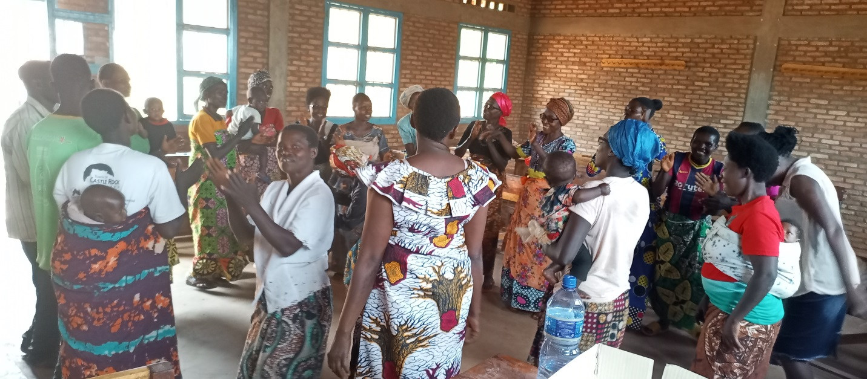
In the same month of August, FWA has continued to implement the project sponsored by the mUnited Nations Peace Building Fund "Connecting the Global to the Local: Strengthening Women's Leadership for the Localization of the United Nations Security Council Resolution 1325 (2000) on "Women, Peace and Security". Kits were distributed to support the remaining income generating activities initiated by women mediators in three provinces (Bujumbura, Cibitoke and Makamba).
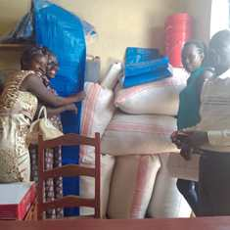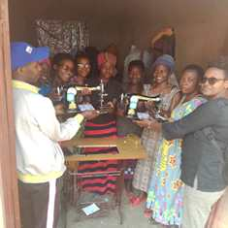
Support in cake for raising pigs in Kabezi commune and support in sewing machines in Nyabiraba commune
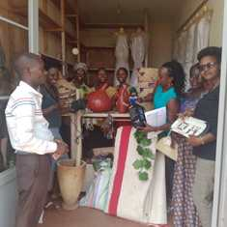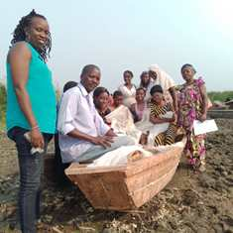
Support in decorating materials for the young girls of the Kabezi commune and a fishing boat for the young girls of the Mutimbuzi commune
Under the support of the Great African Lakes NGOs Consortium, FWA gave educational support to orphans and vulnerable children on August 25, 2022. Each of the 12 students received a kit which included notebooks, two pens, one mathematical set, one latte, one pair of shoes, uniform and a school bag. Then, 50 students were also supported. Each one received kit which included notebooks, pens, mathematical set, and one latte.
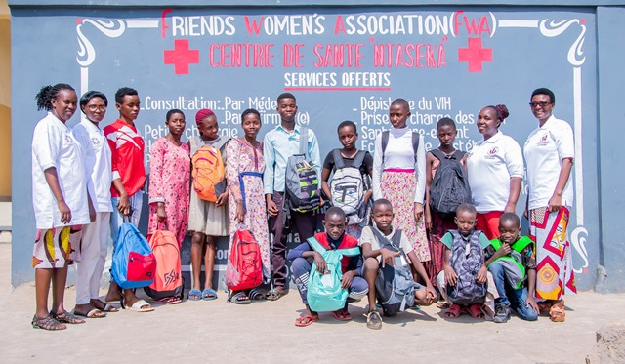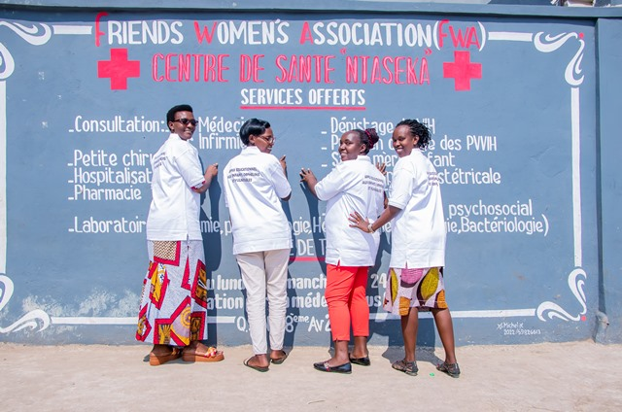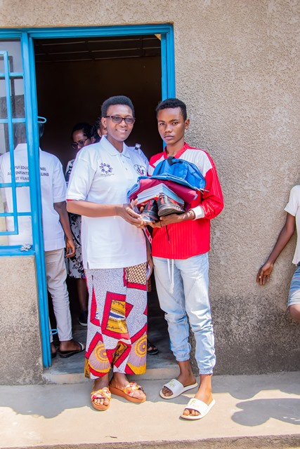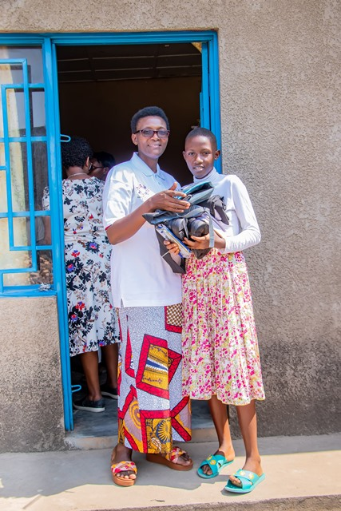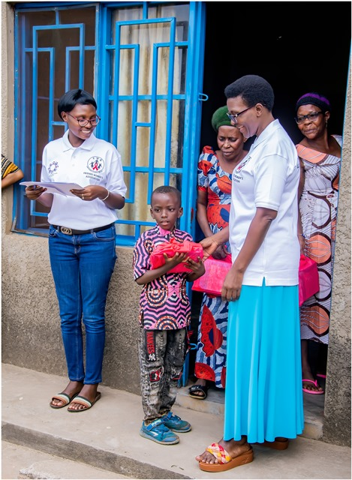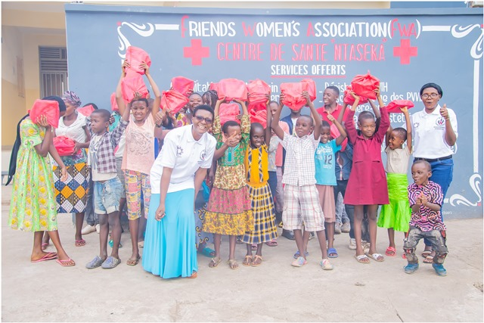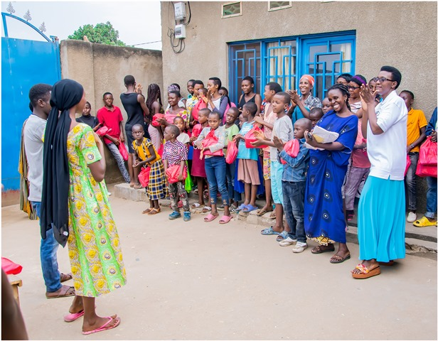

MEDICAL TEAM

CONSULTATIONS
Our medical doctors consulted with 189 cases, including 87 adults (26 men and 61 women), 23 children (11 boys and 12 girls), 28 HIV positive people and 51 pregnant women for ultrasound. The nurse received 269 patients including 196 adults and 73 children.

LABORATORY
In the month of August, apart from HIV voluntary testing, there were a total of 316 tests.
Test | Test completed | Positive | Negative
G.E.  Malaria test | 53 | 22 | 31
Quick malaria test | 61 | 17 | 44
ECBU  Urine test | 18 | 16 | 2
Selles  Stool test | 20 | 19 | 1
Pregnancy | 35 | 12 | 23
Sero-widal  Typhoïd fever | 46 | 17 | 29
Glycémie  Diabetes | 21 | 11 | 10
RPR VDRL  (Syphilis) | 34 | 1 | 33
Complete Blood Count | 23 | 12 | 11
Hepatitis B | 3 | 0 | 3
Hepatitis C | 2 | 0 | 2
Viral Load | 0 | 0 | 0
Total Tests: 316

FAMILY PLANNING
494 people received contraceptives from FWA’s nurse, including 238 old cases and 256 new ones. 350 received the contraceptive injection, 62 were given contraceptive pills, 65 received male condoms, 2 received UID and 15 received implants.

PRENATAL CONSULTATION (PNC)
In August, 75 women came for prenatal consultation (PNC), including 25 who came for PNC 1, 24 for PNC 2, 17 for PNC 3 and 9 for PNC 4.
51 pregnant women came for the ultrasound test.

ANTI-RETROVIRAL SITE
At the end of August, we had 330 patients under retro drugs followed at NTASEKA clinic, including 267 women and 63 men.

PHARMACY
Regarding medications, FWA was able to purchase the minimum needed medicine.

PSYCHOSOCIAL TEAM
In the month of August, 55 people were tested for HIV and received pre and post HIV test counselling. Out of them, only one woman was detected HIV positive with 4% of seropositivity.

Total Number of People Tested: | 55
Total Number of Women Tested: | 49
% of People Tested Who Are Women: | 89%
Average Age: | 26
Median Age: | 25
Total HIV+ : | 1
Total HIV- : | 54
Number of Women HIV+ : | 1
Total % Seropositivity: | 4%
% of Women Tested Who Are HIV+: | 2%

