Friends Women’s Association

APRIL 2021 Report

Table of Contents
Friends Women’s Association APRIL 2021 Report 1
COVID-19 AND NTASEKA CLINIC 2
ACTIVITIES 2
Caring for HIV Positive People (CHIVPP) 4
Improving Women’s Reproductive Health (IWRH) 6
RAPE SURVIVORS’ SUPPORT (RSS) 6
MEDICAL TEAM 8
CONSULTATIONS 8
LABORATORY 8
FAMILY PLANNING 9
PRENATAL CONSULTATION (PNC) 9
ANTI-RETROVIRAL SITE 9
PHARMACY 9
PSYCHOSOCIAL TEAM 9

COVID-19 AND NTASEKA CLINIC
In the month March 2021, Friends Women’s Association has continued to apply Covid-19 restrictions at Ntaseka Clinic for both the staff and the beneficiaries’ protection. On April 22, 2021, the John Gould Family Foundation has provided three UT 100 Hand pulse oximeters. These devices measure heart rate and oxygen saturation.
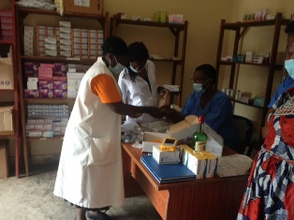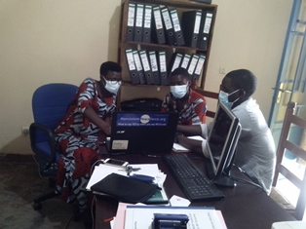
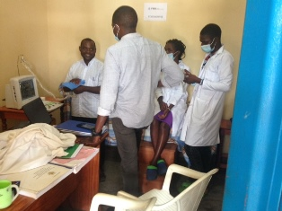
Alain Binamungu, the John Gould Family Foundation biomedical technician, took the opportunity to do the ultrasound maintenance

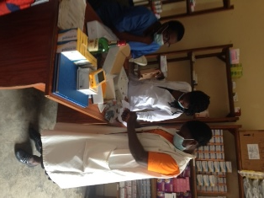

ACTIVITIES

Caring for HIV Positive People (CHIVPP)
In the month of April 2021, medical follow up and home visits were done for our HIV positive people.

Maternity Ward Building
In the month of April 2021, with the support from the Canadian Friends Service Committee (CFSC), we have continued putting broth on the walls of Mtaseka clinic extension plus the control work. The next step will be the tiling of the building, installation of toilets and
showers.
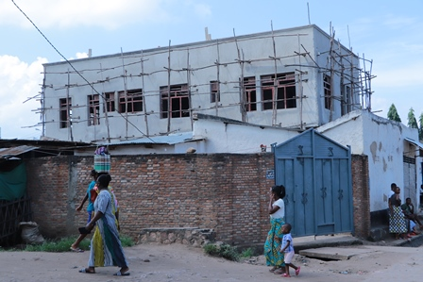
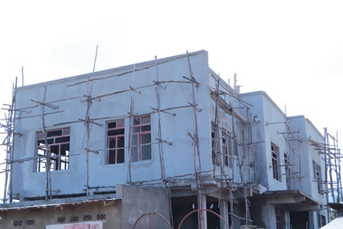

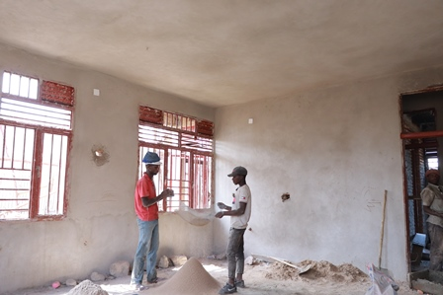

Improving Women’s Reproductive Health (IWRH)
FWA community health workers and FWA staff have continued to educate men, women and young people on the importance of family planning.
Two discussion groups for young girls were done: on April 20&22, 2021.A total of 45 SHGs leaders were touched. The objective was to invite SHGs members to discuss about sexual and reproductive health every time they meet. The Community Health workers will be there to mentor them so that they can be facilitators in the future.
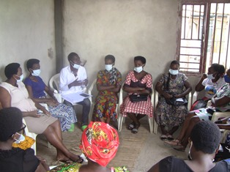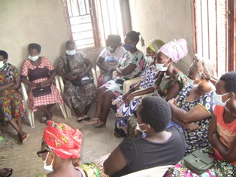

Rape Survivors’ Support (RSS)
In the month of April 2021, Self-Help Groups (SHGs) have continued to meet once a week in Kamenge and 10 SHGs were created in Nyabiraba. At the end of April 2021, we had a total of 128 SHGs in Kamenge, Bujumbura Mairie province for a total of 3013 women and 21 SHGs for 513 women in Nyabiraba commune, Bujumbura province.
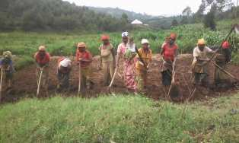
This is one SHG whose members are indigenous people. They are preparing fields where to grow potatoes together
One trauma healing workshop was done on April 26-28, 2021.
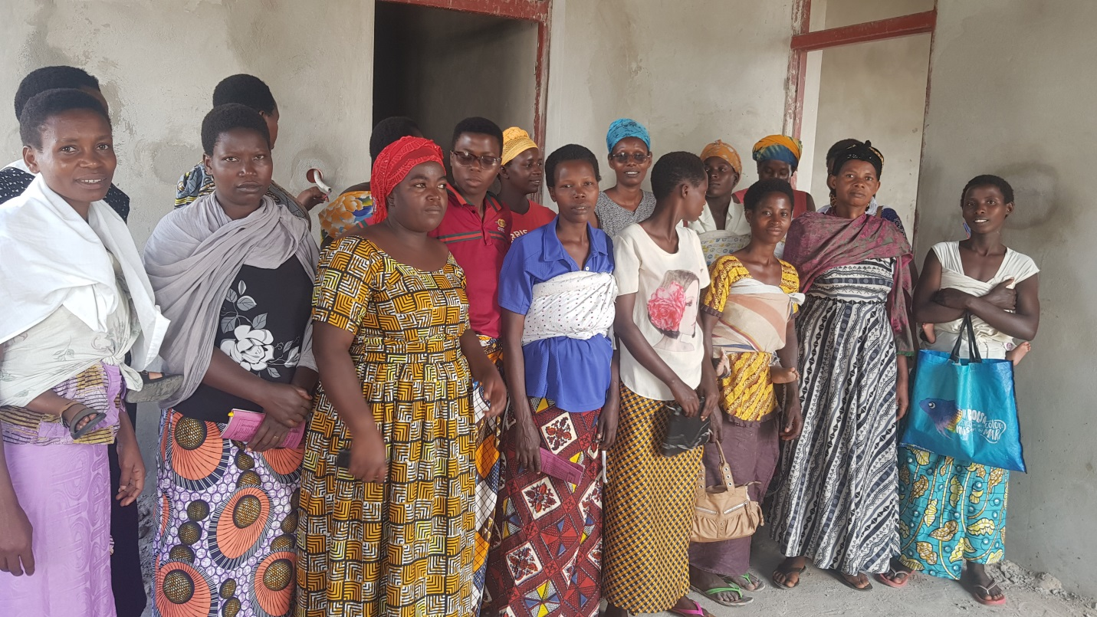
The growing rice project has continued. For this season, we plan to harvest in the Month of July 2021
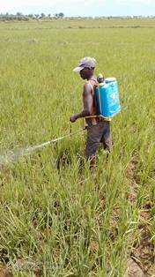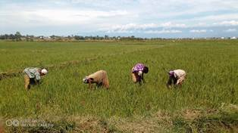
This guy is pumping the rice

ACTION ON GENDER-BASED VIOLENCE (AGBV)
In the month of April 2021, there was preparation to implement the 2021 project which will be supported by the Canadian Friends Service Committee (CFSC).

MEDICAL TEAM

CONSULTATIONS
Our medical doctors consulted with 112 cases, including 46 adults (16 men and 30 women), 14 children (3 boys and 11 girls), 33 HIV positive people and 19 pregnant women for ultrasound. The nurse received 195 patients including 139 adults and 56 children.

LABORATORY
In April 2021, apart from HIV voluntary testing, there were a total of 232 tests.

Test | Test completed | Positive | Negative
G.E.  Malaria test | 53 | 7 | 46
Quick malaria test | 11 | 3 | 8
ECBU  Urine test | 9 | 8 | 1
Selles  Stool test | 15 | 15 | 0
Pregnancy | 37 | 7 | 30
Sero-widal  Typhoïd fever | 16 | 5 | 11
Glycémie  Diabetes | 18 | 8 | 10
RPR VDRL  (Syphillis) | 20 | 0 | 20
Complete Blood Count | 16 | 5 | 11
Hepatite B | 7 | 0 | 7
Hepatite C | 2 | 0 | 2
Viral Load | 28 | 4 | 24
Total Tests: 232

FAMILY PLANNING
601 people received contraceptives from FWA’s nurse, including 339 old cases and 262 new ones. 414 received the contraceptive injection, 51 were given pills, 125 received male condoms and 11 received implants

PRENATAL CONSULTATION (PNC)
In the month of April 2021, 45 women came for prenatal consultation (PNC), including 18 who came for PNC 1, 16 for PNC 2 and 6 for PNC 3 and 5 for PNC 4.
19 pregnant women came for the ultrasound test.

ANTI-RETROVIRAL SITE
At the end of April 2021, we had 330 patients under retro drugs followed at NTASEKA clinic, including 267 women and 63 men.

PHARMACY
Regarding medications, FWA was able to purchase the minimum needed medicine.

PSYCHOSOCIAL TEAM
In the month of April 2021, a total of 68 people received pre and post HIV test counselling and were tested for HIV. Out of the total number, 82% were women and 8 women out of the 10 people detected HIV positive with 15% of seropositivity.
Total Number of People Tested: | 68
Total Number of Women Tested: | 56
% of People Tested Who Are Women: | 82%
Average Age: | 28
Median Age: | 26
Total HIV+ : | 10
Total HIV- : | 58
Number of Women HIV+ : | 8
Total % Seropositivity: | 15%
% of Women Tested Who Are HIV+: | 14%

