Friends Women’s Association’s APRIL 2018 Report
The section below summarizes the work done during the month of April 2018.
ACTIVITIES
Rape Survivors’ Support (RSS)
At the end of April 2018, 13 self-help groups were functioning. RSS is still supported by the African Great Lakes Initiatives (AGLI).
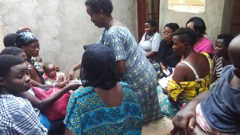
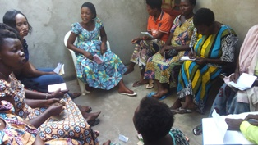
Two trauma healing workshops for GBV survivors were done.
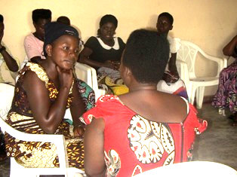
Caring for HIV Positive People (CHIVPP)
During this month of April 2018, medical follow up, nutritional support and home visits were done for our HIV positive people. One discussion group was done on April 5th, 2018. This program is supported by Vancouver Island Monthly Meeting.
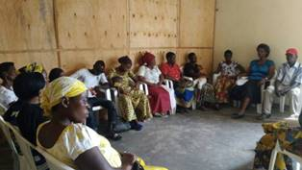
Improving Women’s Reproductive Health (IWRH)
Under the support of Segal family Foundation (SFF), FWA health accompanists and staff have continued to sensitize people to attend NTASEKA clinic for birth control and HIV voluntary test. The result is that more people are attending NTASEKA clinic. Four community mobilization sessions were done.
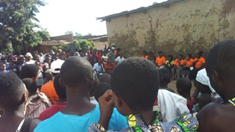
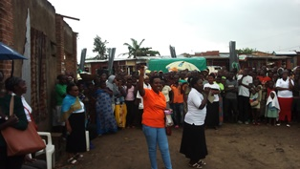

Action on Gender-Based Violence (AGBV)
In the month of April 2018, under the support of the Canadian Friends Service Committee, four GBV basic workshops were done in Gitega province. We had a total of 80 participants, including 40 religious leaders and 40 community elected leaders.
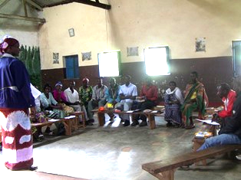
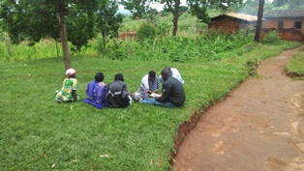
Small groups during the workshops
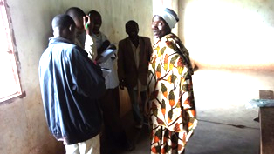
Medical Team
CONSULTATIONS
90 cases were consulted by our medical doctors, including 23 children, 24 adults and 43 people under ARVs treatment. The nurse received 442 patients including 315 adults and 127 children.

LABORATORY
In the month of April 2018, apart from HIV voluntary testing, there were a total of 380 tests.

Test | Test completed | Positive | Negative
G.E.  Malaria test | 115 | 25 | 90
Quick malaria test | 74 | 20 | 54
ECBU  Urine test | 14 | 8 | 6
Selles  Stool test | 27 | 23 | 4
Pregnancy | 52 | 21 | 31
Sero-widal  Typhoïd fever | 51 | 29 | 22
Glycémie  Diabetes | 12 | 6 | 6
RPR VDRL  (Syphillis) | 15 | 0 | 15
Complete Blood Count (CBC) | 20 | - | -
Total Tests: 380

FAMILY PLANNING
305 people received contraceptives from FWA’s nurse, including 184 old cases and 121 new ones. 266 received the contraceptive injection, 15 were given pills, 4 received implants, 3 received collar and 17 received male condoms.

PRENATAL CONSULTATION (PNC)
In the month of April 2018, 24 women came for prenatal consultation (PNC), including 15 came for PNC 1, five for PNC 2, three for PNC 3 and one came for PNC 4.

Anti-Retroviral SITE
At the end of April 2018, we had 225 patients under retro drugs followed at NTASEKA clinic, including 176 women and 49 men.

PHARMACY
FWA had all necessary medicines for the month of April 2018.

PSYCHOSOCIAL TEAM
In the month of Aril 2018, a total of 241 people received pre and post HIV test counseling and were tested for HIV; 56% of them were women and among the 17 people detected HIV positive, 12 were women with 8% of seropositivity.
Total Number of People Tested: | 241
Total Number of Women Tested: | 135
% of People Tested Who Are Women: | 56%
Average Age: | 27
Median Age: | 26
Total HIV+ : | 17
Total HIV- : | 224
Number of Women HIV+ : | 12
Total % Seropositivity: | 8%
% of Women Tested Who Are HIV+: | 9%

