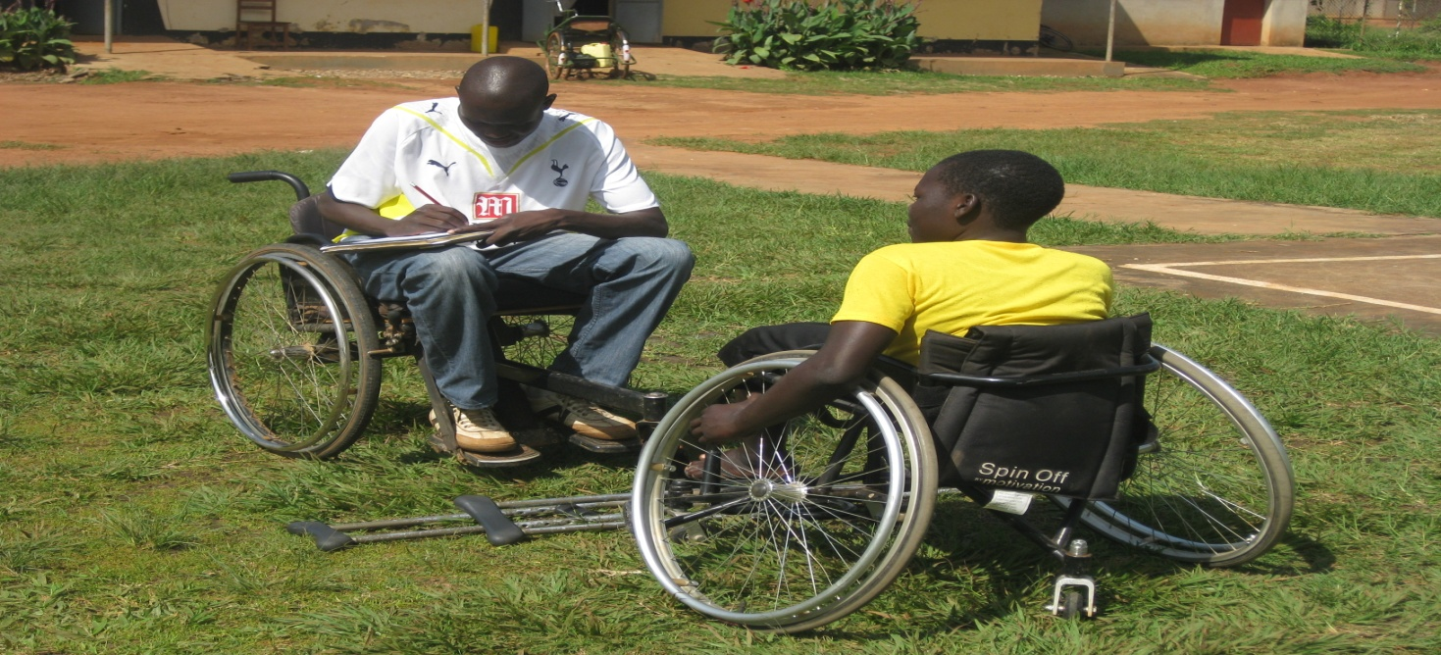

Photo: M&E officer, interviewing Ajok Monica, one of the participants in the sport.

