Rural Area Development Trust run by
Village Rehabilitation Therapy Centre
Theni District of Tamilnadu

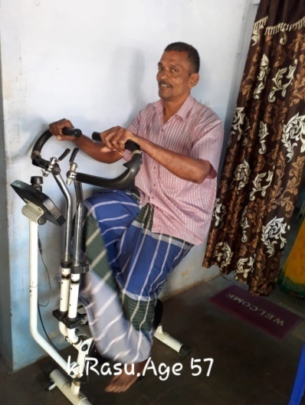
Rural Area Development Trust is a city wide organization working in different areas with the varied scope of service. The organization has been extensively working with the grassroots disadvantaged people under the poverty line. The people belonging to the service area were benefitted with various programs run by the organization like Home based management for the multi-disabled children, Community Based Rehabilitation Program, Inclusive Education for differently abled children and are being benefitted from the Residential program for physically challenged children, Special school and vocational training for the mentally challenged.

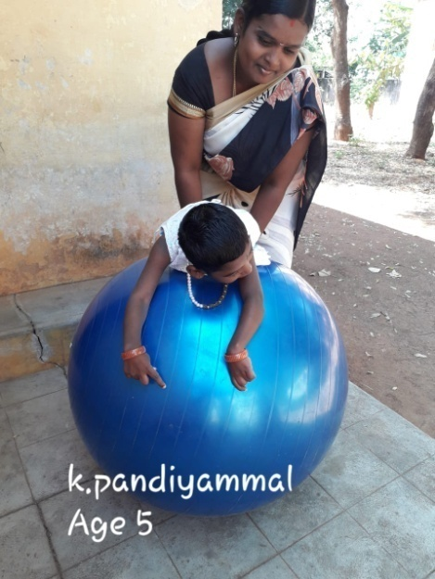
As our service extended, we float an idea of Mobile Therapy Clinic (MTC). The prime object of the MTC was to help heal the lower income people with their physical pains, and the service had an enthusiastic welcome among the target groups. As the program was felt to be a temporary one by the people, we came along with a new initiative of starting a Village Rehabilitation Therapy Center (VRTC), which would permanently find its service, from the block health centers. Our first VRTC was established at a Block Health Centre in a village Doumbucherry, and people poured out their huge support and appreciation.

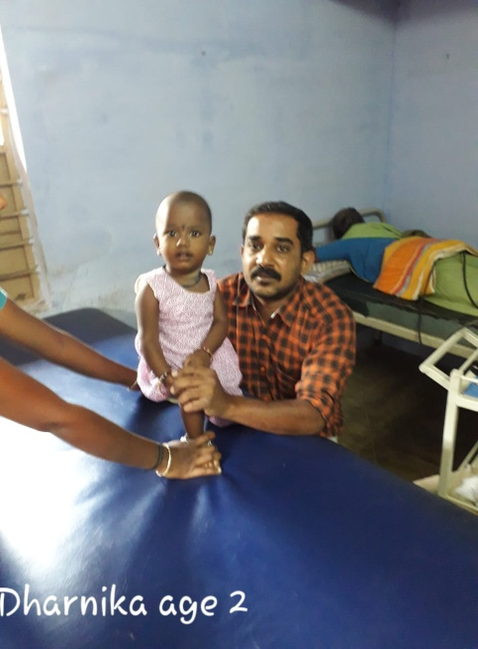
The VRTC is a first of its kind to the state as it renders a physical therapy, occupational therapy, neuro Developmental therapy(NDT) and electrotherapy to the needy people and treats those with most common work related pains and injuries. The patients have access to physiotherapists and multi Rehabilitation workers (MRW). The experienced staffs design a treatment plan for each patient, which is followed until the completion of the treatment. Now, RUADT has 3 successfully running VRTCs across the city, with the fullest supports from the government which provided a spacious ventilated room with a patient's waiting hall. In addition to that, RUADT bears all the other expenses like the treatment costs and equipment. All the more reason for the VRTC is to educate the people about side effects of taking the pain killer which is being given by the government hospitals for a temporary remedy. Moreover, our patients who are not even able to make their ends meet are saving Rs. 1600 per month, which they would not have been able to if they were affording their treatments in a private hospital.

Appeal:

RUADT needs financial support for the continuation and extension of the VRTC, which is essential for the needy people. By contributing you not only contribute us with the money, but also support the big program that reaches out to more than 40 patients per day in each center. These acts of reaching the needy are possible only through your generous contributions.

Rural Area Development Trust, B.Dharmathupatti - 625 582
Village Rehabilitation Therapy Centre - Dombuchery
Month | Average Patients getting treatment for the year 2018- 19 | Average patients getting recovery for the year 2018 -19
April | 20 | 3
May | 19 | 2
June | 20 | 3
July | 18 | 1
August | 15 | 0
September | 15 | 2
October | 15 | 1
November | 15 | 2
December | 18 | 0
January | 15 | 3
February | 17 | 1
March | 17 | 0
Case studies / Sucessful stories 1. Children 2.Stoke patients 3.Pain and other cases
Month | Average Patients getting treatment for the year 2019- 20 | Average patients getting recovery for the year 2019-20
April | 21 | 0
May | 18 | 0
June | 20 | 1
Case studies / Successful stories 1. Children 2.Stoke patients 3.Pain and other cases

Successful stories 1. Stoke patients

Name : K.Rasu

Address : S/o.Kandasamy
Ward -1, Kandasamy puram,
Nagalapuram,
Bodinayakanur, Theni Dist.

Age : 57 Years

Nature of Compliants : CVA Left Hemiparasis

Patient History :

The patient was working as a cooly with daily wages. He used take alcholal daily, one day he was faint when he was doing his work. due to heavy blood pressure. He was admitted near by hospital and the Doctor said that he was affcted by left hemiparasis.He came to VRTC with support of his family members.

Modality used for his treatment:

Passive movements, passive strenghening exercise, over head pully, ankle foot exercise, cycling, Quadercieps table exercise, electrical stimulation and gait training.

Achievement of the patients:

After regularly therapeautic treatment. Now he is able to walk independently, he is able to grasp an objects, he is able to do ADL activiites with out any support.

Successful stories 2. Stoke patients

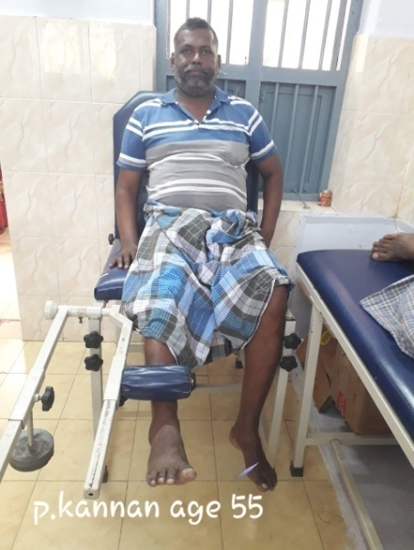
Name : P.Kannan

Address : S/o.Palanisamy
West Street,
Balarpatty
Chinnamanur, Theni Dist.

Age : 55 Years

Nature of Compliants : CVA Right Hemiparasis

Patient History :

The patient was retired army man. He was affected by severe blood pressure. He used take medicine irregularly. One day morning he was faint when he was taking coffee. He was admitted near by hospital and the Doctor said that he was affcted by right hemiparasis.He came to VRTC with support of his wife.

Modality used for his treatment:

Passive movements, passive strenghening exercise, over head pully, ankle foot exercise, cycling, Quadercieps table exercise, electrical stimulation, fine motor activities and gait training.

Achievement of the patients:

After regularly therapeautic treatment. Now he is able to walk independently, he is able to grasp an objects, my hand function is also improved. Now I am able to do my work individually.

Successful stories – 3. Cerebral Palsy

Name : K.Pandiammal

Address : D/o.Karuppaiah
Ward -3,
Pathara Kaliamman Kovil Street,
Pathrakalipuram
Bodinayakanur, Theni Dist.

Age : 5 Years

Nature of Compliants :

Patient History :

My child was unable to move her limbs, her limbs were so tight (Spastic) She was unable to sit, no neck control. My neighbour told me about the VRTC in Doumbuchery Government Hospital. I went there and therapist assessed my child and told me to take therapeutic exercise regularly for 3 years.

After Treatment :

After continuous treatment now my child is able to sit with support, able to control his head, moves her all four limbs freely, able to understand my commands and her tightness in reduced.

Successful stories – 4. Cerebral Palsy

Name : S.Dharunika

Address : D/o.Selvam
North Colony,
Ward – 2,
Pathrakalipuram
Bodinayakanur, Theni Dist

Age : 2 Years

Nature of Compliants : Cerebral Palsy

Patient History :

My child was unable to move her freely, unable to sit. She has no neck control. She was bed ridden. She doesn't see my face. She doesn’t listen to my commands. My neighbour told me about the VRTC in Doumbuchery Government Hospital. I went there and therapist assessed my child and told me to take therapeutic exercise regularly for 6 months.

After Treatment :

After continuous treatment now my child is able to sit with support, able to control his head, moves her all limbs freely, able to understand my commands and her tightness in reduced.

