Rural Area Development Trust run by
Village Rehabilitation Therapy Centre
Theni District of Tamilnadu

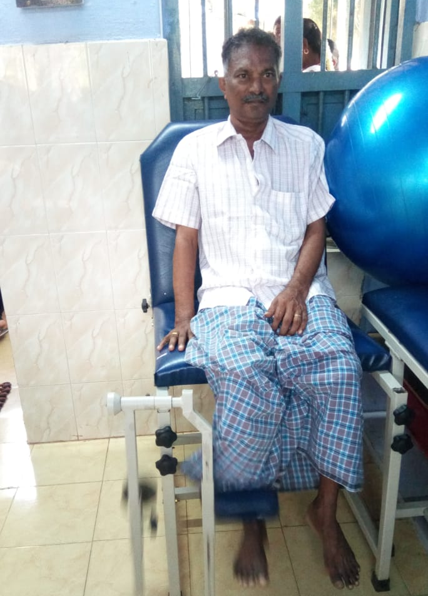
Rural Area Development Trust is a city wide organization working in different areas with the varied scope of service. The organization has been extensively working with the grassroots disadvantaged people under the poverty line. The people belonging to the service area were benefitted with various programs run by the organization like Home based management for the multi-disabled children, Community Based Rehabilitation Program, Inclusive Education for differently abled children and are being benefitted from the Residential program for physically challenged children, Special school and vocational training for the mentally challenged.

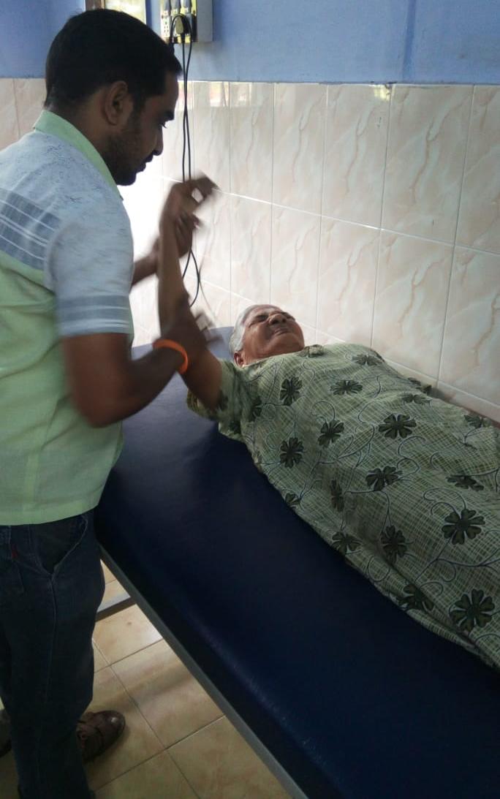
As our service extended, we float an idea of Mobile Therapy Clinic (MTC). The prime object of the MTC was to help heal the lower income people with their physical pains, and the service had an enthusiastic welcome among the target groups. As the program was felt to be a temporary one by the people, we came along with a new initiative of starting a Village Rehabilitation Therapy Center (VRTC), which would permanently find its service, from the block health centers. Our first VRTC was established at a Block Health Centre in a village Doumbucherry, and people poured out their huge support and appreciation.

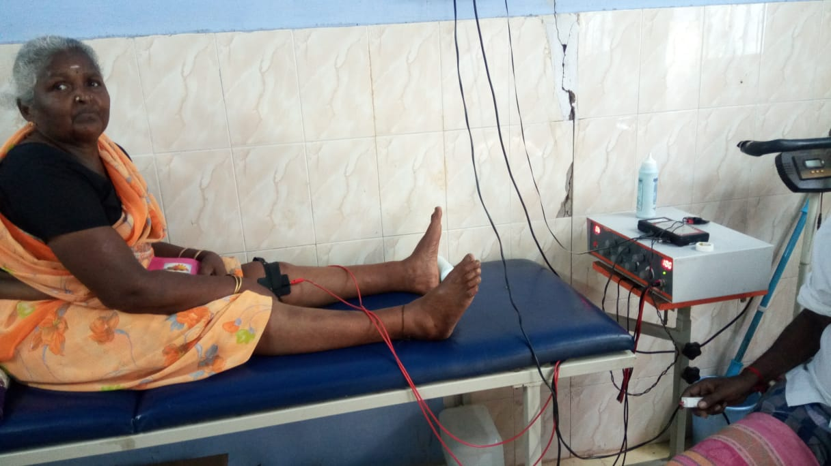
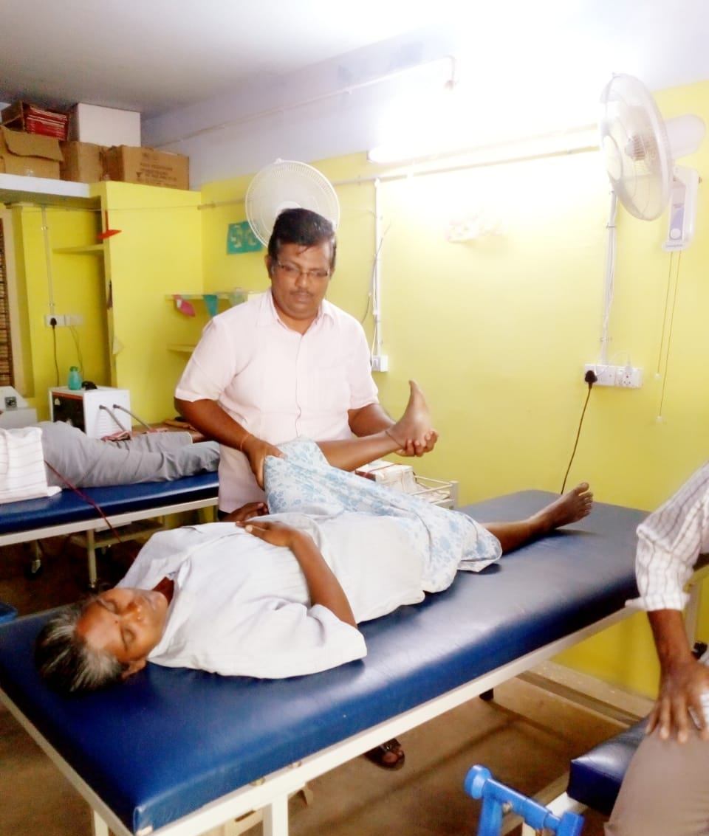
The VRTC is a first of its kind to the state as it renders a physical therapy, occupational therapy, neuro Developmental therapy(NDT) and electrotherapy to the needy people and treats those with most common work related pains and injuries. The patients have access to physiotherapists and multi Rehabilitation workers (MRW). The experienced staffs design a treatment plan for each patient, which is followed until the completion of the treatment. Now, RUADT has 3 successfully running VRTCs across the city, with the fullest supports from the government which provided a spacious ventilated room with a patient's waiting hall. In addition to that, RUADT bears all the other expenses like the treatment costs and equipment. All the more reason for the VRTC is to educate the people about side effects of
taking the pain killer which is being given by the government hospitals for a temporary remedy. Moreover, our patients who are not even able to make their ends meet are saving Rs. 1600 per month, which they would not have been able to if they were affording their treatments in a private hospital.

Appeal:

RUADT needs financial support for the continuation and extension of the VRTC, which is essential for the needy people. By contributing you not only contribute us with the money, but also support the big program that reaches out to more than 40 patients per day in each center. These acts of reaching the
needy are possible only through your generous contributions.
