Extensive damage in Chaitén town generated by fl oods and lahars.
A. Satellite image acquired on May 19 shows both the inundated area and the suspended sediment due to the coastal drift (courtesy of NASA at http://earthobservatory.nasa.gov);
B. Severe damages on the urban infrastructure (photo by L.E. Lara).

Impacts of the eruption were extensive in Chile and Argentina. Floods and lahars inundated the already evacuated Chaitén town on May 12 and up to US$12 millions are the estimated economic losses only by insured public buildings. Ash clouds shut down regional airports and forced the cancellationof hundreds of domestic flights and several international fl ights in Argentina and Chile. Floods alsodisrupted the backbone road of continental Chile and the active aquiculture industry was severely affected (Fig. 4). More than US$36 millions have been allocated

Following article from: http://scienceblogs.com/eruptions/2009/02/volcanism_and_society_what_to.php
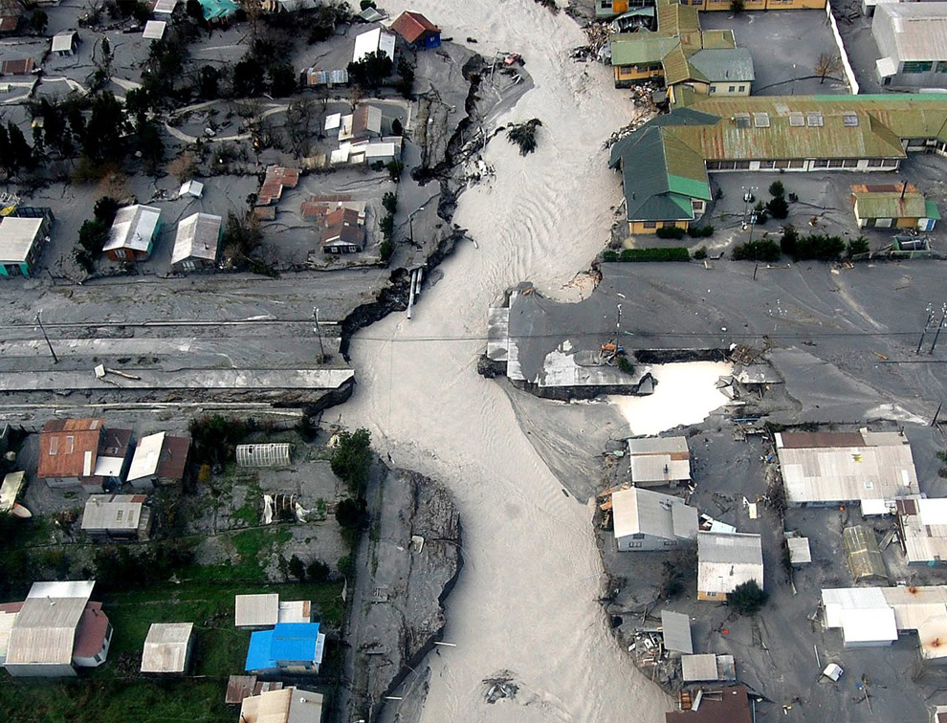

I have never had to leave my home in an evacuation from a natural disaster. I'll put that out there right now. So, I might not fully understand the emotions going through people when they find out that they have to leave their home by no fault of their own because nature has decided that where they live is no longer livable. I especially don't know what it might be like if you are then told you can never go back. You might have a home there. You might own a business there. You might have grown up there. Your great grandparents might have lived there over 100 years ago. Yet, you are told - likely by the government - you can never go back because they have deemed it "unsafe". I'm not even sure who I would respond, especially if you are able to go back to your home to collect your belongings and you see that the town is still there - its not like it has been wiped off the face of the earth. Why should you leave? Isn't it your decision about where you live (and die)?

This is the struggle going on right now in Chaiten, Chile. The volcano has been erupting since May of 2008 with one of the most spectacular eruptions in the (modern) history of Chile, with its latest outburst coming last Thursday (2/19), producing impressive pyroclastic flows and ash falls that blanketed the countryside around the rhyolite volcano and destroyed more of the town of Chaiten (above). Yet even after all this and even after the government has announced that Chaiten (the town) will not be rebuilt, people will not leave. The Chilean government has told the last 200 residents of Chaiten that they must be evacuated from the town, especially after the powerful (and unexpected) outburst from the volcano only 10 kilometers from the town, but a few dozen people have decided they will not leave. I don't want to judge these people, but living near an active, explosive volcano is dangerous and when destruction comes, you likely won't have any warning (or at least not enough time to do anything about it). You can't really mitigate against a pyroclastic flow like you can against flooding or earthquake hazards - a town in the path of a pyroclastic flow will not survive - so you can't blame the government for wanting to just declare Chaiten a "lost town" and move the residents to a safer area. However, the people refusing to leave don't see it that way, and the matter is heading into the Chilean courts and even into the Presidential election in Chile.
This is a difficult situation. The last Chaiteninos say the government didn't give them a say in the decision to abandon the town. However, there really isn't much to discuss with the townspeople - you stay, and likely Chaiten will destroy you or your home. You leave, you leave behind the town you called home and everything in which you are familiar. There is no easy solution. What would you do in this situation? Have any of you face this type of thing? This is really where man and nature butt heads and most of the time, nature wins.
More links with pictures and information on the Volcano and Chaiten:
http://news.bbc.co.uk/2/hi/in_pictures/7381702.stm
http://volcanism.wordpress.com/2009/01/29/chaiten-town-to-be-abandoned-chilean-government-confirms/
http://geology.com/volcanoes/chaiten/
http://www.google.cl/imgres?imgurl=http://cache.boston.com/universal/site_graphics/blogs/bigpicture/chaiten_06_04/chaiten3.jpg&imgrefurl=http://www.boston.com/bigpicture/2008/06/chaiten_volcano_still_active.html&h=751&w=990&sz=289&tbnid=XBc-c7tXZL68jM:&tbnh=113&tbnw=149&prev=/images%3Fq%3Dpictures%2Bof%2Bpeople%2Bof%2Bchaiten&usg=__kWsVNOcd-SIkZEDf8l8yvi9bE0Q=&ei=rvZcSuuDLIzVlAed75DtDA&sa=X&oi=image_result&resnum=4&ct=image

