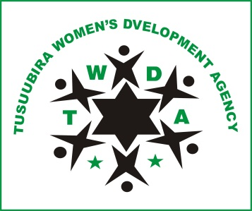
Lwanga zone LC1, Naluvule Parish, Wakiso Sub County, Wakiso District –Uganda.
info@twguganda.org, www.twguganda.org.

Provide cows to 5 deprived families in Namayumba Project Proposal
About us
Tusuubira Women’s Development Agency (TWDA) is a non-profit organisation registered in Uganda and is currently reaching out to the underserved community members within the rural and peri-urban communities in Wakiso district.

This “Provide cows to 5 deprived families in Namayumba Project” mainly focuses on promotion of dairy cows as a nutrition as well as income generation intervention for targeted aged and disadvantaged community members within Namayumba Sub county.

The project will benefit selected community members such as Mzee Daniel a grandfather staying with 3 grandchildren, one being disabled. Mzee Daniel has been the sole provider for these children for over ten years now amidst huge financial challenges. Through his efforts, he was able to buy one local cow which gives him 5 liters per day which he sells to generate income to sustain the grandchildren. He strongly believes that if supported to acquire a high yielding dairy cow which can give him 20liters per day and above, he can be able to improve his income and thus look after his grandchildren with ease.

It is thus believed that Mzee Daniel and 4 other peers will hence have their family nutrition, incomes and ultimately living conditions improved if they are supported through this project with high yielding dairy cows, sheds, trainings and technical follow up visits.

Project budget
Item | Qty | Unit Cost | Requested Amount | TWDA | Beneficiary | Total
Procure in-calf dairy heifers | 5 | 1,143 | 5,714 |  |  | 5,714
Construct a cow shed | 5 | 286 | 1,429 |  |  | 1,429
Conduct training workshops for beneficiaries | 8 | 71 |  | 571 |  | 571
Establish pastures | 5 | 137 |  |  | 686 | 686
Conduct Follow up visits | 30 | 29 |  | 857 |  | 857
TOTAL |  |  | 7,143 | 1429 | 686 | 9,257

