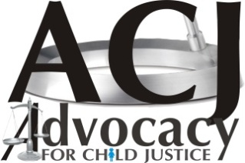
ADVOCACY FOR CHILD JUSTICE
“Bringing Child Justice Closer to the Community”
Plot 1302 Ngwerere Road Chelstone. P.O Box 36732 Lusaka, Zambia
Tel: +260 211 283 241 MOBILE: +260 977 887 667
_____________________________________________________

PROFILE

Advocacy for Child Justice (ACJ) is a Non-Government Organization that uses an issue-based approach to advocate for the rights and best interests of children and promote social development of children. The organization operates out of its head office in Lusaka, Zambia.

ACJ is a member of Children in Need Network (CHIN) Zambia National Education Coalition (ZANEC), Zambia Civic Education Association (ZCEA) and Civil Society Network on Ending Child Marriage (CSNECM).

ACJ has two programmes parallel programs namely Legal Aid Desk and LifeSavers. Lifesavers targets to respond to the social needs of children, especially in the poor communities and rural areas of Zambia where access to education, health services and other social amenities are often limited or scarce. The Programme is designed to create an environment suitable for child habitation and development by eliminating the social injustices at national, community and house hold level. The programme also seek to rehabilitate the children exposed to traumatizing abuses by providing a safe-net at the children’s village and camping facilities.

Legal Aid Desk programme is centred on promotion and protection of child rights for children that are at risk or come into contact with the law in the child justice system in Zambia.

Legal status and identity
- REGISTERED WITH REGISTRER OF SOCIETIES AS NGO. REGISTRATION NUMBER: RNGO 101/0140/13

Year of establishment/registration:

- ESTABLISHED – MAY 2004
- REGISTERED UNDER REGISTRER OF SOCIETIES – 7TH DECEMCER 2004
- REGISTERED UNDER NGO’s ACT ACJ – 19TH DECEMBER 2013

PURPOSE AND EXPERIENCE

STRATERGIC OBJECTIVES

LEAGAL AID:

Strategic Objective 1:
Improved access to justice by children who come into contact with the Law - Under this thematic area ACJ focuses on the development and strengthening of child protection committees at all levels of the Child Justice System and establishment of child friendly spaces in form of Community Correctional Centers (CCC). ACJ has established Community Correctional Centers in Chelstone, and Ndola which provides rehabilitation and reformative programmes for child offenders through the diversion program. ACJ receives referrals from the community, Police and Courts for counseling and rehabilitation. Some of the services provided under this theme are:
- Case tracking and monitoring as well as facilitating Bail and Police Bond
- Provided case management services to over 1200 children
- Build capacity of key stakeholders in the Child justice System – Trained over 220 stake holders in the Child Friendly Justice System
- Build the private sector in child rights and business principles
- Promote and facilitate access to justice services for children whose rights have been violeted – Have worked with over 729 children
- Awareness Creation to over 2000 children in schools

Strategic Objective 2:
All international instruments related to child justice implemented in Zambia - ACJ has on a number of occassions engaged Law Makers to monitor and advocate for the national implementation of the elements from the UNCRC and African Charter into the domestic laws and constitution. The Organisation has contributed significantly on promotion of access to quality Justice System for children including other marginalised and excluded groups of children whose rights are being violated in Zambia.
- ACJ has been advocating for favourable policy and legal environment to ensure that Zambia is in line with the international norms and through submissions to parliament and advocacy meetings. ACJ has participated in formulation of the Child Code, revised customery laws in Chief Mungule’s area
- Build the capacity of the child justice system to ensure access to quality legal help by children whose rights are being violated and promote social accountability, sustainability.
- Integrate a learning agenda through evidence based planning and monitoring and evaluation, and sustainable approaches including cross cutting issues of HIV&AIDS, children with disabilities and gender.

Stratergic Objective 3:
Improved access to quality health services by mothers and children in correctional facility (in line with international standards) - Under this thematic area, ACJ works with children, their family and communities to advocate for improved health care for mothers and children in correctional facilities and provide nutritional and health support as well as legal assistance. ACJ also advocates for improved mental health care and provide psychosocial support to mothers and their children in the correctional facilities.

LIFESAVERS PROGRAMME:

Strategic Objective 1:
Children are protected from all kinds of exploitation and violence - Lifesavers Program works with Partners and Local Communities to promote human rights with great emphasis on child rights in order to create conducive environment for child development. Under this pillar, Lifesavers advocates against injustices against children and women throgh the improvement of both national and Traditional policies and laws. ACJ is implementing projects on ending child Marriage and Prostitution in John Howard, Chongwe and Lukata (Chibombo district). The Project has been working with Teenagers, Guardians, Traditional Leaders and other stake holders in the transformation of risky bahaviours, cultural systems and traditions which oppress the vulnerable in communities.
Lifesavers has contributed to the reduction of child marriage incidents in the areas of operation. The communities are more aware about the dangers of child marriage and the customery law has been revised in Mungule Chiefdom to encumpus child protection policies. The main objectives include:
- Creating awareness on human including children’s rights – reached out to over 10000 children and adults in schools since 2014
- Counseling and rehabilitation of Children withdrawn from marriage and prostitution
- Advocacy for policies that protect children – Have withdrawn over 143 children from marriage and prostitution
- Conducting Radio Programs to create awareness on issues that affect children – reached out to over 12000 people through radio programs.
- ACJ has trained over 240 children in assertive skills

Strategic Objective 2:
Contribute to improved access to quality health services for mothers and children in the Vulnerable Zambian communities – ACJ focuses on improving the health status of children and their families in rural districts through innovative community-based behavioural change strategies and improved access to health services. The health projects has implemented a number of projects such as the Sexual Reproductive Heath, Influstructure development and awareness campaiagns to address the causes of morbidity and mortality among children and women. These include malaria, diarrhea, pneumonia HIV and AIDS and other sexually transmitted infections. This sector is very important as it seek to scale up sensitization on HIV prevention, to enhance HIV prevention strategies, to strengthen community care for OVC and PLWHAs, and also to provide livelihood support to the vulnerable, especially OVC and PLWHAs.
ACJ is working with International and local Partners to build the Clinic in Lukata of which the Hospital equipment has already been secured and sitting on the site of the Clinic.

Strategic Objective 3:
Contribute to improved quality and inclusive education for children in community and government schools - The Lifesavers education and life skills sector contributes to various development priorities of the communities in a number of ways. The sector works with community schools in Chainda, John Howard, Lukata, Chongwe and Nyimba to improve the quality of education by promoting reading and arithmetic skills through reading groups and competitions. Furthermore, the projects empowers communities to lobby government and other partners to build school infrastructure in areas with critical shortage. ACJ is currently supporting the building of a Teacher’s flat at Lukata Basic School in Chibombo District.
The main target for this sector includes, children (Primary and Secondary level) and their parents/guardians, teachers, government and other stakeholders. ACJ ander the LifeSavers projects runs a volunteer programme with support from partners based in the USA to provide expert human resource to Chainda Open Community School who help to build capacity for the Teachers andas well cution the shortage of man power at the school.
The education project is also supporting 24 girls who were withdrawn from child marriage and prostitution in meeting their school requirements.
Lifesavers program also target out of school youths who for some reason cannot go back into formal education system for skills empowerement such as door mat making in John Howard.

Strategic Objective 4:
Contribute to improved food security at house hold level in the rural parts of Zambia - ACJ is committed to building capacity in the target communities to improve food security at community and house hold level. The programme is working with Women groups in Chongwe, John Howard and Chibombo in the Empowerment Projects which aims to end poverty by strengthening the house hold economic status through empowerment projects which helps the guardians of the children and some youths to competently compete in the economic market.

Strategic Objective 5:
Contribute to improved wellbeing of children through Sponsorship Project – ACJ under the Lifesavers Programme runs a Sponsor a Child Project support by partners in the USA who are sponosring over 30 Children in community and Government schools. The Sponsor a Child project also helps to fundraise for the community projects such as the building of the clinic in Lukata.

ACJ has reached out to more than 40 thousand Children and adults from time it was established

Specific funded interventions from 2013 to date

Project period | Title/ theme | Budget | Financial sources  / partner
JUNE 2013 – NOVEMBER 2013 | Maternal and Child Health in the Prison System in Zambia | $9,925.00 | PATH
OCT 2013 – DECEMBER 2013 | Legal Aid Desk for child offenders and at Risk | ZMW200,000.00 | SIDA/SAVE THE CHILDREN
JANUARY 2014 – DECEMBER 2014 | Legal Aid Desk for child offenders and at Risk | ZMW680,120.00 | SIDA/SAVE THE CHILDREN
January 2013-December 2014 | LifeSavers feeding Programme for vulnerable children in the Community Schools | ZMW 100,834.44 | USA LifeSavers partners
January 2015 – December 2015 | Legal Aid Desk for child offenders and at Risk | ZMW450,000 | SIDA/SAVE THE CHILDREN
October 2015- December 2016 | MUTULE CHILD PROTECTION PROJECT –Combating Child Marriage and Child Prostitution | ZMW868,975 | Danish Mission Council for Development Department (DMCDD)
January 2016 – December 2016 | Legal Aid Desk for child offenders and at Risk | ZMW450,000 | SIDA/SAVE THE CHILDREN
January 2016 – December 2016 | Child Participation and Protection Project | ZMK270,000 | NORAD/PLAN INTERNATIONAL
January 2017 – December 2017 | Child Participation and Protection Project | ZMK270,000 | NORAD/PLAN INTERNATIONAL
January 2017 – June 2017 | Legal Aid Desk for child offenders and at Risk | ZMK200,000 | SIDA/SAVE THE CHILDREN
April 2017 – March 2019 | MUTULE CHILD PROTECTION PROJECT –Combating Child Marriage and Child Prostitution | ZMK1,200,000 | Danish Mission Council for Development Department (DMCDD)

Advocacy for Child Justice is looking for more funding in order to operate at full capacity.

- GOVERNANCE AND ACCOUNTABILITY

Category | Number  Male / female
Founding Members (sometimes called owners or patrons) | MALE - 4
Board (sometimes called executive committee or steering group) | MALE – 6  FEMALE - 3
Staff (total number of paid staff) | MALE - 4  FEMALE - 5
Volunteers (sometimes called unpaid staff) | MALE – 1  FEMALE - 1

BRIEF DESCRIPTION OF FUNCTIONS OF THE BOARD AND STAFF
ACJ BOARD
Oversee the policies that govern the Organisation.

EXECUTIVE DIRECTOR
Provides Leadership and direction to the Organisation, projects and Staff

Finance and Administration
Monitoring funds and preparing timely financial reports

Programme Coordinators
Responsible for the projects implementation and coordination of all project activities and ensuring reporting is done in a timely manner.

Advocacy and Communications Officer
In charge of policy engagement and lobbying, capacity building on key issues, development and dissemination of IEC materials, promote and maintain the visibility of the Organisation

Administration Assistant
Provide support to the administration and acts as link between operations and administration
Projects.

Project Officers
Responsible for direct implementation of the project activities

Community Mobilisers
They are responsible for mobilising the community stakeholders for implementation of the projects

Volunteers
They provide support in the implementation of our projects.

CONTACT
Name:  ADVOCACY FOR CHILD JUSTICE | Abbreviation of the organisation:  ACJ
Address:  P.O BOX 36732, LUSAKA, ZAMBIA | Telephone:  +(260) 211- 283-241  Mobile:  +(260) 953-015-765
Contact person of the organization:  MR JOSPHAT NJOBVU  Executive Director | Contact Address:  e-mail: admin@acjzambia.org  www.acjzambia.org  www.facebook.com/lifesavers.zambia  www.facebook.com/child.justice.37

Pictorial Profile on some of the achievements
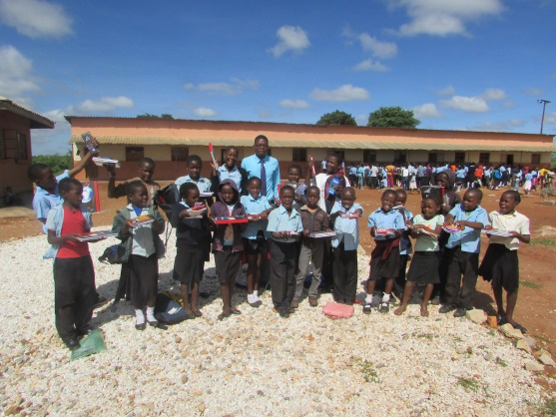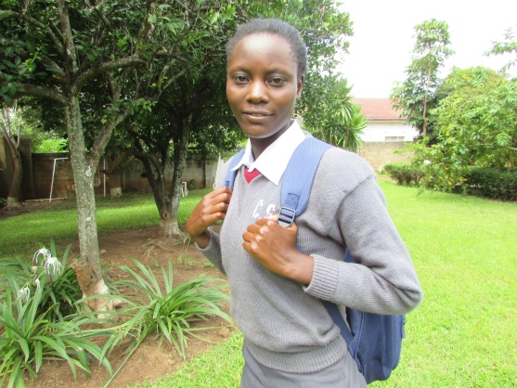
Best performing pupils awarded presents One of the Sponsored girls

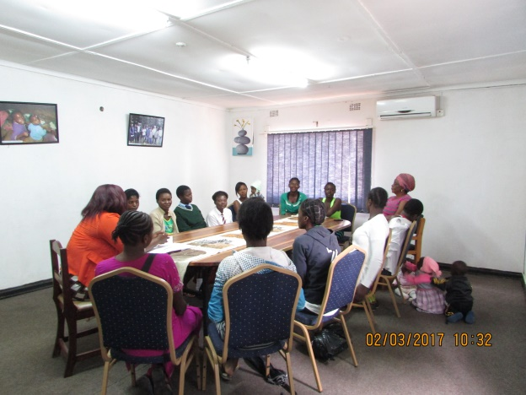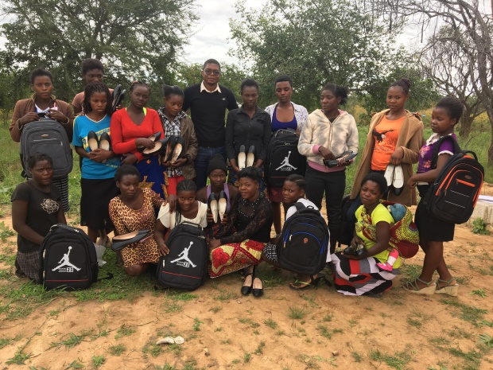
Children withdrawn from child marriage and prostitution were rehabilited and supported to re-enter the school system
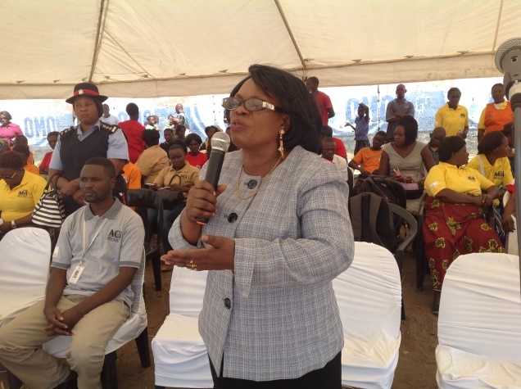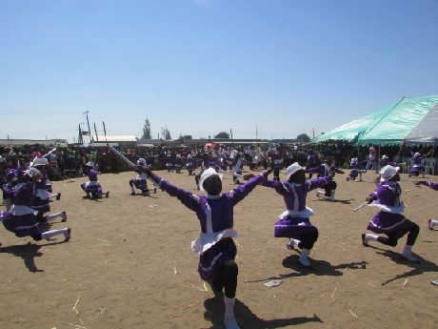
Figure 1The Minister Prof. Ngandu Luo Kick starts the Awareness Campaingns on ending Child Marriage in Chawama

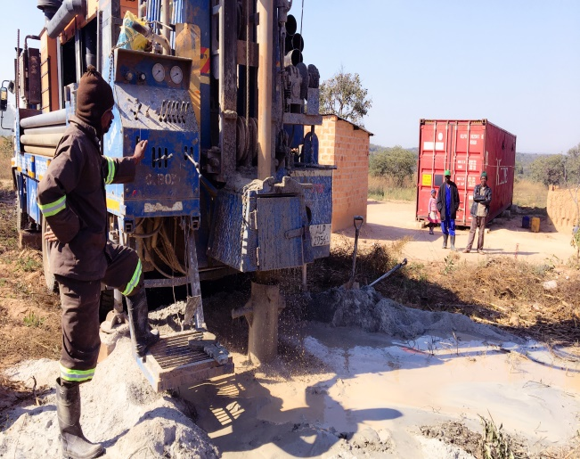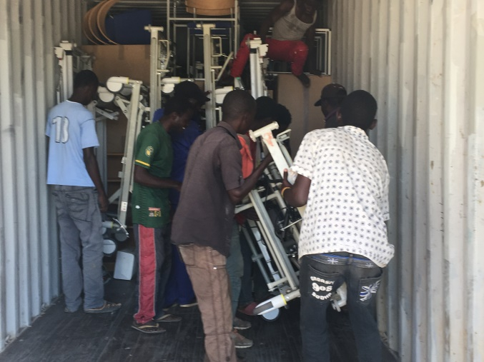
The contruction site of the Lukata Clinic. The container full of hospital equipment.

The Borehole has already been done in readiness for construction works

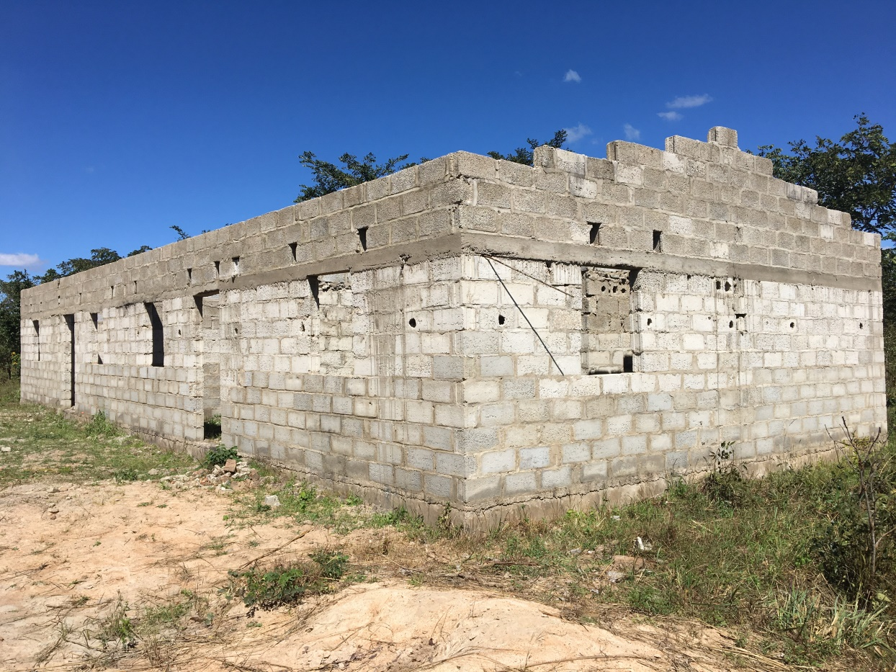
1 x 2 Teachers House under construction at Lukata School

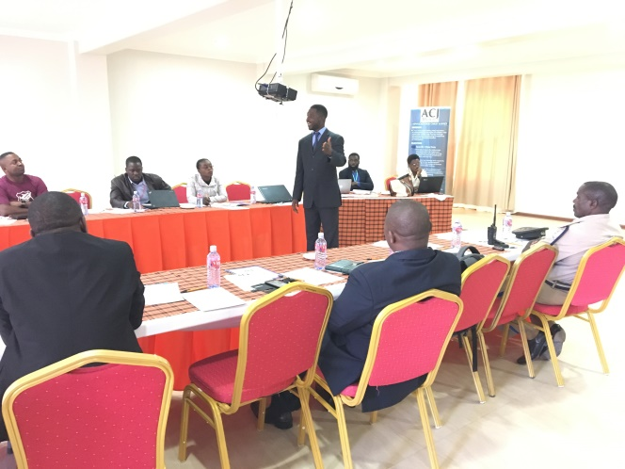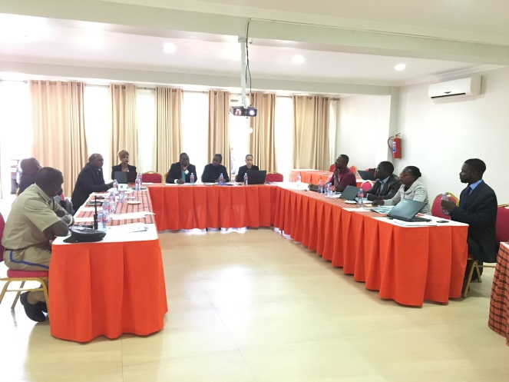
Capacity Building workshop for stake holders in the Justice System.
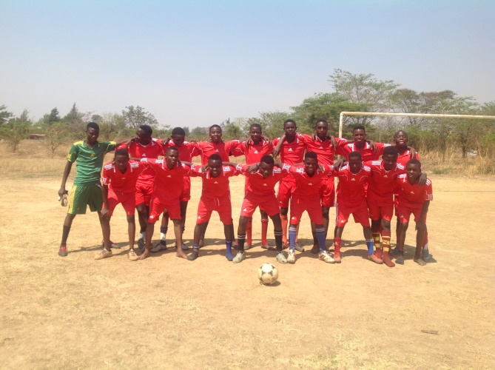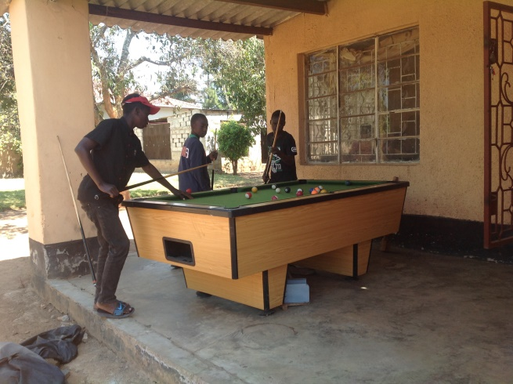
Recreation is one way used to rehabilitate children who come into cantact with the law
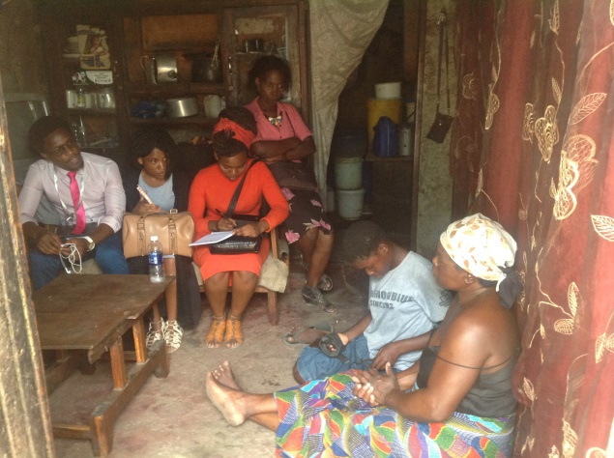
Home Visits One of the transformed boys now has a good Job

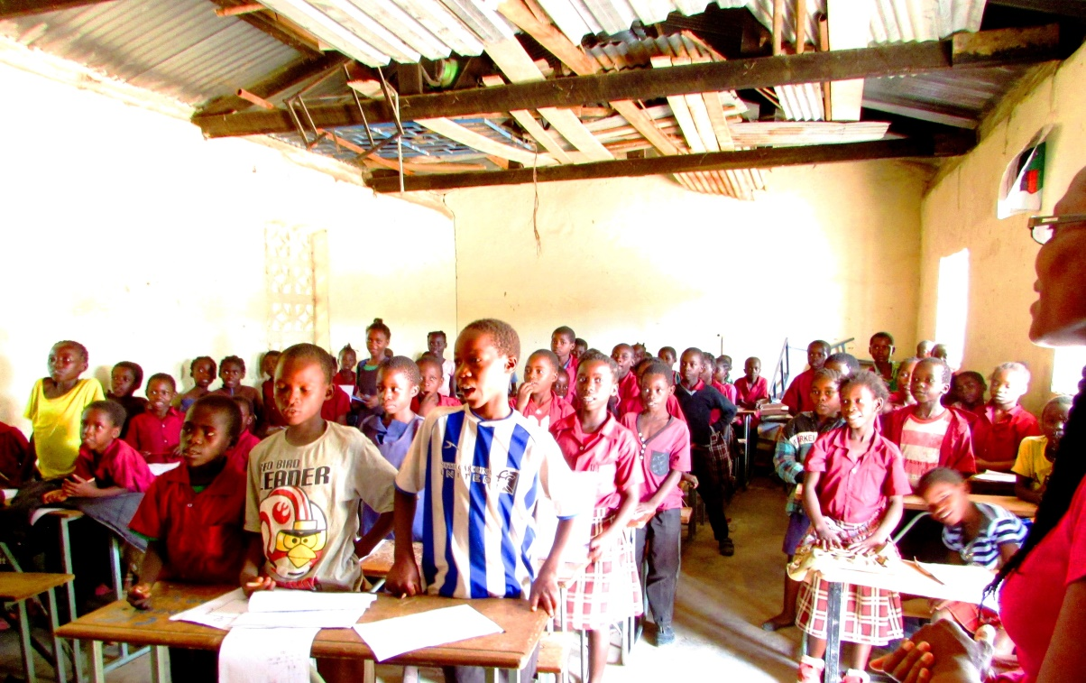
Childern of Lukata Community School who seek sponsorship to aid in acquiring uniforms, school stationery and community development.

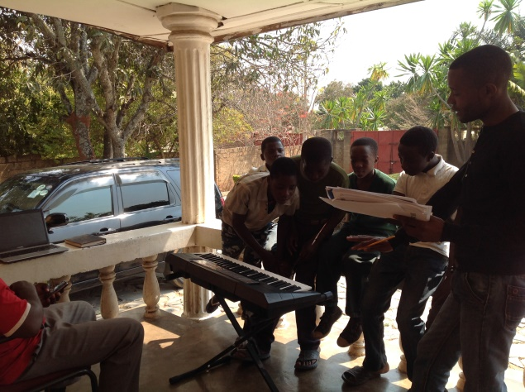 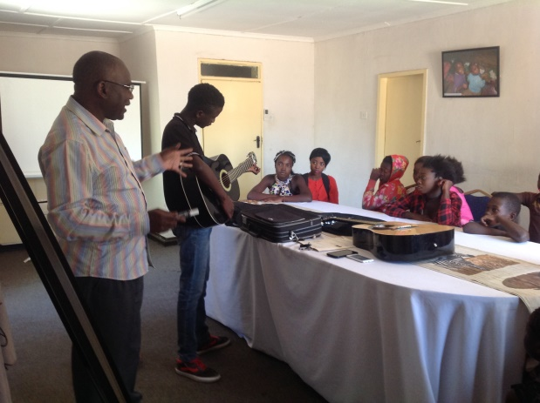Children recieve alternative skills at the Cummunity Correctional Centre which they are now using in their communities.

