Community Health Worker Empowerment Programme
Ziuaddin University, Hyderabad

An update on the Community Health Worker Empowerment Programme Phase - 2

In early 2021, MAITS embarked on the training of 6 therapists to become MAITS Master Trainers (Master Trainers in Training - MTiTs) from Ziauddin University. 3 of these MTiTs are based in Hyderabad and have subsequently trained 15 Community Health Workers (CHWS). These CHWS have been visiting families in Hyderabad (small city close to Karachi) and feeding back their casebooks to MAITS. So far we have received 50 baseline reports (data from 50 families) – the survey that is filled in on the first visit to their families. We have also received one review report (follow-up) from each family which is completed each quarter.

The 50 children in this study are aged between 2-15 years old.

The carers were asked a few generalised questions at the quarterly review visit. The results are below. We will continue to ask these questions at each subsequent review in order to monitor changes.
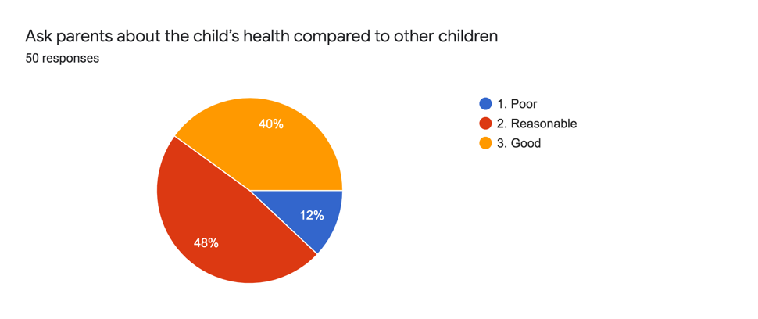

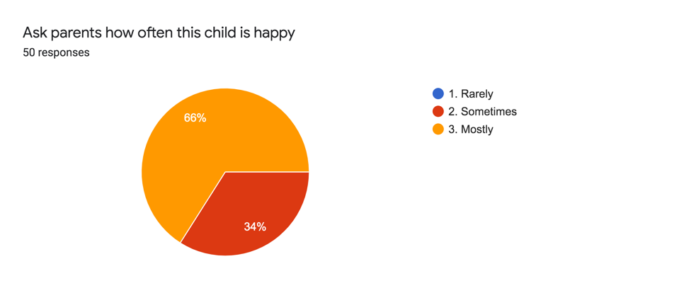
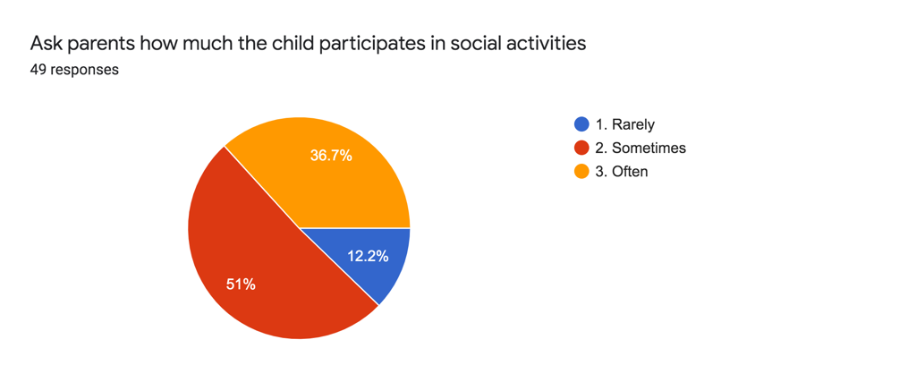
Activities of Daily Living

On the CHWS first visit, the families were asked about activities of daily living (ADLs) and to score how their child is managing from 1-5 (one being not well, 5 meaning fully independent). From the initial baseline reponse and the review report we can monitor what progress is being made.

Toileting
From the baseline report we can see the following for Toileting (1 = very poor, 5 = independent):

1 – 10 children
2 – 8 children
3 – 18 children
4 – 8 children
5 – 6 children

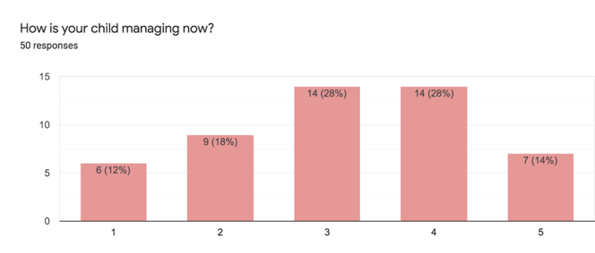
From the quarterly review, 28% of the families saw some improvement in toileting.
Scores are now:
1 – 6 children
2 – 9 children
3 – 14 children
4 – 15 children
5 - 7 children

And some feedback:
Better sitting after the use of CP chair
Improved due to flexibility of muscles
Little changes
She informs mother sometimes with the help of the picture
Use card for washroom in therapy room or outdoor activities

Bathing

From the baseline report:
1 – 9
2 – 11
3 – 11
4 – 14
5 – 5

From the Quarterly review we can see that 36% of families saw an improvement in bathing.
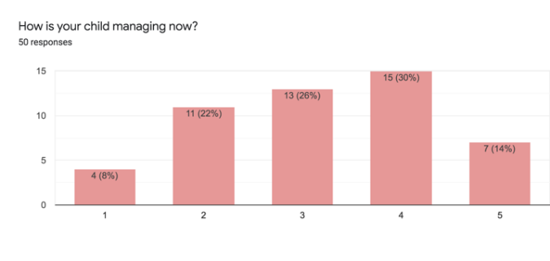
1 – 4
2 – 11
3 – 13
4 – 19
5 – 7

Feedback from the families
Sometimes without the help of mother
She enjoys it
Need assistance in taking off clothes
Improved due to correction in body posture
As sitting is achieved so she enjoys bath
Manage sitting with support during bath

Dressing

From the baseline report:
1 – 12
2 – 11
3 – 14
4 – 10
5 – 3

Again 36% of families saw an improvement in dressing of their child but still levels remain quite low:

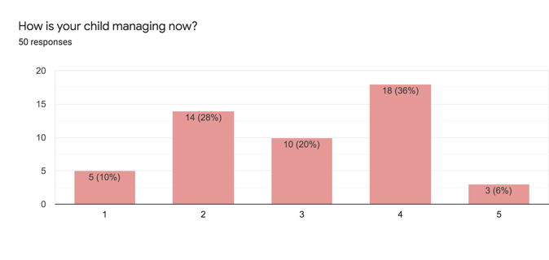

1 – 5
2 – 14
3 – 10
4 – 18
5 – 3

Very little improved
She chooses her own dess
Takes names of colours of shirt
Can change clothes on demand

Grooming

Baseline: The grooming ability amongst the children achieved low scores in the baseline interview:
1 – 15
2 – 5
3 – 21
4 – 6
5 – 3

There was small improvement in the review with 22% seeing a difference in their children’s grooming

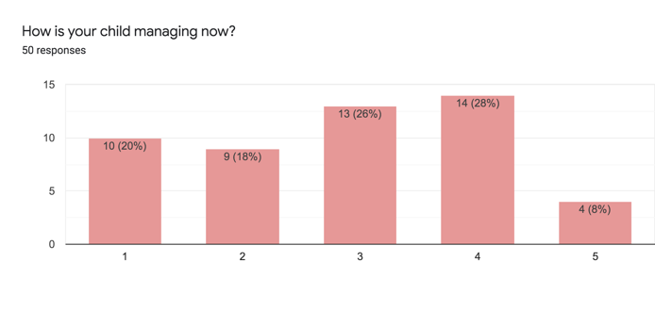
1 – 10
2 – 9
3 – 13
4 – 14
5 – 4

New concept, now have started giving choice from the field of 2 for shirts
Choose dress when comes for therapy to Hyderbad
Very hygenic
Improved
He is able to comb his hair
Selects his clothes

Eating and Drinking

The baseline levels for eating and drinking were higher than other areas:
1 – 4
2 – 4
3 – 18
4 – 6
5 – 18

However, there was a 52% improvement at the Quarterly review

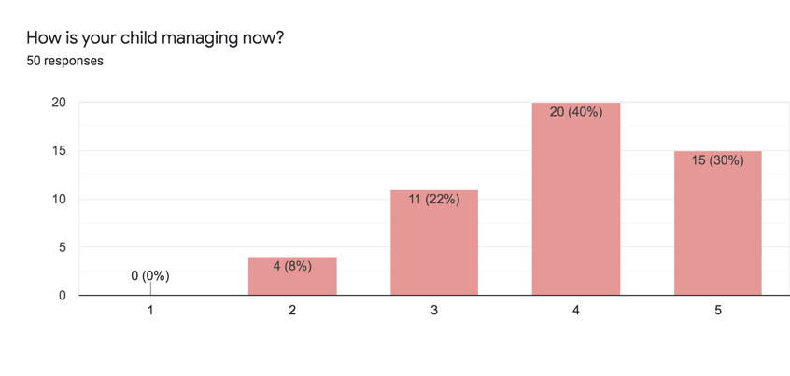
1 – 0
2 – 4
3 – 11
4 – 20
5 - 15

Requesting by saying ‘I want”
Tries self eating especially french fries
Names or requests by naming the desired items
Initiates to grab spooon
Maintains posture whilst eating
Request when hungry
He can eat with hands but unable to hold spoon
Improved as child is able to hold his neck

Brushing Teeth
At the baseline interview, the ability to brush teeth was evenly split between unable to do it and able to do this independently

1 - 11
2 – 9
3 – 12
4 – 9
5 – 9

At the quarterly review there had been a small improvement in this area of 38% seeing progress

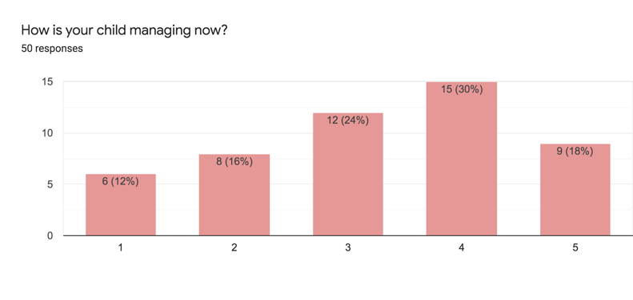
1 - 6
2 – 8
3 – 12
4 – 15
5 – 9

Educational Activities/Play

Baseline Interview
1 – 6
2 – 17
3 – 9
4 – 11
5 – 7

There was a remarked improvement in this area of 54%

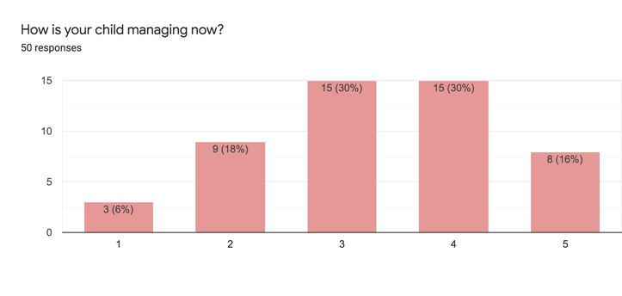
1 – 3
2 – 9
3 – 15
4 – 15
5 – 8

A lot, enjoys doing it
Willingly practice for 30 minutes a day
Love to interact in session and activities that are easy for her
Vocalizations observed
Improving

Resting and Sleeping

This area scored quite well in the baseline interviews
1 – 1
2 – 6
3 – 19
4 – 12
5 – 12

There was a 30% improvement at the quarterly review:

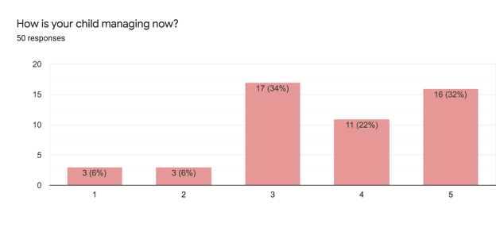
1 – 3
2 – 3
3 – 17
4 – 11
5 – 16

After school her sleeps better
Manage sleep cycle
Tries to sleep without using screen

Going to School

From the baseline:
1 – 13
2 – 6
3 – 18
4 – 3
5 – 10

From the quarterly review we can see a 44% improvement in behaviour

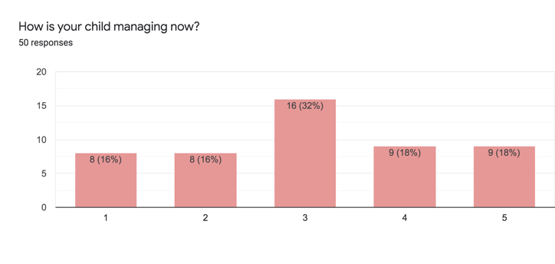
1 – 8
2 – 8
3 – 16
4 – 9
5 – 9

Going to the shops

Baseline interview

1 – 11
2 – 12
3 – 9
4 – 8
5 – 10

A small improvement of 33% of going to the shops.

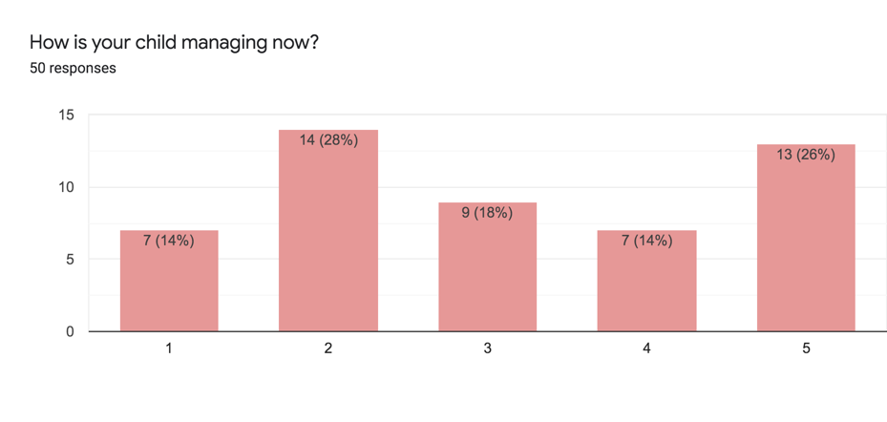

Conclusions

The primary carer was asked what the most useful thing they learnt from the CHW was. The most popular answers were as follows:
Behaviour management – 13
Strengthening and stretching exercises – 5
Working on academic skills – 6
Positioning – 2
Speech and language skills – 5
Increasing attention span/functional activities at home - 4
Potty training through pictures - 1
Parental training – 2

And then they were asked what they would like to continue to work on:
Parental Training – 4
Behaviour management - 6
Speech and language – 19
Social skills – 2
Occupational Therapy – 9
Dressing and grooming - 1

