ST. CYRIL CANCER TREATMENT FOUNDATION
THE YEAR 2022!
February 28, 2022

So far, the year has gone well, and we've completed several fantastic projects. We convey our warmest greetings and express our gratitude to every one of our generous supporters.
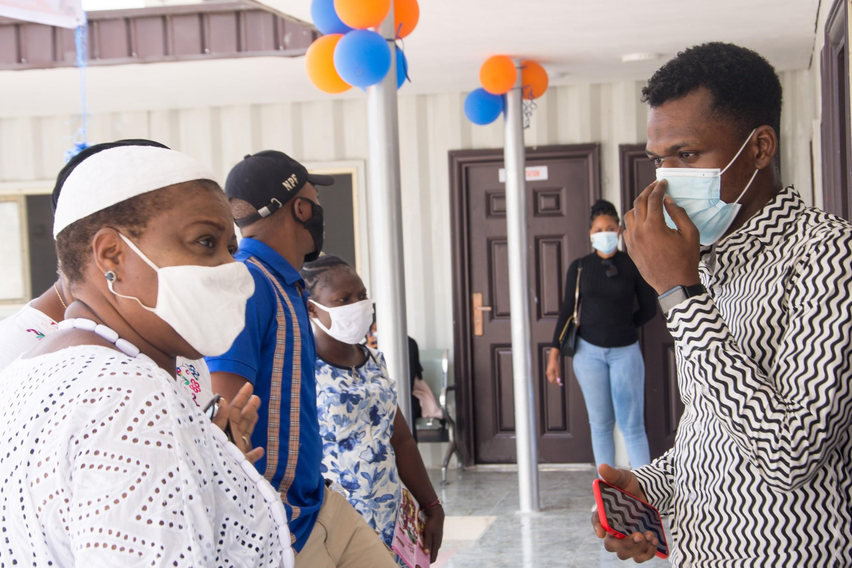
During the first few months of the year, we have completed a number of projects, which ranges from the continuation of our target to give free cervical and breast screening to 1000 community women. Also, we had our first ever Doctor’s open house for our new cancer facility in Surulere, Lagos.
With the help of our volunteers and donors, we were able to achieve these goals. We express our gratitude for this.

First quarter of 2022
JANUARY- Free Cervical Screenings and Breast Ultrasound
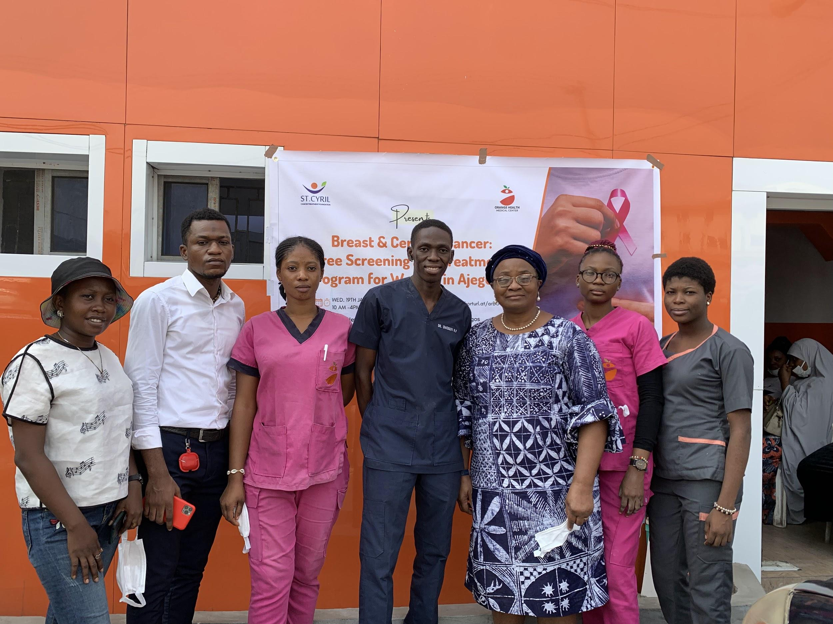
In 2018, the WHO developed its global strategy to accelerate the elimination of cervical cancer as a public health problem. This strategy is made up of three key targets – the 90-70-90 targets – to be reached by 2030: 90% of girls fully vaccinated with HPV vaccine by age 15 years, 70% of women screened with a high-performance test by 35 years of age and again by 45 years of age, 90% of women identified with cervical disease receiving treatment (90% of women with precancer treated, and 90% of women with invasive cancer managed).
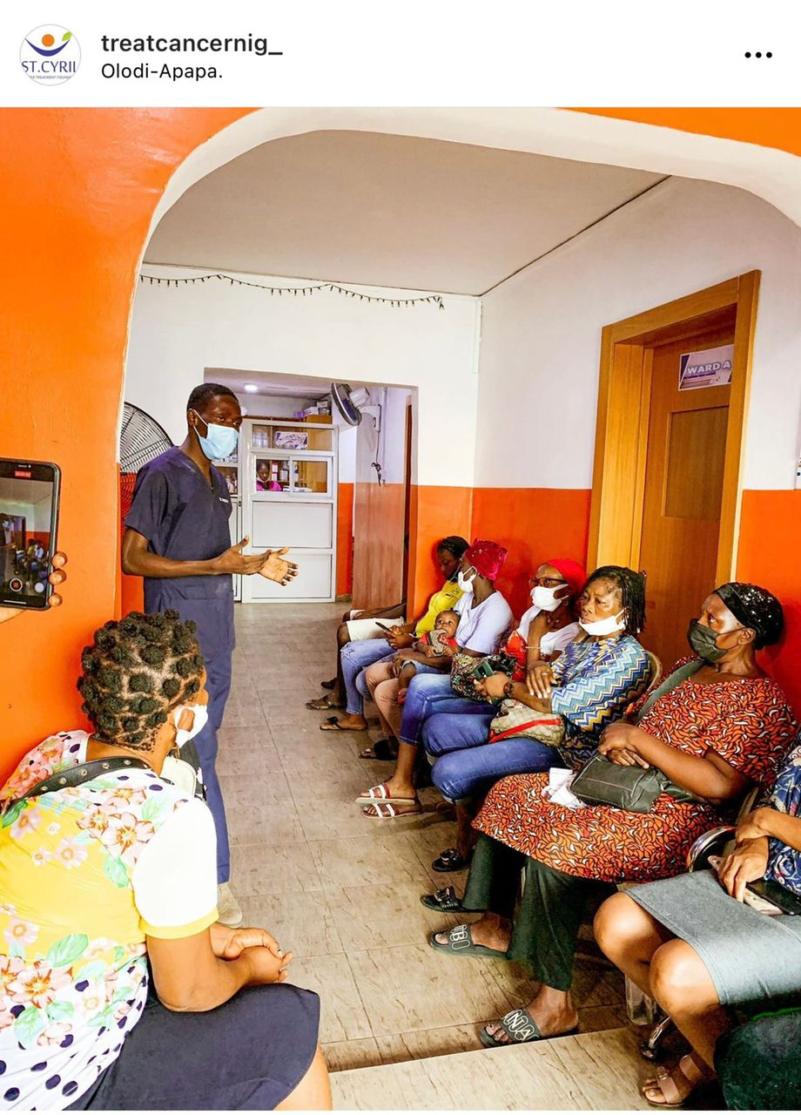
In order to meet this target, the foundation (In 2020) launched an initiative to provide free screenings to 1000 community women in Surulere, Mushin, and its environs. To progress on this, we partnered with Orange Health Medical initiative and we have screened over 300 women in total.

FEBRUARY
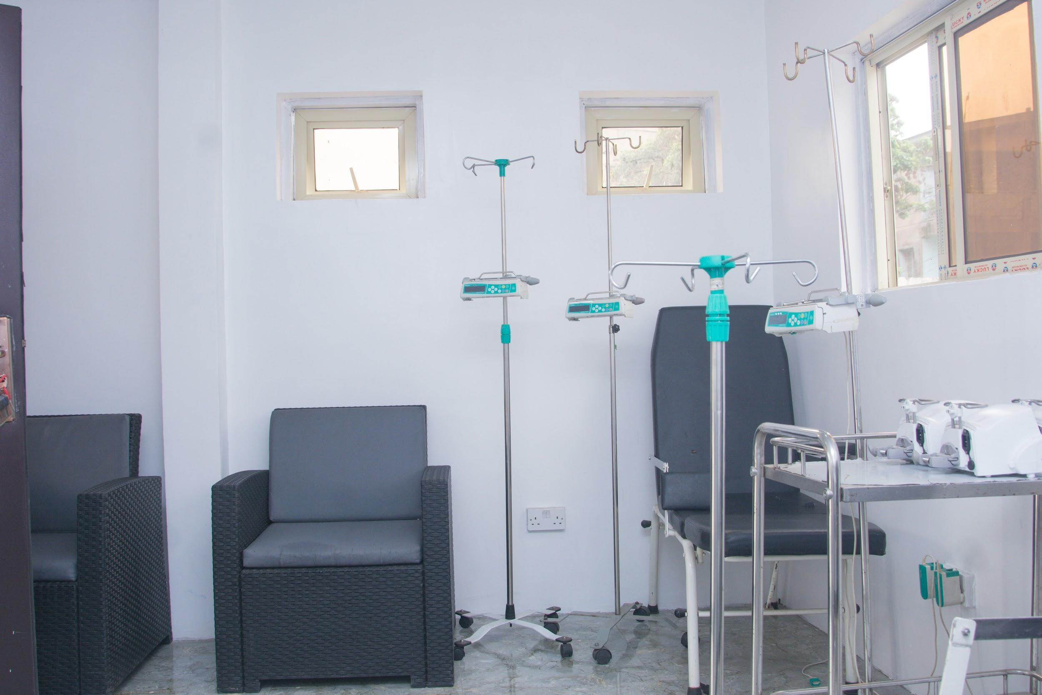
Doctor’s Open House
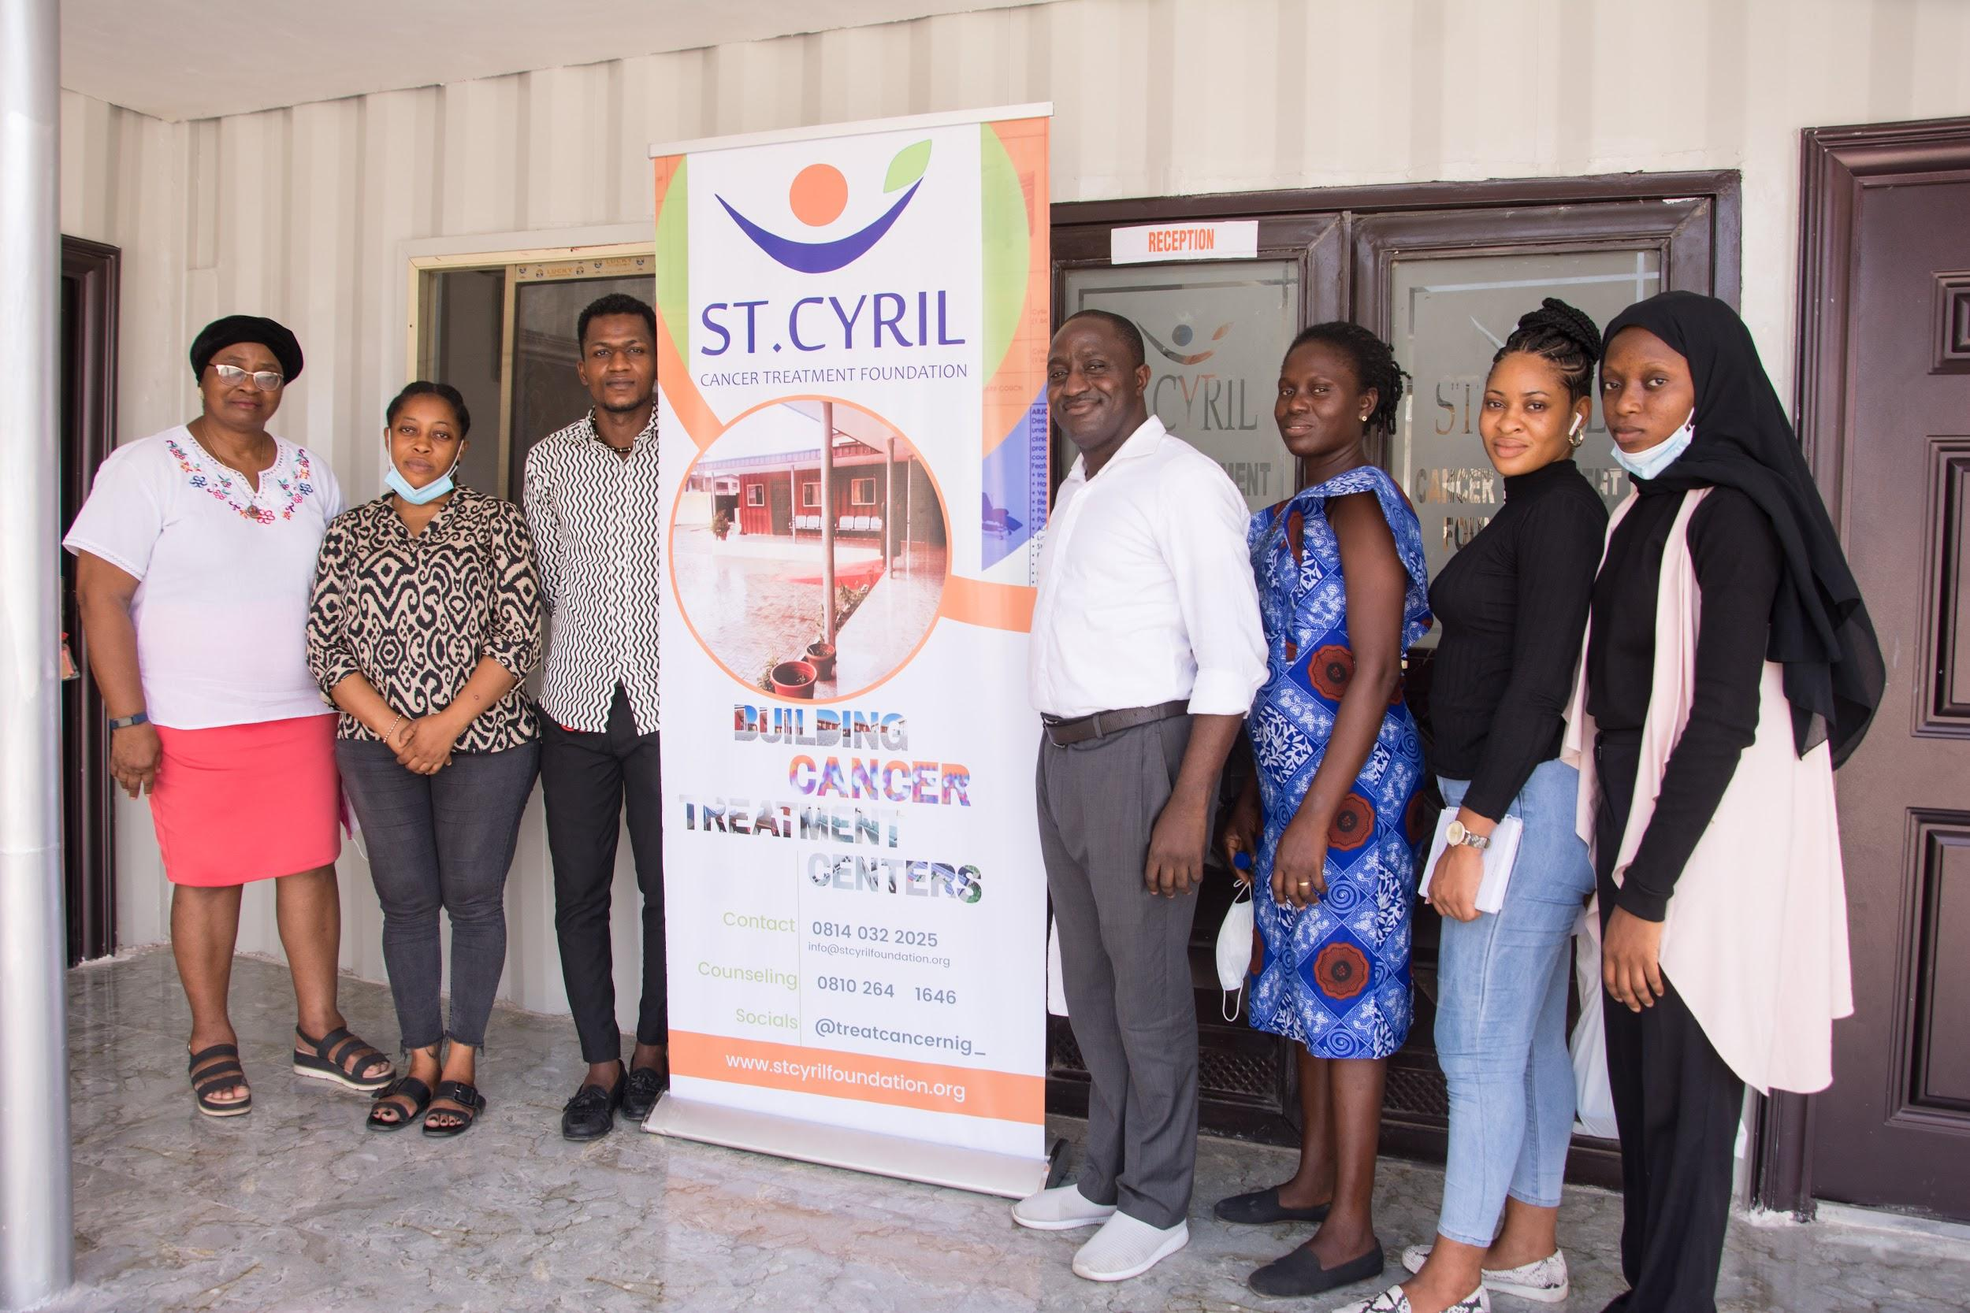
The doctor’s open house event held at our Cancer Facility in Surulere, Lagos on 18th of February. The goal of the open house was to ensure that nearby hospitals/doctors and specialists are completely aware of the facility and ways of maximizing the resources of the facility for the sole purpose of helping cancer patients.

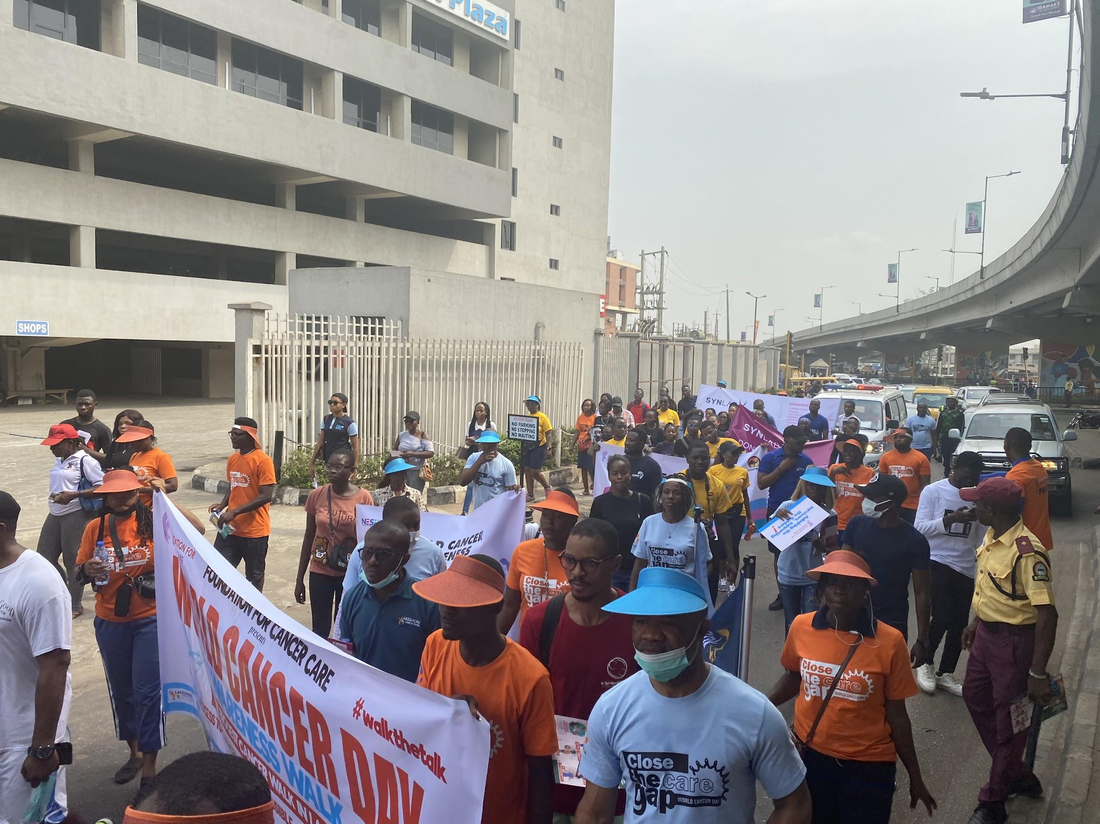
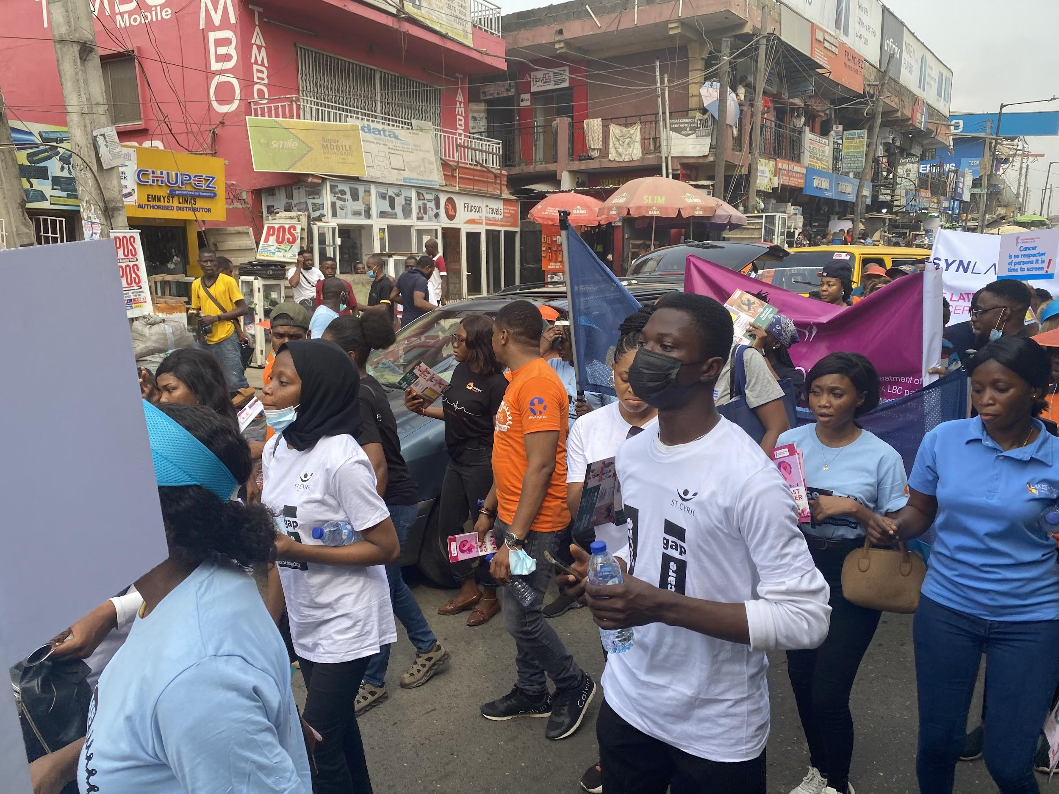

Also, to commemmorate World Cancer Day, we participated in a cancer walk hosted by Foundation for Cancer care on the 19th of February and the main aim of this walk was to sensitize and create awareness on the different types of Cancer.
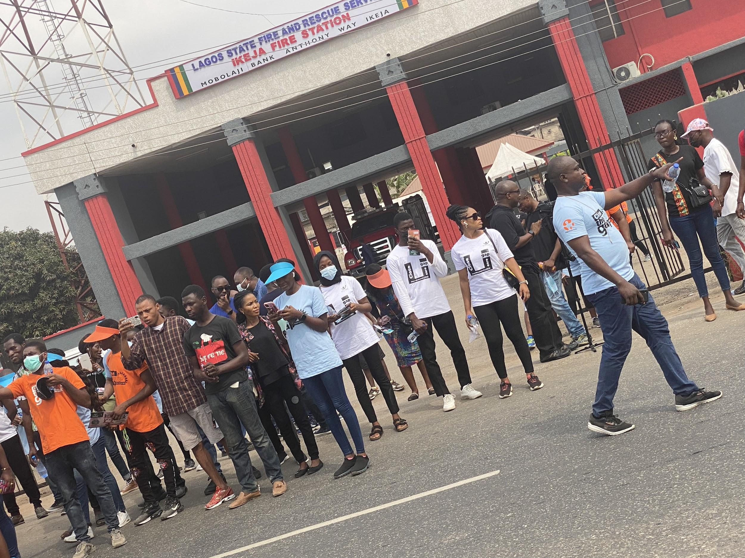
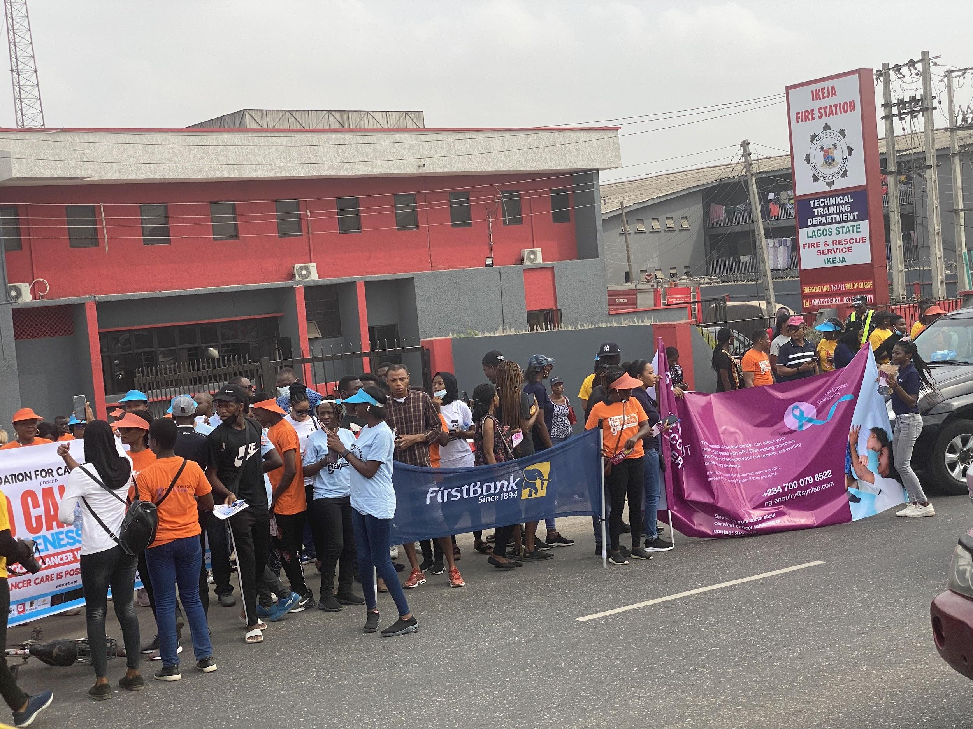

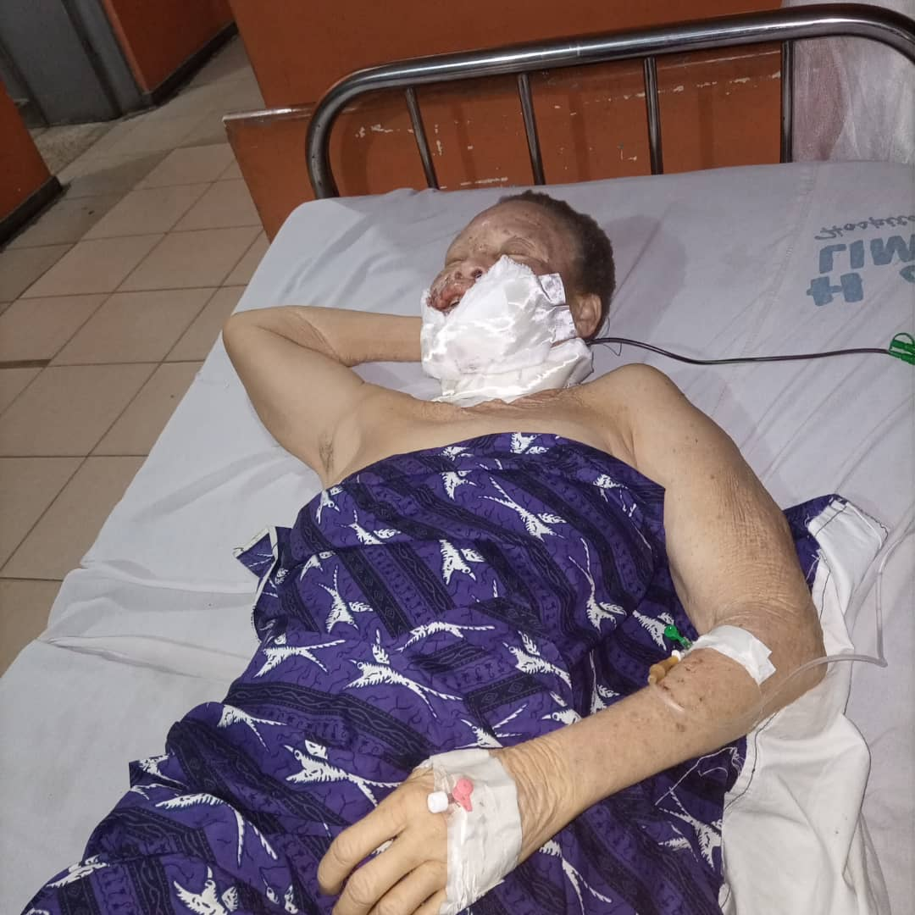
ST. CYRIL INITIATIVE FOR PATIENTS’ SUPPORT
Not forgetting our St. Cyril Initiative for Patients’ Support (S.C.I.P.S), we have focused on ensuring Mrs Silver gets quality treatment, with her having little or no funding. Mrs Silver was referred to Eko Hospital and we supported her with over NGN300,000 for her Radiotherapy. We also committed to supporting Mrs Ifeanyi Juliet (also a S.C.I.P.S beneficiary) with the sum of NGN15,000 monthly (for 6 months) with her Chemotherapy drugs.

Furthermore, with the launching of our counseling care line in October 2021, we have given free counselling to over 40 individuals.
Thank you for your support so far.
We look forward to continue striving to make the best of impacts to humanity.
© St. Cyril Cancer Treatment Foundation
35A Itafaji Rd, Dolphin Estate, Ikoyi, Lagos.
Instagram and Twitter - @treatcancernig_
Facebook and LinkedIn - St Cyril Cancer Treatment Foundation.
Donation Link - https://www.globalgiving.org/dy/cart/view/gg.html?cmd=addItem&projid=31709&frequency=ONCE&vo_id=164702&vo=30

