INTRODUCTION

India opened its door to the world in early 1990s and entered into a tumultuous and challenging economic frontier. Exchange of technology and facilitating policies in trade and commerce by the government led to the Age of computers in India resulting in a huge demand for component/Hardware and networking professional. A large number of institutes grew at a phenomenal rate but faced closure as they were not providing 100% quality training.
It is in this gap that we at Vidyadhiraja propose to operate and equip the youth from the school and the community with professional skills required to make them employable with IT IMS skills.

OVERVIEW

This course is for two categories of youth directly and indirectly connected with the Vidyadhiraja Institution.
The first category are the higher secondary students of the school who are aged 16-18 yrs. It is proposed to provide them the BPO training free of cost to these students so that they can walk in straight into a Call centre and work for empowering themselves.
The second category of youth are from the immediate slum community who will be trained in the same skills but at a concessional cost only to ensure their commitment and regularity.
Both these categories of children do not have a learning space. Their homes have small spaces shared by lots of members and hence it is necessary to provide training at the centre itself with no further references or writing or preparation needed from the home.

A PROFILE OF THE SCHOOL
Vidyadhiraja High school is a small resource school based in the slums of Nahur, a north-east suburb of Mumbai.
Students to this school are first time learners generally – but more so impoverished of ideas and solutions to the challenges they face on a daily basis. The school has customized academics to help them enjoy learning by doing and introducing the concept of entrepreneurship. The school has won the SCHOOL ENTERPRISE CHALLENGE Award from Teach a man to fish U.K in 2012 for this concept of working.
The School is also awarded by THE BRITISH COUNCIL with THE INTERNATIONAL SCHOOL AWARD twice in the years 2012-15 and 2015-18. This is an expression of the quality of work done in the school to bring a big number of students to an English medium school and fine tune their talents to be achievers.
The school is committed to working with the disadvantaged children by being rooted in the community with a national agenda and of an international quality.

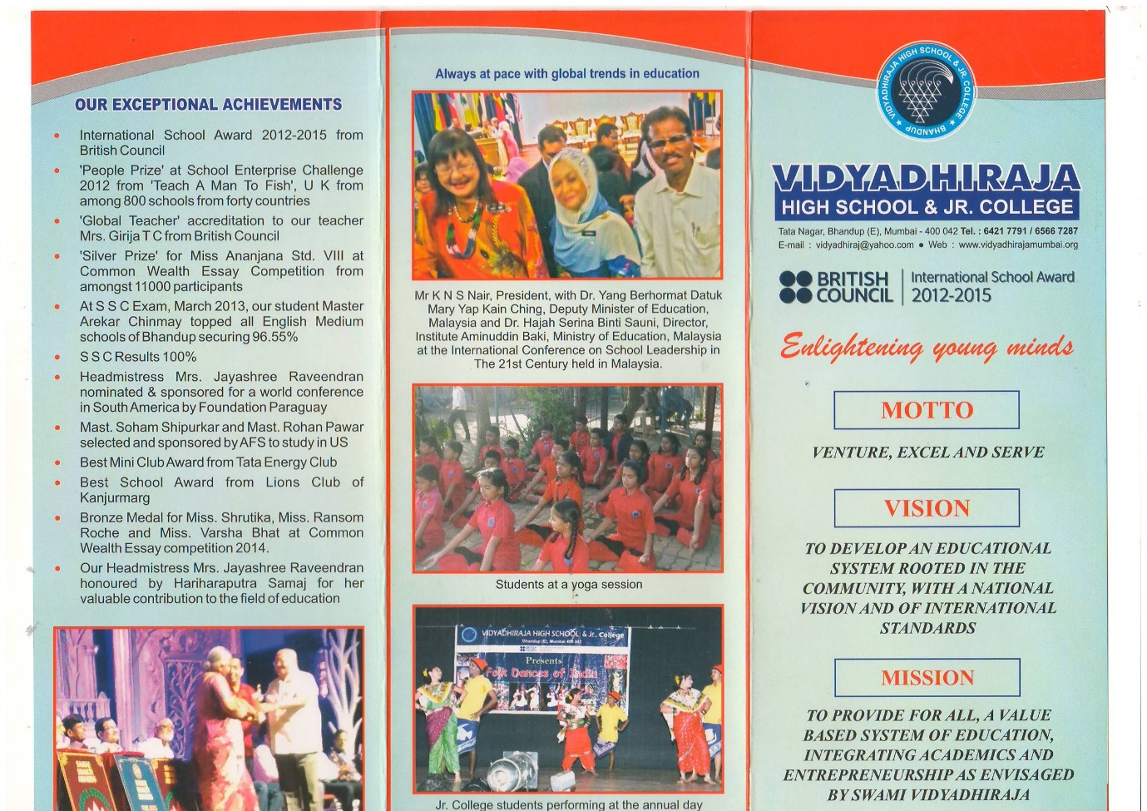

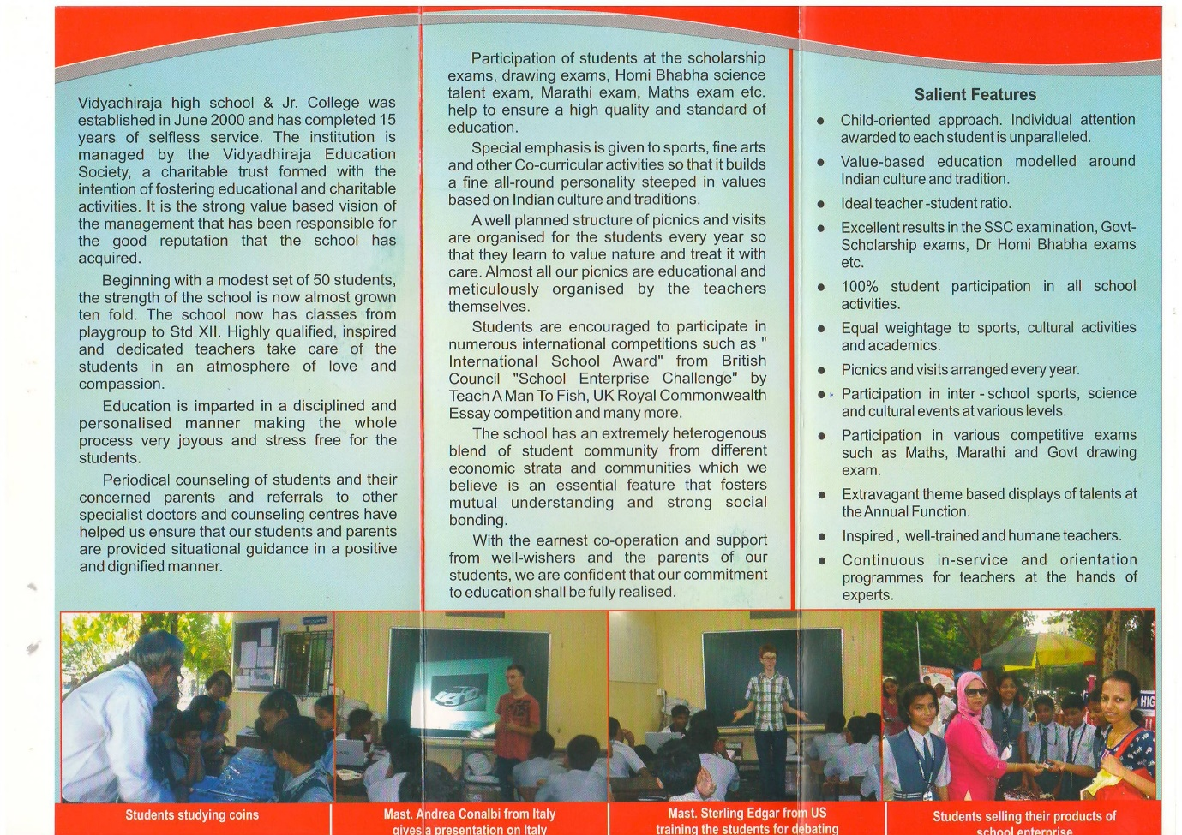

OBJECTIVES OF BPO TRAINING
- Technical skills in IT IMS, computers and Networking.
- Personality development
- Interpersonal skills
- Communication skills
- Leadership skills
- Team building skills
- Negotiating skills
- Training and presentation skills
- Importance of a positive attitude.

SYLLABUS FOR THE BPO TRAINING COURSE

THE MAJOR TOPICS THAT WILL BE COVERED ARE:

1. Tele-marketing
2. Online marketing.
3. E-commerce solutions
4. IVRS solutions.
5. Mobile solutions.
6. Lead Management solutions.
7. Click to call solutions.
8. Engagement/loyalty programs.
9. Customer service contact centre.
10. Creating self-help platforms online and on the phone.
11. Email/chat support
12. Retention and renewals.

TOPICS COVERED

Major topics covered in these sessions are:
- Data conversion
- Data Processing / Data Punching
- Back Office operation relating to computerized data
- DMS Service
- Cloud computing service
- Data Storage Service
- Report Analysis Service
- Website Development & Hosting
- IT Solution Providers & Implementers

A brief explanation of the above services is as follows:
Tele- Marketing
Telemarketing is a very common form of marketing companies use to connect with potential customers of their products or services. Historically, telemarketing consisted of companies making telephone calls to existing or potential customers. With new technology, telemarketing has expanded to include video conferencing calls as well, although those are typically conducted with existing customers. Telemarketing is often used to try to sell a product or service, but it can also take the form of surveys or information gathering. For instance, political campaigns use telemarketing heavily prior to elections to inquire about voting preferences.
When companies call new customers, the activity is referred to as cold calling. This means the consumer has not purchased from the company before nor have they requested a call from the company.
There are many industries that rely heavily on telemarketing, such as:
- Cable and Internet services
- Home security systems
- Financial services
- Vacation and time share
Data Conversion Services:
Using leading-edge technologies and skilled staff unstructured data of all manufacturing units into a variety of useful digital formats. This helps in l capture data from all types of handwritten forms accurately, rapidly, and cost-effectively and convert it into a powerful management resource. Data conversion y or other data in to excel sheet or any other RDBMS. Our data conversion services training will include:
Conversion from any-to-any Database or format (e. g tally or any of software to EXCEL, ASCII to DBF, ASCII to SPSS, EXCEL to ASCII/DBF, PDF to Doc conversion etc.)
- Conversion of sales order in delivery challan
- Conversion to images (from any format)
- Extracting selected text from any document and converting it in a Database
Data Entry / Punching Services
We will provide quick and accurate data entry training services to our students on how data to be extracted from any source. E.g. Sales order punching in system which will help to convert in delivery challan.
Our Data Entry Training services will include:
- Computer Data Entry in any form including
- Text, Numeric or Alphanumeric entry
- Printed or Handwritten matter
- Hardcopies or Scanned Images
- Data Entry for telephonic order
- Online Data Entry through URL links
- Mailing Lists
- Full text data capture
- Payroll services
- Accounting & Book keeping entry

COST OF THE PROJECT

No. | Particular | No. | Cost
1. | Furniture |  | 50,000
2. | Electrical installation |  | 14,000
3. | Hardware
 | PCs | 12 | 1,92,000
 | Workstation | 16 | 80,000
 | Server | 1 | 80,000
 | Headsets | 12 | 21,600
 | Tech support centres |  | 10,000
 | UPS | 1 | 40,000
 | Telecom Infrastructure |  | 9,000
4. | Software
 | Firewall | 12 | 9,600
 | MS office | 12 | 60,000
 | Window software | 12 | 25,000
 | Dialer Predictive | 12 | 1,25,000
 | Antivirus | 12 | 8,400
 | Recording software |  | 25,000
5 | Housekeeping |  | 10,000
 | Fire safety |  | 10,000
 | TOTAL |  | 6,40,000

Project Execution
For the college students
class | Months | hours
XI | 2 | 30
XII | 2 | 30

For the community

Community | Months | Hours
English | 2 | 30
BPO | 2 | 30

Sustainability of the project

The setting up of the project is the first step which involves a lot of effort and financial support.
The next step however is to conduct the course at intervals of 3 months each. Thus we envisage four cycles in a year for the course.
If the project can take in 12 students at a time then it will be enough to bring in revenue by way of fees charged for the training and also placement charges.
The revenue accrued can take care of the trainers remuneration and maintenance charges.
The school and the community thus stand to benefit each other.

CONCLUSION

Since the basic infrastructure facilities, other supporting conditions for training and tie up with a BPO company is already in place it will help in also imparting specialized training to make the students ready for jobs. Thus, the project is technically feasible and economically viable.
Tie up with a couple of leading BPO is in place and they are ready to hire students from our institute.
Thus we are convinced that the BPO centre in the school will be a trend setter in the field of education. It will be a cause for social metamorphosis. Economic status of the individual and the society will be uplifted. The educational and professional mobility of the individuals will undergo an upward scaling thus leading to greater self-esteem and more dignity to individuals.

