MTENDE HOMECRAFT FOUNDATION
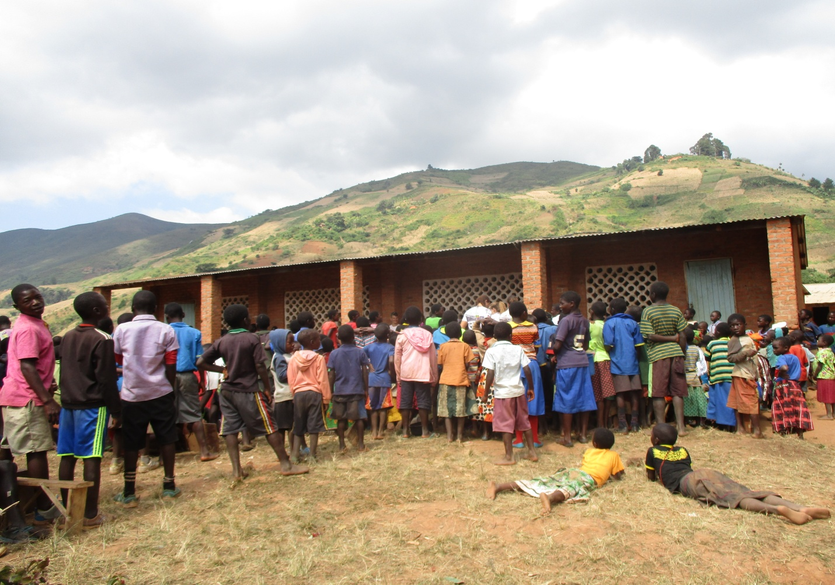

Project Title: Support school children with learning materials - Malawi

Submitted by;
Mtende Homecraft Foundation
P.O.Box 21,
Livingstonia. Rumphi
Malawi. Africa

Phone : +265 991 590 510 / +265 888 505 339

E-mail: mtendehomecraft@yahoo.com / rmwabanga@hotmail.com
www.facebook.com/rockin.mwabanga

Project background

‘Support school children with learning materials - Malawi’ is a community driven initiative facilitated by Mtende Homecraft Foundation, trying to provide school children with teaching and learning materials for 5000 learners in 10 schools around Livingstonia – Malawi.
Following Government adoption and implementation of free primary school education in 1994 in Malawi there has been many children registering for primary education. This has affected the quality of education as there is an imbalance on teacher pupils’ ratio, number of classrooms, inadequate teaching and learning materials and not forgetting poor sanitation among others. The situation has not spared Livingstonia- schools where a number of children have no or limited basic needs for their education and communities had to respond to the challenges by establishing a number of initiatives such as construction of temporary shelters as learning facilities at school compass. Geographically, Livingstonia –school is located on a hilly and plateau area with full of escarpments and hardly to reach and this situation put the Livingstonia-Phoka as one of the excluded areas in terms of equal distribution of Government public resources and Donors support for rural development projects. Despite that, the school registered a good enrolment number of learners approximately 11,600 learners in 10 primary schools.

Project goal

To increase school child enrolment rate for better quality education by 60% by 2020 through provision of school basic needs.

Specific objectives
- Improved child learning environment and increased child school enrolment rate through school material support.
- To increased retention rate in schools especially for a girl child through supply of school uniform and stationery materials.

Project main activities

- Purchase and supply of teaching and learning materials to 10 schools.
- Support vulnerable children with school uniform and other basic needs.

Project expected results
Following the implementation of the above proposed project; the project expects to achieve the following key results;
- Improved school learners’ retention rate
- Reduced child abuse, absenteeism and exploitation.
- Increased a girl child enrolment in school and reduced poverty

Project Implementation duration

The proposed project is expected to take 9 months starting from April 2018 to December 2018.

Project risks

Culture
The prevailing culture that leads to discrimination, abuse and exploitation of children in our catchment area will retard the achievement of the project goal. The project therefore will draw chiefs and local leaders to sensitization campaign programme and further abolish such kind of culture so that more children are able to participate and achieve their rights to education. As custodian of cultural norms, their involvement is very critical for successful cultural and practical change.

Gender
In Livingstonia – Malawi gender aspect, boys and girls, men and women assume culturally different identities and traits. The status is worse among females as compared to their male counterparts. For instance, a female headed household has 14% less consumption per capita than a male headed household mainly due to gender based differences in access and control over resources (UN-Malawi 2010 Report). In addition, girls and boys experience some form of GBV during their life time. The experience of violence increases the risk of HIV and other sexually transmitted diseases. This could probably explain the fact that HIV prevalence among women and girls is still disproportionately higher at 12.9% than the national average of 10.6% while that of their male counterparts is at 8.1% (DHS 2010).
It is in this context that addressing a girl child education is among the priorities of Mtende Homecraft Foundation through the above mentioned project which complement UN and Government of Malawi agenda on universal access to education and poverty reduction programmes.
Education is essential for social-economic development and industrial growth. It is an instrument for empowering the poor, the weak and voiceless as it provides them with equal opportunity to participate in local and national development (Malawi Growth and Development Strategy II).

Project beneficiaries

The project current target is 5000 learners in 10 primary schools as beneficiaries.

Project involvement

As already highlighted above, to ensure accountability to its members, Mtende Homecraft Foundation will continue to involve community participatory approach strategy that involves all stakeholders including the marginalized group in the society to take part in project designing and implementation and this creates community project ownership.

Project sustainability
As regards to project future participation and sustainability, a strategy has been designed in such a way that school management committee of Livingstonia primary school as primary beneficiaries will be drawn into capacity building programme. This capacity will provide and facilitate development of strong, effective and equitable service delivery to school management programme which in return will achieve project management mechanisms and ownership and this will help to support the on-going project activities.

Project budget estimates

The proposed project budget for completion of school block is US$ 10 500. This budget will be used to purchase school stationery, uniform and other school basic needs.

Fundraising strategy
Proposed starting date | Proposed ending date | Type of donation options (minimum) | Projected project donation volume | Donation project Goal
December 2017 | December 2017 | $100 (major donors) | $10,500 | To increasing school child enrolment rate in 10 schools and achieving quality education.
^^ ^^ | ^^ ^^ | $20 (Small & individual donors) | ^^ ^^ | ^^ ^^

Organization background

Mtende Homecraft Foundation is a Faith Based Organization registered with Malawi government as Local NGO in 2014. The organization goal is to improve lives of vulnerable communities and strives to develop a well informed and self sustainable community through capacity building programmes in various levels of rural development.
Vision
Developing a well informed and self sustainable community for better rural livelihood.
Mission
Working in partnership with vulnerable communities and diverse them to overcome illiteracy, hunger and promotion of health among rural communities.
Core Values

- Participation: - To promote participation and association in social activities.
- Professionalism: - Execution of duties without exclusion and partiality and corruption.
- Transparency and accountability: - We are committed to being transparent, honest, accountable and trustworthy.
- Sustainability: - We believe in comprehensive sustenance of social-cultural and moral values and development infrastructure.
- Christ centered spirit: - We believe in executing our duties with Christ spirit of non discrimination and condemnation.

Goal
- To improve lives of vulnerable communities through support, care and capacity building programmes in various areas of rural development.

Strategic objectives
- To provide care and support to orphan and vulnerable children (OVCs) in education sector.
- To empower smallholder farmers to alleviate poverty and attain food security at household level.
- To create community awareness and support on health issues with focus on HIV/AIDS, Tuberculosis (TB) Malaria and other related diseases.

Location
Mtende Homecraft Foundation is located at Mantchewe village next to Mantchewe waterfalls 5km away east of Livingstonia Mission Station in Rumphi district - Malawi. The Organization’s catchment area covers 2 Primary Education Zones within Livingstonia–Phoka Zone area in Traditional Authority- Kachulu inRumphiNorth constituency. Livingstonia –Phoka Zone is hilly area full of escarpments and hardly reached with warm tropical climate with an average annual temperature of 28.2 to 35 degrees Celsius. The area has over 35 000 people with an average population density of around 70 people per sq.km. Women head 25% of the households, which are disproportionately poor.
Governing Board
Mtende Homecraft Foundation has a functioning Board of Trustees composed of 7 members chaired by Dr. Foster Lungu, a lecturer at Mzuzu University who head the governing board of the organization and a secretariat is headed by Executive Director who runs the daily operations of the organization. According to constitution, the supreme authority is vested in Quadrennial congress which is convened in every 4 years.
Mtende represent the most marginalized people such as women and children in the area of education, health and poverty reduction. Since inception, the Organization has conducted a number of community capacity building interventions aiming at improving rural education standard. These capacities include community training, care, support and counselingin child rights to education supported by Democracy Consolidation Programme and other partners.
To ensure accountability to its members, Mtende Homecraft Foundation developed a community participatory approach strategy that involves all stakeholders including the marginalised group in the society to take part in project designing and implementation. These stakeholders include Village Development Committees, Area Development Committees, Parents and Teacher Associations, School Committees and other relevant Community committees who take a leading role in planning and implementing the project interventions.

Achievements

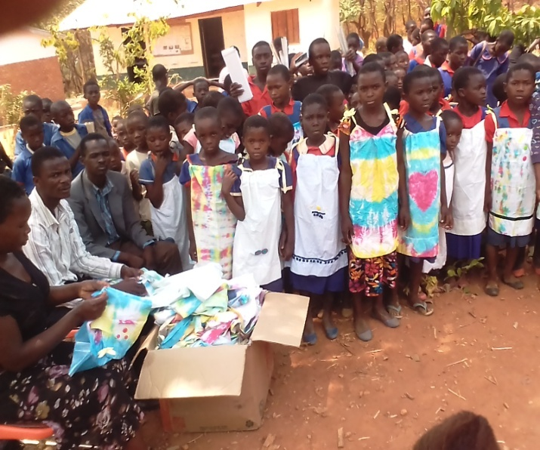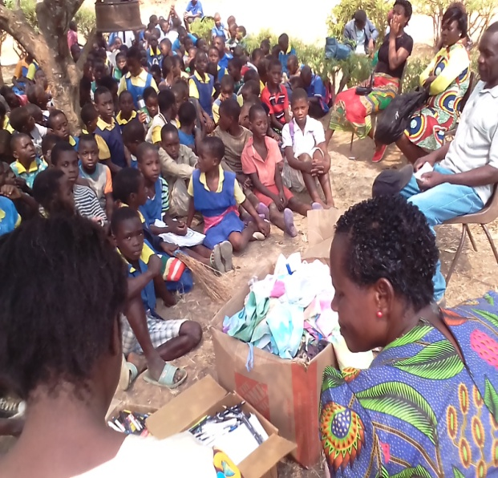
Vulnerable children supported with school uniforms by Mtende Homecraft Foundation
