**Hope for Children International Inc.**



To restore dignity, respect to homeless children through advocacy

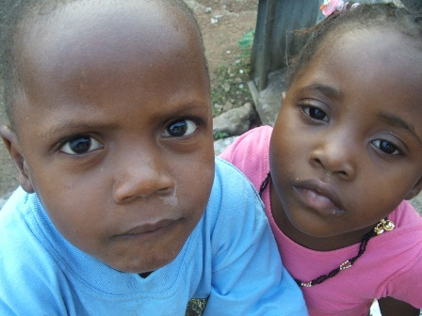

“It takes a village to raise a child.”

**Volunteer for Hope for Children International Inc**

**Outreach Program in Massachusetts or aboard**

If you are interested in saving a child, visit us

at our website at [www.hopechildrenintl.org](http://www.hopechildrenintl.org),

if you would like to support

Hope for Children International Inc or   
volunteer, please contact Blessing Rogers  
(Founder and President) at [Ngorzi@aol.com](mailto:Ngorzi@aol.com).

To make a financial gift please make your

check out to Hope for Children International   
Inc of Massachusetts and mail to the address  
below.

P. O. Box 3637

Brockton, MA 02304-3637

Phone: 508.436.2710

617.516.7498

857.204.3347

P. O. Box 3637

Brockton, MA 02304-3637

Phone: 857.221.1755

**617.516.7498**

**Hope for Children International Inc.**

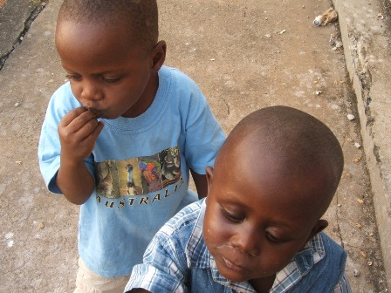

“It takes a village to raise a child.”

P. O. Box 3637

Brockton, MA 02304-3637

Phone: 508.436.2710

617.516.7498

857.204.3347

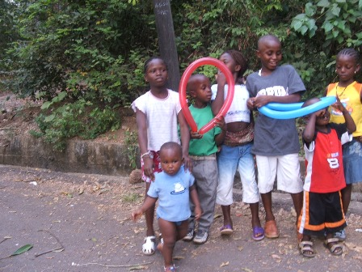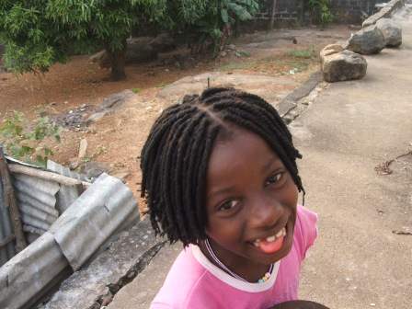

# 

# What is Hope for Children International Inc.

Hope for Children International Inc is a non-governmental organization whose goal is to empower and help children who are living in impoverished conditions in the streets to have a better life in a world that is increasingly neglectful of children

These children lack voice, exposed to conflicts, homelessness, run-away, child soldier, abuse, trafficking, exploitation, violence, and slavery.

Hope for Children International Inc adapts the model of inclusive programming whereby the graduates of Hope for Children International will be encouraged to help another child, within, bearing in mind that it takes a “village to raise a child.”

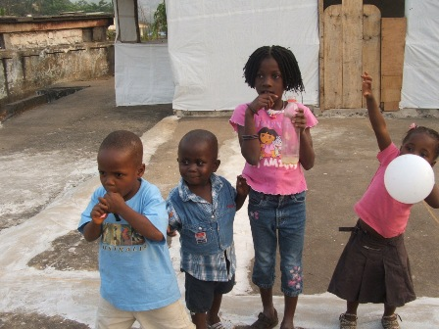

# Program Component

* Outreaching to children living on the street in identified (rural, city, or war torn Countries)
* Providing program that offers shelter or adoption to families
* Ensuring a successful transition from streets to homes or shelter
* Facilitating children’s exposure to trade skills and life skills
* Encouraging voluntary runway children to return to families
* Ensuring that children from various faiths are connected within their faith by soliciting such entity
* Providing spiritual counseling
* Encouraging faith based survival skills

# Children Homelessness in the world

**40% of the** world's **street** children **are** homeless**, 60% work on the street to support their families**

* **U.S** - Over 1 million children homeless, estimation 48,000 homeless students in Massachusetts
* **Sierra Leone** - Over 1,500 children live on the streets in Freetown, capital of Sierra Leone alone
* **Nigeria** - there is over 15 million children in child labor and prostitution
* **Liberia** – 3000 number of street children in the city of Monrovia alone
* **Ethiopia**- as of 2005 4.8 million orphans
* **Sudan**- 36,931 homeless children in the northern provinces

**Donations**

**“Save a child”!** Your donations will make a difference in the life of a child who lives on the streets, runaway, child soldier, orphans, neglected, and abused children.

Hope for Children International Inc of Massachusetts is a 501(c) (3) tax- exempt nonprofit organization.

If you will like to hold a “Save a Child” fundraising or drive at your workplace, house of worship, group meeting, please contact Hope for Children International Inc for more information

“It takes a village to raise a child”

