Friendship Secondary Education
Annual Report: January- June 2021

Organization | Friendship | Project location | Gaibandha and Kurigram Districts, Bangladesh
Project number |  | Reporting period | January-December 2020
Project name | Friendship Secondary Education Programme | Date of report | July 2020

- Children´s Voice

Chan Mia’s commitment to continue his studies

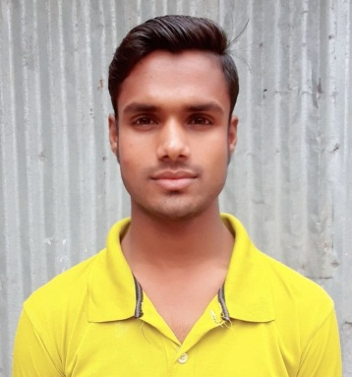
Chan Mia is a student of Grade X at Paglar Char Secondary school. He is one of the first batch students who is set to appear at Secondary School Certificate (SSC) Examination from Friendship school in 2021. Chan Mia has been a student of Friendship school from pre-primary grade. However, due to extreme poverty, in March 2020 he had to leave his home, parents and siblings to engage in small scale laundry business at the capital city of Dhaka. When the Friendship education staff got to know about this, they contacted his parents and convinced them to call him back to the char in April 2020. SMC members along with facilitators of the Paglar Char Secondary school conducted multiple counselling sessions with Chan Mia and his parents to make them aware of all the benefits of completing the secondary school level. His parents were also reassured that completing the SSC exam will only open more employment opportunities for Chan Mia. Seeing the efforts of facilitators and SMC members Chan Mia changed his mind and decided to give the SSC exam in 2021. He said, “If my facilitators and SMC members can put in such efforts to bring me back to continue my studies, I can definitely concentrate on my studies and appear in the SSC Exam.”
Chan Mia, a student of Friendship paglar Char Secondary School

- Fulfilment of Project Objectives and Results of Activities

Since 2015, Friendship’s secondary education program is implemented in some of the most remote and inaccessible river islands and riverbank areas of northern Bangladesh. The overall objective of the programme is to improve access to equitable quality secondary education for children in remote and inaccessible areas of Bangladesh. To achieve the overall objective, Friendship’s Secondary Education Programme has progressively created opportunities for the children specially for girls living in the Chars.

Activities and Numbers
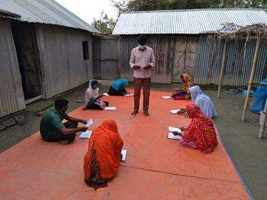
During the reporting period, Friendship had 16 secondary schools in total. This report covers the data, activities and achievements of all the 16 secondary schools but it is to be noted that among these 16 secondary schools, 5 schools are funded by other two donors i.e., SIF (4 secondary schools) and AEM (1 secondary school).

Alternative teaching methods adopted for COVID-19 Pandemic
Due to COVID 19 outbreak, secondary schools of Friendship along with all other education institution of Bangladesh have been closed from 18 March 2020. Hence, all the regular school activities had to be cancelled or postponed. However, teachers maintained regular communication with students through telephone calls to students as well as parents, home visits by teacher/students (where possible with necessary safety precautions), group study session (maintaining social distancing protocols) etc. to ensure students remain engaged with their studies as per the class schedule. During the period January 2021 to June 2021, a total of 18,395 phone calls had been made to the students to monitor and provide support to students’ studies and also make them aware of the pandemic situation. In addition, 14,290 home visits were conducted by the teachers to the students’ homes and 31,256 visits were also conducted by students to the teachers’ home for study support (Details outlined in Monitoring and Follow-up part).
- Every week, each student, on average, has been reached out for almost 2 times over phone.
- Each student, on an average, were reached through visits at least 3 times by teachers.
A group study session of the secondary students

No assessments or examinations did not take place in the reporting period. However, eight assignments, as per Government instructions, have been taken from students of Grade VI-IX and two assignments from Grade X. 100% students submitted their assignments accordingly. These assignments covered all the subjects of every grade, and the result of these assignments was satisfactory (equivalent to GPA: A). The main purpose of these assignments was to assess students learning competency acquired through alternative learning methods.

During the reporting period, following activities were also carried as against the relevant statistics:

SL | Activity (January-December 2020) | Achievements (numbers-unless otherwise stated) | Remarks
1 | Number of Schools | 16 | There were 17 secondary schools in FEP, but 1 school shut down due to river erosion. Among these 16 Schools, 05 are sponsored by other donors i.e., SIF and AEM.
2 | Number of students | 731 | As of June 2021, for 16 schools.
3 | Average attendance rate at schools | N/A | Schools are closed since last year
4 | Number of newly enrolled students | 22 | From January to June 2021
5 | Number of student left Friendship schools | 20 | From January to June 2021
6 | Number of basic trainings for facilitators | 1 | In January 2020  41 participants
7 | Number of quarterly follow up training for facilitators | 2 | 1,-online training and 1- in person training with 41 participants.
8 | Number of community meetings held | 3 | 3/school (from January to March 2020)
9  ok | Number of CDs (compact disc) with video recorded lessons delivered | 175 | From January to June 2021. No delivery after March 2020 due to the pandemic. However, in total, 2,636 CDs are available till date.
10 | Number of Birthday celebrations at schools | N/A | Schools closed
11 | Number of Important Day’s Celebrations | 4 | January to December 2020
10 | Number of Home Visits | 14,290 | January to June 2021

Student number and Gender Composition

The number of girl students is higher than the boys in the Friendship secondary schools. During the reporting period, 57% of the secondary students were girls. The grade wise opening students (in January 2020) information for the reporting period is shown in the table below:

Grade | Girls | Boys | Total
VI | 104 | 90 | 194
VII | 106 | 80 | 186
VIII | 102 | 125 | 227
IX | 30 | 29 | 59
X | 19 | 17 | 36
Old X | 17 | 12 | 29
Total | 384 | 310 | 731

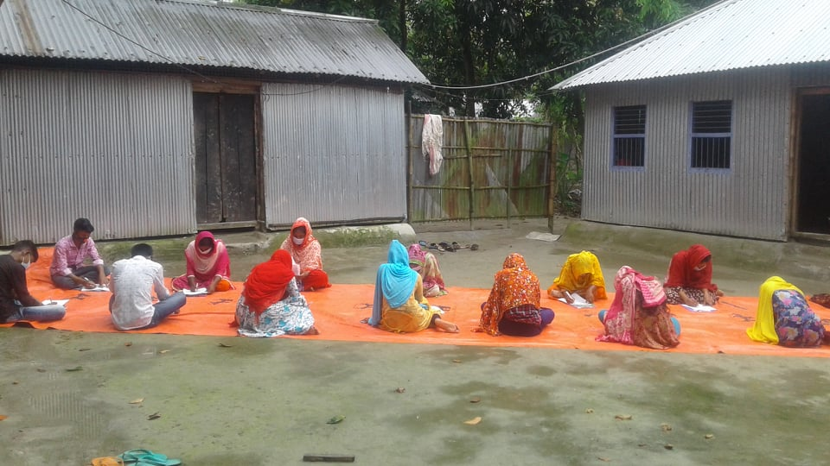
Junior Secondary School (JSC) Exam Result

In 2020, JSC exam was cancelled due to COVID-19 as per Government’s decision, and all students were auto promoted from Grade VIII to Grade IX. However, Friendship at its own has taken a short assessment test at the end of the year at respective house yards (which were used for group study sessions). A total of 105 Grade VIII students (Girls-59, Boys- 46) of 105 Secondary schools were promoted to Grade IX. 54 of the 105 students were enrolled in the Grade IX of the Friendship secondary schools. Among the 51 remaining students, 48 students (30 Girls, 18 Boys) got admitted to other schools (in chars where Friendship doesn’t have any school) and 3 remaining girls were subjected to early marriage. Area wise students’ information passing Grade-VIII is shown in the table below:
Boraibari secondary students giving the assessment test

Area | Girls | Boys | Total
Gaibandha | 22 | 31 | 53
Kurigram | 29 | 21 | 50
Rowmari | 51 | 73 | 124
Total | 59 | 46 | 227

- Time Schedule

Friendship secondary education follows Government Secondary Education academic calendar for the school days and examinations. During the first 3 months of 2020, Friendship followed this academic calendar without any interruptions. But, since March 18, March 2020, following government order all types of School level activities was paused due to COVID-19 Pandemic situation. The government order has been applicable for all education institutes across the country. However, to ensure the continuation of education for the secondary students, Friendship took alternative approaches that includes, study supports over phone, visiting students' home by teachers to follow up on their studies (by maintaining social distancing protocols) and students visiting teachers’ home for group classes. Details are discussed separately.

- Monitoring and Follow-up

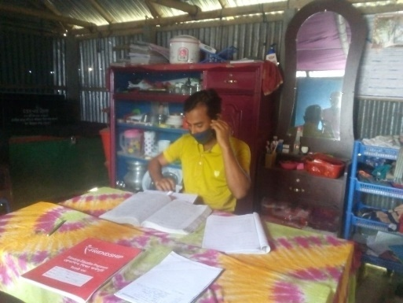
During the first 3 months of 2020, the project staffs in the regional level, paid weekly visit while the staffs from Head Office monitor the programme periodically. But due to COVID-19 pandemic, after March 2020, all the secondary schools along with all other education institution of Bangladesh were closed. But, Friendship’s teachers, who are recruited from the same islands in which they work, always helped students with their studies over phone and visiting them at their homes. During the lockdown period, Friendship Education staffs from their respective home (mostly are in their duty stations) supervised and monitored the program activities, as stated above. As physical monitoring and follow-up was not possible due to lockdown, as an alternative monitoring approach Friendship staffs did the following activities:
Anwar, a facilitator providing study support over phone to his students

Alternative monitoring approach followed during pandemic
(January-June 2021)
Activities | Total
Number of times students received lessons support given by teachers at their homes | 31,256
Number of times teachers visited students at their homes | 14,290
Number of telephones communication made with students over phone | 18,395
Number of telephones communications made with Parents/guardians and communities over phone by Friendship field staff | 22884
Number of Communication made by Friendship field staff with School Management Committee (SMC) members | 12061

- Participation of Target Groups
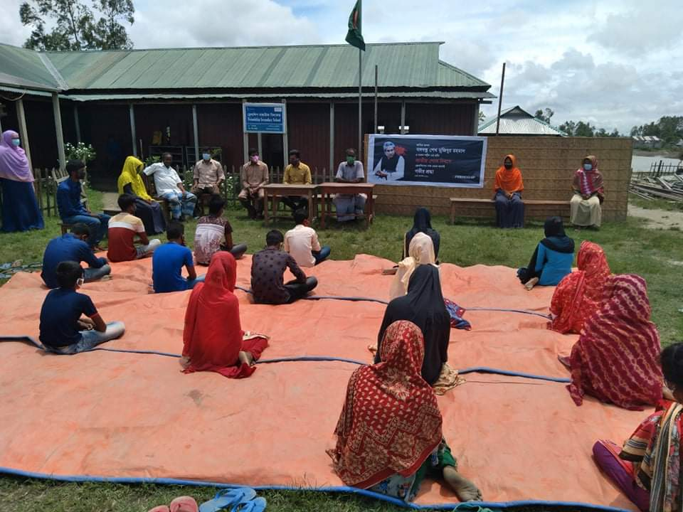
The key target group of the program is the secondary students. Students took an active part in various routine co-curricular and extra curricula activities from January to March 2020. But due to COVID-19 pandemic situation, all regular and extracurricular activities of the students were paused after March 2020. From January to March 2020, the students regularly prepared monthly Wall Magazines and operated School Libraries. Until March 2020, a total of 1,577 books (on average, 3 books for each student) were issued to secondary school libraries. As of December 2020, a total of 2,317 books are available for the secondary students at the school libraries. As of Book festival/ First day at school ceremony was also observed on 1st January 2020. Students of all the secondary schools received books and others education materials on this day. The students also actively took part in ‘Clean School Clean Home’ program and helped in school gardening and in improving the outlook of the school.
Celebration of national mourning Day in small scale maintaining social distancing

In addition, 7 national and international day celebrations were planned (for the whole year?) among which only International Mother Language Day (21st February 2020) was observed in a wide scale. Nevertheless, World Environment Day (June 5, 2020) and National Mourning Day (August 15, 2020), World Teacher’s Day (October 5, 2020) were also observed in a small scale after lockdown measures were relaxed in the later part of 2020.

- Actors
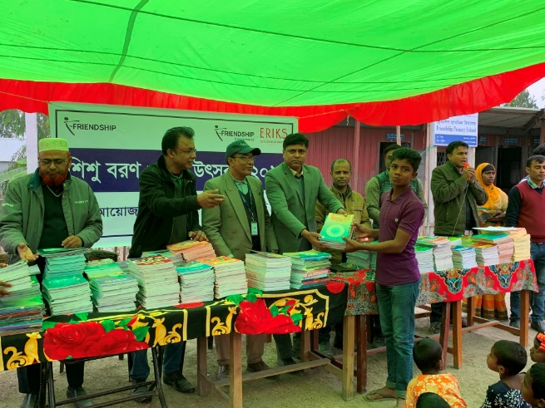
Secondary schools continued to maintain regular coordination and interaction with Government officials in the locality specially Districts and Upazila Education Officers. During the first 3 months of 2020, it was frequent and on regular basis and during pandemic on need basis to keep them apprises on our alternative learning methodology as well as remaining in picture with Government instructions on schools functioning during pandemic. Besides Friendship staff visiting their offices, Government officials also attended in a teachers training in Chilmari, Kurigram.
Assistant Upazila Education officer, Gaibandha sadar handing over books to a Secondary student at Sadhai Secondary school
The community was also actively involved in the management of the secondary schools, like previous year. From January to March 2020, 3 monthly meetings, one per school per month, were held with SMC members, parents and community people in each school. As such, a total of 51 meetings were held in 17 secondary schools with SMC members, parents and community elites/representatives. But after March 2020, due to COVID-19 pandemic, all SMC meetings were paused because social distancing is not maintained during the meetings as it gathers a huge number of people. Nevertheless, SMC (School Management Committee) members and teachers visited school premises periodically for ensuring safety and security of school properties. However, after the lockdown measures were eased, 3 SMC meetings were held in small scale (maintaining social distancing) in October, November and December.

- Other Matters

Contribution on Distant Learning at National Level
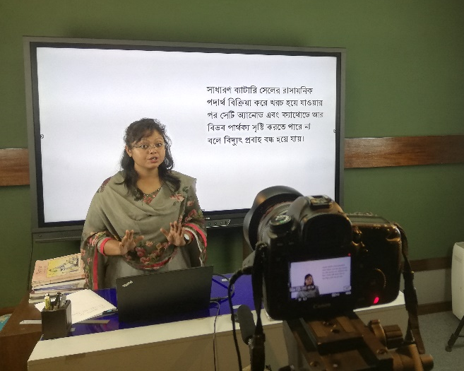
As all education institutions remained closed for a longer duration and students are deprived of their learnings, Friendship opened its resources i.e. all video recorded lessons for secondary classes for all students across the country by uploading its video recorded lessons in Friendship Education YouTube Channel which is again connected with Government online platform Kishore Batayon. http://konnect.edu.bd/my-school jointly operated by the Ministry of Education and the Ministry of ICT. Till December 2020, a total of 856 video recorded lessons were uploaded in the You Tube Channel after due screening on its content and quality of recording. It has been planned to upload the remaining lessons out of approximately 2000 Friendship possess. Friendship Education has also contributed as a partner to a Government program in telecasting video recorded lessons for secondary classes through Sangsad Television since May 2020. To improve the quality of the lessons being recorded newly, an interactive smart board has been installed in our Studio in September 2020. Hence, this pandemic situation has opened a new dimension to extend Friendship secondary school’s resources at the national level and enhanced interaction with the concerned ministries.
A VIDEO LESSON IS BEING RECORDED AT THE HEAD OFFICE FOR TELECASTING

COVID-19 awareness campaign by students
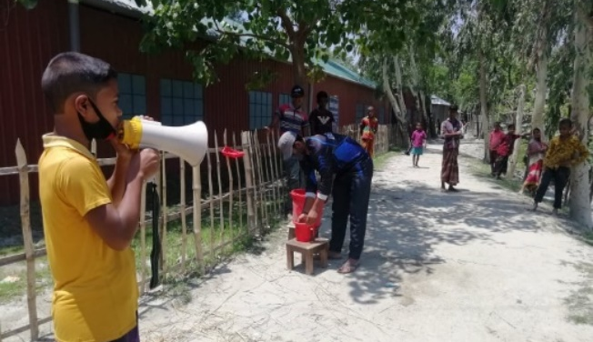
During the pandemic period, the secondary students took active part in disseminating awareness messages in the community. They understood the severity of this virus and encouraged the community members to not go out of their houses without any emergency. They also voluntarily disseminated awareness messages on washing hands, keeping social distancing, wearing masks for preventing the spread of the virus. For an example, a student named Shujan, a Grade VI student of Nawshala Secondary School even miked (provided locally) in his community to aware the community members about COVID-19.
Shujan miking in his community to spread the awareness messages on COVID-19

Students’ support during harvesting season
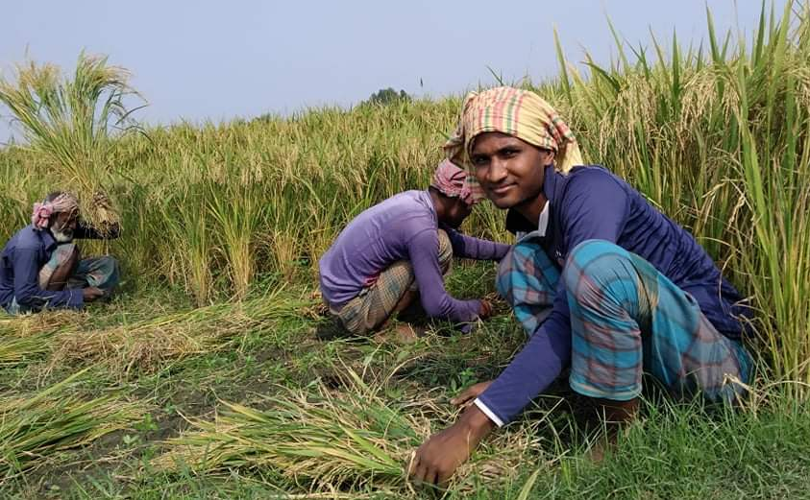
During the crop season in the chars, a large number of manpower is required to harvest the crops from the fields. In 2020, owing to the COVID-19 pandemic and movement control imposed by government, it was really hard to get labour for working in the fields. The community people were suffering as their crops were left untouched during the harvesting season as day labourers were hardly available. During this dire need of the community, secondary school students voluntarily started working in the fields of their respective communities. This noble act of the students ensured that the community people could harvest their crops in time and do not go through an economic crisis.
Shahin, a Grade VII student helping his community members during harvesting Season

Independent Evaluation of Friendship Education Program

After running Primary and Secondary Education programs for over a decade in the northern riverine chars of Bangladesh, Friendship commissioned an impact evaluation, which, after a competitive bidding process, was awarded to Institute of Education and Research (IER), University of Dhaka. The research, which was both qualitative and quantitative in nature, included stakeholder interviews, field surveys, data analysis (including students’ performance related comparative analysis), and interpretation. Specific suggestions and recommendations were also given in the research to strengthen the secondary education teaching learning process particularly to make classroom learnings more interactive. It was conducted from late 2019 until mid-2020 and the final report was made available in October 2020. The complete research report can be downloaded here.

International Webinar: Friendship Education Programme: Nurturing Values and Empowering Communities
Friendship organised an international webinar to share the results of the evaluation on November 19, 2020. The webinar, titled Friendship Education Programme: Nurturing Values and Empowering Communities, was attended by 175 guests online from six countries and witnessed by 1700 viewers on Facebook Live. Dr. Dipu Moni, MP and Minister, Ministry of Education, People’s Republic of Bangladesh attended the webinar as the chief guest. Mia Seppo, the United Nations resident coordinator in Bangladesh, joined the program as the special guest. The IER team presented the keynote paper and six distinguished government high officials and academics from home and abroad participated in the discussion as guest panellists. The webinar report provides further details.

- Follow-up of Recommendations received
One major recommendation came from the independent evaluation team is the improvement of pedagogical skills of teachers. They suggested to improve pedagogical issues by providing more real-life examples, engaging children and making the lessons more interactive. The team further recommended to strengthen the linkage between video-based teacher and facilitator to make the secondary learning environment effective. Based on this recommendation, Friendship conducted a 3-day long residential training titled “Training on Integration of Pedagogy in Academic Monitoring”.

- Financial Matters
Financial report is being sent separately.

- Learning and Experiences

Dropout and early marriages remain a major challenge for Secondary Education

During the reporting period, a total of 125 students (88 Girls and 37 Boys) dropped out from 17 Secondary schools for several reasons. The reasons for dropouts are given below:

- Migrated to other locality (where Friendship has no schools) with their parent for better livelihood/river erosion: 77
- Early Marriage: 42
- Admission to Madrasah (Religious School): 4
- Sickness: 2

Gradewide student dropout information is given in the table below:

Grade | Girls | Boys | Total
VI | 25 | 20 | 45
VII | 45 | 11 | 56
VII | 18 | 6 | 24
Total | 88 | 37 | 125

Early marriages during pandemic went up especially due to long closure of schools and teens girls were subjected to early marriages on ground of social safety, security, and prevailing socio-economic conditions. Our efforts are continuing in collaboration with Inclusive Citizenship (IC) Sector to sensitize all stakeholders to minimize early marriages.

- Analysis of Project Context

During the reporting period the two issues deserve special mention:

- Friendship teachers and Facilitators went beyond their call of duty during pandemic through their courage and drive to reach students physically visiting their houses and accepting student at their home to ensure continuation of studies. These front-line warriors remained committed to their responsibilities when their contemporaries in other schools were hesitant to go out.

- Parents were not only happy to see that their children continued to get education support when schools remain closed but also came forward to support whole heartedly. They used their mobile phones for communication between teachers and students, provided space in the courtyards for group sessions and even assisted in supervising the assessment where teachers were unable to be present. This was a collective effort and results of these assessment exams were very satisfactory.

- Signatures
________________________________
Brig. Gen Ilyas Iftekhar Rasul, ndc, psc (Retd.)
Director and Head of Education, Friendship

Pictures: Secondary Education 2020

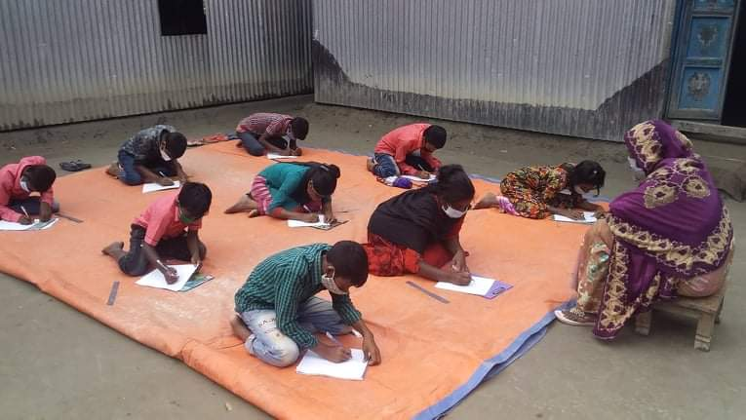
Students participating in assessment test
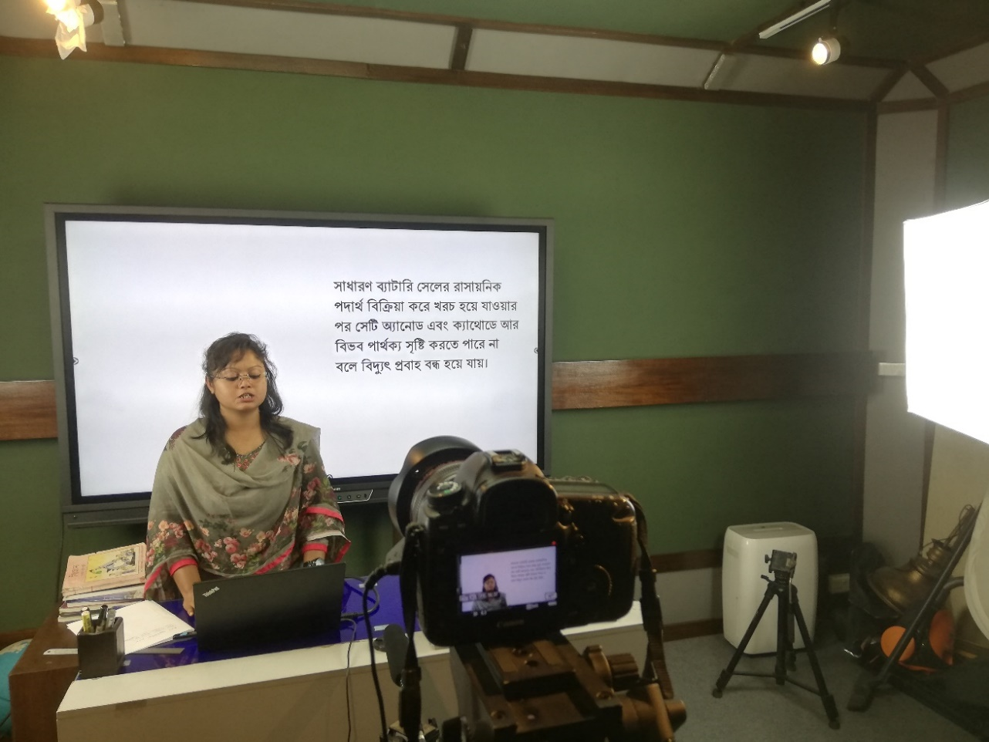
c
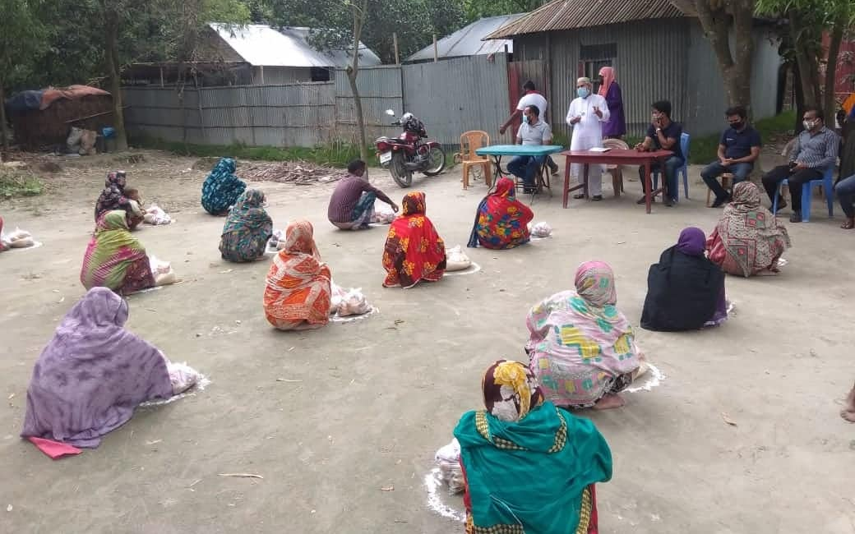

Food distribution with the support from secondary students
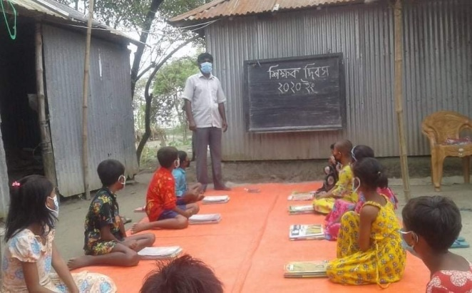
Celebration of world Teacher’s Day in small scale
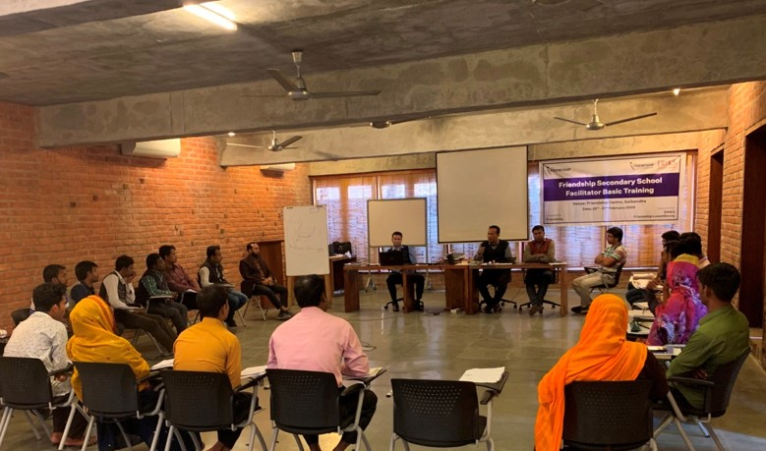

Basic training for secondary school facilitators
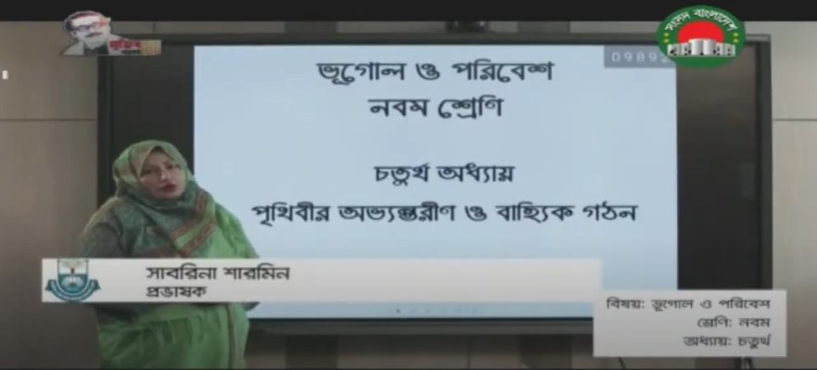
Friendship video recorded lessons telecasted through Sangsad Television

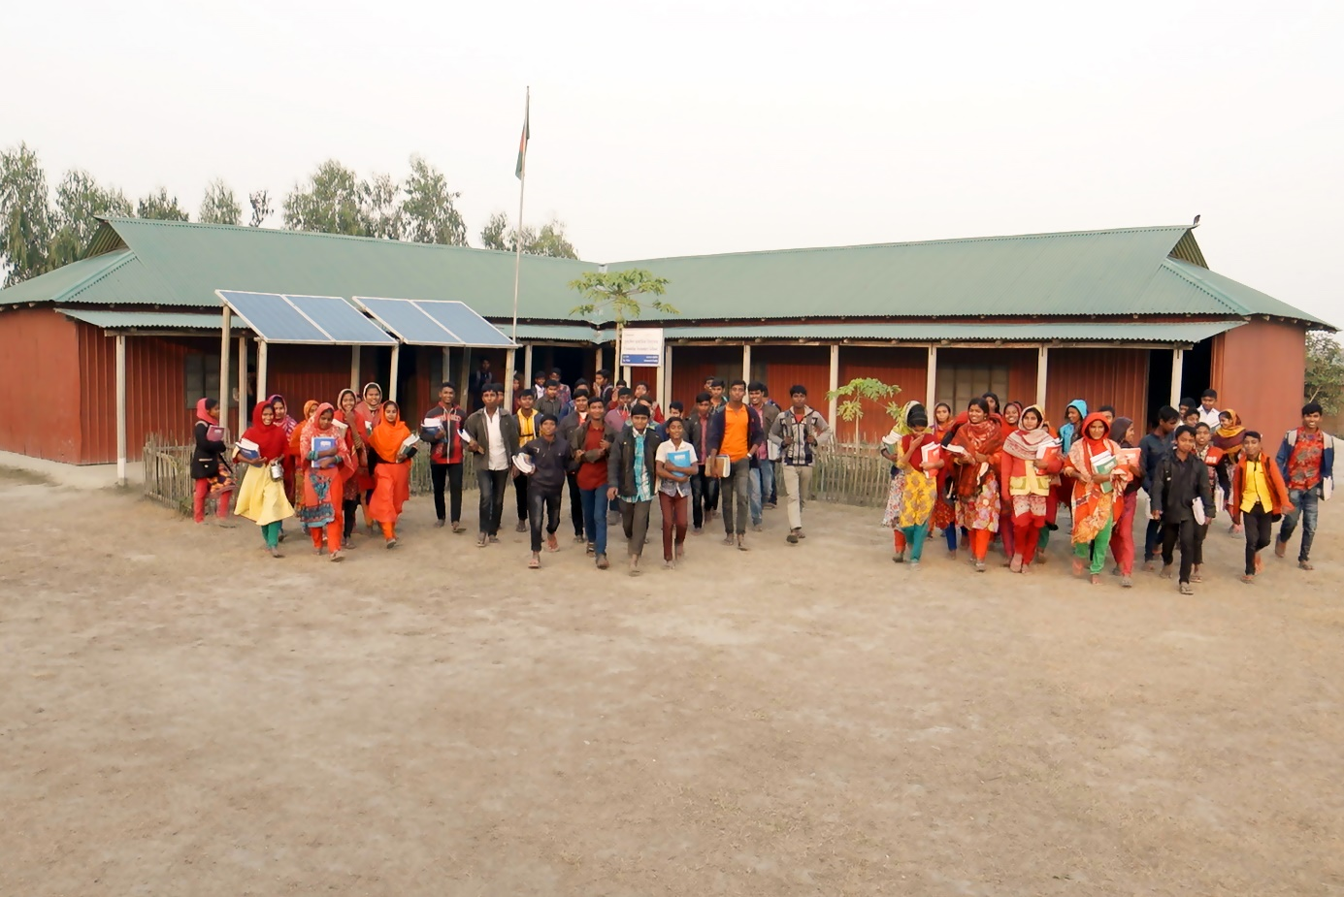
Secondary students of Batikamari secondary school
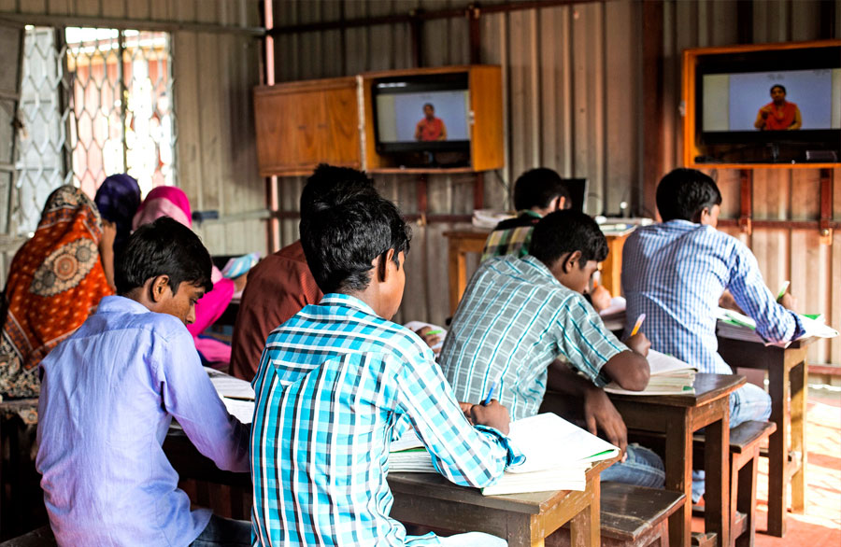
Secondary students in class

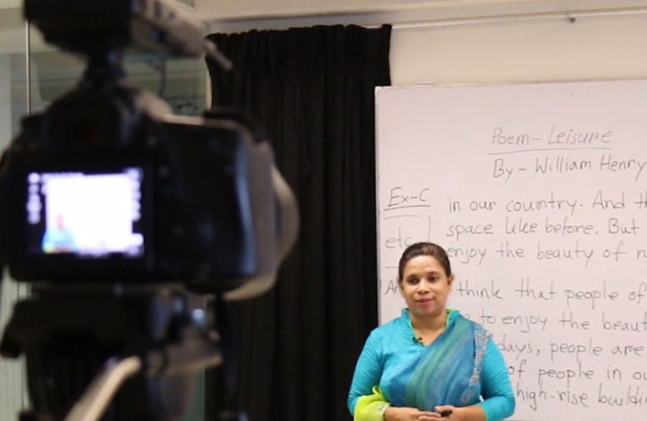
A video lesson is being recorded at Head Office
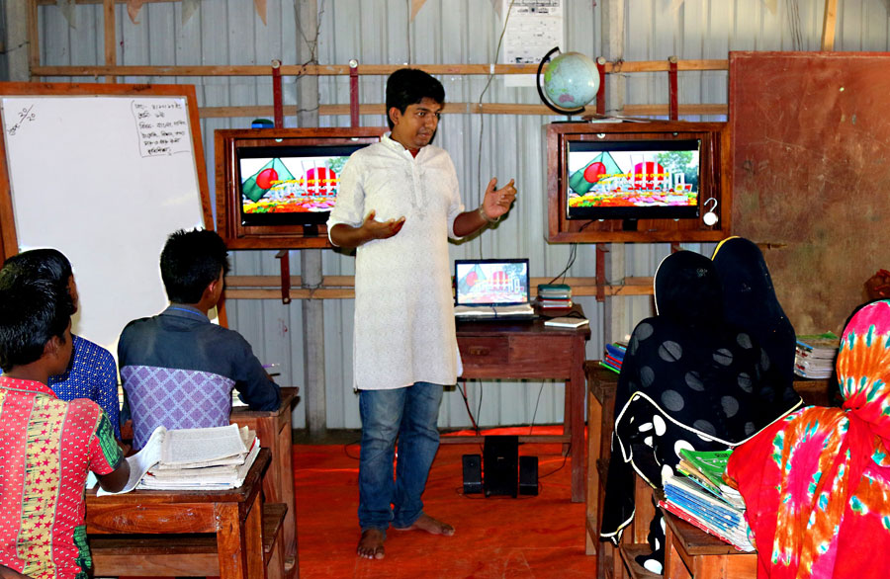
Secondary school facilitator conducting a class

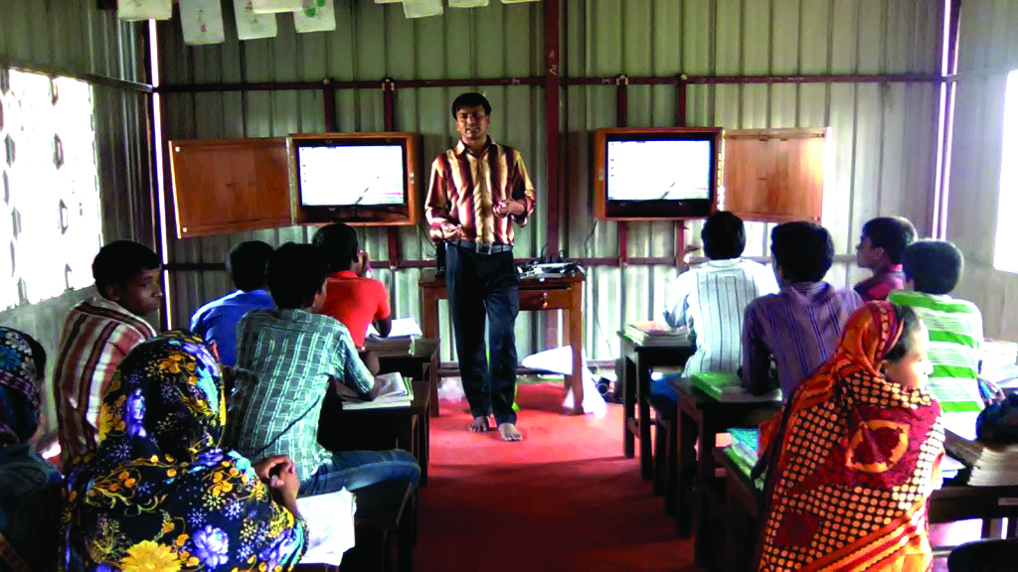
Secondary school facilitator conducting a class
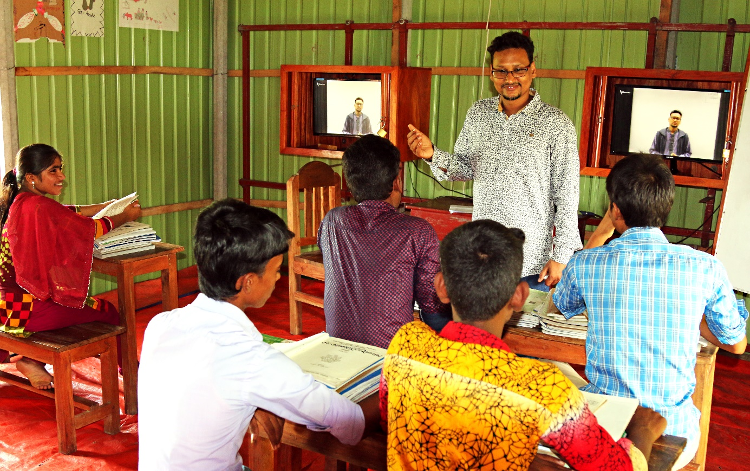
Secondary school facilitator conducting a class

