**KOLE INTELLECTUAL FORUM**

**Annual report 2023**

**Introduction**

Kole Intellectual Forum (KIFA) is a Community Based Organization registered with Kole District Local Government of Uganda in Uganda in 2016. Since then, the organization has been promoting quality, sustainable and potential education through action research, modern telecommunication system and entrepreneurship skills.

Although the vision of the organization has been set up to make the organization to become one of the leading Development Partners in the world; this would have not been possible by 2023, it at all, the organization had not mainly being supported by the donors on the platform of GlobalGiving despite the facts that: some of the funds that the organization is also getting support from its membership fees and other grants from some partners.

The year 2023 has been a remarkable year that Kole Intellectual Forum has consolidated its activities in different areas of operation, achieving successes with minimal challenges; a part from promoting quality, sustainable and potential education; the organization is the process of establishing a health facility in Kole District Local Government of Uganda in the nearby future.

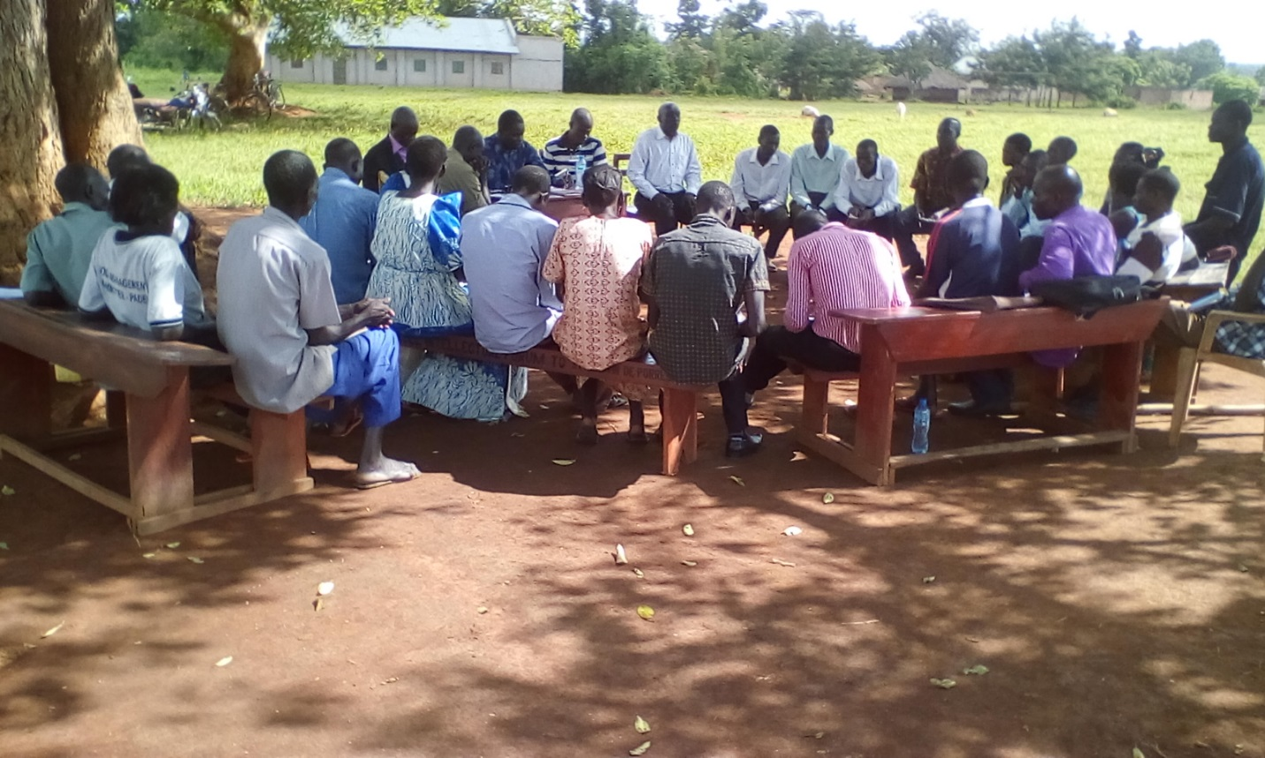

Community being engaged in Focus Group Discussion – a process of developing an action research

*Message from the CEO*

*Dear Supporters and Friends,*

*As we reflect on the past years that Kole Intellectual Forum (KIFA) has existed, we are filled with immense gratitude and pride. Since our inception in 2016, your unwavering support has turned our vision into a vibrant reality and we are over excited with the year ending December 31, 2023*

*Despite the unprecedented challenges posed by economic hardship leading to the low rate of donations to our projects as to compare to the other previous years; we have still remained steadfast in our mission, promoting quality, sustainable and potential education through action research to children in and out of public primary schools within the Local Government of Kole District.*

*Thanks to your generous donations, we are thrilled to announce that every year, academic year 2023 inclusive, we had been admitting 10 girls out of school to our Institute of Home Economics and where necessary once in a while we also integrate boys project into that of girls purposively to address gender equality, a testament to the transformative power of your contributions. This achievement not only marks a significant milestone but also symbolizes the positive impact we continue to make in the lives of our youth within our society.*

*KIFA started as a shared vision among a few passionate individuals that today has been transformed into reality with the support of the donors from the platform of GlobalGiving and our dedicated donors that has made this vision to grow into a thriving institution focusing on its real mission.*

*Our journey, fueled by your generosity, has been nothing short of remarkable particularly the year that ended December 31, 2023*

*This year, we proudly participated in outreaching program, community integration program, as well as highlighting our commitment to empowering girls through Home Economics, we are indeed grateful with our donors support*

*As we look to the future, we remain committed to our core values and the continued empowerment of our community. We are excited about the opportunities ahead and will continue to work diligently to expand our impact. Your support has been instrumental in our progress, and together, we will reach new heights.*

*We give thanks to donors for being a vital part of our journey. We look forward to do more than it is expected; that is, to strive to make a difference in the lives of those we serve.*

*With heartfelt gratitude,*

*Obua George*

*Director, Kole Intellectual Forum (KIFA)*

*Regards from the patriotic students of the Institute of Home Economics of Kole Intellectual Forum. They believe that: love for yourself and your country is translated into peaceful living and economically viable homestead*

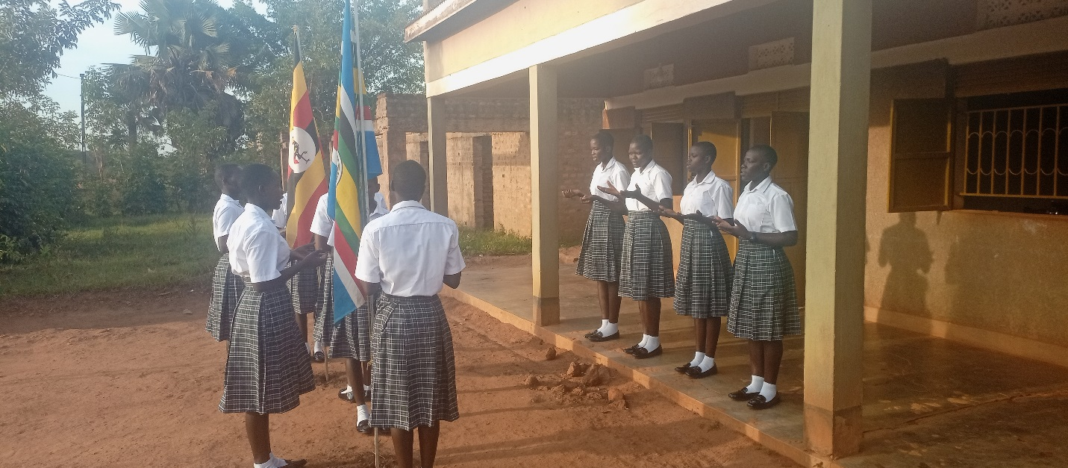

The year 2023 had been the year that a number of activities has been conducted by the team of Kole Intellectual Forum; among them are:

**A).** Outreaching program

Although the term outreaching program may mean differently to different people depending on what they intend to do or say; however according to Kole Intellectual Forum, the term Community outreaching program is meant to explain what Kole Intellectual Forum does to reach out to the community they work for to develop more programs or to seek for their decisions on what to do; and because of that, Kole Intellectual Forum has been consolidating on this program with the intention to build its capacity and trust among the community they work for; this has made it possible for them to realize a positive results in the public primary schools they intervened at, follow up on their intervention and correct errors in the areas of negative outcome or develop a new approach to address the same problem.

Reaching out to the community has helped the organization to identify crucial issues and develop the programs to address them.

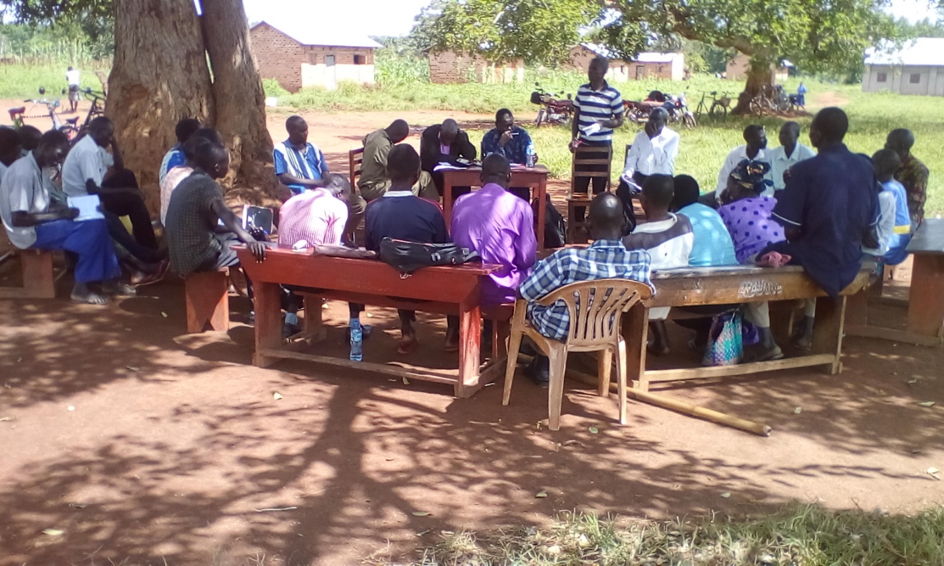

The community has been reached out at different perspective

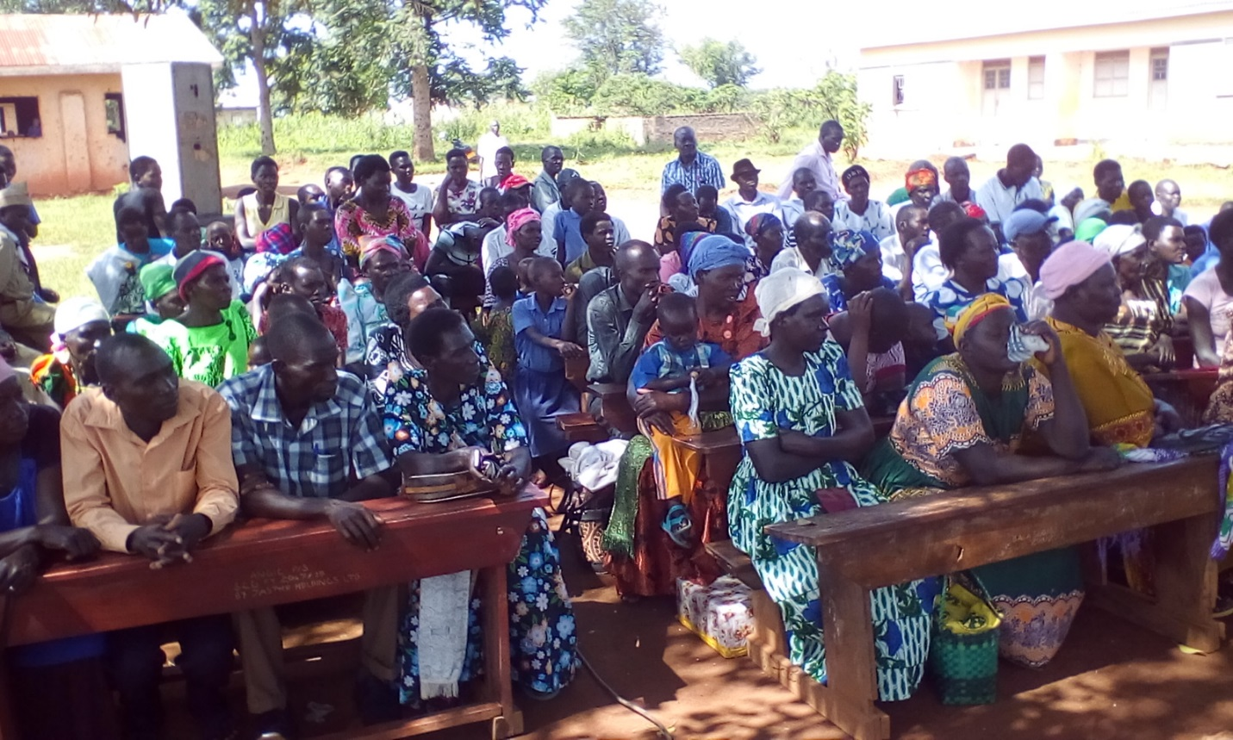

Because of gathering data from the community on the best way to address problem related to poor performance in public primary schools; quality and sustainability education was then realized in the schools of intervention

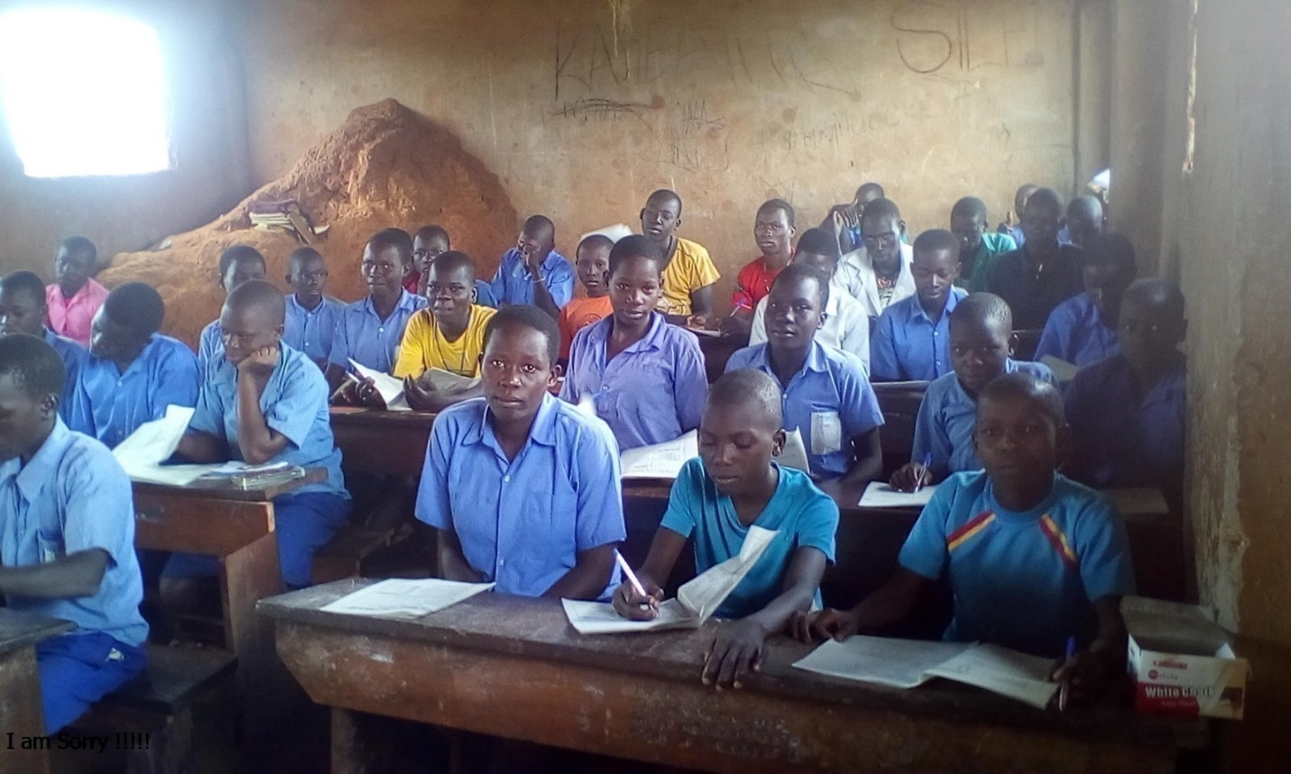

In the year of 2023, children have tried with their best to concentrate on their academic work given that all the educational stakeholders are meeting on their responsibility

Surprisingly, even the sustainability at schools have quite improved. These are some of the sample schools

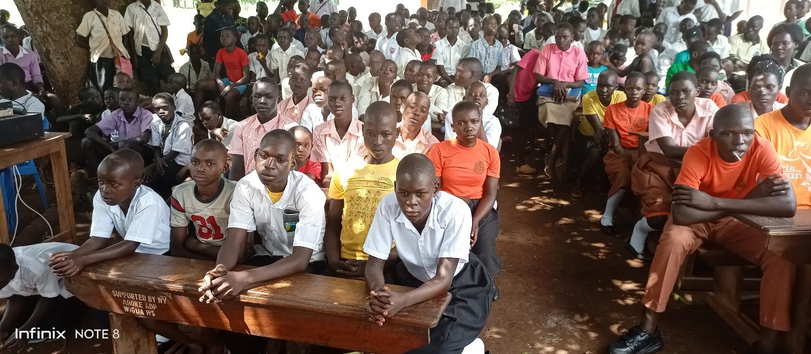

Another sample of children sustainability

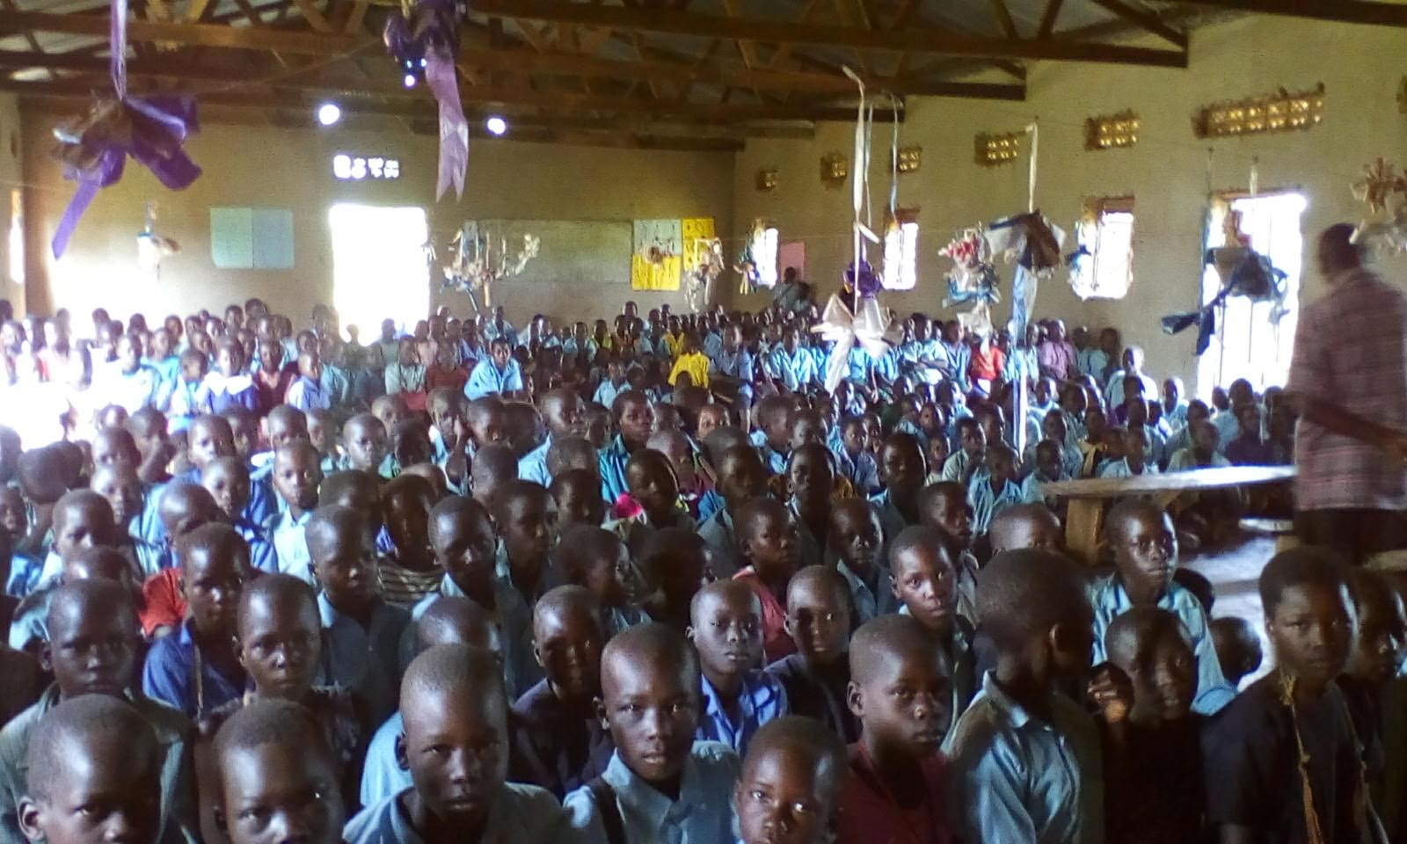

**B).** Another activity that the promoters of the organization have handled with deep concern is the program of Community Integration.

Just like outreaching program: Kole Intellectual Forum has found out that, it is not worthwhile for the project promoters just to reach out to the community to present to them with what they intend to do or just to seek for their decisions in a particular project; but rather to integrate them into the program, so that at the end of it all, they can also participate in the selection of the direct beneficiaries and indirect ones.

The year 2023 has been a year of great community integration program than the previous years and this has brought about a new style of working system that calls for an inclusive environment that at the same time tailor to individuals' needs; hence,

Community integrated into the project to help in designing the program units that benefits their society

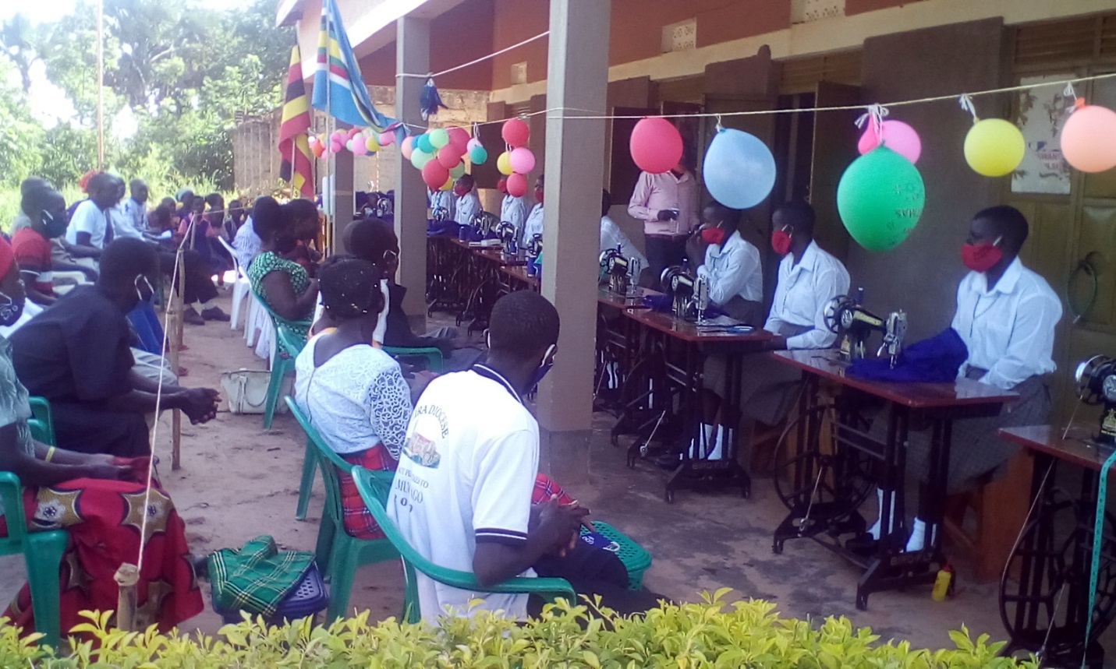

With a deep concern, the community has also through their integration and intervention program have helped the organization to identified real needy students who managed in2023 to complete their training exercises

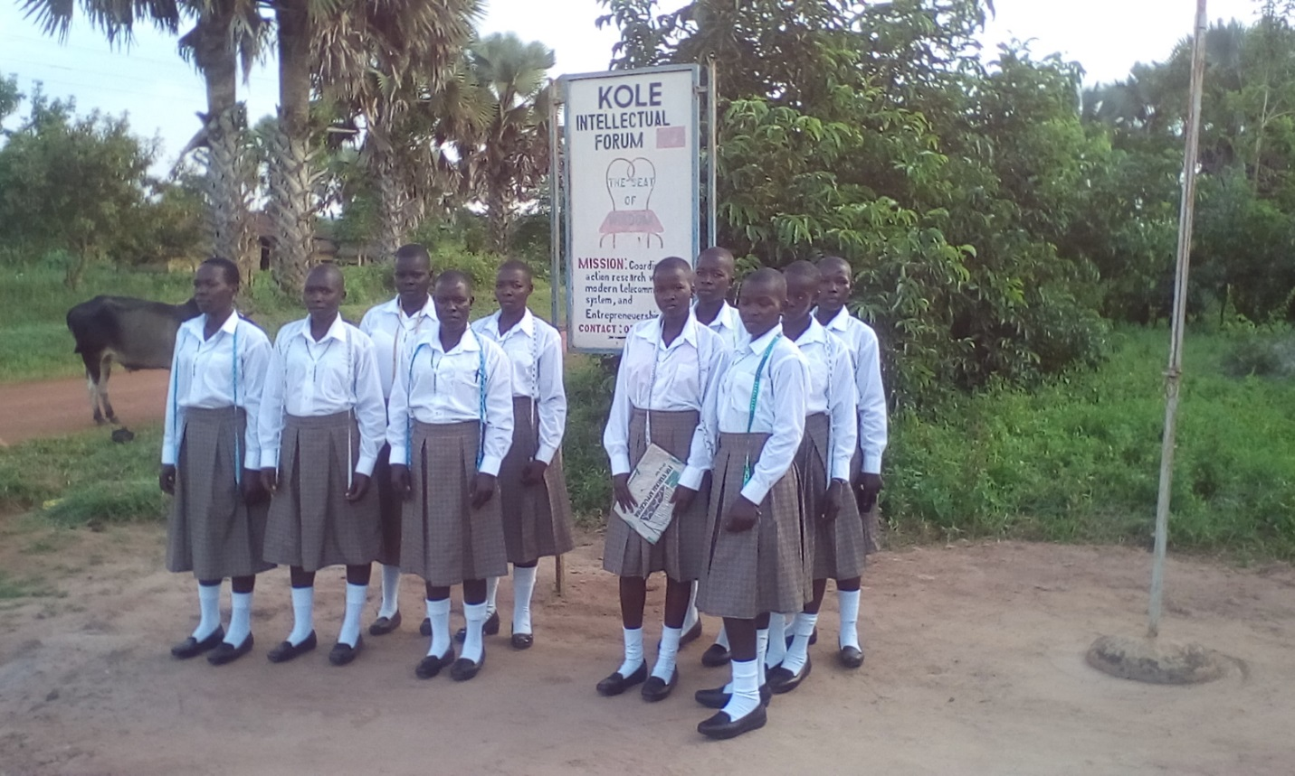

Real needy students identified through community integration Program at the Institute of Home Economics of Kole Intellectual Forum.

**C).** Key to the project activity is the empowering of a girl child for self-reliance project.

Having outreached the different community in their different location, identified the immediate problem to be addressed, seek for their decisions and integrate them in their areas of operation in term of identifying the location and service provision; Kole Intellectual Forum, in the year of 2023 followed up their students that at previously being supported by their intervention in the academic year 2020/3; the intervention the revealed that: these students who had managed to pass very well at Uganda primary Leaving Examination especially the girls the greatest percentage were at home without any hope of going out for further education due to a number of factors. Hence, as usual, the team of the organizational research team, had to revisit their program of Home Economics, modified and a gain admitted 10 girls for that same program and they were trained and passed out successfully.

The selected and trained students of the Institute of Home Economics at Kole Intellectual Forum for the academic year 2023

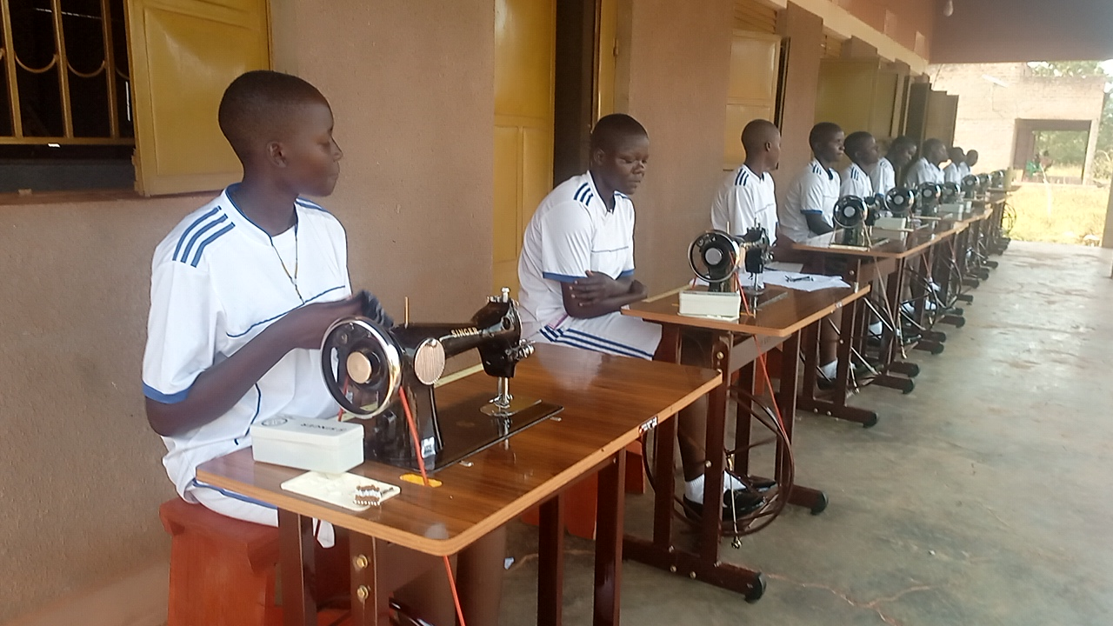

Despite the fact that: the activity of Kole Intellectual Forum circumnavigate around girl child empowering project; it was not then not surprising to note that: when some fund comes in to this project, the programmers of the project would always design a concept that would integrate boys ideal issues into that particular project.

For instance, when the Institute wanted to build the Institute of Home Economics; boys out of schools were identified and given that tasks to build the Institute with the fund that could have been given to some other expert; and we are grateful that they are in the process of building the Institute to be used by the girls.

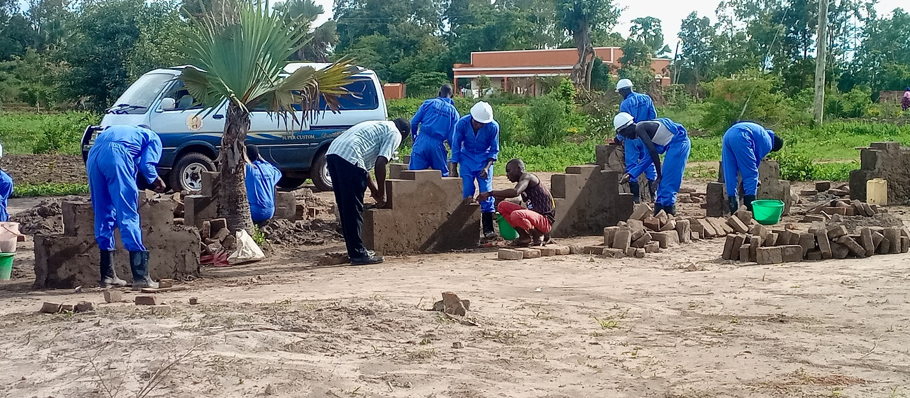

Boys are at the site learning about block laying and concrete practice

Achievements. In the last eight years of existence, that the organization was formally registered with Kole District Local Government; the organization has so far made up some achievement and there is hope for more to come.

* Construction of the Institute of Knowledge is underway

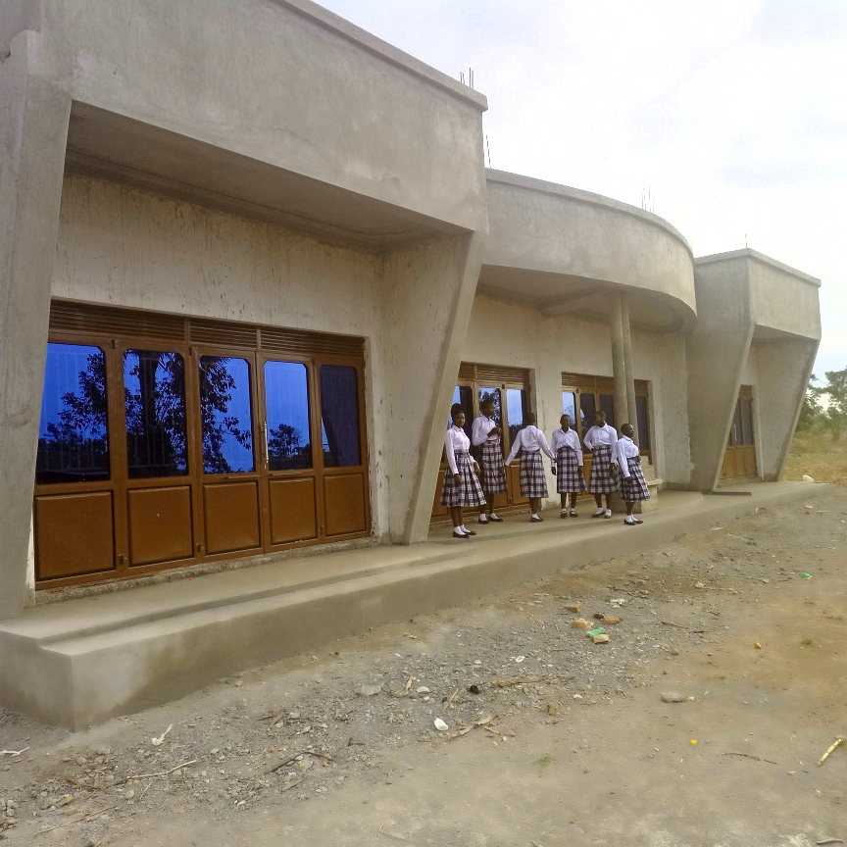

There is hope to complete the building by 2024. We give credit to GlobalGiving to be the main player.

* We have always been successful in training and passing out 10 girls every year including academic year 2023.

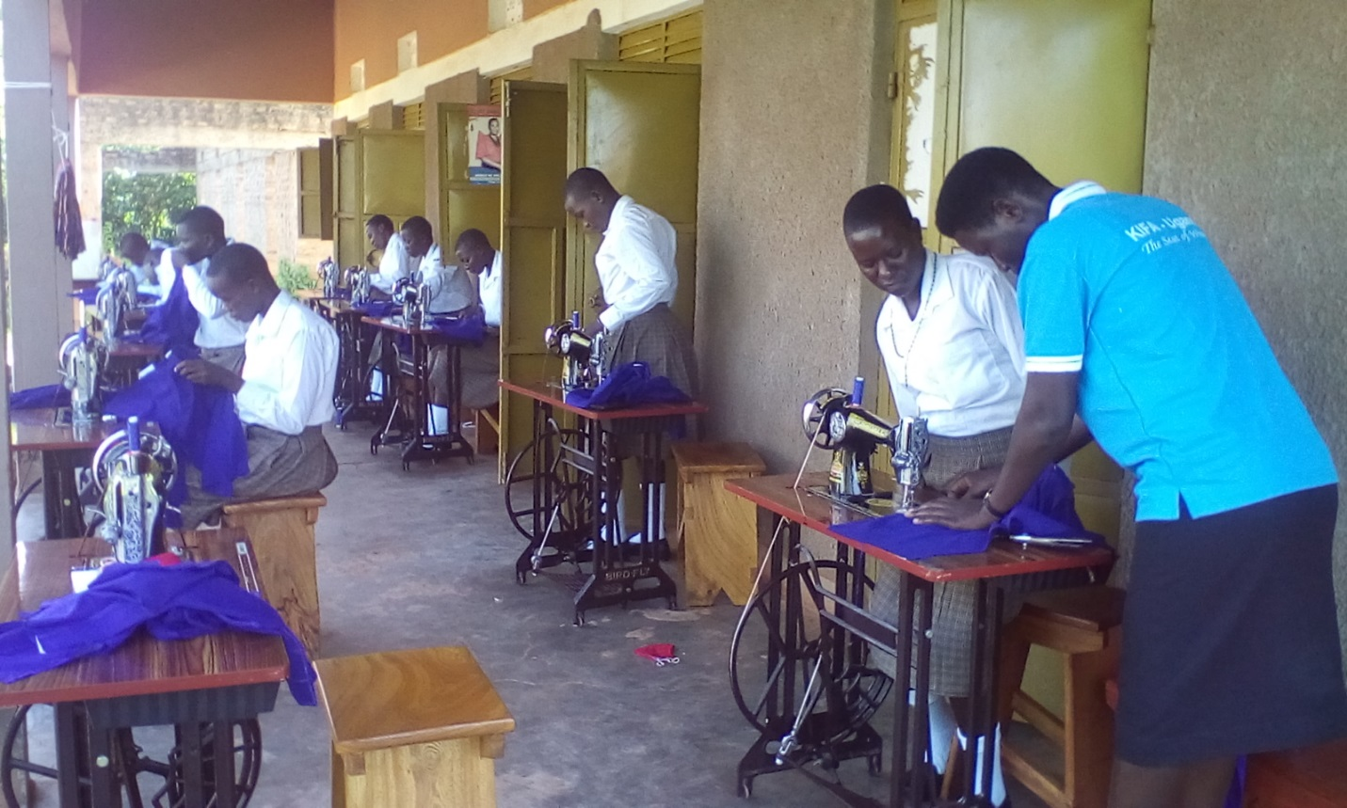

* Acquisition of the school van that is expected to be used at the Institute of Knowledge and at the proposed health facility

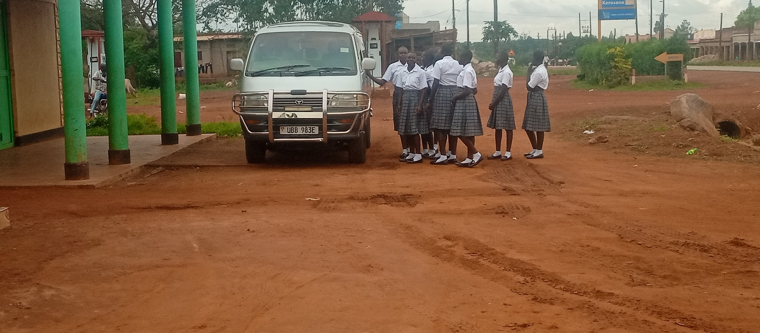

At present, they year 2023: the school van is being used to facilitate a course unit of exposure that the students are made to visit various places of interest.

Some challenges that are being faced by the organization – Kole Intellectual Forum

Although the activities of Kole Intellectual Forum have been progressing steadily; to some extent there are some challenges that the organization is facing; especially on the reduction on the donations. So many students and community have shown interest to join the Institute, but to our disgrace we may not be in a position to admit more than what we had been admitting in the previous years. Given that: a number of factors contribute towards their wellbeing in terms of accommodation, classes, feeding, limitation in the school space, and many more.

Conclusion.

2023 marks the seventh year of existence of Kole Intellectual. In the valuation, we arrived at a position that indicates that Kole Intellectual Forum is steadily progressing despite the fact that the organization is financial depression. This is because, the members of the organization through their membership fees are ensuring the fill the gap and they are also using their financial policy bill to guide them in financial risk management; the organization has an insurance policy put in place for such circumstances.

Because of that: the year 2023, the organization has made a remarkable achievement in its areas of activities; like to train 10 girls yearly, partly construct the Institute of Knowledge, and planned to establish health facility in Kole District.