Chairs, Whiteboards And Bikes For The Most Disadvantaged Youth In Vietnam

I am a volunteer in REACH and one of my duties is to teach students basic English. REACH is a non-government and non-profit organization in Vietnam. It provides free vocational training, career advice and job placement service for Vietnam’s most vulnerable youth aged from 16-30 years, and also the young women who are from marginalized groups such as trafficked women, and women from families living with / affected by HIV or other difficult circumstances. In REACH, each batch of programme lasts from 3-6 months and so far REACH is now having her 40th batch.

After two weeks of teaching in REACH, I think I should do more to help my studious and hardworking students (or more accurately, my peers). Most of them are around 20 and basically, they don’t have English foundation. So, for every batch REACH starts from the very basic 26 Alphabets and International Phonetics System. It is gratifying that every student knows how important it is to learn English and they always trying best to study in class. After you see the following pictures, I believe you will have the exact feeling.

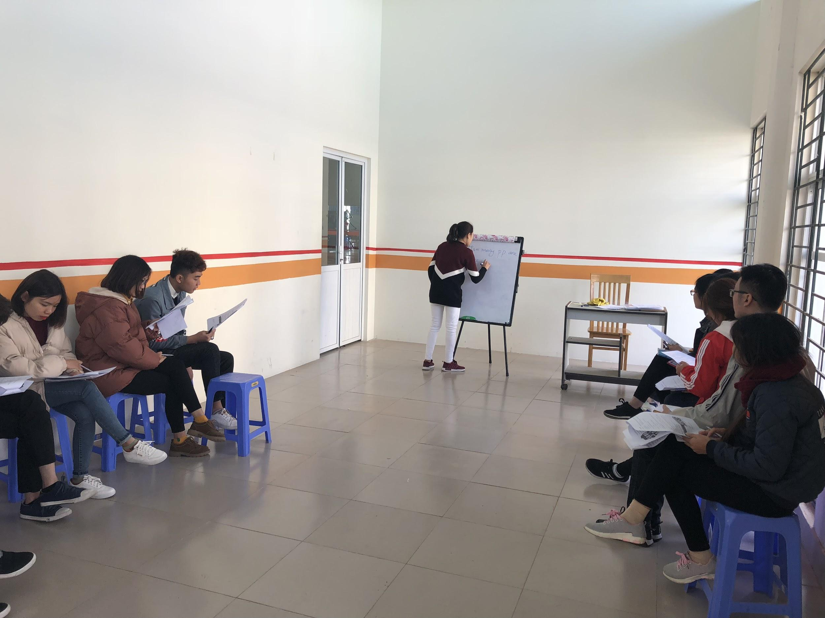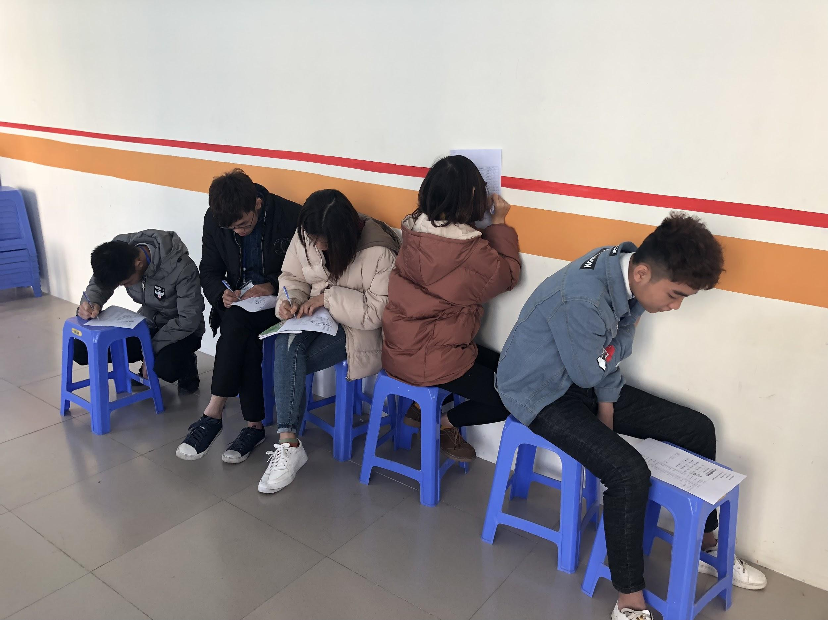

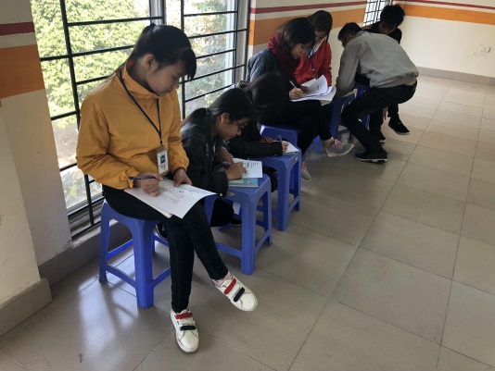
These pictures were taken in class. A tiny whiteboard and some plastic chairs are everything they have for lessons. Because there is no table in this classroom, students need to take another plastic chair to write. Or, write on the wall.

I asked an 18-year-old girl named Linh, who is a current student registered in cooking class, ‘do you think it is quite inconvenient because you don’t have a table when you are taking notes in class?’. She said she did not think it inconvenient to have a class without a table because it was a trivial matter that was easy to overcome. ‘It was already fortunate to study here in REACH’. She continued, ‘I like cooking and to find a job as soon as possible can help release the financial burden of my family. I want my family members to live a happy life.’
Speak of Linh’s family, they are from the middle part of Vietnam which is far away from REACH Centre. Linh’s parents are farmers and she has two sisters and one brother. She was supposed to finish her university degree but when considering the time length to complete her study and the poor financial condition of her family, she decided to find another way out. For Linh, it will be a good opportunity to get free vocational training in REACH and make her dream come true: working in a five-star hotel and have her own restaurant.

Based on the criteria of REACH to take in students (the most disadvantaged ones), most of the students are from rural areas. They are living in the cities and neighboring provinces of Hanoi, Hue, Danang, and etc. Some of them ride motorbikes to REACH, some of them rent a house near REACH Centre and share rooms with their friends or classmates.

REACH provides bikes for students to borrow. There are around 200 students this batch, but only 8 bikes REACH can provide. And all the bikes were second-handed---they cost less money.

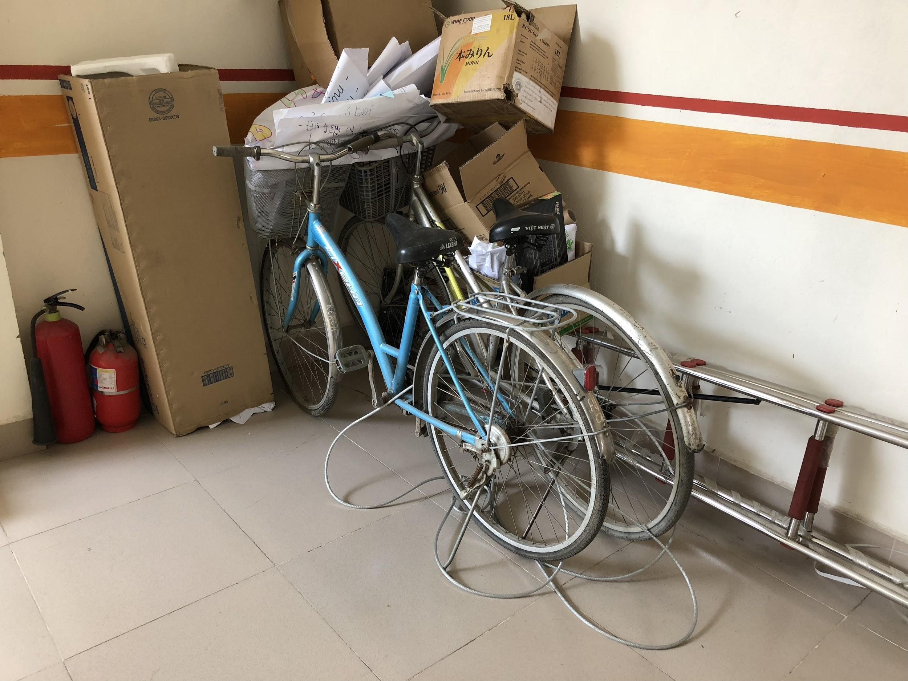

This week a student came to me said he wants to borrow a bike from reach. He didn’t know which staff to talk to, then he asked me. The boy named Nguyen Hoang Hieu in Graphic Design class also comes from a remote area and now he rents a house along with his classmates nearby REACH center. I asked ‘how do you go to school every day?’ He said ‘15 min of walk’. I was wondering if this boy is a bit lazy because it takes only 15 mins of walk! But I was wrong. He wanted to help his disabled roommate---his classmate Khai. Khai was born with his legs handicapped, so he is on crutches all the time. He can walk with crutches, but it takes 40 min to walk to REACH center every day. That’s the reason why Hieu wanted a bike! Right after he told me the reason, I took him to my colleague and he successfully borrowed one.

Looking at the students participating so actively in class and always care for each other, I made the decision to raising fund to purchase new facilities. There are two classrooms without big whiteboards and desks. And about the desks, Ms. Hang (Training Coordinator cum Business to Youth) said we can buy the chairs with desks.
Every penny will be used for purchasing equipments in REACH centre, Hanoi. And I will keep on updating.

