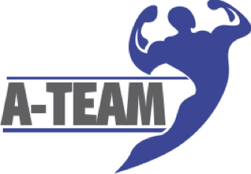
A-Team Fitness Lifestyle

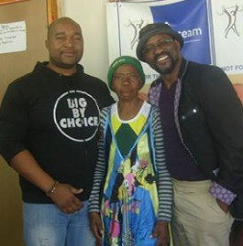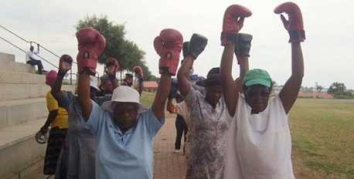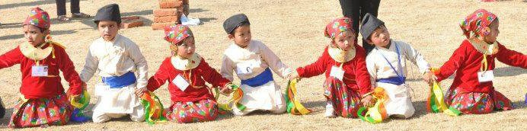community building
through sport

NPO Number: 162-644

Our details

Address: 2366 Cosmo city Multipurpose hall, Cnr Angola & South Africa, Cosmo city Ext 2 , 2189
Website: www.ateamgp.co.za Email: info@ateamgp.co.za Telephone: 011 074 7401
Fax: 086 622 8559

Facebook: Petrus molefe bodybuilding Show

Twitter: theateamgp

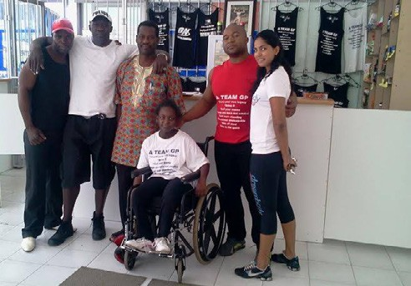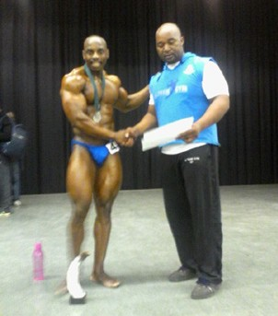Instagram: ateamgp

The A-Team Fitness Lifestyle (known as the A Team) is a Not for Profit Organization founded by team coach John Claude Maphosa in 1999 in the quiet location of Cosmo City. The A Team’s initial purpose is to develop individuals who want to follow an amateur or professional career in sports like body building and fitness, boxing, aerobics, athletics, volleyball and soccer.

Who we are

Some of our professional sport initiatives include the Annual Soweto Petrus Molefe Eco Park Bodybuilding Event, which gives a platform to community members from Soweto to showcase their talents. The event comprises a ‘healthy living’ component, which gives exposure healthy lifestyles choices.

We give motivational talks in townships, such as in Alexandra geared to inspire the youth to stay focused and not give up on their goals regardless of what those goals may be.

The A Team is happy to promote and assist all athletes from all walks of life and Coach Claude is often called to provide his insight and expertise in various sport initiatives and competitions.

Our development initiatives now include Arts & Culture, student after-care and health and fitness for the elderly and people with special needs.

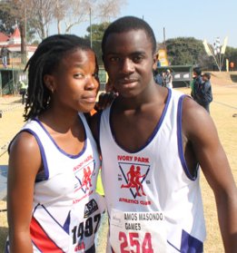
We are a multi-spectrum community service with partners that have the same heart to reach out to the public to change lives and create a culture of love and respect for all.

A-Team Fitness Lifestyle would like to thank you for giving us the opportunity to submit this social investment proposal for assistance in our community development programs in Cosmo City.

Thank you

We have a number of consistent healthy lifestyle initiatives which we run daily, weekly and annually - all of which contribute to the well-being of the residents of Cosmo City.
The help we may receive from you will enhance this offering and add to the benefit of all those who participate in our events especially since we are the only free health and fitness wellbeing resource for hundreds of people, young and aged.

This communication will outline the various events and groups involved and the needs that you could meet for each instance, if you choose to do so.

- A-Team Gym Senior Citizens
Programs and events
A fitness and lifestyle program designed around the physical needs of senior citizens and the physically disabled. Attendees are registered with the clinic based at the Cosmo City Multiplex hall and meet every Tuesday, Thursday and Friday.

Boys & Girls
An after-school care and study program for Grade 8 to Grade 12 students that offers a chance to do homework with dedicated assistant teachers. This service is run daily Mondays to Fridays providing children with a safe environment where they are able to concentrate on their education with minimum disruptions.

Pregnant Mothers Clinic Visits
There are a number of pregnant women who visit the clinic.

Food hampers for the general public
We often provide this benefit to the public whenever the opportunity to do so arises.

Looking forward to your response.

Claude Maphosa
Founder of A-Team Fitness Lifestyle

info@ateamgp.co.za www.ateamgp.co.za

