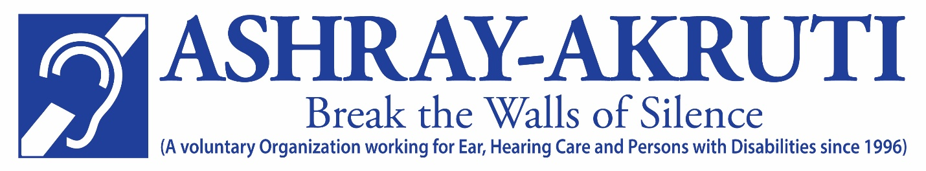

Support Special Education for Children with Hearing Impairment

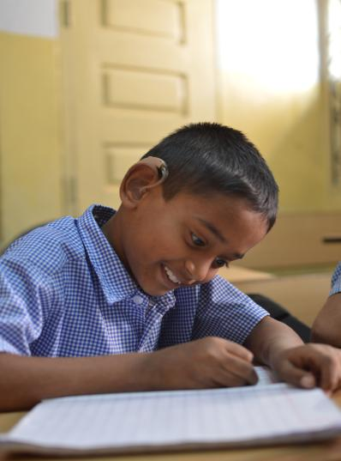

About The Organization
Ashray Akruti is a registered non-profit, non-religious organization; working since 1996, to improve the lives of people with disability and marginalized sections of society. The organization strongly believes in the potential of persons with disability and envisions a society where people with disability lead a life of dignity as equal citizens with equitable access to opportunities and services. It’s belief in ‘rights’ based approach to development, are rooted in the principles of participation, empowerment, accountability and transparency.
Ashray Akruti is an accredited organization certified by “Credibility Alliance”, following norms of accountability, transparency and good governance.

VISION
Empower people with disabilities & people from underprivileged background, through quality education, health care and sustainable livelihood.
MISSION
To create institutional, non-institutional and community based interventions for the people to help them become independent self-reliant and contributing citizens of the country.
OBJECTIVES
- Provide comprehensive teaching and rehabilitation programs for children with disability
- Provide market-aligned skill training for ‘hearing-impaired’ youth
- Provide screening facilities for new born children in public hospitals and diagnostic facilities to identify hearing abilities.
- Provide early intervention facilities to children with disability
- Support and facilitate Cochlear Implant Surgeries / Aids, and appliances for hearing impaired children; to promote health care
- Organize ear-care health camps for the children and the aged
- Develop human resources for the disability sector, trained professionals.
- Work with corporates, to advance social responsibility and development
CORE VALUES
- Empowerment
- Innovation
- Accountability and Transparency

OVERVIEW
The organization currently implements programs, across Health, Education, and Skill Development, for people with disability and the marginalized sections of society.

Education:
Ashray Akruti’s educational programs include:
- Government recognized special schools
Special education for children with hearing-impairment, at its three centers in Hyderabad.
- Early Intervention Centre
Intervention services to young children identified with hearing loss, with an aim to develop their speech and communication.
- Diploma in Special Education (Hearing Impairment)

D. Ed course in special education (Hearing Impairment) recognized by Rehabilitation Council of India, to develop special educators for the sector.

Health:
Health programs offered include:
- Cochlear Implant Surgery
Cochlear Implant Surgery for young babies with the support of organizations like National Institute of Hearing Handicapped, Max Foundation and Government sponsored Rajiv Arogyasri scheme.
- Hearing Diagnostic Facility
Advanced hearing screening facilities such as BERA, Impedance, and PTA to people from underprivileged backgrounds.
- Community Outreach Program
Hearing screening for new-born babies at government and charitable hospitals, hearing screening for senior citizens at old-age homes and ear health camps for students of Government Schools.
- Rehabilitation center for children with special needs
Rehabilitation center in the Borabanda area of Hyderabad provides services like speech therapy, physiotherapy, occupational therapy and behavioral therapy for children with various disabilities.
Skill Development
Skill Development offered include

- Market aligned Skill Training: A unique skill based vocational training center for Hearing Impaired Youth in Computer Graphics, Multimedia and Animation.
- Computer Training for Hearing Impaired Youth: Training in basic computers to hearing impaired youth in Kadapa District.
- Pre Vocational Training: Pre vocational training in Tailoring, Banjara Embroidery, Mehndi designing, paper bag making for Ashray Akruti students.

About the Project

Special Education of Hearing Impaired Children

Project Area:
Srinagar Colony Hyderabad, Telangana

Number of Beneficiaries
50 Hearing Impaired Children

Goal of the Project
- To provide comprehensive educational and rehabilitation program for children with hearing impairment and promote Inclusion.
- To provide activities that foster holistic development and, to the maximum extent possible, assimilation into regular school and community activities

Project Objectives
- To provide a comprehensive instructional program from Nursery through high school.
- To Provide Hearing evaluation and appropriate hearing aids
- To provide speech therapy and auditory training
- To provide counseling services to students and parents
- To encourage parental involvement and understanding of special education programs.
- To provide support and services for the students to enable them to access higher education.

The Need
Hearing loss is the most common sensory deficit in humans today.
- WHO estimates, 360 million persons in the world are with disabling hearing loss. Approximately 8 % (32mn) of total affected population are children, majority of them are in South Asia.

- 2 in 1000 children born in India are deaf.

- 6 in 1000 children born in Andhra Pradesh /Telangana are born deaf which is three times the national average and six times the global average.

Globally, children with disabilities count for one-third of all children out-of-school. In developing countries, the numbers are even more staggering, with 90% of all children with disabilities out-of-school.

With regard to India, The Equal Opportunities, and Rights of Persons with Disabilities Act 1995 was comprehensive breakthrough legislation that, provided for education and economic rehabilitation of people with disabilities. It states that free, education for children with disabilities up to the age of 18 years must be provided in an appropriate environment. The government has launched the Sarva Shiksha Abhiyan (SSA). This proposes to implement ‘universalization of elementary education’ (UEE) in a mission mode.

Further Right to Education (RTE) mandates free and compulsory education to all children from 6-
14 years of age. The key objective of RTE- SSA is Universalization of Elementary Education (UEE).
This goal of UEE, has further been facilitated by the Constitutional (86th Amendment) Act, making
free and compulsory elementary education a Fundamental Right, for all the children in the age
group of 6-14 years. This Amendment has given a new thrust to the education of Children with
Special Needs (CWSN), as without their Inclusion, the objective of UEE cannot be achieved.

However, the programmes launched by the government have been able to make only a limited impact in terms of increasing the participation of children with disabilities in formal education. Most of the students remain outside the formal school system or make only very limited progress in regular schools as the schools lack resources to support a child with disability.

Key Activities

Provide Hearing Aids
The school actively encourages the children to use hearing aids and trains them to listen and speak. It helps the children in using their residual hearing power.
The organization provides digital hearing aids to the children as they provide right kind of amplification and support. Most of our students hail from poor families and cannot afford Hearing Aids which are priced Rs.15000 and above.
Auditory Training and Speech Therapy
Auditory training:
At Ashray Akruti, the students are provided regular, intensive training in listening.
Listening might seem easy to a person with hearing. But for a child with hearing loss, listening is often hard without proper training. Like other skills, the skill of listening must be learned.
Most children who are deaf have some hearing. This is called "residual hearing". The child is helped to use this residual hearing with the help of hearing aids or cochlear implants.
Speech therapy:

The speech therapist in the organization provides one-on-one training to help children to speak and develop speech and language skills.

Speech therapy is a clinical program aimed at improving speech and language and oral motor abilities.

Academic Training
Oral Aural Method of teaching and Instruction:

Regular state syllabus is followed in the school and at the end of the academic program children take the tenth grade public examinations conducted by the state board.

The School follows Oral Aural Method of teaching to develop speech and communication among the deaf students. This approach combines speech, use of residual hearing and speech reading. The child is trained to use his or her hearing and develop expressive speech.

Special Educators as instructors: The Organization employs special educators to train and educate the children.

Instruction to these children are individualized, tailor made to suit their intellectual capacity and residual hearing powers. At the same time these children are given the skills to cope with the ‘mainstream’ world, they are trained academically to face the school and university qualifying exams.

Trained mothers to train the children: The school involves the mothers of the hearing impaired students in the effective development and to promote further learning at home. Some of the mothers have been trained to teach the Hearing Impaired children. Many mothers are working with Ashray Akruti as teachers.

Low teacher student ratio: The Organization maintains low teacher student ratio to enable each student to get the individual attention they deserve.

Visual Information in Teaching: The School relies a lot on the Visual teaching Aids to impart education to the Hearing Impaired Children.

Activity / Field trip based Education: The lessons are taught through activities field trips etc.

Co-Curricular Activities

The Students are encouraged to participate in Co-curricular activities like Dance, Karate, Swimming Art Craft Drawing and coloring. Besides developing the students holistically these activities have found to have been enormous therapeutic value on the children.
We have a regular Yoga, Karate and Dance teacher and PT teacher for the students.
Pre Vocational Training
Ashray Akruti imparts pre vocational training for the hearing impaired children in
- Tailoring
- Banjara Embroidery
- Mahendi Designing
- Painting
Residential Facility
Ashray Akruti has full-fledged residential facility which at present caters to the needs of 86 Hearing Impaired Children. A dedicated team of wardens, a home mother, cooks and ayahs work to ensure love, care and protection is given to all the students in the hostel.
We ensure the children get healthy and nutritious food and a home mother to care for every 15 students. We have a dedicated school bus to take the children to the school and back, ensuring punctuality and safety.
We have regular study hours scheduled along with yoga classes in the morning. Additionally, we conduct drawing and painting classes on Sundays and holidays. We also encourage volunteers to teach the children art, craft and games during weekends and holidays.
The facility caters to mostly those from outside Hyderabad. There are students from various districts of Telangana and Andhra Pradesh .We also have few students from other states of India like Jharkhand, Maharashtra and Kashmir.

Measurable Outcomes:

- Listening Skills improved among Hearing Impaired Children

- Speech and Communication Skills improved among Hearing Impaired Children

- Language Skills improved among Hearing Impaired Children

- Academic performance improved Hearing impaired Children improving

- Parents’ skills improved to deal with Hearing Impaired children

SOME OF OUR IMPORTANT DONORS
- Price Waterhouse Cooper (PWC)
- QUALCOMM ( Grant Review by E&Y)
- Wipro
- Colryut
- Microsoft
- United Way of Hyderabad
- Granules
- Vasant
DUE DELIGENCE
- PWC
- E&Y
- D.ESHAW
- Indian Institute of Corporate Affairs (Ministry of Corporate affairs)
- HSBC
- Credibility Alliance
- Give India
- Charities Aids Foundation India, USA, UK
AWARDS AND RECOGNITIONS
- Best NGO in the District of Hyderabad by Government of Telangana in June 2016
- Best NGO in the State Government o Telangana in December 2016

Support Sought

We have about 550 children studying in five locations in Hyderabad. Most them come from poor and lower middle class families .The organization is striving to provide quality education to them so as to shape a better future for them.

We request you to support the education of children studying at Ashray Akruti School.

FACT SHEET
Chief Executive: D.P.K. BABU, Secretary and Director
Address: 8-3-1027/A2, Srinagar Colony
Lane opposite Indian Bank
City: Hyderabad 500 073
State: Telangana
Country: India
Telephone: +91 40 40042250 (Office)
Website: www.ashrayakruti.org

REGISTRATION DETAILS:
Type of registration: Society
Registration number: 5489/96
Income Tax: 80G
Date of registration: October 24th 1996
FCRA No.: 010230590

