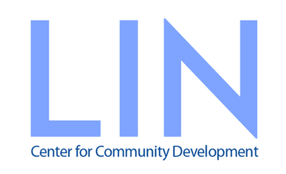

Sponsorship Proposal
SAIGON – GLOW & GLARE
An event to bridge inequalities in Vietnam
Saigon Kitchen Restaurant, Hotel des Art
12 January 2018, 18.30 – 21.30

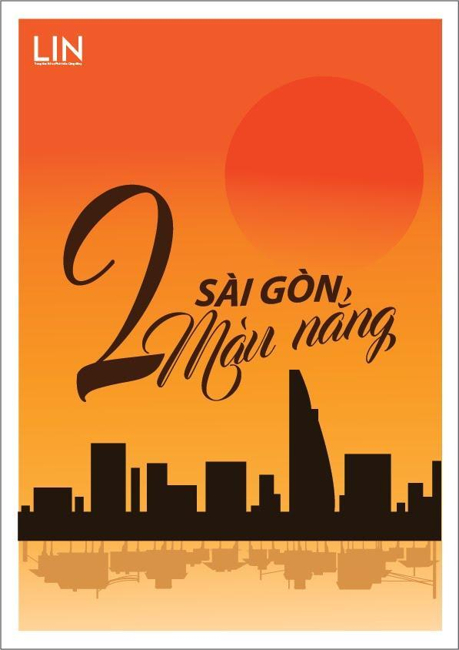

Join the common efforts of LIN Center and hundreds of its partners to enable sustainable development, poverty alleviation, and citizen participation in Vietnam!
“Alone we can do so little; together we can do so much”
Helen Keller
Did you know?
Vietnam is a fast growing economy, has middle income status. This brings many opportunities for the country, communities and business.
There are 2 sides of this story.
The richest man earns more in a day than the poorest Vietnamese earns in 10 years. In an hour, the richest Vietnamese can earn from their wealth almost 5,000 times more than what the poorest 10 percent of Vietnamese spend every day on their basic needs. Vietnam's 210 super-rich earn more than enough in one year to lift 3.2 million people out of poverty and end extreme poverty in Vietnam.
There are growing inequalities. Over 9% of the population, equivalent to approximately 8.2 million are classed as poor, earning up to US$ 40/ month, not having access to the necessities of life many of us take for granted including education, healthcare, housing, sanitation and information.

About LIN
Since LIN Center for Community Development began in 2009, around 500,000 people in Ho Chi Minh City and Southern Vietnam have directly and indirectly benefitted from LIN’s services and support by helping our grassroots nonprofit partners provide improved access to equal opportunities to local people.
LIN provides support services of information, expertise, networking, and funding to nearly 300 local nonprofit organizations, connecting thousands of skilled professionals to pro bono service opportunities, and assisting hundreds of individual and institutional philanthropists with information and strategic giving consultation.
LIN envisions local people and organizations leading successful efforts to reduce poverty and increase opportunities for everyone in Vietnam (irrespective of age, race, gender, ethnicity, origin, etc.). Only through one single program (out of LIN’s 14 different services), LIN has awarded 167 small grants, enabled over a hundred nonprofit organization partners to deliver various initiatives, including but not limited to: access to education or basic needs of water, electricity, sanitation, health care, etc., improvement of education quality, equal access to opportunities for people with disabilities, livelihoods for low income people, improving public awareness of these issues and taking actions toward environmental protection, among many other causes.
To inspire locally based individuals and businesses to join LIN’s journey of making inclusive and collective impact, and improve the lives of thousands more people in Vietnam in 2018, LIN is organizing the fundraising event “Saigon – Glow & Glare”.

‘Saigon – Glow and Glare’ Overview
The event rings in the New Year by highlighting many sides of Saigon. Guests will experience the contrasts of the city by all senses with premium dinner, inspiring art and entertainment performance, cozy atmosphere, and redolent sounds, sights, stories of the city we all love and call home.
The night aims to remind the guests about the gap to life and opportunities in our community, and importantly to highlight the impacts of LIN’s work to narrow the inequalities.
By providing funding or in-kind support for the event, getting a ticket to join the evening, making contribution, or bidding for interesting auction items, every individual or corporate partner becomes a champion supporting LIN’s efforts to amplify its impacts toward sustainable development, poverty alleviation, and citizen participation in Vietnam.

The evening for 120 people will include a four-course set menu with free flow drinks (value VND 1.8m++) provided by Chef Anne-Cécile Degenne of Hotel des Art.
Anne-Cécile Degenne’s passion for gastronomy has led her around the world to learn new techniques and gain inspiration for her métier. Her journey started in the South of France at a Michelin-starred restaurant, then to the French West Indies as Executive Sous Chef for a boutique hotel. She next set her sights on Asia, overseeing the kitchens for Sofitel So Singapore before becoming Executive Chef at Hôtel des Arts Saigon.

Guests will be treated to special and inspiring music and art performances including children with visual impairment from Thien An Shelter, singer Trong Khuong - the Voice 2012 candidate, Dance performance by Thao Dan and AMPA (Asia Music & Performing Arts Education) and live painting by an Artist with disabilities from Vui House initiative, together with Artist Nguyen Hai Anh.
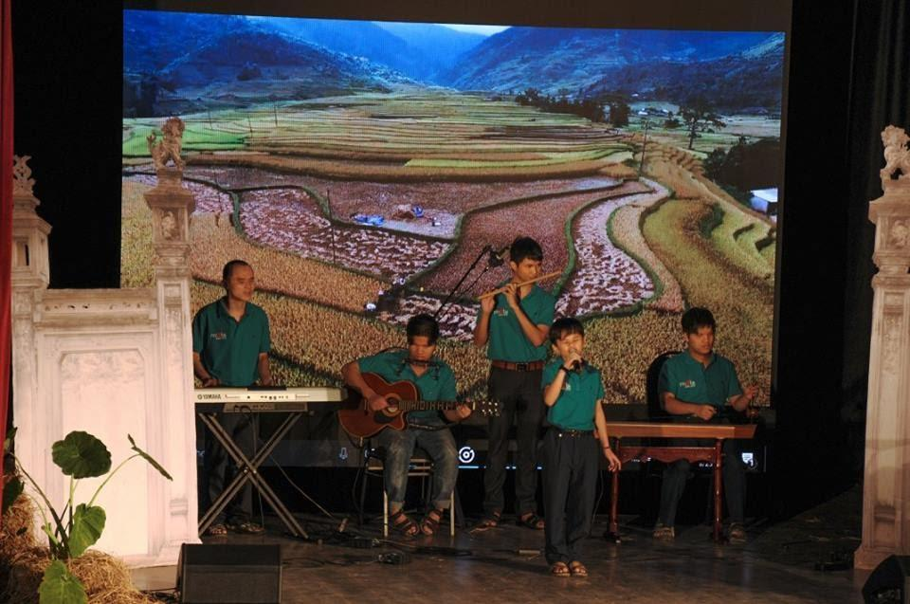
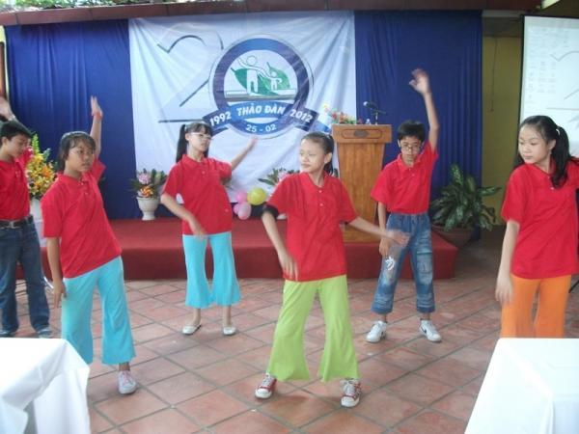

Stories – message featured across the event:
Saigon’s Sunny Season
beautiful glowing clear skies for some… and glaring hardships for many others
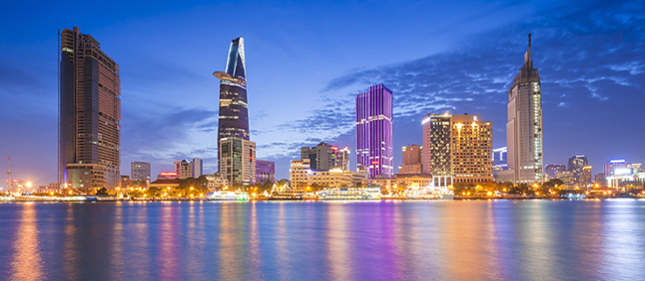 | 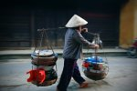  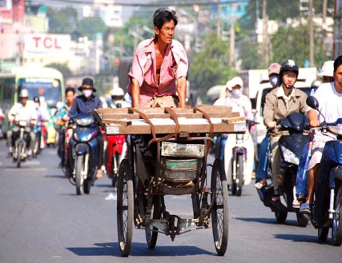  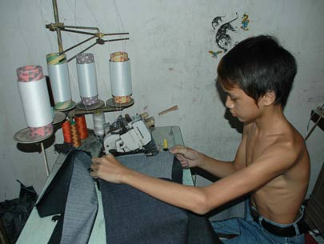

Same concerns shared
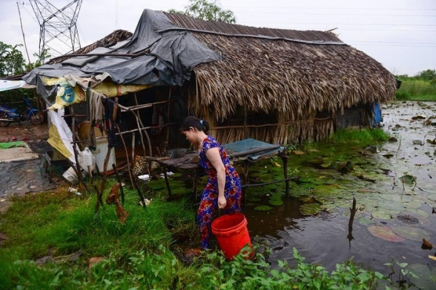
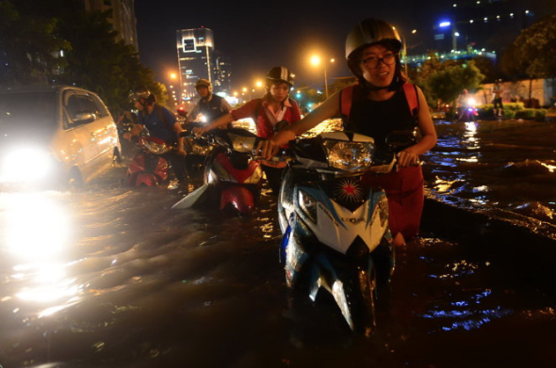
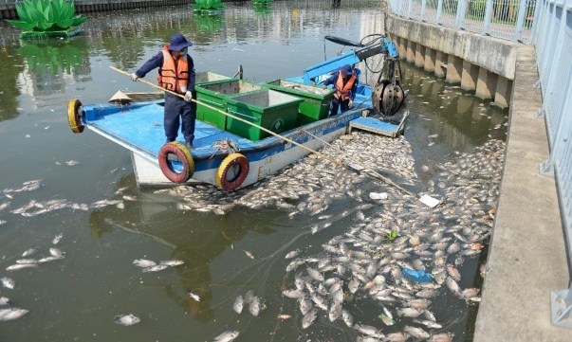
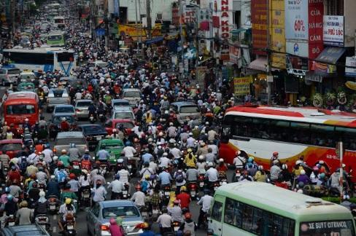

~500,000 people have been supported to have equal access to opportunities…
as the restless efforts of LIN and its partners
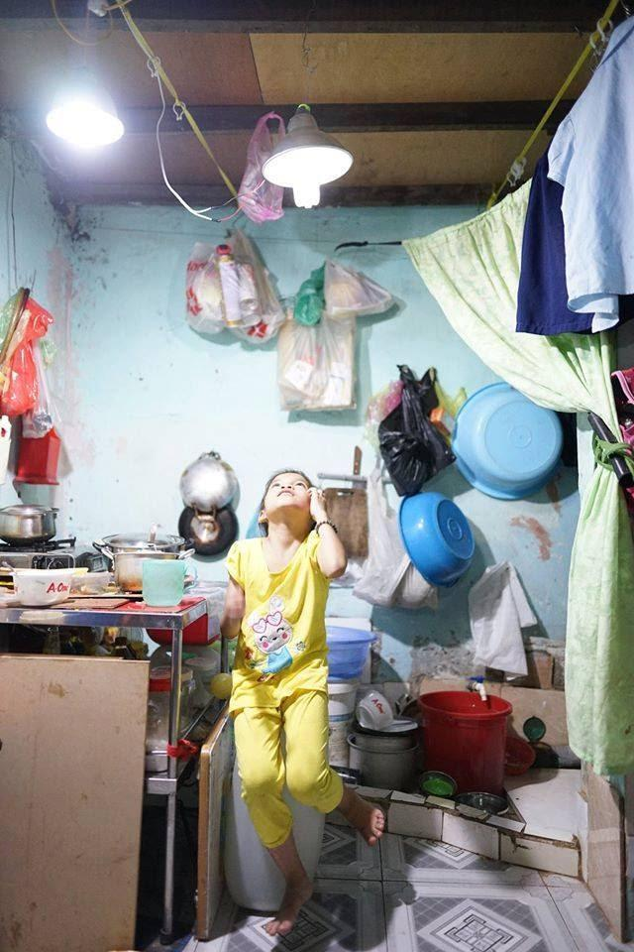  Low cost solar lamp for low income families in Can Gio,  an initiative of Light of Happiness, LIN’s NPO partner | 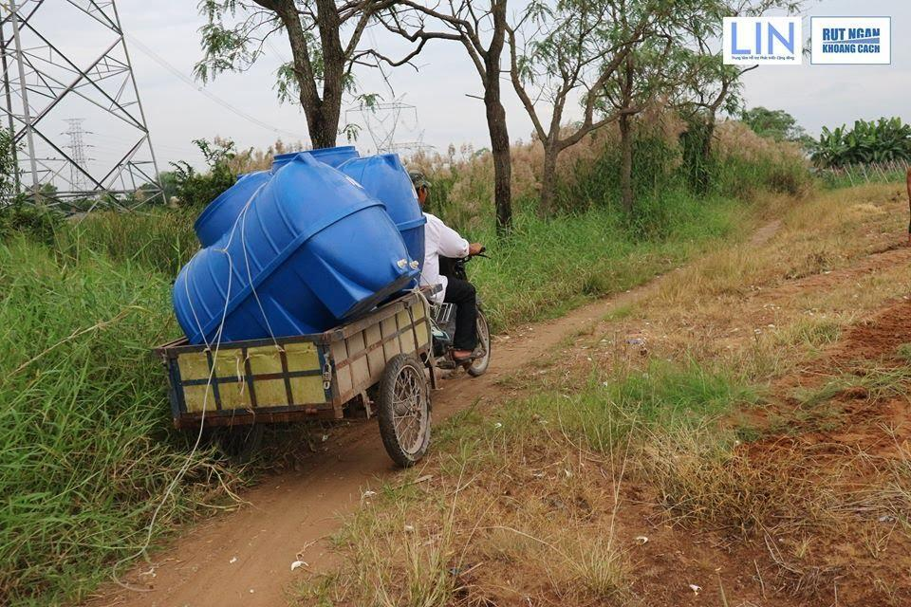  Providing access to clean drinking water for 50 families in District 8, project delivered by FFSC, LIN’s NPO partner
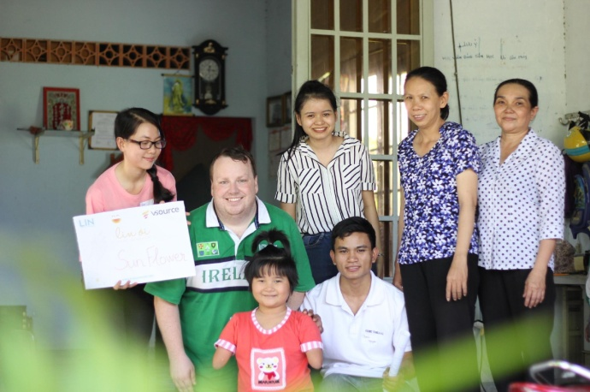  Partnership between vsource company and Ho Chi Minh City Association of Victims of Agent, Cu Chi (VAVA Cu Chi) as vsource’s CSR strategy, facilitated by LIN | 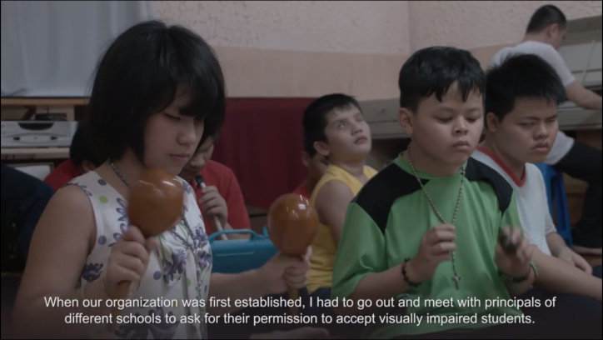  Visually impaired children and young people are supported with access to education and job opportunities by MATA, LIN’s NPO Partners
And many more lives could be changed…
Join LIN to transform our community!

Estimated Budget:
 | Item | Amount  (VND) | Note
1 | Revenue target
 | Event Sponsor | 220,000,000 | To cover costs to organize the event
 | Voluntary donation (before event) | 30,000,000
 | Ticket sales | 215,000,000 | Target to sell 90 tickets (40 early bird @ VND 2.250m/each + 50 full price @ VND 2.5m/each).
 | Auction | 420,000,000
 | Pledge/donation on the night | 67,500,000
 | Raffle tickets | 11,250,000
 | Selling lucky money envelope, & Tet card | 20,000,000
 | Total Revenue | 983,750,000
2 | Expenses
 | Venue
 | Food & Beverage | 132,000,000 | 1.1m nett/pax; assumption of cost for 120 pax
 | Food for volunteers | 5,000,000 | 10 volunteers
 | Event setup & decoration | 2,000,000
 | Sound system | 8,000,000
 | Lighting | 2,000,000
 | Theme
 | Equipment rent -props | 8,000,000
 | Backdrop & standee | 2,500,000
 | Interpretation | 8,000,000
 | NPOs and Volunteers
 | Support fee for participants from NPOs | 6,000,000
 | Post-event follow (meeting volunteers) | 5,000,000
 | Transportation | 5,000,000
 | Door gifts | 5,000,000 | With LIN's logo
 | Marketing & Comms
 | Digital campaign – PR & Marketing | 22,000,000 | Video, media, etc.
 | Invitation/ticket printing | 7,000,000
 | Total Expenses | 217,500,000
3 | Profit/Loss | 766,250,000 | ~US$ 34,000

*Revenue is deliberately budgeted based on LIN’s fundraising event’s outcome in 2016; the event could exceed this modest budget with your generous support!
LIN will publicize its Annual Report and Audited Financial Statement, which present how the fund raised from the event is disbursed.

Sponsorship Opportunities
SOLE SPONSOR – VND 220M
Benefits include:
(1) two complimentary tables (20 tickets, value ~50m) to the event;
(2) complimentary LIN Oi, Where Are We Going service - a teambuilding community service event for up to 30 sponsor’s staff members (value ~30m);
(3) recognition as the Sole Sponsor of the event with dominant sponsor logo and branding placement on event backdrops and banners, tickets, all other publications, and on LIN’s website.
GOLD CO-SPONSOR – VND 110M
Benefits include:
(1) one complimentary table (10 tickets, value ~25m) to the event;
(2) complimentary LIN consultation service regarding staff volunteer opportunities with LIN’s NPO partners (value ~15m);
(3) recognition as the Gold Co-Sponsor of the event with large logo and branding placement on event backdrops and banners, tickets, all other publications, and on LIN’s website.
SILVER CO-SPONSOR – VND 55M
Benefits include:
(1) five tickets, value ~12.5m to the event;
(2) recognition as the Silver Co-Sponsor of the event with logo and branding placement on event backdrops and banners, tickets, all other publications, and on LIN’s website.
Donor
Additionally, all donors have an opportunity to: cross-market via Facebook social media (outreach to 13,000+ people); distribute donor-branded gifts and marketing materials; and receive a trophy (Sole) or certificate of appreciation recognizing its support to LIN in 2018.

Contact:
Ms. Tran Vu Ngan Giang
Executive Director
giang@linvn.org
+84 903 782 952
LIN Center for Community Development
180/47 Nguyen Huu Canh, Ward 22, Binh Thanh District, Ho Chi Minh City
www.LINvn.org

Event Agenda:
18.30 – 19.15: Registration & Networking
Activities: - Pin your location with LIN’s community projects
- Art painting performance by Vui House (an Artist with disabilities) and Artist Nguyen Hai Anh
- Photo exhibition of LIN’s impacts with ultimate beneficiaries (through LIN’s Narrow the Gap), LIN’s staff & Board’s stories, volunteers, donors, and NPO partners
- Raffle tickets sales
19.30 – 19.50: Event starts
Activities: - Sounds of ordinary lives of Saigon
- A small journey to District 8 to provide access to clean drinking water for 50 families (video)
- Dining in the dark: experience “Your Understanding – Lightens our Lives”, a project that LIN and its partner, Thien An Shelter has enabled people with visual impairment to job opportunities; music performance delivered by children with visual impairment from Thien An Shelter
- Lit up the candles – shine up our community
- Make pledge/ contribution to LIN
19.50 – 20.05: Dining – Music & Art Performance
Activities: - 2nd course served
- Dance performance: Thao Dan & AMPA
- Music performance: Trong Khuong
- Music performance: Thao Dan & Rapper Tien Dat
20.05 – 20.45: Dining – Live Auction
Activities: - 3rd course served
- Live auction
20.45 – 21.00: Desert served & Raffle Draw
21.00 – 21.05: Wrap up: closing & announcement of the fund raised
21.05 – 21.30: Networking & Farewell

Report on Inequality in Vietnam, 2017 by Oxfam

