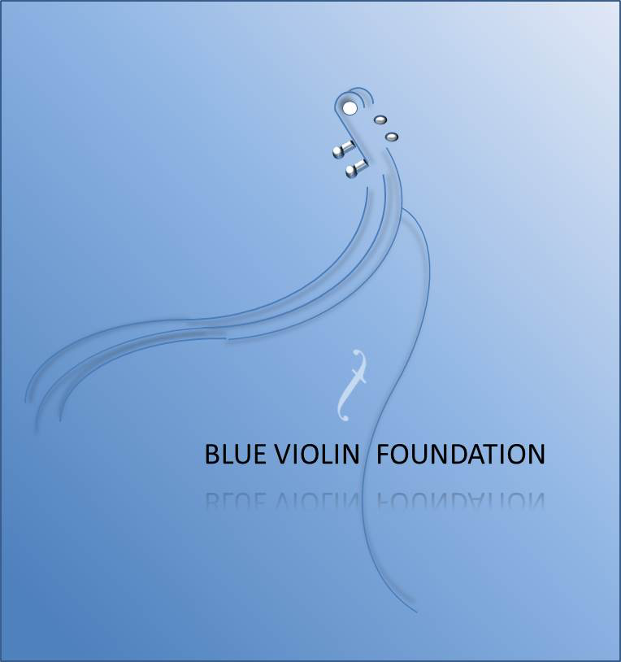

BRING LA’S HIP-HOP & ROCK YOUTH ORCHESTRA TO LIFE!

ITEM DESCRIPTION | AMOUNT
1. 20 Beginner Violin Outfits for ages 8-11 (instruments, bows, cases, music stands, accessories, supplemental instructional material) | $10,000.00
2. 20 Beginner Violin Outfits for ages 12-17 (instruments, bows, cases, music stands, accessories, supplemental instructional material) | $10,000.00
3. 10 Beginner Viola Outfits for ages 8-11 (instruments, bows, cases, music stands, accessories, supplemental instructional material) | $5,000.00
4. 10 Beginner Viola Outfits for ages 12-17 (instruments, bows, cases, music stands, accessories, supplemental instructional material) | $5,000.00
5. 10 Beginner Cello Outfits for ages 8-11 (instruments, bows, cases, music stands, accessories, supplemental instructional material) | $5,000.00
6. 10 Beginner Cello Outfits for ages 12-17 (instruments, bows, cases, music stands, accessories, supplemental instructional material) | $5,000.00
7. 50% tuition assistance for 80 music students for one year of lessons | $32,000.00
8. Replacement set of strings for 50% of the instruments in library | $3,000.00
9. Rosin for one year for all instruments | $1,200.00
10. Performance T-Shirts for 80 students receiving financial assistance | $1,600.00
TOTAL | $77,800.00

