All About Familias Especiales
Santa Julia Billiart
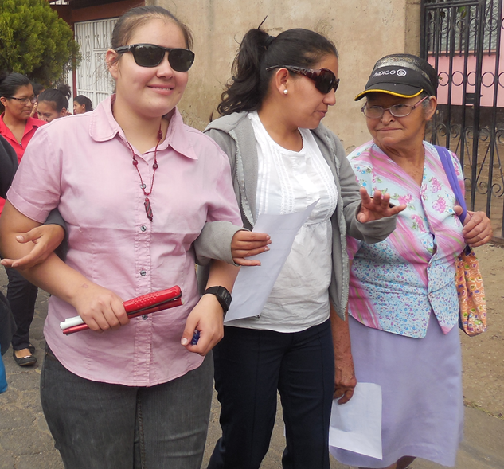
FE de Santa Julia Billiart (FE) of Matagalpa, Nicaragua, is a non-governmental, non-profit agency that was founded in 1996, with legal affirmation in 2001. Our prime objective is to work with mothers who have children with disABILITYs, empowering and enabling them to meet their special needs and reach out to others who share similar obstacles. FE works as a community the majority of our staff either have a disABILITY or someone in their family has a disABILITY. We work for the families to attain basic resources and services in the areas of health, education, employment, recreation, physical accessibility, transportation. FE is also committed to educating the greater community about the abilities and needs of People who have a disABILITY and their families.
Programs
Over the past 21 years, FE has organically developed programs that effectively address the challenges of having children with disABILITIES. Health & Nutrition, Education & Social Awareness, Social Integration & Recreation, and Employment are at the heart of all our programs. We are proud to announce that our programs have improved the lives of over 1200 individuals and their families!
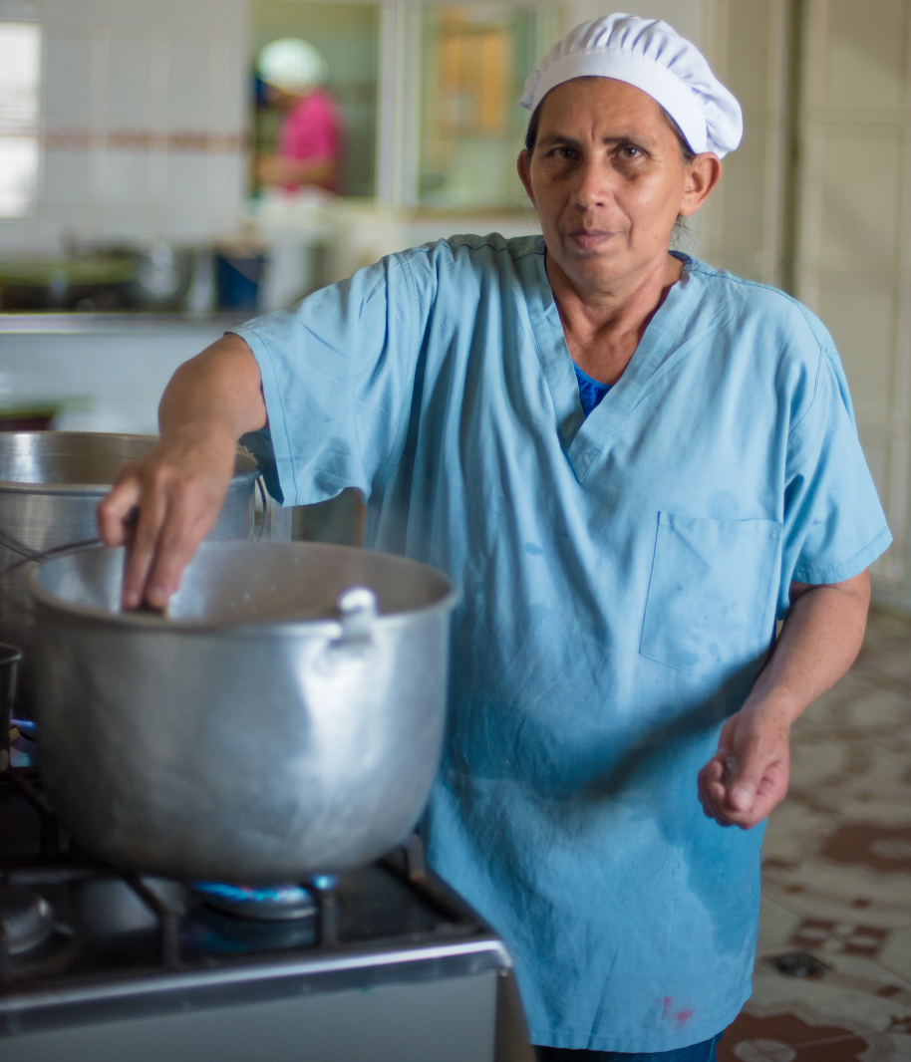

Health and Nutrition

Mental Health Services: FE works directly with a neurologist and psychiatrist to evaluate the mental condition of children and young adults in the Matagalpa area. FE also works hard to provide essential medication at low cost to families. Without this service, most mental health conditions would go untreated due to inaccessible professional services and expensive medication.
Psychological Services: Three full time psychologists work to evaluate the needs of each individual who comes into the organization. These psychologists offer therapy, special and practical education, counselling and education for mothers and children, and vocational therapy, as well as conduct follow up work for medical specialists.

Physical Therapy and Horse Therapy: Physical Therapy in the Park of Stars as well as Home Therapy for those unable to travel. FE has a titled Horse Therapist from the University of Gimbernat in Barcelona Spain. This therapy has become a cherished activity for many children with disABILITIES. Besides the children from all the neighbourhoods of Matagalpa there are families in rural areas who bring their children to Matagalpa to participate in our different therapy programs.
Yogurt con Amor: A yogurt and cheese factory to make nutritional products available in Matagalpa and to help support our Smile Lunch Program. These natural products are also used within FE as a nutritional supplement in all of our programs. It is also sold to the public. It has become a source of employment for young people with disABILITYs and their family members. Smile Lunch Program: Serves more than 110 nutritional lunches a day to individuals with different abilities who work in our organization, including the children in Special Education We also provide grains and nutritious food directly to families in the neighbourhoods.

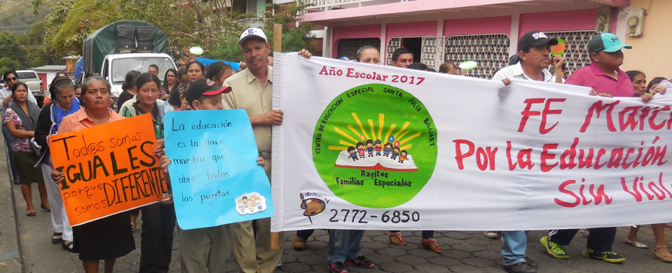
Education and Social Awareness

Rayitos, Special Education Primary: FE realized in 2001 that the majority of children with a disABILITY were not attending any type of school or education program. Thus, Rayitos was developed. We serve children with language and communication problems, learning disABILITIES, downs syndrome, physical disABILITIES, autism, and sensory disABILITIES. Rayitos works to integrate students into regular school when possible and also provides practical education .
Educational Scholarships: FE gives scholarships to all the children who attend Rayitos. Additionally, we encourage all of our staff members to further their education and provide financial assistance when possible. Over 40 members of FE staff are studying in primary, secondary, or university / vocational programs.
Social Awareness: FE is committed to educating the greater community about the abilities and needs of the person with a disABILITY and their families. We have published a booklet and held several workshops on Nicaraguan Federal Law :763 Prevention, Rehabilitation and Equal Opportunities for Persons with a DisABILITY. FE was instrumental in starting the first Mayor’s Commission on disABILITY and we continue to work hard to promote sensitivity on the local level, as well as nationally by holding different events to create awareness.
Weekly Radio Program: FE coordinates a weekly radio program, Voices of FE that was founded to help educate and inform mothers, as well as the local community. Subject material ranges from natural medicines and therapies to the activities and resources we offer.
Neighborhood Outreach & Mother Leaders: At the heart of FE is our neighborhood outreach program. This program consists of mothers working together with professionals to expand and distribute the services that we offer, while educating the local community about disABILITIES. Mother leaders There are over 45special mother leaders. They serve as the communicators with the mothers with children with disABILITY in their neighborhoods. They have a monthly meeting which includes training.

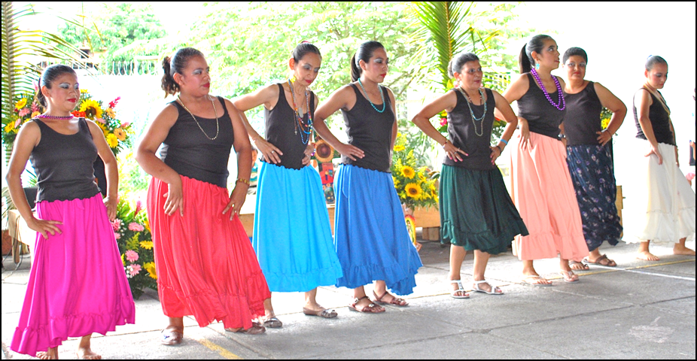
Social Integration and Recreation

Saint Julie’s Park of Stars: This special park opened in 2004 and it is the only park in Central America specifically made for people with different abilities. Our goal with Park of the Stars is to create an atmosphere where integration can take place as well as to provide an accessible playground to children with special needs. Our special education program, Rayitos, and our Therapy programs utilize the park to offer progressive exercise and entertainment. The park is open to the public as well, which has brought together all types of children and adults in a safe, recreational spot to have fun and mix together. FE also has regular events such as a 5K race, a mothers march for education, different fairs, etc. with the idea of always keeping each other active and inspired.
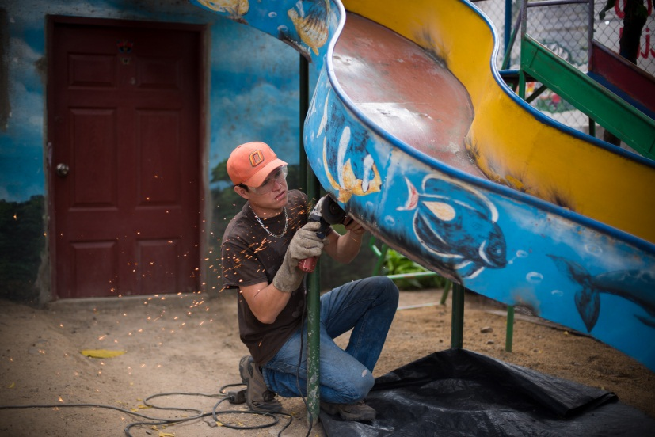
Employment Programs

Saint Julie’s Wheels: Our wheelchair workshop employs people with disABILITIES to maintain, repair, and adapt items according to the needs of each individual. This service gives mobility to people who have a disABILITY and depend on auxiliary apparatuses to have a more independent life. Having a wheelchair, walker, crutches, cane, or ramp can often make it possible for a person to integrate into society. The young people who work in the wheelchair workshop learn practical maintenance skills in carpentry, electricity, soldering, cement work, and plumbing as well.
Sunflower Center – Centro Girasol: This unique center houses an art store and small café, It was started to support the wheel chair workshop. We sell art from our Special Arts program. Our café is a great place to relax and enjoy our Yogurt with Lover or a typical Nicaraguan meal. The Matagalpa Treasures Program, which is a series of maps for day hikes, is also part of Girasol. Many special mothers in FE have started their first jobs in this center, gaining positive work habits and skills.
Dorothy Stang House Recycling and Special Arts: FE created this dual program for young people with disABILITIES who wanted to develop their artistic work or help the natural environment through recycling. Special Arts gives young people opportunities to earn income by creating their own paintings, drawings, piñatas, crafts, banners, and murals. Our Recycling program also provides job opportunities for young people with disABILITIES, while contributing to a cleaner, healthier environment.

