- TDCF Childhood Cancer Handbooks: Series 1
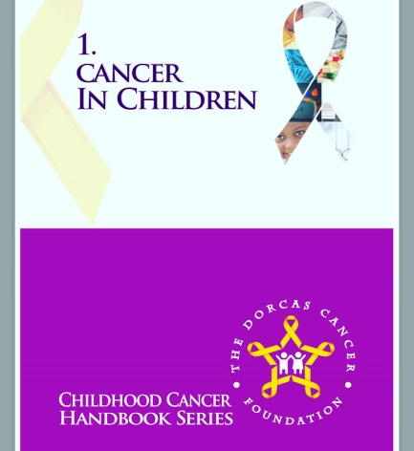

N 5,000 per copy
TDCF Childhood Cancer Handbook is published to disseminate information to patients and healthcare professionals, and give psychosocial support and counselling to families dealing with cancer in Nigeria.
It is the first book in the series, with plans to translate each title to the common colloquial and vernacular languages in Nigeria i.e. Pidgin-English, Yoruba, Igbo, and Hausa.
The foundation has set a goal to donate 5,000 copies of the handbook to clinics, primary health centers, and hospitals across Nigeria. This will be tied to a community awareness program to re-educate health workers at the community level to look out for the common signs of cancer in a child.
The handbook also contains contact details to ensure smooth referrals for children who may have any of the signs detailed.
Most parents agree that receiving a report of cancer in their child is one of the worst experiences anyone can imagine. Many parents and families feel overwhelmed and confused in the first days, weeks and even months after a cancer diagnosis. This handbook has been created with that in mind. It is designed to answer any questions about cancer in children. It will provide answers for families dealing with this condition, explanations to the curious observer, and awareness to the general public.
It will also teach healthcare professionals how to counsel families and answer questions about cancer in children.
It is for:
The parent or guardian with questions that need answering
The family member who wants to know how to help
The observer who wants to be involved
The medical professional who wants to know how to answer questions about cancer in children
The health worker who wants to remember what signs to look for in a child that may point to cancer
The older child/young adult who wants to understand their cancer diagnosis
This book will give the right information and act as a guide.
The books are not to be sold or re-sold. They have been provided as a free resource to parents, community health workers, and community members who have questions about cancer in children.

