Thank You for Your Support and Staying Connected!

STANDING IN FAITH MINISTRIES, INC. (SIFM)

(Our Goal is to Make a Difference by Helping Others!)
We are still standing in faith for meeting our financial goal.

Here’s a few updates on our Restoration Efforts for this Quarter:
- We have 3 computers – software pending
- Located Housing for 5 Homeless Individuals
- Assisted 5 individuals with locating Jobs
- Transported individuals to Food Pantries, Social Security Appointments, Food Stamps Appointments, and ID Appointments

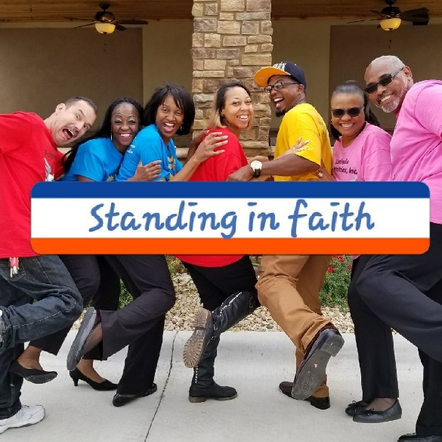

Standing In Faith Ministries, P. O. Box 91483, Houston, TX 77291-1483

We are a 501c3 Non-Profit Organization and
Your Donations Are Tax-Deductible.

Consider making a donation Today! Thank You Again for Your Support!!

