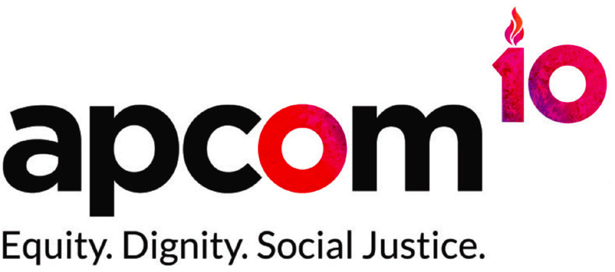

#OctoberTest – 4,000 young men know their status

Objective: 4,000 young gay men have tested and know their HIV status throughout the month of October 2018 in Bangkok, Ho Chi Minh City, Jakarta and Manila.

Men-who-have- sex-with-Men (MSM) are currently the major risk group in Asia Pacific to get HIV. A study published in 2013 described the HIV prevalence among men who have sex with men in Bangkok as an 'explosive epidemic', with HIV prevalence in 2010 on 31.3% and 41% of the new HIV infections in Thailand being transmitted via MSM, of which most are not aware of their HIV status.

HIV prevalence among men who have sex with men is more than 5% in Indonesia, Thailand and Vietnam | Prevalence is particularly high 15% to nearly 31% in large urban centres like Bangkok and Jakarta
The Philippines has registered the fastest-growing HIV/AIDS epidemic in the Asia-Pacific in the past six years with a 140-percent increase in the number of new infections occurring mostly in young men who have sex with men. | Only about half of men who have sex with men in Asia-Pacific get tested for HIV.
https://www.apcom.org/wp-content/uploads/2016/01/APCOM_Brochure_Final.pdf

It is of the utmost importance to target MSM and make sure that MSM know their HIV status to end the epidemic.

APCOM implemented in 2014-15 a regional campaign approach, Test XXX, which focused on community designed behaviour change communication. Understanding the importance of partnership for increased investments in HIV work, Test XXX prioritized strong partnerships from across different sectors, like community organisations, media and the private sector. The first campaign was launched in Bangkok with significant results: a 38% increase of MSM getting tested from the research population. This campaign is unique and innovative as it breaks the cycle of ad-hoc interventions as were implemented until now in Bangkok, Ho Chi Minh City, Jakarta and Manila. Further, the project brings together unusual players: community organisations, clinics, private sector and local authorities, which has not been done before in Bangkok. Ultimately, the innovation lies in linking visible campaigning (road show) with social media and the use of social and geo apps and a lifestyle that attracts many MSM (sex dating, health and party patterns). Combining these ingredients make the APCOM TestBKK-approach unique and innovative.

As a result of the 2014/2015 campaign, with a mix of events, messaging through social dating apps and social media messaging and the partnerships, an increase of 38% of MSM who voluntarily took an HIV test was measured. Based on these encouraging results, APCOM likes to expand the campaign with a month long testing campaign, called #OktoberTest to be simultaneously implemented in 4 cities in Southeast Asia. The objective is to persuade 4,000 MSM to take a voluntarily HIV test in order for them to know their status throughout the month of October 2018.

The proposed estimated cost for the entire project is 50.000 USD per city. Thus the total is 200,000 USD.

Item | Description | Amount
Testing Campaign | Geo Apps (Adverts/Direct Messages)  Website Promotions  Posters and flyers  Magazine Promotion | $ 10,000
Fresh Up Event | Venue and equipment hire  Decoration and entertainment  Testing Card | $ 18,000
Satellite Events (4) | Staff / Volunteer allowance  Transportation  Venue hire and decoration | $ 8,000  ($ 2,000 per event)
Lucky Draw Incentive | iPhone (4, draw once per week) | $ 3,000
Community solidarity event | Venue and equipment hire  Sponsorship Fee | $ 4,000
OctoberTest Coordinator  Salary | August – December  (1,500 per month, 4 months) | $ 6,000
Road Show | Van rental cost & insurance (one month)  Staff /volunteers allowance | $ 1,000
Total |  | $ 50,000

