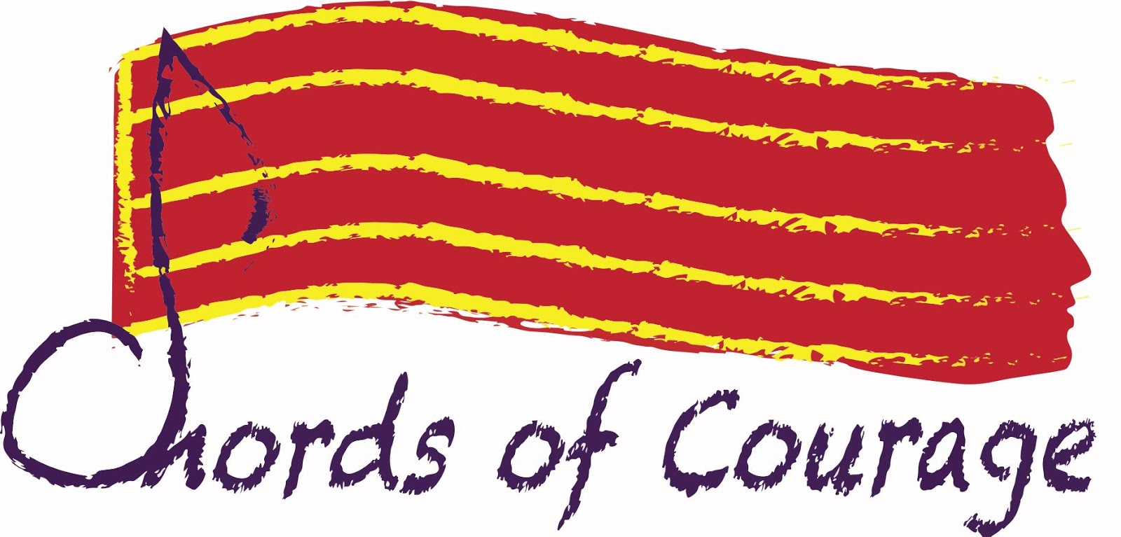
www.ChordsofCourage.org 202-966-7270
Caron Dale, Project Director Susan Coti, Education Director

STEP UP FREDERICK! Student Songwriting Contest
2017-2018 School Year
A Program of Chords of Courage

Chords of Courage is changing the conversation from the demoralizing and cynical to the hopeful and inspirational - one song at a time. We have created the first songwriting contest of its kind in the world and will be conducting it right here in Frederick, Maryland. The contest is open to Frederick County middle and high school age students and encourages them to use their creativity to write dynamic and powerful songs about people of particular courage.

Using Songwriting as a Catalyst for Social Change

Winning songs will be presented at a Grand Finale Concert. Student songwriters then take leadership roles to encourage the audience to join them in acts of STEPPING UP! inspired by the courageous people about whom they wrote their songs. It’s a great way to empower teens to be active members of their community and an incredibly profound experience for everyone.

By creating socially conscious songs today,
we help to create socially conscious citizens for tomorrow.

These actions promote civil discourse and reinforce our belief in the power of one song to make a real difference.

We are supporting participating students by offering free songwriting sessions, mentors, and assistance for those students who can’t afford the application fee. We anticipate this will be the first of many STEP UP! song contests hosted in Frederick. In future years, we plan to add more counties, perhaps the entire state.

We are proud to include among our partners, sponsors and advocates:
- The Delaplaine Foundation
- The Ausherman Family Foundation
- FAME: Frederick Acoustic Music Enterprise
- SHIP: Student Homelessness Initiative Partnership
- Boys & Girls Club of Frederick
- YMCA Frederick city and county

We are honored that Frederick County Public Schools is strongly encouraging student participation to complement academic growth and endeavors.

Chords of Courage is a 501(c)(3) charitable organization making your contribution tax deductible.

