**We keep moving…**

Love for Mexico is going strong and forward.

Our main goal is to impact as much as we can in Mexican population. This time Hidalgo is one of the states that will be benefited with this program. Likewise, we continue working our Free Medical Attention Days program, at highly marginalized communities in the state of Chiapas and Tabasco. Managing to offer family consultations, dental interventions and ultrasounds and electrocardiograms.

Our best interest is to keep providing a healthier life for those in need.

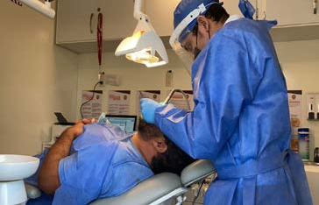

***“I liked a lot that you could came and help, I just can say that everything was ok”***

***Noé N.***

***(Assigned name to protect our patient’s privacy)***

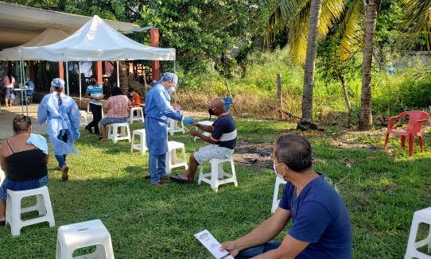

***“I want to thank the help you have brought us. Hope you can come back to our community”. Alejandro N.***

***(Assigned name to protect our patient’s privacy)***

We keep working side by side with the General Hospital of Cholula. Our Medical mobile Units are working to provide medical attention in the process of respiratory triage for COVID -19 patients.

October is a very important month for women and us. We provide women from Hidalgo, Chiapas and Tabasco Free Medical attention with ultrasounds. Breast Cancer fight starts with prevention.

Thankfully, more and more women are taking care of themselves by going to regular checkups and not only when they have symptoms.

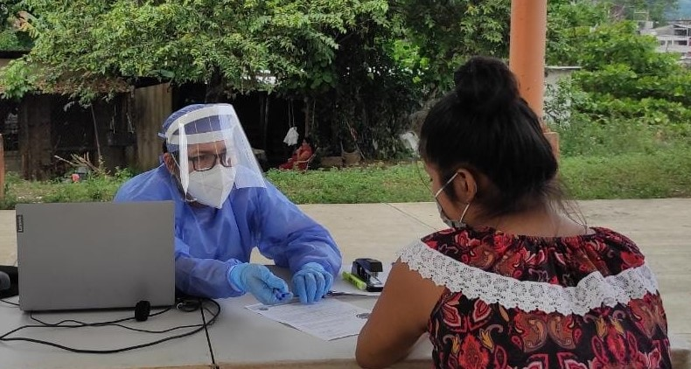

We celebrate our 16th anniversary providing humanitarian help to people in most need. We are proud of our work, but we know we need to do more. We appreciate all of our donors, volunteers and collaborators for their wonderful and hard work.

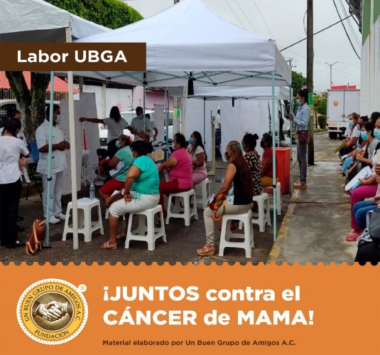

***“Very well explain by the staff. Thank you very much for taking in consideration families that live outside the main community”. Olivia N.***

***(Assigned name to protect our patient’s privacy)***

Our goal is to provide the best medical health service and change lives. We provided a wheel chair in the state of Tabasco by the program “Health Support Management” December the 1st.

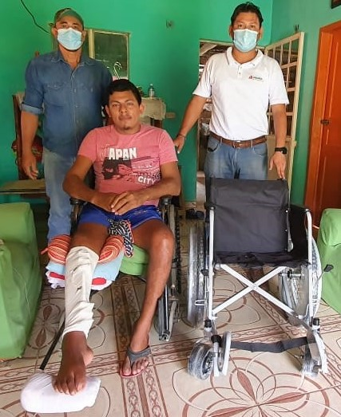

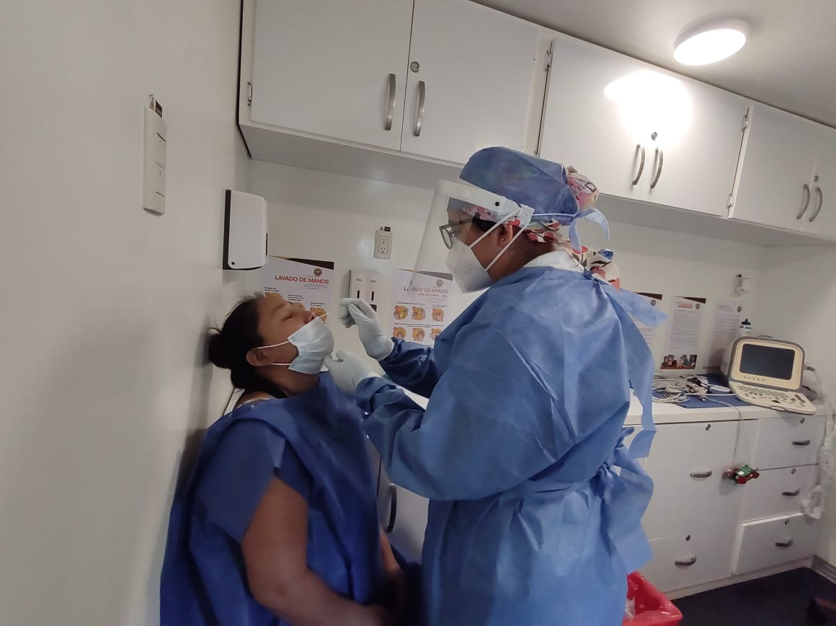

We continue offering COVID-19 detection tests and constant sanitization of our Medical Units to provide a safe environment to our patients, always within Mexico´s government medical standards.

We offer health promotion workshops like proper tooth brushing, prevention of COVID-19 infection and improving meal plans by our nutritionist.

***“I was very well taken care of. I hope you continue doing what you do for the benefit of our community”. Abigail N.***

***(Assigned name to protect our patient’s privacy)***

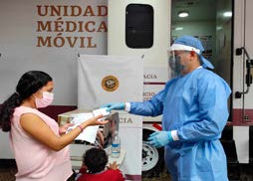

With love,

UN BUEN GRUPO DE AMIGOS, A.C