GlobalGiving Report

Thank you! We would like to express our heartfelt gratitude to all the donors who generously contributed to making our Free Medical Care Days possible for the vulnerable population in communities across Mexico. Your support has allowed us to provide much-needed medical attention, supplies, and medicines to those who would not have access otherwise. Thanks to you, we can make a tangible difference in the lives of those who need it most. Your generosity and kindness are greatly appreciated, and we are honored to have you as partners in our mission to improve the health and well-being of our communities.

LOCATIONS

We remain firm in our commitment to providing medical care to the most vulnerable communities through our Free Medical Care Days. January thru March, thanks to our dedication and joint efforts, we managed to attend:

17 localities in the state of Campeche, 28 localities in Chiapas, 26 localities in Hidalgo, 6 localities in the state of Mexico, 8 localities in the state of Nuevo Leon, 30 localities in Puebla, 179 localities in Tabasco, 45 localities in Tamaulipas, and 92 localities in Veracruz.

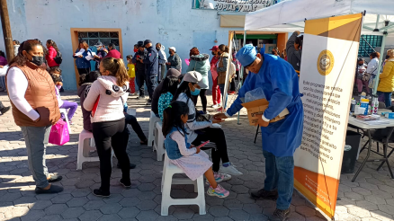

OUR IMPACT

Thanks to the generous support of donors like you, we have been able to reach thousands of people who otherwise would not have access to basic healthcare. From carrying out medical campaigns to delivering supplies and medicines, our work has focused on providing practical and sustainable solutions to improve the health and well-being of the most vulnerable communities.

Campeche | Chiapas
3,750 Family medical consultations | 3,250 Family medical consultations
5,250 Dental interventions | 4,350 Dental interventions
220 Ultrasounds and electrocardiograms | 200 Ultrasounds and electrocardiograms

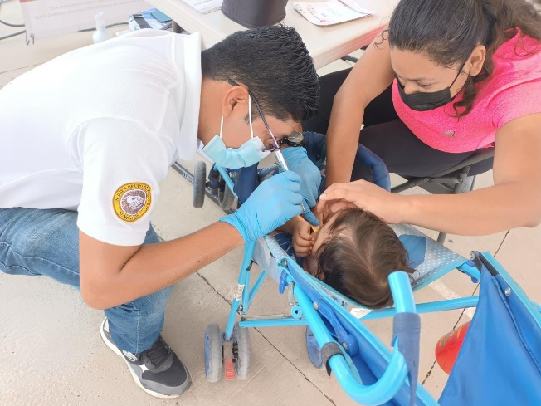
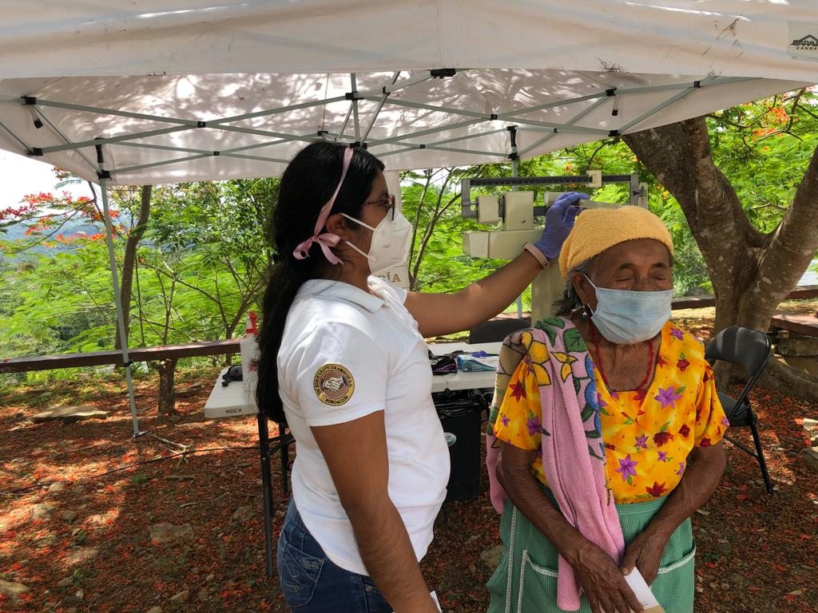

Hidalgo | Puebla
2,140 Family medical consultations | 960 Family medical consultations
4,750 Dental interventions | 2,920 Dental interventions
110 Ultrasounds and electrocardiograms | 230 Ultrasounds and electrocardiograms

Nuevo León | Estado de México
300 Family medical consultations | 470 Family medical consultations
380 Dental interventions | 800 Dental interventions
7 Ultrasounds and electrocardiograms | 15 Ultrasounds and electrocardiograms

Tabasco | Tamaulipas
29,850 Family medical consultations | 3,450 Family medical consultations
45,446 Dental interventions | 4,900 Dental interventions
2550 Ultrasounds and electrocardiograms | 160 Ultrasounds and electrocardiograms

Veracruz
7,500 Family medical consultations
10,200 Dental interventions
340 Ultrasounds and electrocardiograms

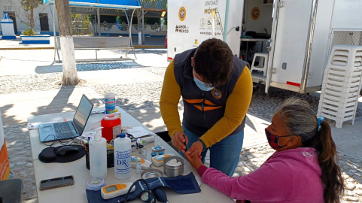

RECOGNITION OF OUR #LoveForMexico

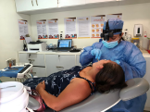
“We are grateful to the Mobile Medical Unit for providing us with medical assistance. I received free dental care, an ultrasound, and a medical consultation.”
Matilde S.
(Name assigned to protect patient's privacy)

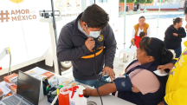
“I am very happy, they treated me very well, and they have excellent doctors and medicines. They will be welcome to come back anytime they want.”
Guadalupe B.
(Name assigned to protect patient's privacy)

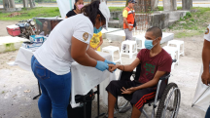
“We are grateful to the Mobile Medical Unit for the benefits it provides to the community, for giving us consultations and medicines in order to support our health.”
Arturo R.
(Name assigned to protect patient's privacy)

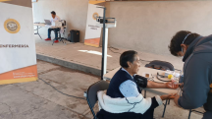
"It is a great benefit to the community that the unit has come mobile doctor and thank you very much because the doctors are very good."
Miguelina H.
(Name assigned to protect patient's privacy)

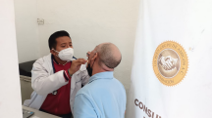
I would like to thank you for the medical care you offered me on the day of
today, excellent treatment and the doctors are very professional."
Carlos R.
(Name assigned to protect patient privacy)

With Love,
UBGA

