Goodbye 2023

In December, we concluded the year by providing medical assistance to individuals who still required aid in the area affected by Hurricane Otis.

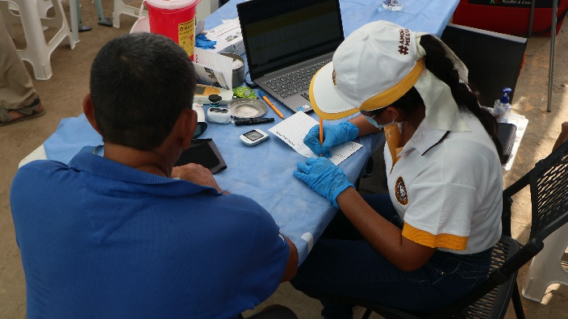
We manage to attend in Guerrero 575 medical consultations, 812 dental interventions and 4 Ultrasounds and electrocardiograms. As always, our Free Medical Care Days were attending Campeche, Chiapas, Guanajuato, Hidalgo, Puebla, Tabasco, Tamaulipas, and Veracruz.

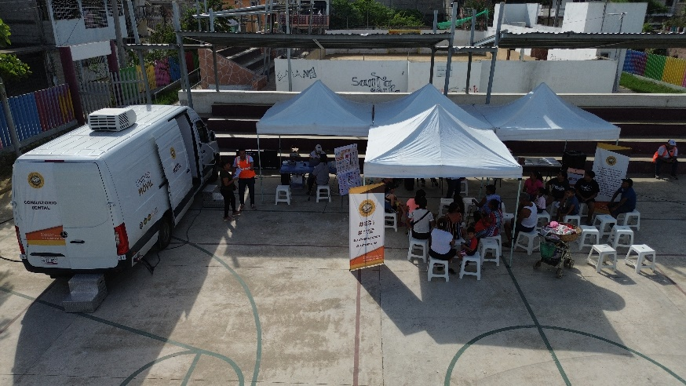

Our Impact
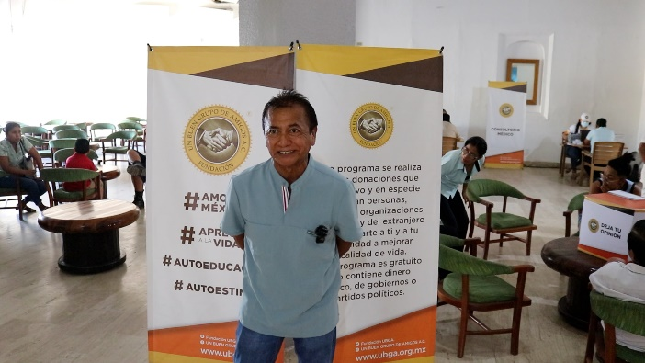
"I thank the Un Buen Grupo de Amigos Foundation for all the support they have provided us during this disaster contingency we had in Acapulco due to Hurricane Otis."

Sergio C.
(Name assigned to protect patient privacy)

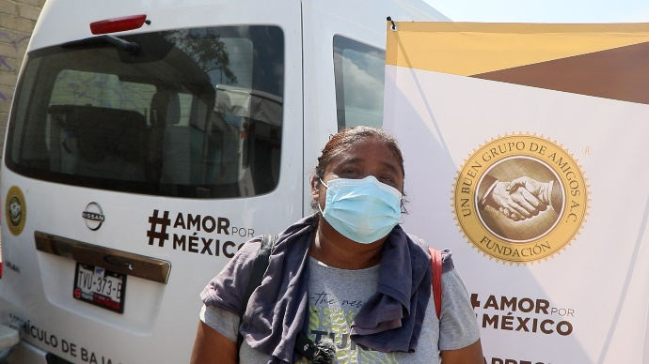

"The medical care they are providing right now is really good, to be honest. My son was sick and they prescribed medication for him."

Itzel M.
(Name assigned to protect patient privacy)

Welcome…

…2024 marks the beginning of a new year filled with opportunities to make a difference. For us, this year not only signifies the passage of time but also the opportunity to bring aid and hope to hard-to-reach communities in Mexico.

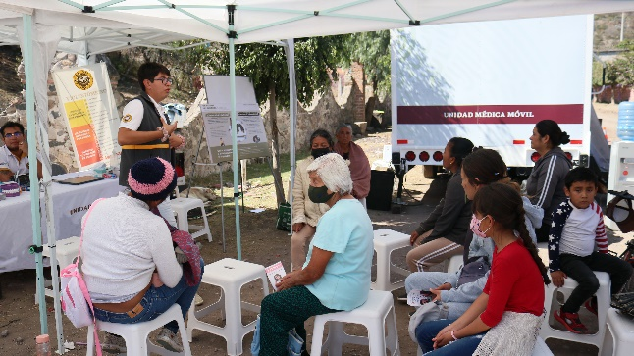
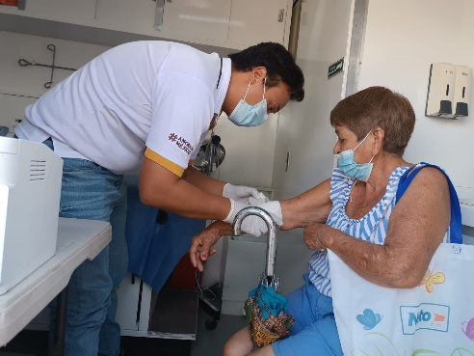

Our Impact

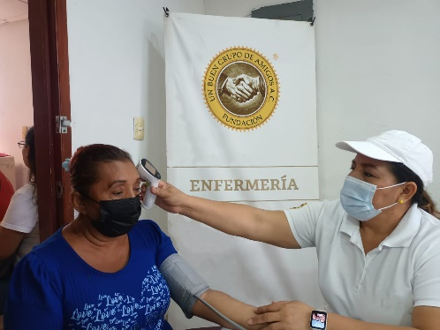
"I thank the medical unit that comes to our community to support so many families that really need this, and I am grateful that they always arrive."

Adriana D.
(Name assigned to protect patient privacy)

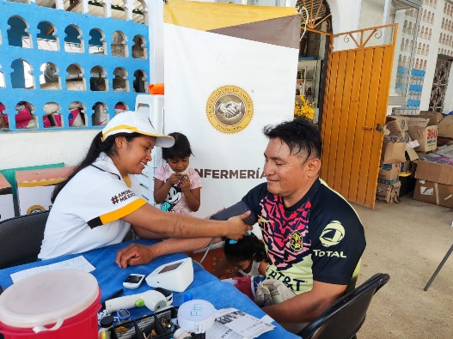

"I came for a consultation and received good care from the doctors and all the staff who are collaborating. Thank you."

Juan G.
(Name assigned to protect patient privacy)

Thanks to your donations, we have been able to bring hope and medical attention to those who need it most in the communities of Mexico.

February
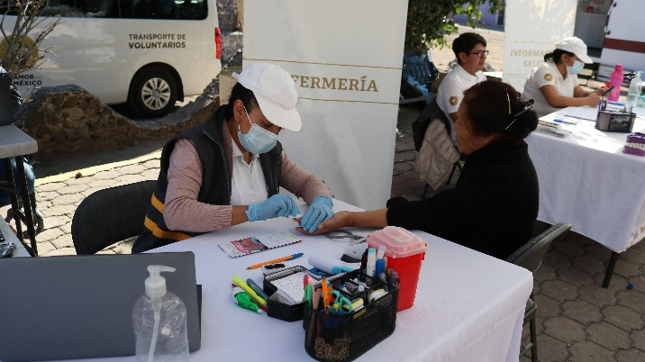
It is important to remember that prevention and early detection are essential to prevent cancer. Adopting a healthy lifestyle, avoiding tobacco, maintaining a healthy weight, exercising regularly, and undergoing regular medical exams can help reduce the risk of developing cancer or detect it in its early stages, when it is most treatable.

Our Impact

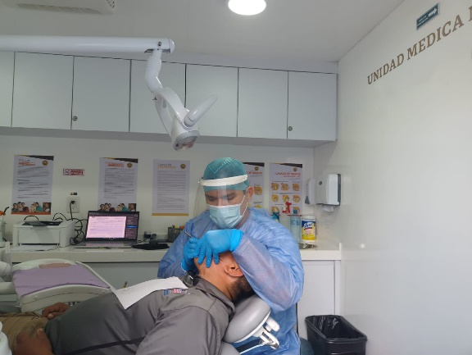

“I want to thank you for the free medical care you gave us and the pharmacy was a great help. Thank you for taking care of us!”
Jorge C.

(Name assigned to protect patient's privacy)

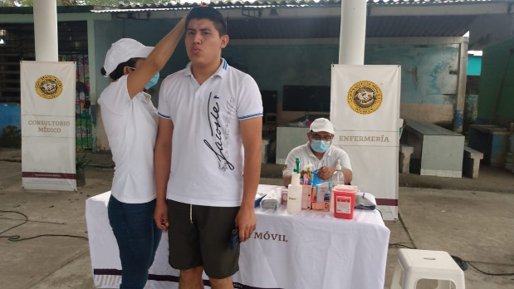

“The care I received at the medical consultation and at the dentist was very helpful. I hope they can come back soon.”
Gerardo T.

(Name assigned to protect patient's privacy)

March

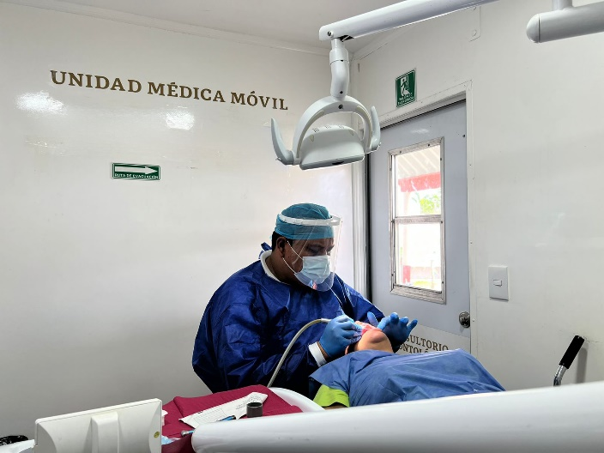
World Oral Health Day is celebrated in March every year. This date aims to raise awareness among the population about the importance of maintaining good oral health and promoting healthy oral hygiene practices.

Oral health is critical to overall well-being, as issues such as cavities, gum disease, and other conditions can have a significant impact on overall health, including cardiovascular health.

Maintaining good oral hygiene, including regular brushing, flossing, regular dental visits, and a balanced diet, can help prevent dental disease and promote a healthy smile.

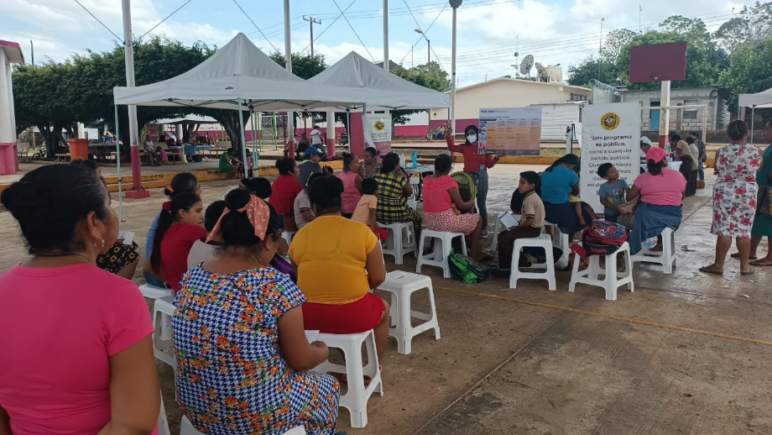

Our Impact

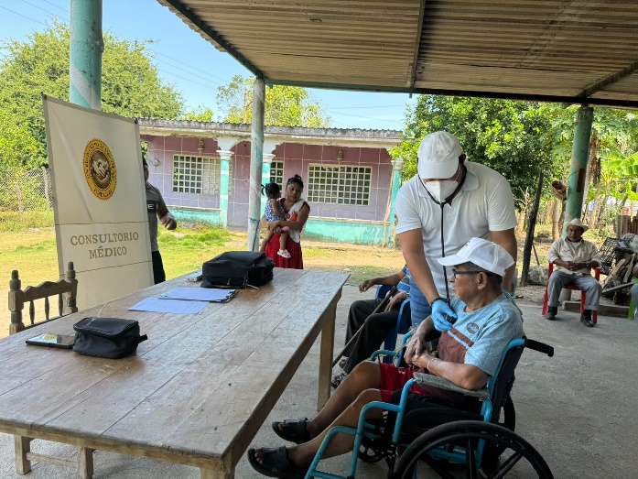

"Thank you for the consultation and the medicine I received, for your
generosity and care. Thank you from the bottom of my heart!”
Armando V.

(Name assigned to protect patient's privacy

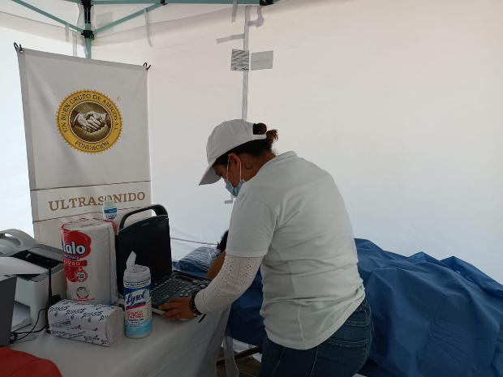

During these past four months, we have successfully provided medical care to 10 states across the Mexican Republic, spanning 618 vulnerable and hard-to-reach communities. This initiative has been instrumental in ensuring that essential healthcare reaches those who need it most.

We manage to provide 63,595 medical consultations, 111,010 dental interventions and 78,742 diagnostic examen like electrocardiograms and ultrasounds.

For your support, THANK YOU…

