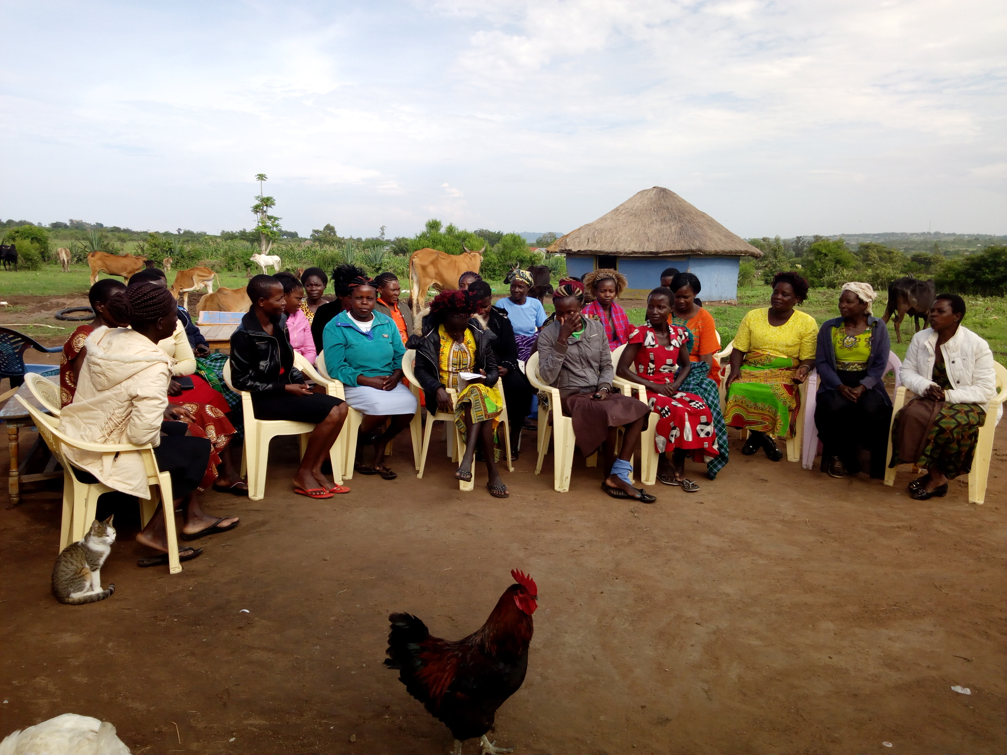

**The Women pose for a photo during empowerment workshop.**

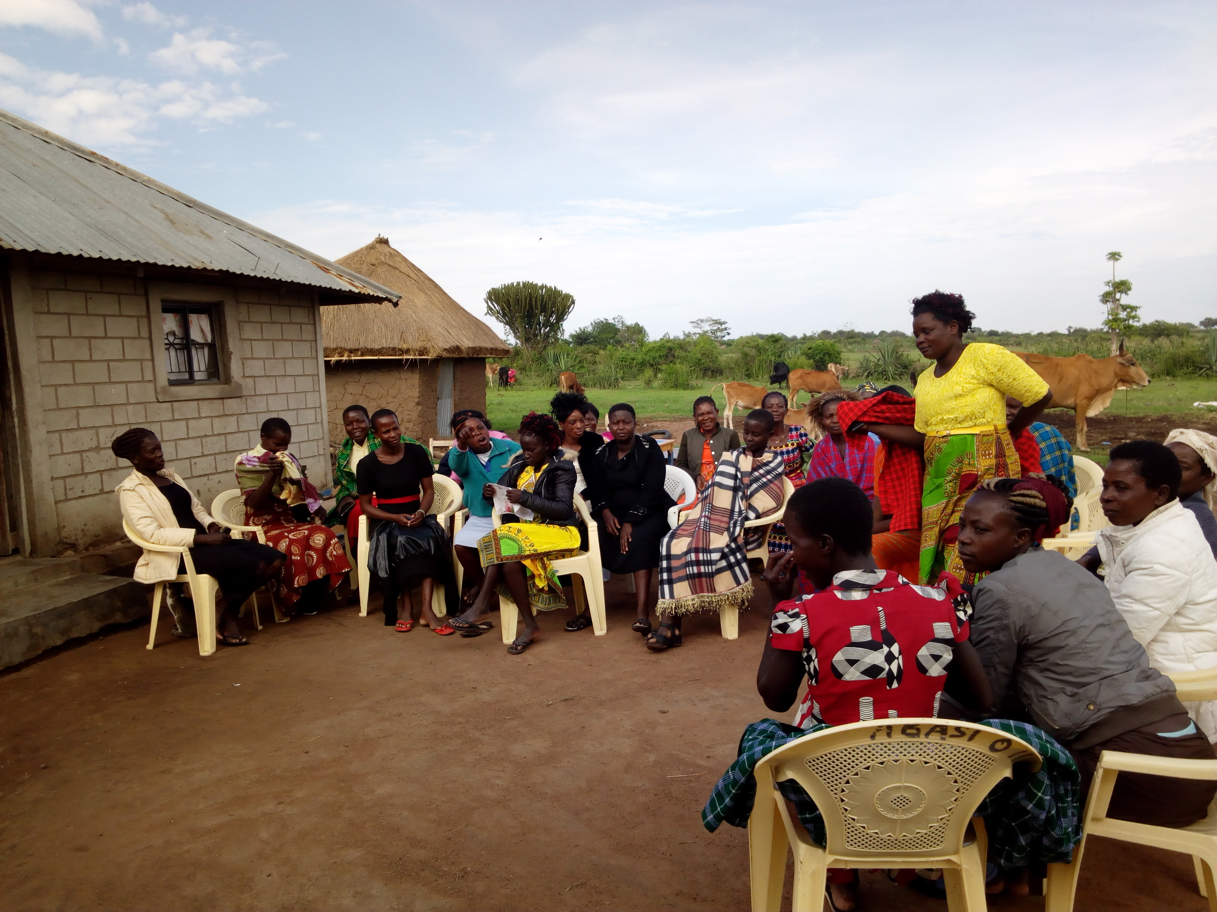

The Participants during the training.

**Training expenditure Report**

|  |  |  |
| --- | --- | --- |
|  |  |  |