Sample of the training photo

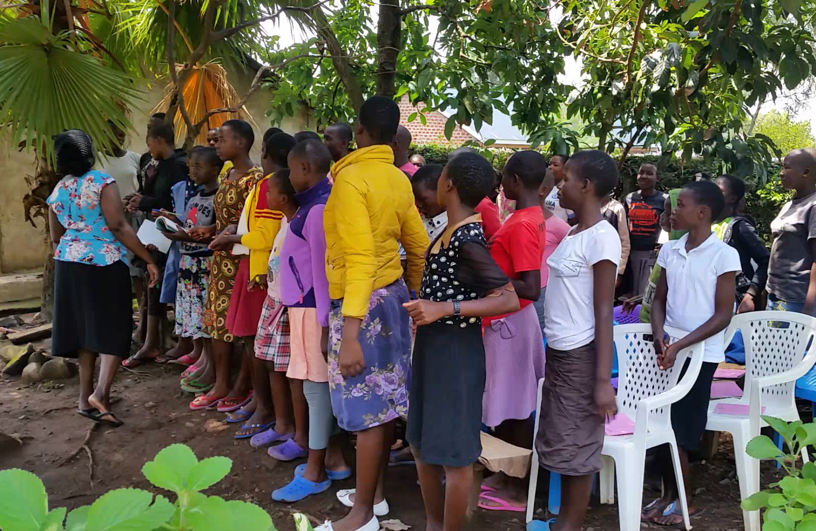

Girls’ club 1 during the workshop

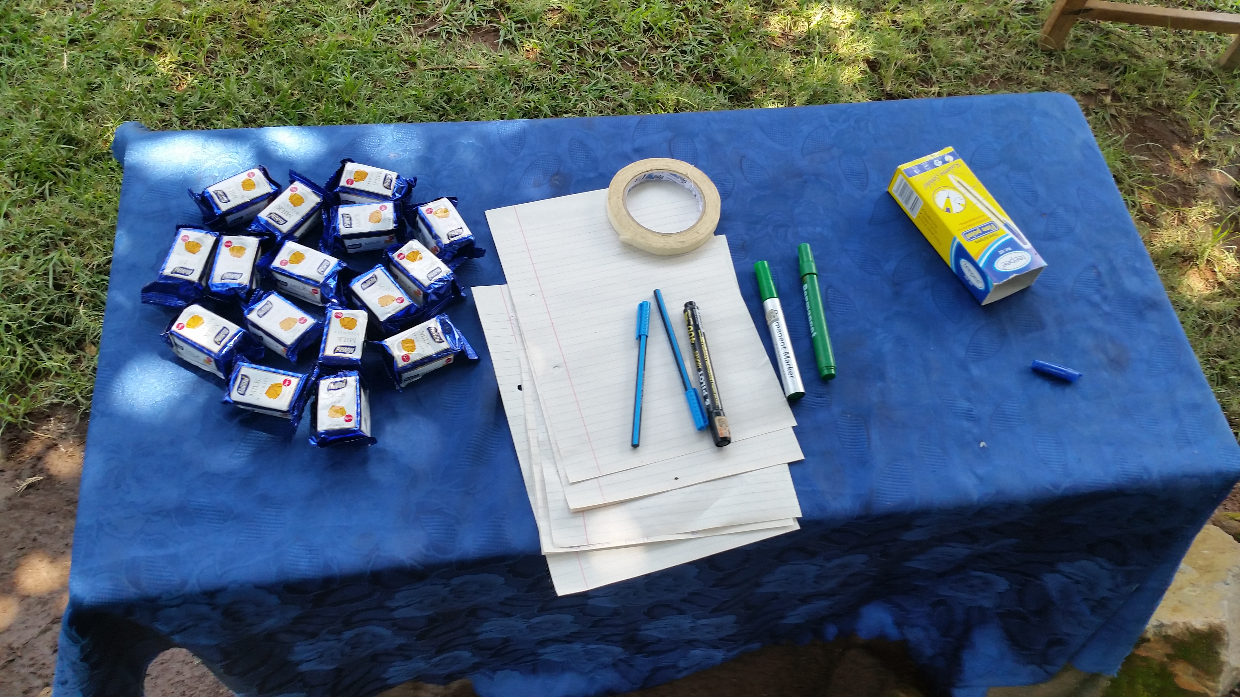

Some packets of biscuits used to motivate the girls to speak up.

Training expenditure Report
Budget Line | Details/Item | No. of Units | Unit Size | Unit Cost | In $ | No. of days | Total cost(Kshs) | In $
1 | FOOD | 0 | 0 | 0 |  |  | 0
1.1 | Participant's Food
1.1.1 | Lunch | 28 | 1 plate | 220 | $2.20 | 4 | 24640 | $246
1.1.2 | Ten Oclock Tea | 28 | 1 cup and a bite | 100 | $1.00 | 4 | 11200 | $112
1.1.3 | Drinking Water | 28 | 500mls | 30 | $0.30 | 4 | 3360 | $34
1.1.4 | 4 Oclock Soda | 28 | 300mls | 40 | $0.40 | 4 | 4480 | $45
1.2 | Facilitator's food | 0 | 0 | 0 | $0.00 | 0 | 0 | $0
1.2.1 | Lunch | 2 | 1 plate | 220 | $2.20 | 4 | 1760 | $18
1.2.2 | Ten Oclock Tea | 2 | 1 cup and a bite | 100 | $1.00 | 4 | 800 | $8
1.2.3 | Drinking Water | 6 | 500mls | 30 | $0.30 | 4 | 720 | $7
1.2.4 | 4 Oclock Soda | 2 | 300mls | 40 | $0.40 | 4 | 320 | $3
 | Sub-Total |  |  |  | $0.00 |  | 47280 | $473
3 | VENUE COSTS | 0 | 0 | 0 | $0.00 |  | 0 | $0
3.1 | Hiring Conference Hall and chairs | 1 | Hall | 1500 | $15.00 | 4 | 6000 | $60
 | Sub-Total |  |  |  | $0.00 |  | 6000 | $60
4 | TRANSPORT |  |  |  | $0.00 |  | 0 | $0
4.2 | Staff local transport | 2 | Kshs. | 600 | $6.00 | 4 | 4800 | $48
 | Sub-Total |  |  |  | $0.00 |  | 4800 | $48
5 | STATIONERY | 0 | 0 |  | $0.00 | 0 | 0 | $0
5.1 | Flip Chart | 1 | Pc | 500 | $5.00 | 1 | 500 | $5
5.2 | Felt pens | 5 | Pcs | 100 | $1.00 | 1 | 500 | $5
5.4 | Note books | 28 | Pcs | 30 | $0.30 | 1 | 840 | $8
5.5 | masking Tape | 1 |  | 60 | $0.60 | 1 | 60 | $1
5.8 | Pens | 28 | Pcs | 20 | $0.20 | 1 | 560 | $6
 | Sub-Total |  |  |  | $0.00 |  | 2460 | $25
6 | FACILITATION FEES | 0 | 0 | 0 | $0.00 | 0 | 0 | $0
6.1 | Facilitator 1 | 1 | Kshs. | 6000 | $60.00 | 4 | 24000 | $240
6.2 | Assisting staff | 1 | Kshs. | 3000 | $30.00 | 4 | 12000 | $120
 | Sub Total |  |  |  | $0.00 |  | 36,000 | $360
 | Grand Total |  |  |  |  |  | 96,540 | $965

