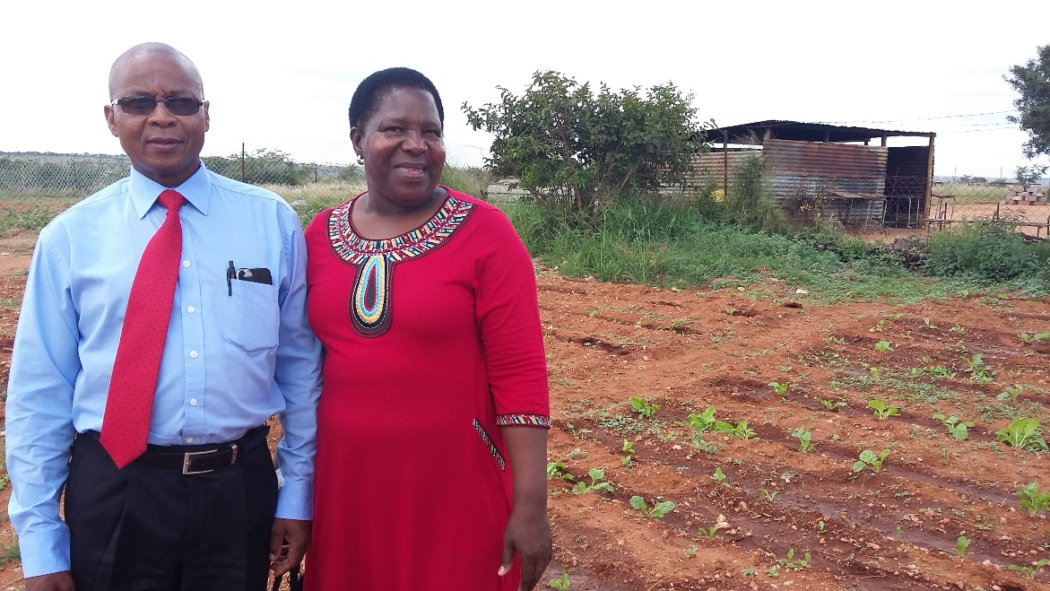 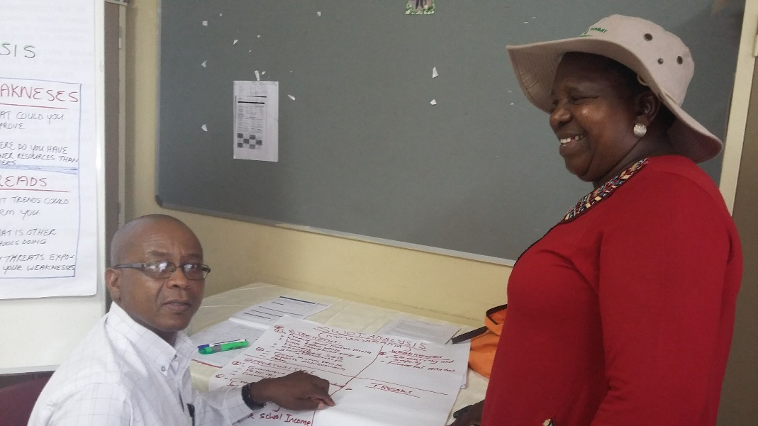 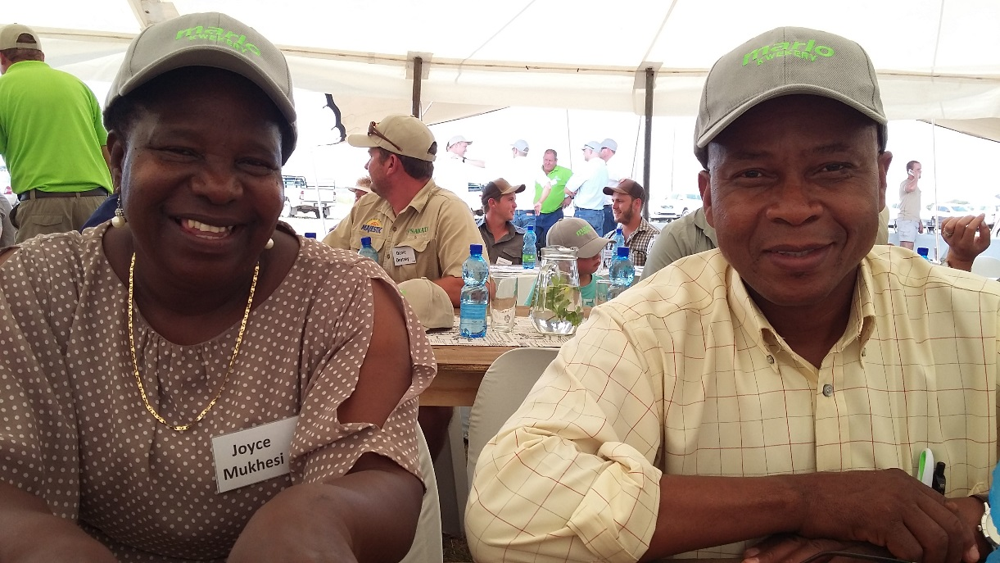

Refilwe and Joyce at Mmamarama High School with their new established vegetable garden, Photo 2 at CoP4 – Ramathope and photo 3 at the Farmers day at Marloe nursery

# CoP4C:\Users\Marietjie\Pictures\Partners for Possibility\APRIL 2018 CIRCLE1\20180315_132205.jpgC:\Users\Marietjie\Pictures\Partners for Possibility\APRIL 2018 CIRCLE1\20180315_132202.jpg

1st row: From left to right: Matsobane, Refilwe, Lesetja, Simon

2nd row: From left to right: Marius, Shapule, Grace, Mapinini and Joyce

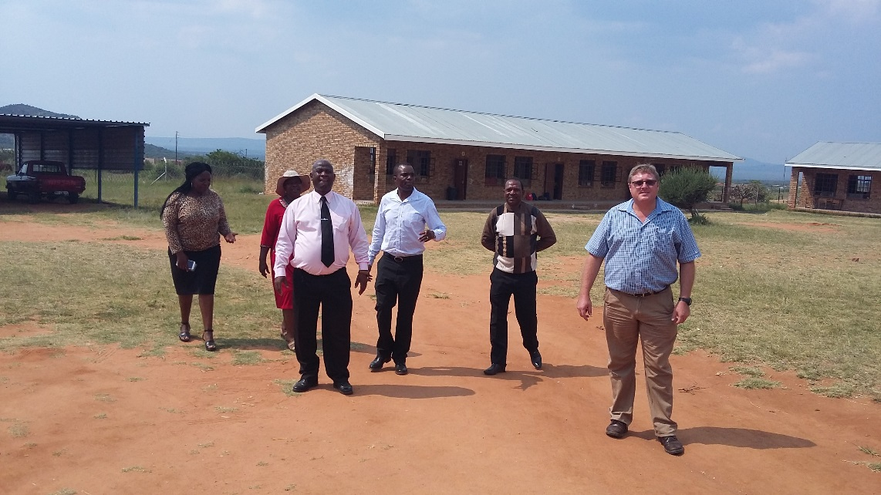 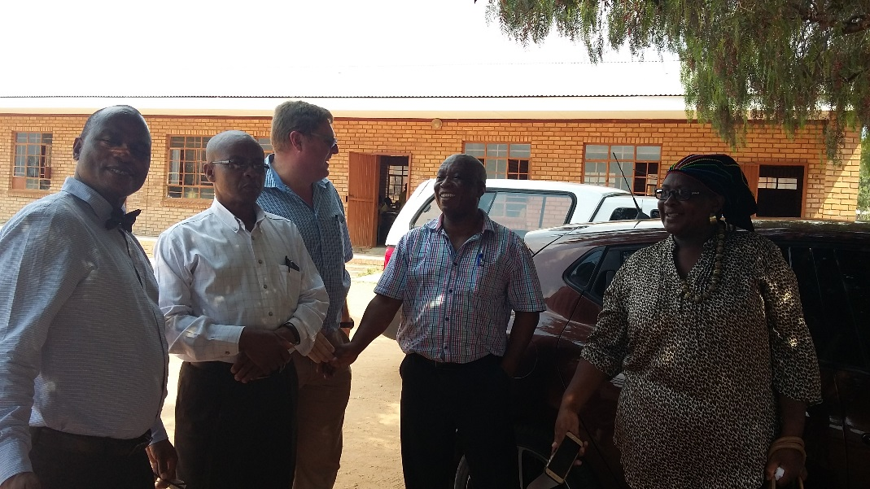

From left to right back: Marius and Harrison

From left to right front: Simon, Refilwe and Grace

From left to right back: Shapule, Joyce and Matsobane and Mapinini

From left to right front: Lesetja and Marius

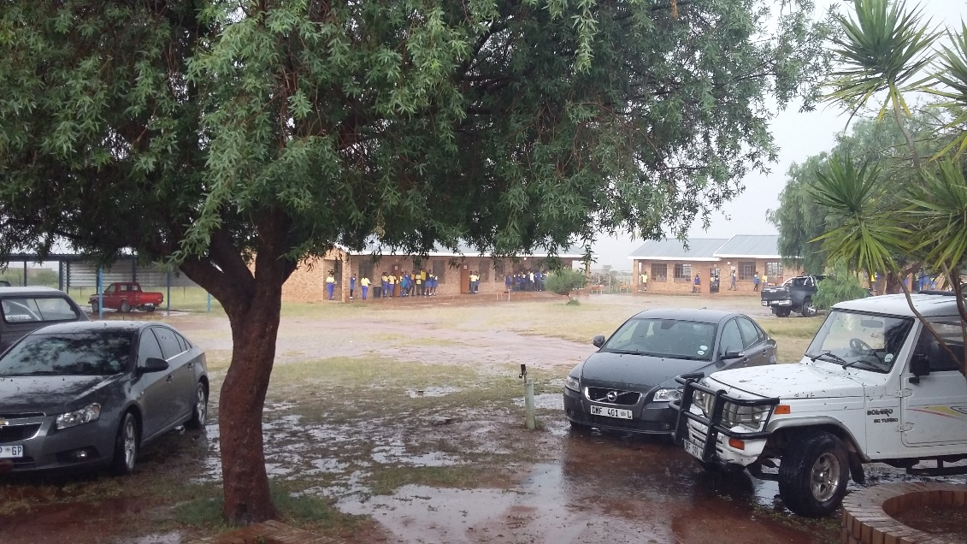 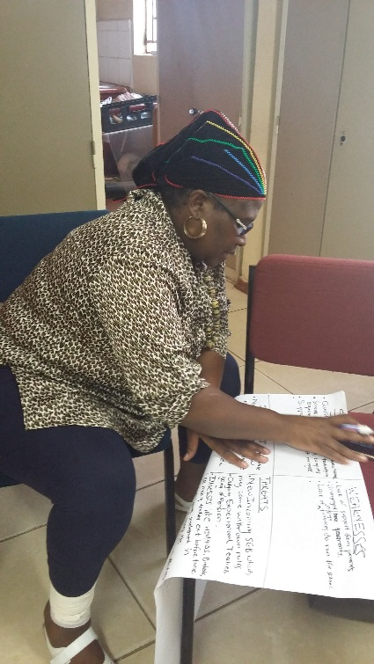 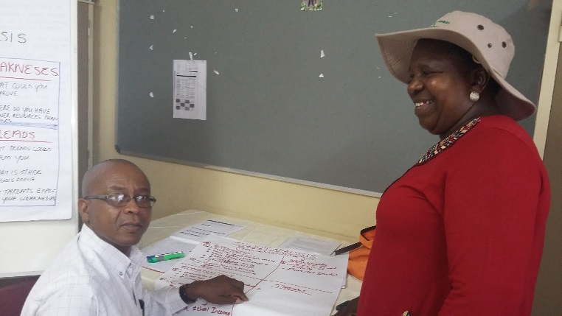

Refilwe and Joyce

Grace Sibara

Come rain, come hail, we go on at Ramathope CoP4

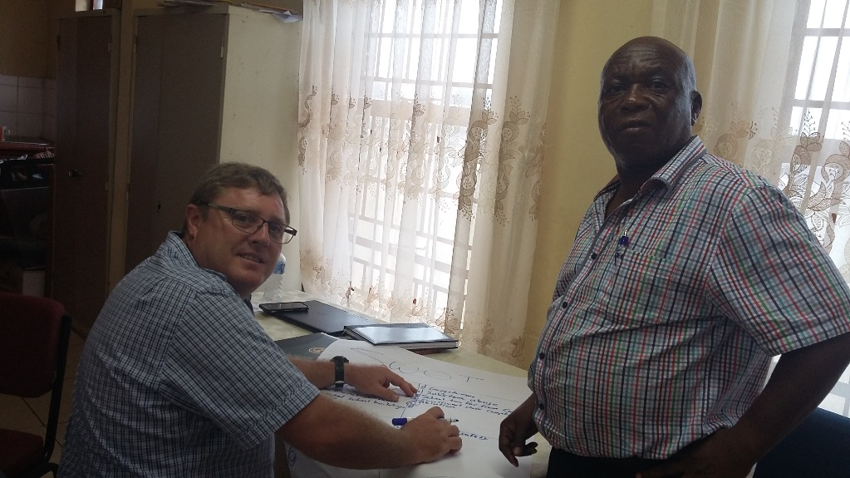 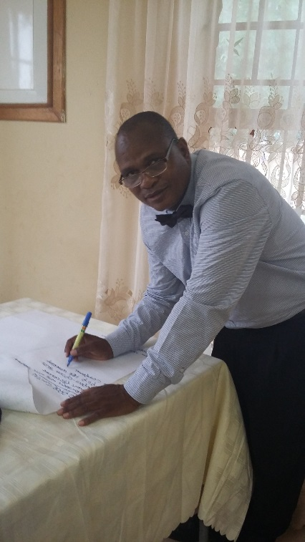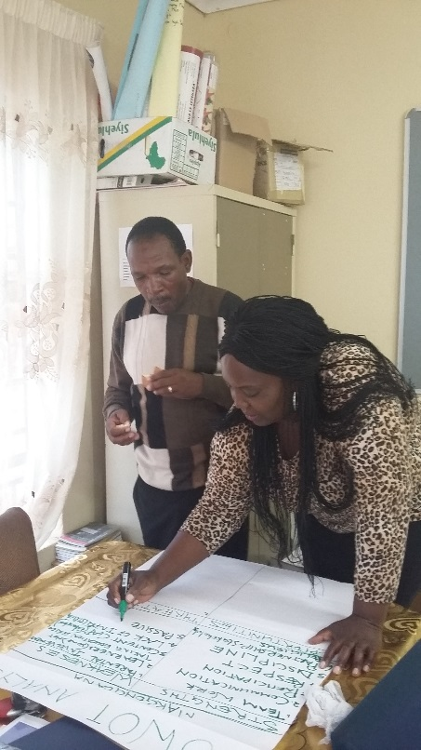

Mapinini and Shapule

Marius and Harrison

Simon Sebake

z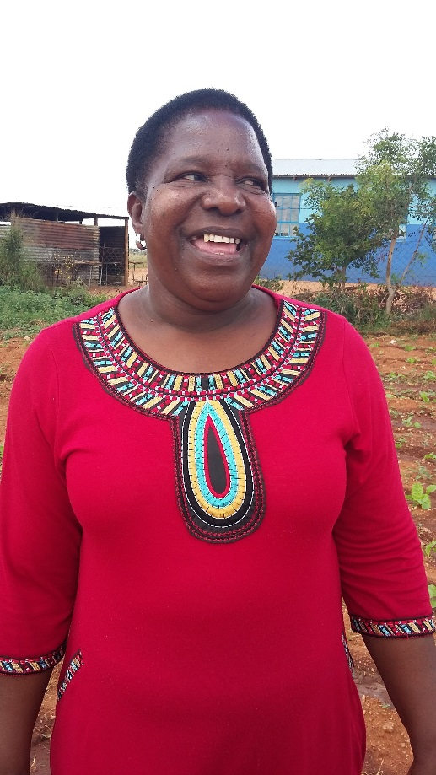 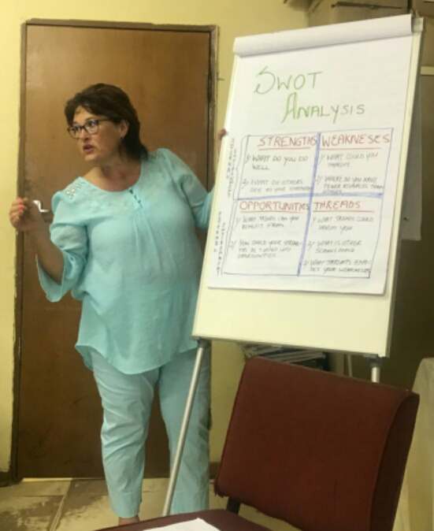

Marietjie du Toit - LPF