Report for Holiday Swim Program, August 2017
For Global Giving

Report for Holiday Swim Program, August 2017
For Global Giving
Swim Benin is a California 501c3 nonprofit established in January 2016. Our mission is to provide swimming programs and teach water safety in low-resource areas such as Benin, West Africa. We do this by promoting recreational swimming through developing partnerships with existing infrastructure in Benin as well as in neighboring African countries like Felix Fitness in Ghana. We are an authorized training center of Starfish Aquatics Institute in the U.S. Special thanks to Goggles for Guppies for their generous support.
Since our founding in 2015, we have held 4 swim events in Benin and we look forward to an even greater 2018.

Background of Swim Benin
I. April 2016 - Inaugural Instructor Training
Swim Benin’s first event was a swim instructor training. Held from April 4 - 11, 2016 at the Rada Hotel in Cotonou, founder Dan Airth traveled to Benin to host the event. Also participating was Felix Uzor of Felix Fitness who provided his expertise. Five instructors where trained; Henri Joel Amoussou, Carlos Bossouvi, Benoit Monctho, Sika Da Silveira and Olympe Fanou. Also attending was the prior Public Affairs Officer of the US Embassy Paco Perez.
- July 2016 - Baseball in Benin Swim Lesson
In July of 2016, we partnered with Baseball in Benin, an established nonprofit in Benin. We hosted 40 boys from the local baseball team to have a one day survival swim lesson. This also provided further training for our instructors . Our instructors were fortunate to meet with the CEO of Baseball in Benin, Wally Longfellow to plan this event.
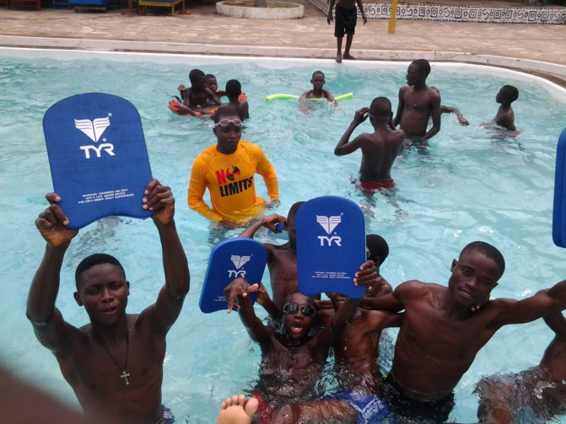
- December 2016 - Benin Swim Federation Instructor Training
From December 15th to December 17th, 2016, we expanded the instructor staff by organizing a 4-day instructor-only training session in the Olympic Pool at Cotonou Friendship Stadium. This training was held in conjunction with Narcisse Alognisso, coach of the Benin Swim Federation’s club. Four of the Federation’s swim instructors joined Swim Benin increasing our total instructors from 4 to 8. Also participating was Felix Uzor of Felix Fitness in Ghana.

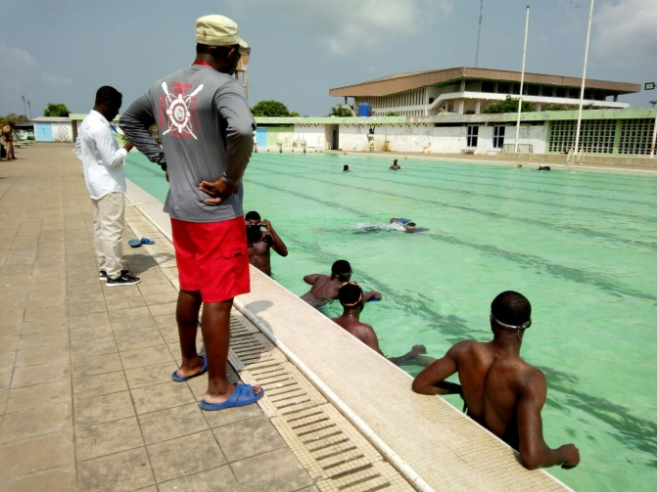
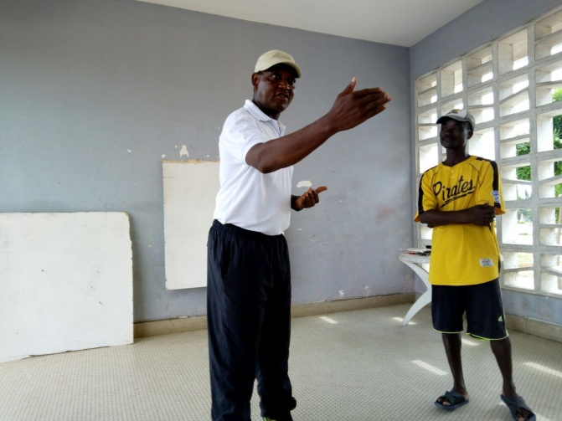
- June 2017 - World’s Largest Swim Lesson
On June 22, 2017, Swim Benin participated in the World’s Largest Swim Lesson, a worldwide event that took place at over 600 swim schools simultaneously. Starfish Aquatics Institute provided support for this event as well as the U.S. Embassy in Benin which hosted the event. The WLSL allowed us to gain publicity and a higher visibility in Benin and was a great success.
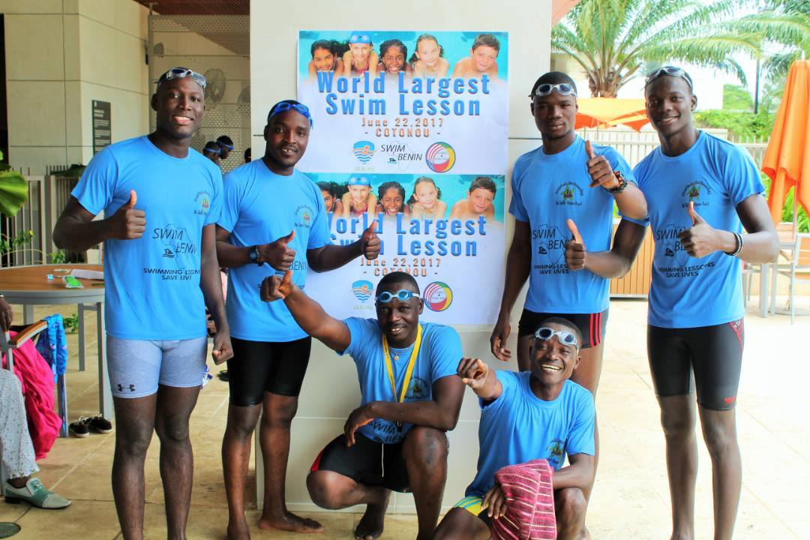
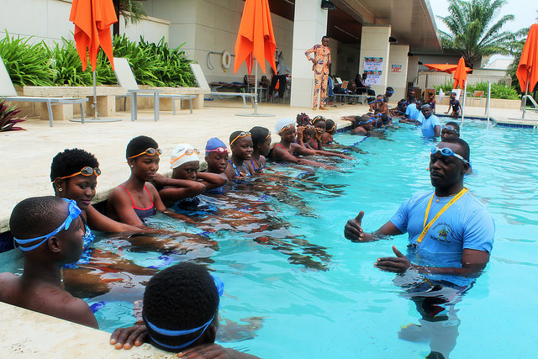

V. August 2017 Holiday Swim Program

Over 4 consecutive weekends last August, Swim Benin held its first swim camp over the holiday period in Benin. Called the Holiday Swim Program, the event was held at the La Capra Hotel in Cotonou.
The instructors trained sixty-one participants of all ages. Monika Rohmer, an associate swim coach from France, traveled to Benin for this event.
In one month, the following was acheived :
- introduction of 61 participants ages 3 to 45 years to swimming
- capacity building in swimming for higher level students
- an accelerated course of instruction in water rescue
- Training of swimming instructors and rescuers in CPR techniques
- Cross-cultural sharing of experience in swimming and water rescue.

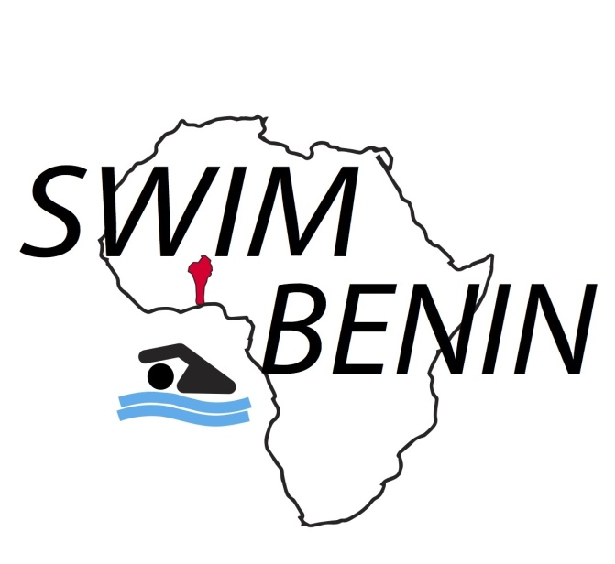

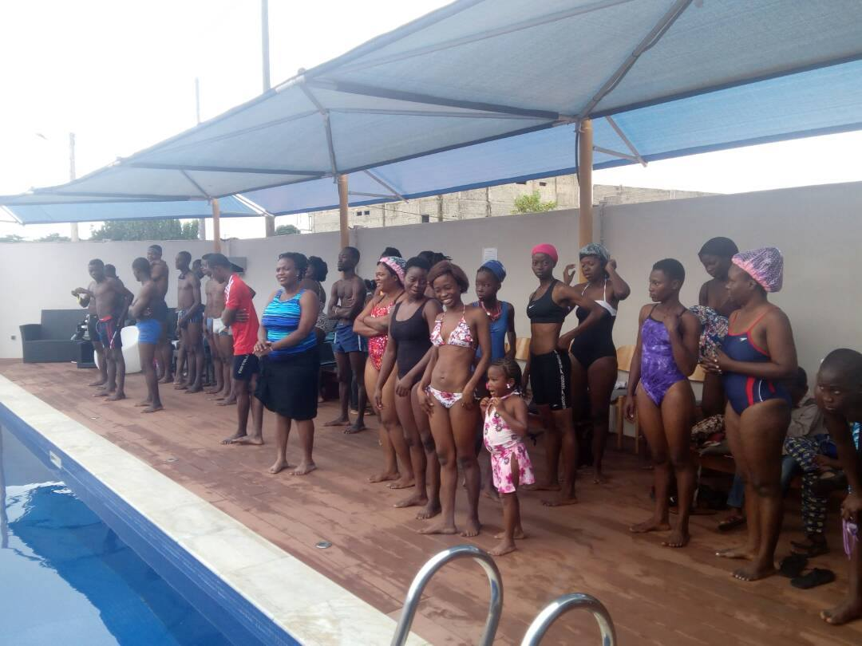 | 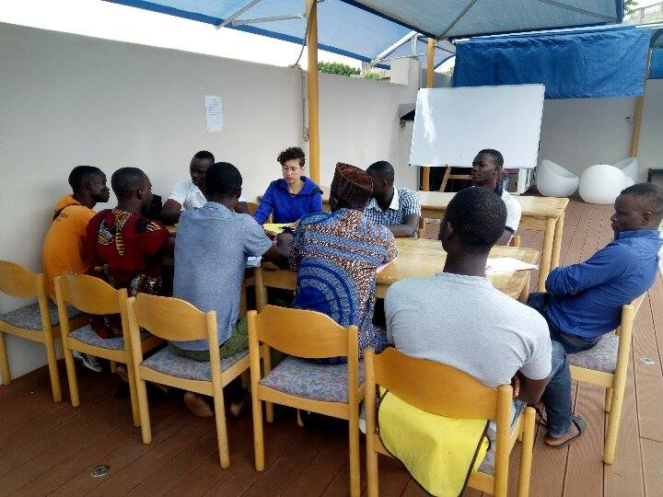
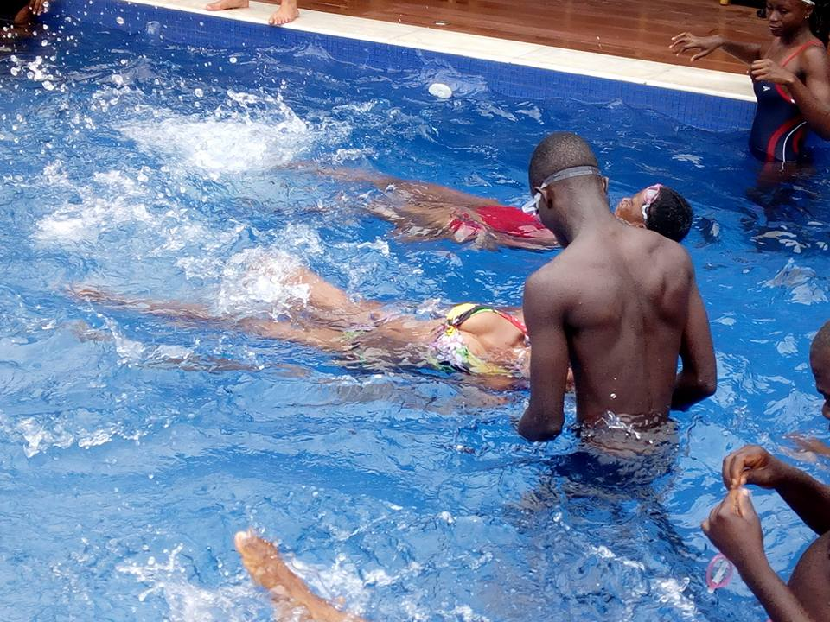 | 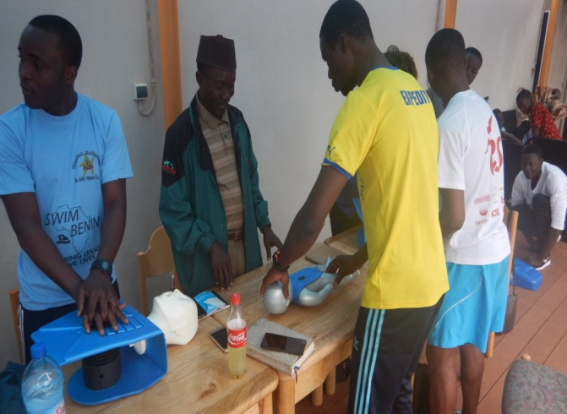
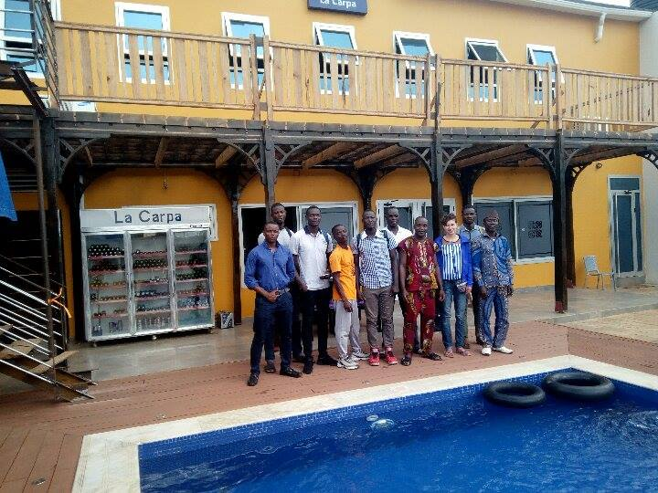 | 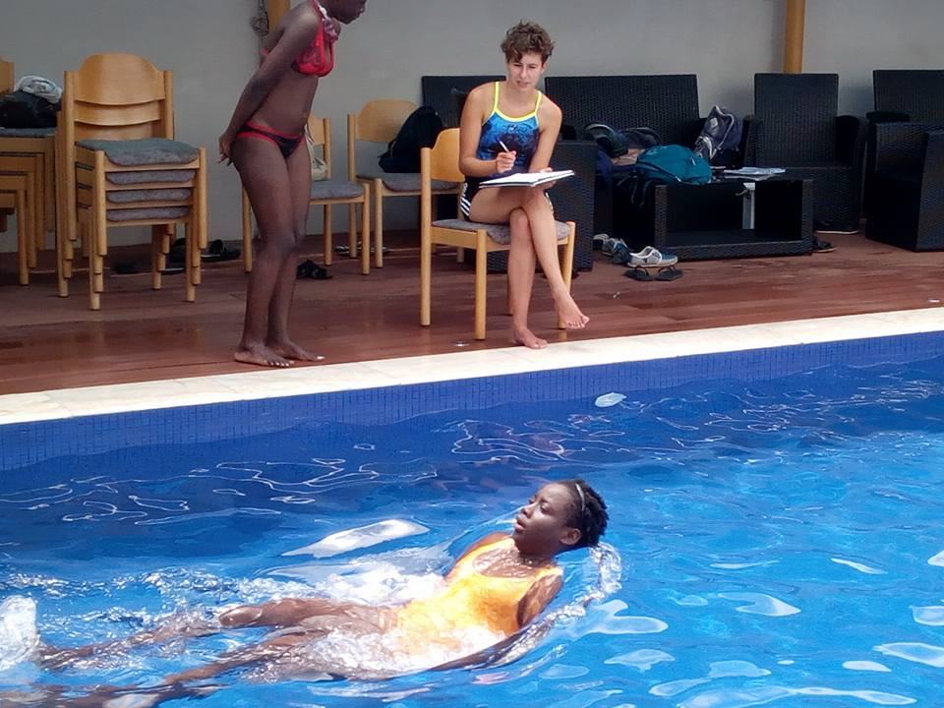
Holiday Swim Program, August 2017 La Capra Hotel

Swim Benin
Dan Airth, Founder
Henri Joel Amoussou, President
Carlos Bossouvi, Vice-President
Romuald Houegbeme, Secretary General
Expedit Atamnou, Assistant Secretary
Olympe Fanou, Treasurer
Monika Rohmer, Assistant Treasurer
Benoit Montcho, General Organizer
Rayane Alognisso, 1st Deputy Organizer
Rock Amoussou, 2nd Deputy Organizer
Narcisse Alognissou, Accountant

