Global Giving Water Wheel Report February 2018

Dalit Freedom Network

Dear Friend,

Thank you for your generous gifts to help provide water for more than 600 families across India. Here is an unedited report directly from the field in which your contributions are making a powerful difference.

Thank you for being involved,
Leah Kadwell
Strategic Partnerships

For the past two years, DFN has helped 675 families in Rajasthan, West Bengal, Uttar Pradesh, Maharashtra, Manipur and Tamil Nadu.

DFN’s India-based partner, Good Shepherd Economic Development, placed a new order for 100 more Water Wheel units for West Bengal to will be distributed end of June 2018. From the above order, 50 units will be distributed in one of the Kolkata slums as the women from slum were traveling a very far distance to collect their daily ration of water.

The women folk of these families are grateful to DFN for providing Water Wheels, as water fetching is mainly done by the women in the family. Hundreds of millions of women and girls spend hours every day hauling heavy loads of water to their homes. The time and physical and health burdens of water collection combine to trap entire families in a vicious cycle of poverty.
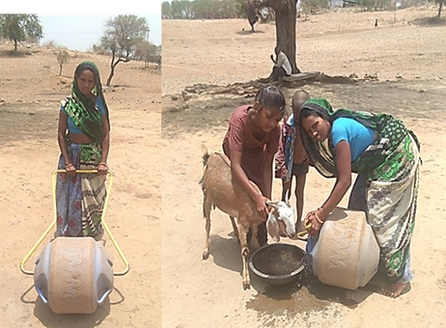
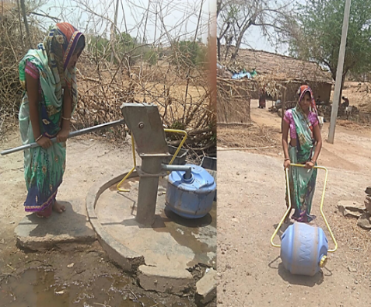
Isnaben (name changed) lives in a small village in the North Indian state of Rajasthan. She is 29 years old and is an active member of DFN’s locally-based Self Help Group. She spends most of her time bringing water for her 5-member family for use in cooking, washing and other needs. She has to walk two kilometers with four pots to bring water for her family and on average she makes eight trips per day in order to have enough water. As she is a DFN Self Help Group member and our field managers have learned of her struggle, we provided her with a Water Wheel. She has been using this unit for eight months and now she testifies how much time she saves. She is thrilled to be able to give more time to her family. She makes fewer trips to get enough water for her family with the Water Wheel and it is easy for her to bring without any strain. She is so thankful to DFN for making her life happy.

Laxmiben (name changed) is 30 years old and also lives in a small village in Rajasthan. She has been using the water wheel for past one year. She is also a member of a DFN Self Help Group and must get enough water daily for her six family members and three goats. She testifies that life has become much easier while bringing water with the Water Wheel. She, her family members, and ever her goats are so thankful.

