Global Giving Water Wheel Report February 2018

Dear Friend,

Thank you for your generous gifts to help provide water for 600 families across India. Here is an unedited report directly from the field in which your contributions are making a powerful difference.

As communities continue to exist and grow in numbers water is an essential requirement for human existence. But as communities grow so does requirement of water. But in the many semi-arid areas of Rajasthan state water has to be carried from its source to the villages and homes where people live. This is usually the burdensome duty of the women folk of each household, making it a physically straining task for them to carry water right on their physical bodies usually in pots and covering many kilo meters each single day. In this context a simple device for transporting water which does not require a big investment in obtaining it and also running it would be suitable. And the water wheel ideally suits this requirement of the rural poor in Rajasthan state and other places where people are afflicted with both, poverty and water scarcity.

Water Wheel Beneficiary

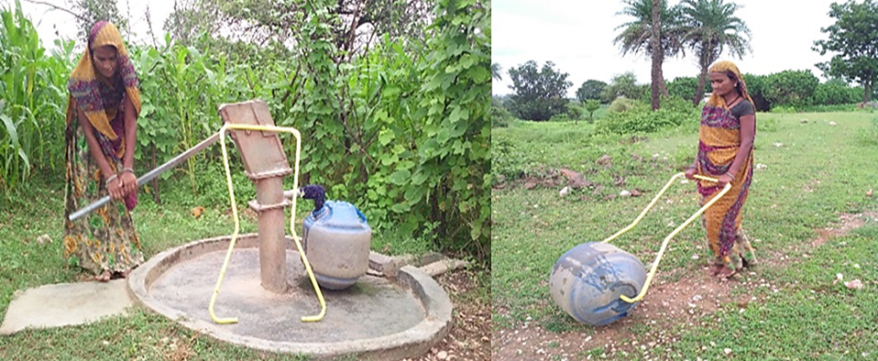

Sangita (age 25) is one of the Lamp group members since four years. She lives in a joint family system with seven family members who reside in Garadiya village of Baswada District of Rajasthan state.

Most of Rajasthan state is semi-arid at best and living with water shortages is a common feature for many here. For Sangita to fetch water for her family meant that she had to carry pots of water on her head and also in her arms which was not only laborious job but injurious to her physic and if this practice prolonged, it could leave her with severe bodily damage.

However, after the water wheel was introduced to her through her Lamp Group, it has hugely relieved her. Now, she can bring home lot more water for drinking and washing purpose from the tube well located five kilo meters away.

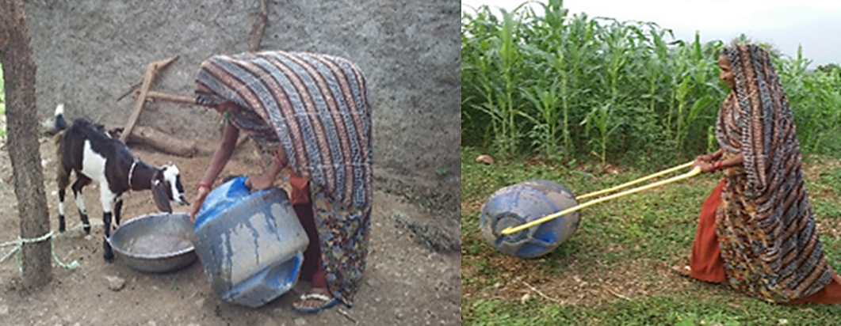

Sena (age 49) lives in a joint family system in Sagva village of Baswada District in Rajasthan state. She is a Lamp group member since three years. Her home is on a small hillock of this village.

This meant that each day for meeting the water requirements of her joint family, she had to walk down to the well/tube well at the foot of the hill and climb back to her house covering about nine kilo meters and the maximum quantity of water she could get to her house was barely a couple of pots.

But after the water wheel was provided to her, she now rolls twice that amount of water every day for her family to meet their drinking, and washing requirements. Even if she had to do this exercise twice a day, the load of weight on her physic was way less. In fact, the few heads of farm animals that they have also get enough water raising their yield significantly.

The above testimonial stories are only a symbolic few but each and every user of these water wheel is tremendously blessed with the irreplaceable benefits of the water wheels. Not only time and human effort is economised by these households that are using them but the women can now be lot safer from physical harm which they were otherwise exposed to when they used to carry water over their bodies. And now, they can more fruitfully pay attention to their families.

