

BEADS FOR LIFE
P.O. BOX 327-01100 KAJIADO,
TEL: +254714618060
EMAIL: goodliving1773@gmail.com

PROJECT TITLE:
Beads for livelihoods of 5000 women.
PROJECT SUMMARY: Good Living Initiative is embarking on a one-year program to combat household poverty in Kajiado Central constituency, Kajiado County in its quest to improve the lives of the women and communities in Kajiado Central constituency, Kajiado County.
Promoting and establishing income generating activities for the women and the communities to rise out of poverty, the program is aimed at buying beads and beading materials and improves the bead making skills. Due to availability of income the households will increase access to quality basic education, medication, clothing food and well-being.
Good Living Initiative is requesting funds that will support in the establishment of quality shades, beads, and bead making materials for the women at Kajiado Central. The bead making the buying of beading materials and beads is expected to take place as soon as the funds are available but shades are expected to be built within the 1st quarter of 2018. The project will be for a period of one year from the time funds are received.
THE AMOUNT OF THE REQUESSTED GRANT
Good Living Initiative is requesting for $30,375
GRANT BREAKDOWN
- Market shades – $11,572
- Beads and beads making materials – $8,281
- Marketing and promotion- $3,857
- Monitoring and evaluation - $4,339
- Training – $ 2,326

PROBLEM DEFINATION
Due to the current global economic crises, rural poverty in Kajiado central constituency community that have sent even more people unemployed, living poorer and migrating from rural areas to urban centers in the neighboring towns searching for employment, yet are neither competitive in the labor market nor become self-employed. Some of these people are women and uneducated youth. Most of the time, they come back to us for what we can do for them to continue supporting their families as well as coping up with this most stressful kind of life. Supporting for their living independently is the only way forward.
The household poverty is the single biggest factor preventing children from realizing their right to education, medicating, nutritious food, and well-being. The program aims to improve children’s lives and reduce the incidence of poverty that tends to flow from one generation to another. The effects of the current global macro- economic crises have played themselves out at the micro household level through crises shortages of food and fuel, the loss of employment, and the forced liquidation of family assets.
Women have to struggle hard to feed themselves and their children because of lack of sustainable sources of income for the household. They depend upon unprofitable microenterprises to feed their families.
SOLUTION TO THE PROBLEM
Supporting for the establishment of a quality beads project will help to reduce on the unemployment problem, provide and promote productive assets or opportunities that enable self- reliance among the women. This opportunity also will help to curb down the vicious and intergenerational cycle of poverty among children that tend flow from one generation to another in the rural communities of Kajiado Central.
POTENTIAL IMPACT
The project will improve the lives of 5000 women, 1000 youth and 1000 children allowing them to raise out of poverty which will provide for their families, health, food education, shelter and well-being.
PROJECT MESSAGE
I grew up in rural community of Kajiado Central in Kenya where women had minimal access to the basic forms of education and income generating activities; through this project we are turning these same women into a productive workforce in managing their own affairs.
KEY WORDS
Good Living Initiative is located in Kajiado Central Kajiado County in Kenya. It strives to improve the lives of the most disadvantaged people and communities in Kajiado Central through bead making and selling. In this case, we are going to support women and unemployed youth in Kajiado central to learn to earn a living on their own, thus promoting skilled hands for self-reliance.
EVALUATION, FUNDING MANAGEMENT, AND PLANNING:
To help the group achieve its objectives, we have set up a team to oversee the progress of every project that the group is initiating. This team of management involves people from the group and other experts from outside the group. We have also planned our program to occur in phases, to be completed within the stated timeframe.
For the effectiveness, efficiency and sustainability of the program, we have made compulsory for each member to pay a fixed amount of money equivalent to ksh.500 per month, through the sales of beaded products, to enable the group to meet its monthly operations, and to make all the members responsible of the facility as well as business operations and to give the members a sense of belonging as well as responsible program progress. The intuition behind the whole program is to make the group to operate on its own, without depending on the donors income for progress. The group has also appointed a team of five people with deep knowledge of auditing, to carry on an audit of all the group expenditures, in order to prevent the embezzlement of the group funds. The team has as well set leaders in each of the clusters, and set a time frame in which the programs and other activities can be conducted and reports given to the management. The report constitute a number of issues, but mostly the way each member has use the beads given and the outcomes of the sales.
BOARD OF DIRECTORS:
Good Living Initiative is fully formed. It has a Board of Directors composed of two people. The overall role is to oversee the progress of the group and forecast for new opportunities to increase the group’s income.
Board of Directors and Contact Information
Name Role Contact
Mrs. Ann Tobiko Chief Executive Officer +254722240211
Mr. Moses Kantasi Logistics Manager +254724709556

BUDGET:
LIST OF EXPENSES AND COSTS FOR THE PROGRAM
Expenses | Estimate Amount (us dollar)
Market shade Construction  Beads & other materials purchasing  Marketing and promotion  Salaries, monitoring and evaluation  Members Training | 11,572  8,281  3,857  4,339  2,326
Total expenses | 30,375

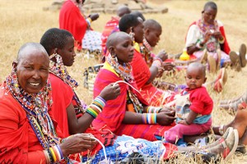

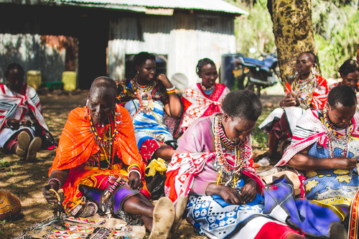

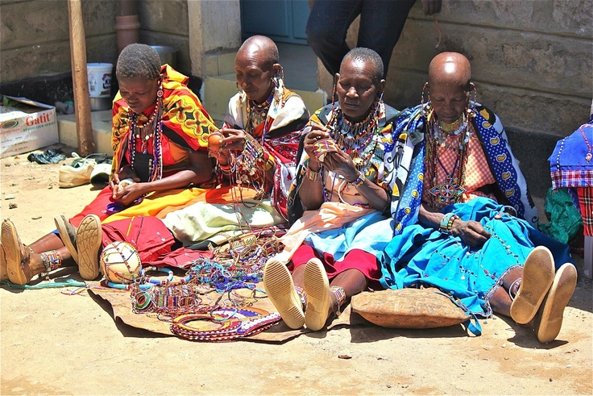

Maasai women making beads during a market day in Ilbissil.
Prepared By: Mrs. Ann Tobiko, CEO
Signature 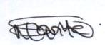 Date; September 26th, 2017
For Good Living Initiative

