Global Giving 1000 Day Report February 2018
Dear Friend,
You subscribed to email updates from 1000 days - Education & Support for Mother & Child by the Dalit Freedom Network (formerly by RED International), a project on GlobalGiving. Here's the unedited update from the field.

Thanks to your support, the Dalit Freedom Network was able to continue funding its Community Health Workers (CHWs) as they play a key role in caring for antenatal and postnatal women. The 77 CHWs working for our partners, the Good Shepherd Health Initiative and the Good Shepherd Schools, send regular reports of how they have helped women take better care of their own health and the health of their babies.

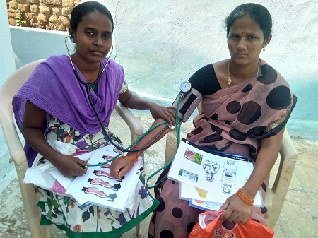
The probability of a good pregnancy outcome is greatly increased if antenatal women attend local primary healthcare facilities for basic antenatal care. However, often these clinics are busy and focused on delivering key interventions, such as tetanus vaccination and iron and folic acid tablets. The staff do not have time to spend with the women themselves to address their understanding of pregnancy and care of the new-born.

This is where the CHWs can really make a difference - as these stories from the CHW Radika illustrate:

Whilst visiting Bondugula village she met a 34 year old woman who was pregnant. The woman asked Radika to check her blood pressure, which she did. She also checked that she had visited the PHC for antenatal check-ups and a tetanus injection. The woman replied that she had. However, Radika was concerned that she appeared to be anaemic so got out her flash cards on nutrition and spent time with the woman explaining the key aspects of a healthy diet, particularly iron rich foods. She also encouraged her to take the iron and folic acid tablets that she had been given at the Health Centre.

She explained to the lady that healthy diet, as well as her iron and folic acid tablets, is very important if she wants to deliver a healthy baby. She left with the encouragement to visit the PHC for her second tetanus injection.

When her returned the following month she found that the woman had followed her advice – she looked bright and healthy. She asked to go through the flash cards again as she wanted to understand more of the information the Health Worker had given her.

The woman said,” I have not heard about this kind of teaching and for the first time I am hearing. I am five months pregnant now.” The CHW said, “Follow the same things till you deliver your baby and even after delivery. I will come and visit you again.”

The pregnant woman said to the CHW “Thank you so much for coming.”

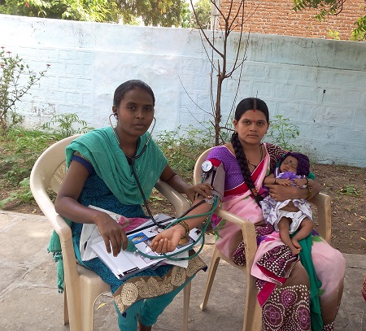
On a different day Radika visited the same village and visited a 27 year old lady called Jyothi, who had delivered a baby boy three months previously. Both mother and baby appeared pale and weak so Radika asked in some detail about the diet Jyothi was eating. She discovered that Jyothi’s diet was very low in vegetables and iron rich foods. She reached for her flash cards and taught Jyothi about healthy eating and its importance for the breast feeding mother. Both Jyothi and her husband listened carefully and when Radika had finished and the discussion was over, Jyothi said:

“Now I understood what will happen to my baby if I do not eat healthy food. I want my baby to grow healthy. I will only breast feed my baby. I do not want to lose my baby. So to have enough milk I will follow good healthy diet as you taught me”

Twenty five days later the CHW visited them again. Both the mother and baby gained little bit weight. The CHW did the normal check-ups and bid bye to the family.

The woman touched the CHW’s toes and thanked her for her teaching and visit. “It is been a great help to her and the baby. We as a family will never forget your help, said the woman.”

Based on the figures obtained from 365 reports from 65 health workers collated over a period of twelve months, it can be estimated that each health worker sees approximately 9 antenatal or postnatal women each month. This represents 28% of their time spent with individual patients.

This was estimated as follows:
- 3,288 contacts reported from 365 reports = 9 contacts per month for each health worker.
- 3,288 ANC / PNC contacts as a proportion of the total number of patient contacts, 11,604 = 28%

For 77 health workers, this equates to over 690 contacts for every month that they visit villages, or over 6,900 antenatal / postnatal contacts per year. Health workers check blood pressure and signs of pregnancy complications. Antenatal teaching at individual or group level is facilitated by visual aids provided by the health worker project.

