PROJECT: PREVENTION OF YOUTH VIOLENCE IN AYACUCHO, PERU

1.HISTORY
a) Summary
In Ayacucho, Peru, there are a high number of at-risk adolescents and young people, with many unmet basic needs. This does not only include unmet needs on a physical level, but also on an psychological and social level. Adolescents and youth from the poor sectors suffer economic shortages to pay for their food; live in precarious housing; and work in underpaid and poor working conditions. They do not have spaces for socialization and less attention for their health. In addition to these shortcomings, the youth have serious problems of family violence, sexual violence, poor social and communication skills, low tolerance to frustration, and other situations that make them vulnerable.
These difficulties make young people seek attention, affection, and spaces where they can be heard. In that search, they meet other youth and are taken to consuming alcohol and drugs, enter into gangs, human trafficking, and committing crimes, among other situations that make their lives much more vulnerable.

Our work is carried out in three extremely low-income neighborhoods, where we have opened three premises - to offer an Alternative Youth Space. It is an alternative space to alcohol, drugs, and violence. It is a space for building friendships, positive socialization, and healthy learning (especially for improving reading comprehension and mathematics). It is an extra-curricular space for the youth to participate in during their free time. In short, this program includes a series of activities for adolescents and at-risk youth to develop their skills and abilities, and socialize in a healthy way. It will help them have a better today, so they will have a better future. This project will contribute to today´s youth in Peru and society as a prevention of youth violence promoting a culture of peace.
In the three Alternative Youth Spaces, various activities will be carried out with adolescents and youth, such as: the creation of a youth group with the participants; team work; life skills training; educational program; art, dance, and music; and activities in the neighborhood. These Alternative Youth Spaces will also have a recreation room and library with a reading space that they will be able to share with other young people in the neighborhood.
b) Challenge / Problem
It is an alternative space to alcohol, drugs, and violence. It is a space for building friendships, positive socialization, and healthy learning (reading comprehension and mathematics). We need to cover expenses of the activities in the three Alternative Youth Space locations. Therefore, we need to raise at least USD 10,000.
With the financing, it will be possible to pay the rent of the three premises in order to operate the Alternative Youth Spaces. In addition, it will be possible to have a social educator in each zone and we will be able to buy books, equipment and acquire recreation materials.

c) Solution
With the donation, adolescents and youth will avoid falling into situations of violence, drugs, alcoholism and other problems; improve their family ties and relationships; improve their psychosocial skills and abilities; manage their emotions and feelings; control their impulses; and will practice positive attitudes of interpersonal sociability and group development.
The youth will develop and strengthen their values such as: punctuality, teamwork, respect, solidarity, among others. They will have a healing and therapeutic space to lower their aggressive behavior and improve their self-esteem.
They will be social actors of their own change and reality, participating actively in activities of social projection for the benefit of their neighborhood and their community.

d) Long-term Impacts
The project is long term as it is intended to have these Alternative Youth Spaces for several years. We want to serve adolescents and young people in the most difficult and vulnerable moments of their lives. We want the youth to be able to heal their wounds, be empowered, and be strengthened as citizens of society. We want to strengthen their organizations so that they can achieve better living conditions, to which they are entitled to as human beings and as participants of society. The proposed project is for one year with the hopes of continuing in the future.
e) Resources
CENTRO LOYOLA AYACUCHO
Web : www.loyolaayacucho.org.pe
Facebook : Loyola Ayacucho Center
Link video: https://mega.nz/#!BEUAxBoD!5VZYzqiuh9-ZdpVVHfDzmPnmwPd9Hy4LRqPzRZsabIY

Testimonials:
Testimony 1.- "My mom screams at me a lot, she's always nagging and complaining about me. I do not like being at home. On weekends I work at my aunt's house and she gives me tips. My stomach hurts all the time, some days I do not have anything to eat at home. Seldom is my mom at home". (Mayra Elizabeth Quispe - 13 years old - Participant of the Alternative Youth Space of Quinuapata).
Testimonials 2.- "I live alone with my 16 year old brother in a rented room. My parents work at the farm and come once a month to visit us. Being alone makes me go to the internet booths most of the time, and I go to be with my friends in the streets. A while ago I joined a gang at the insistence of my friends; but they drank, smoked, and once I saw a young man get assaulted in the neighborhood. I wanted to leave, but I could not because they threatened me and at one point they even beat me. I could not leave the group. Out of fear I had to change where I lived to another neighborhood."
(Daniel Enciso Moya, 14 years old Youth Group United for Change - 2016)"
Photos
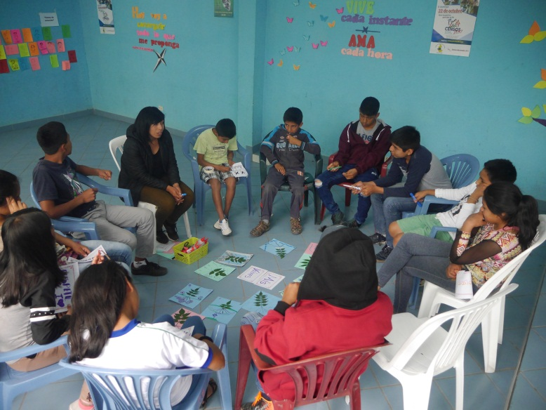
Group workshops that include topics of: teamwork, sexuality, managing emotions, leadership, self-esteem, and more.

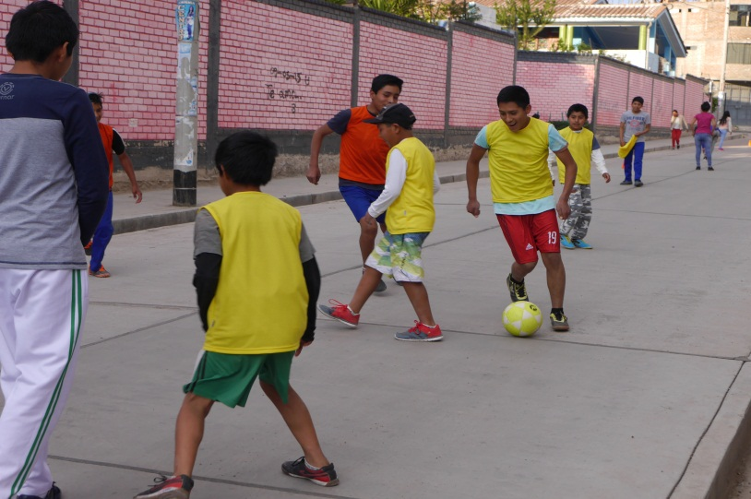
Recreation and sports: practicing skills and teamwork through sports and group activities. This gives the youth an alternative space to participate in, reducing the risk of gang activity.
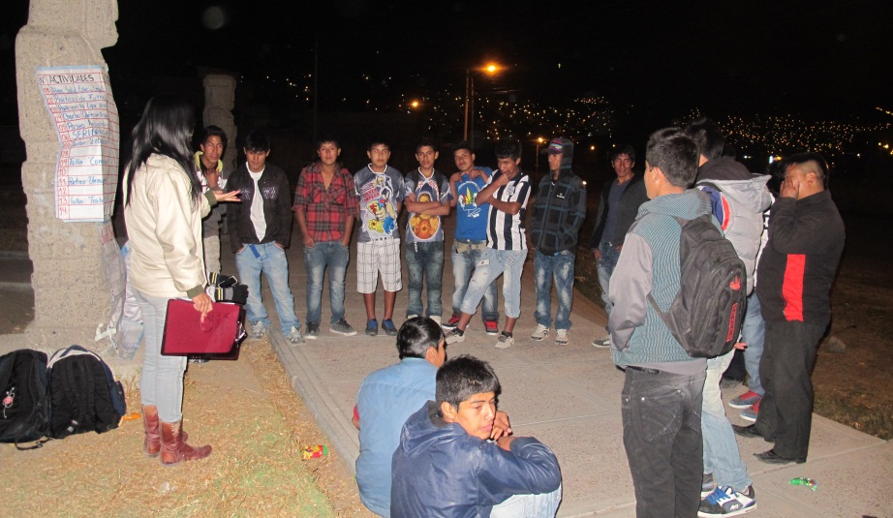
Meeting Youth Where They Are At: At times, our staff give workshops and presentations in the street as that is where the youth are. Engaging the youth where they are at is critical in developing trust and confidence of the youth.

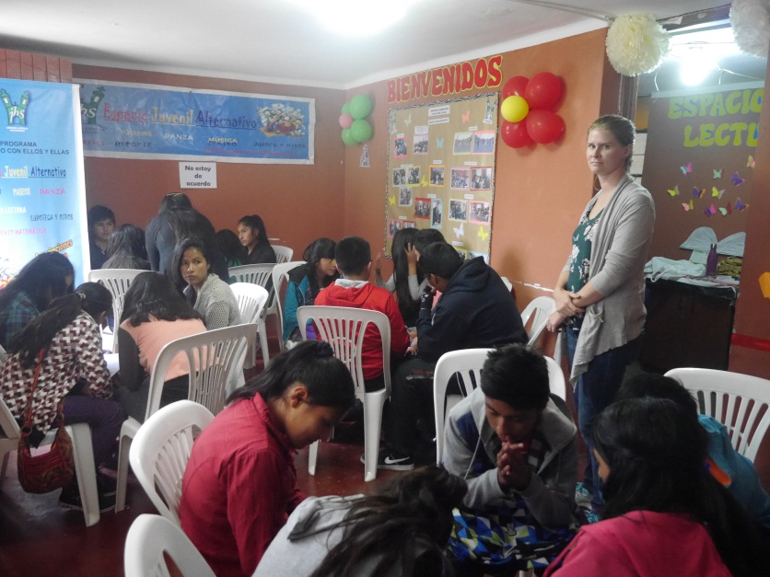
Positive Role Models: The staff promote positive values and socialization to the youth. Many of the youth come from backgrounds with family violence, poverty, and neglect as their parents work in other cities.

