**PROJECT ACTIVITIES REPORT**

Prevention of youth violence in Ayacucho – Peru

Operation: work in three vulnerable zones of Huamanga

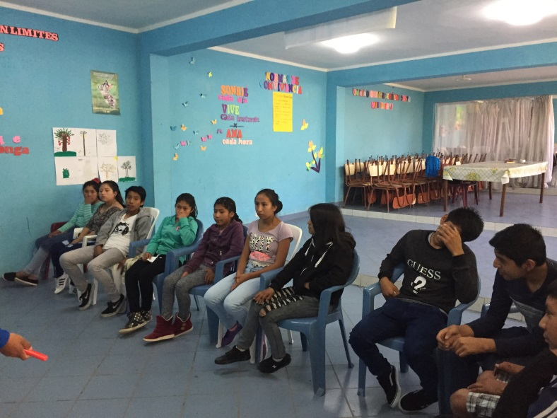 This year 2018 the Alternative Youth Spaces work in three zones of the city: Zone of the Peace in the District of Carmen Alto, Zone of Quinuapata and the Zone of Covadonga both in the   
in the District of Ayacucho.

During the months of March, April and May, the Alternative Youth Space - EJA of the three zones works three times a week with training, play and social projection activities for the benefit of adolescents and the neighborhood.

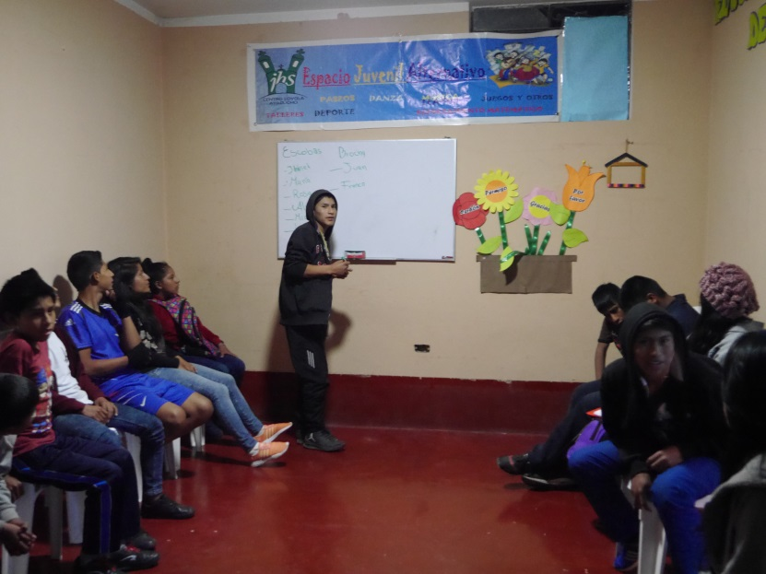 In the EJA, other types of activities are also developed with the adolescents, such as: weekly group meetings, life skills training, reading comprehension reinforcement, education through art, playroom space, reading space, walks, learning spaces fellowship, video projection, etc.

The various activities offered help adolescents and young people find spaces and opportunities for personal change to find meaning in their lives, especially when they carry out positive activities for the good of their neighborhood, such as painting the soccer goal, taking care of the park, pass a movie to the community, among others; the same ones that allow them to improve their image in front of the leaders of their neighborhood and their neighbors in general.

**REINFORCEMENT IN READING COMPREHENSION**

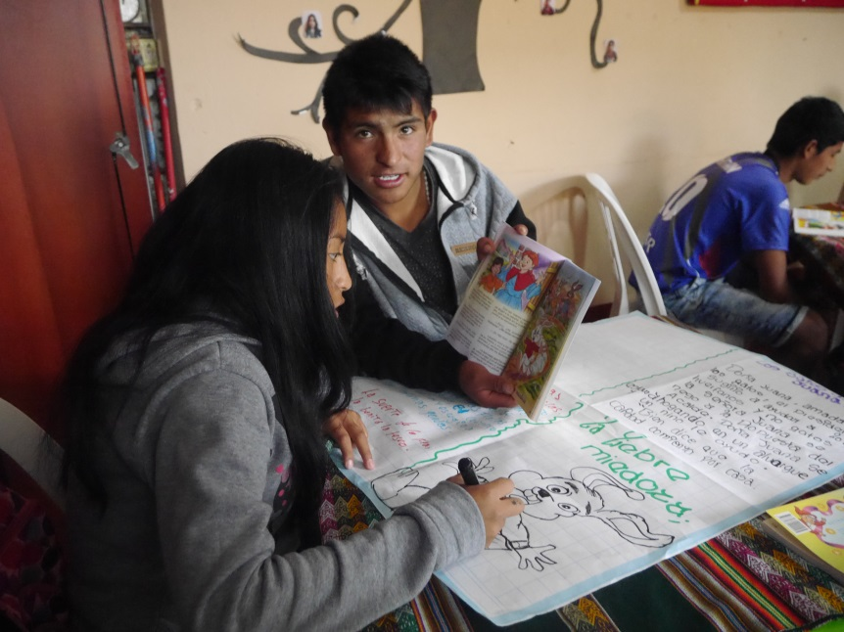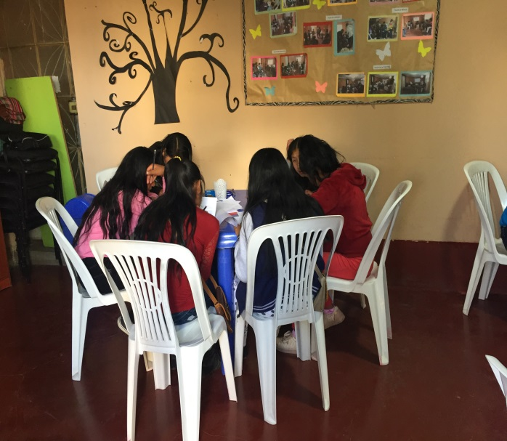 During these months, reinforcement activities are being carried out in reading comprehension to adolescents, activity that occurs once a week in the three areas where the EJA are.

For this activities are performed as: reading of some books chosen by adolescents, the same ones who read aloud to improve their reading ability, in addition the adolescents are losing the fear and the shame of reading in public and it is generated in them the taste for reading.

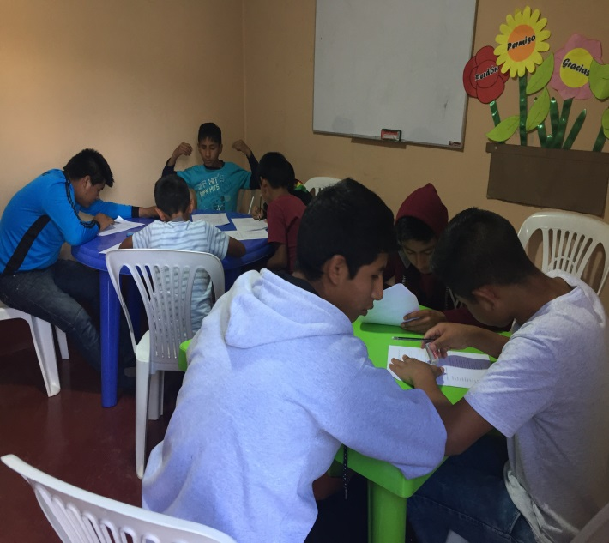

**INFORMATION WORKSHOPS**

**Workshop: "What is an organization"**

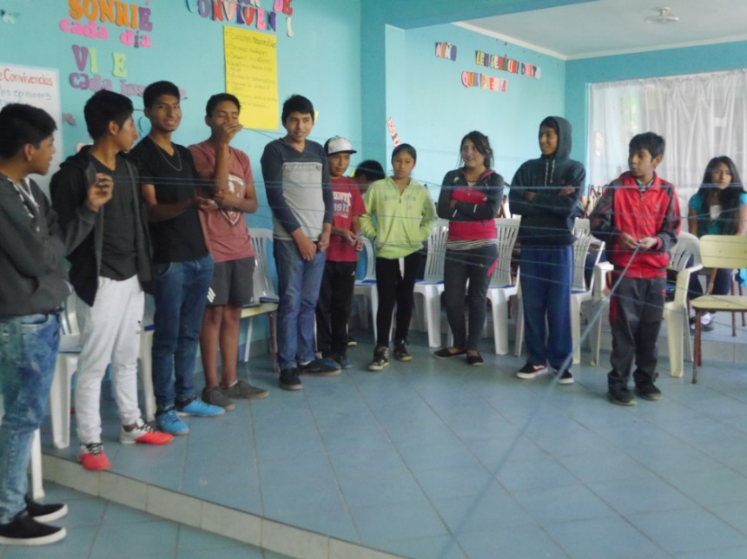

The Organization workshop was held in May with the adolescents of the Alternative Youth Space of the Quinuapata and Covadonga areas.

The difference between what is a group and what is an organization was presented; the importance of an organization; how an organization is formed; among others.

The activity is carried out in a playful and practical way. They are reinforced with participatory dynamics that strengthen group cohesion.

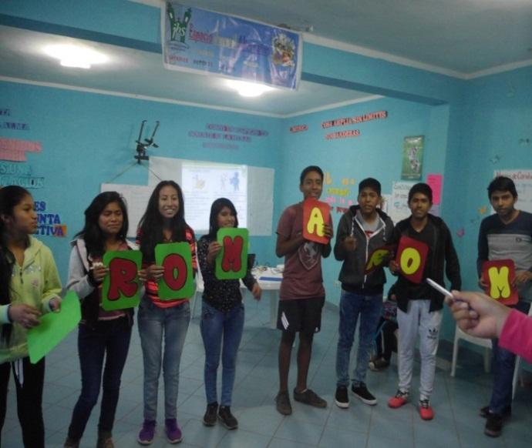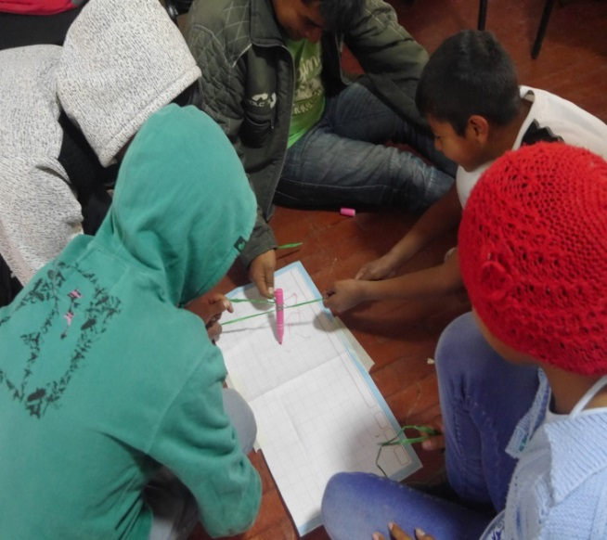

**ARTISTIC AND SPORTS ACTIVITIES**

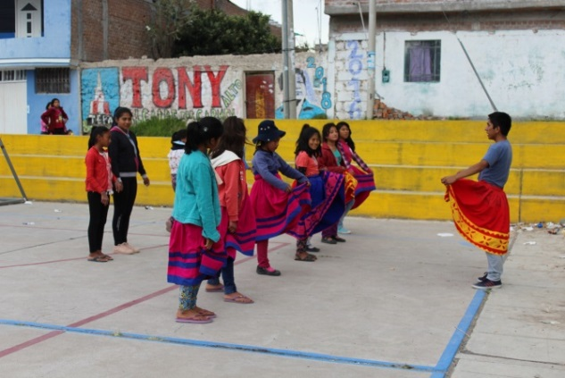

In the Alternative Youth Space of the three Zones, during these months there have been various artistic activities such as: dance, music and sports activities such as football and basketball.

The activities are carried out in the same premises and in the neighborhood where the adolescents live, they have a teacher who teaches them the different specialties.

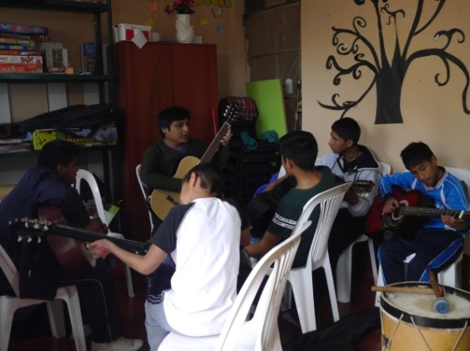With artistic and sports activities adolescents occupy their free time doing positive and recreational activities, it is through these activities that they practice different values ​​such as: companionship, cooperation, "healthy" competition; it also serves as a means of motivation for solidarity, integration and responsibility. This also allows adolescents to develop their skills, integrate as a group, lose their fear in front of the public, as well as reduce stress and value their culture.

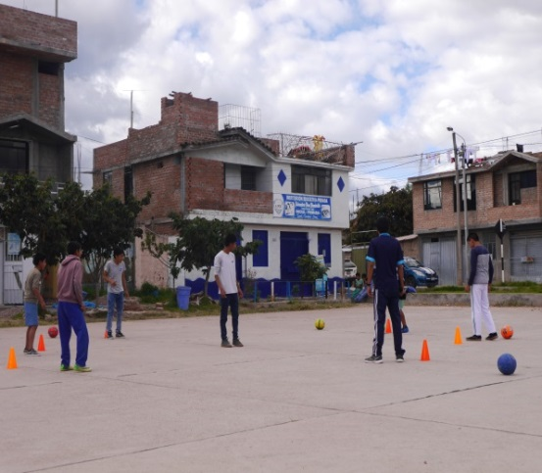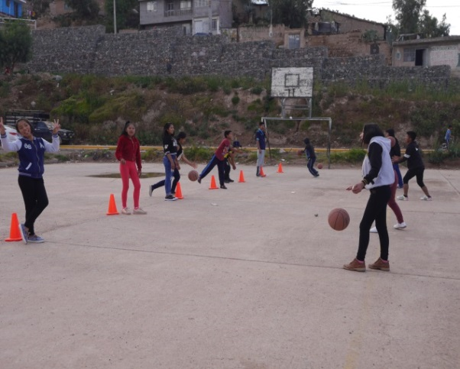

**SPACE OF LUDOTECA**

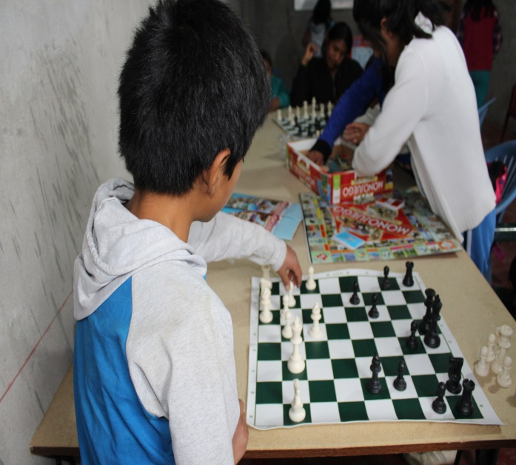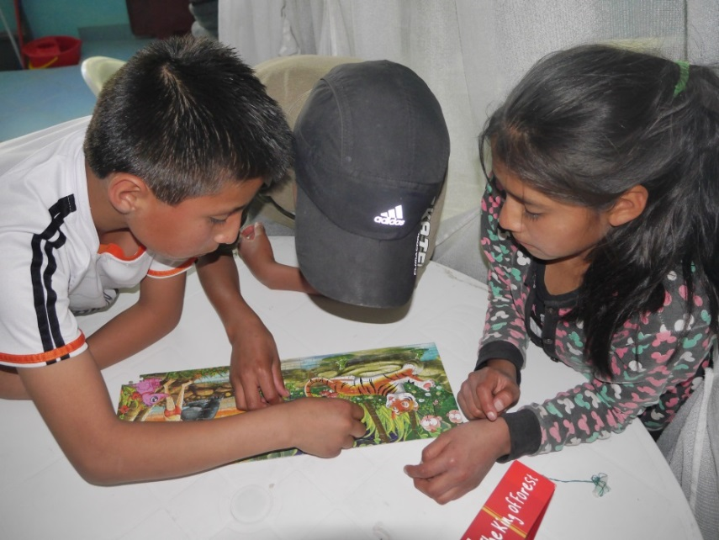Durante During these months, the Ludoteca space has operated in the three zones of the Alternative Youth Space. The teenagers have been able to know and use different playful and educational materials such as: chess game, monopoly, ludo, cubes, among others. The adolescents, according to their abilities and preferences, choose and perform the game. Group play is promoted to encourage solidarity cooperation and teamwork. In the playroom space you could see the skill for the game, the skill, teamwork and camaraderie among them, as you can see how some teenagers teach their classmates to learn to use the rules or techniques of each of them. the mentioned games.

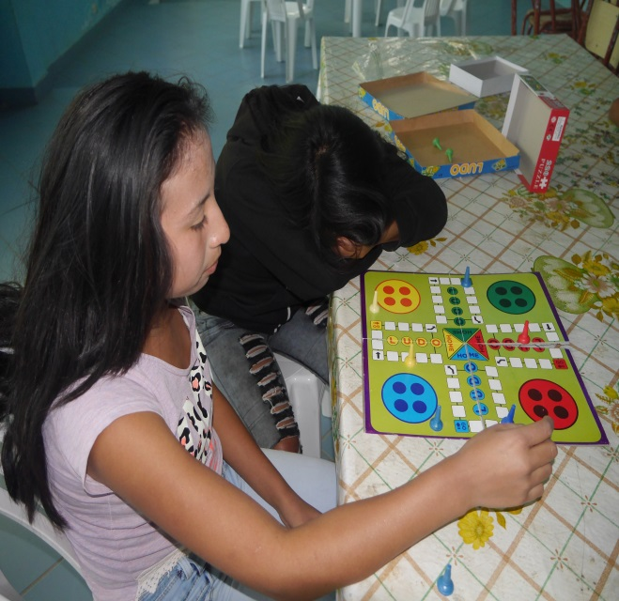

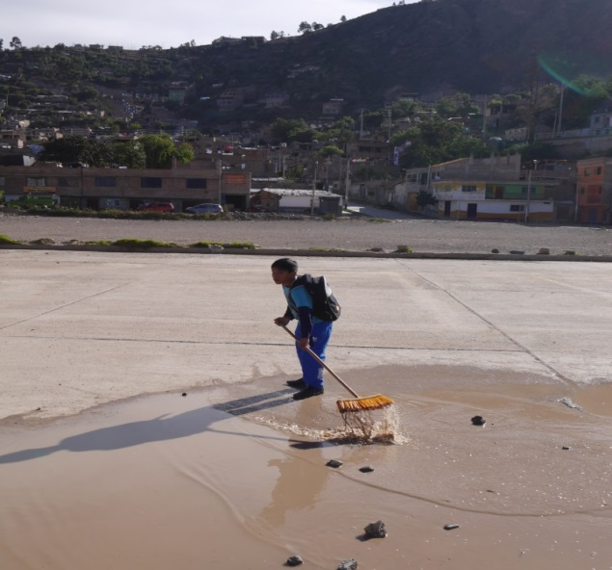**SOCIAL PROJECTION ACTIVITIES**

During these months of work the adolescents carried out various activities of social projection such as: cleaning the sports field of the neighborhood, making pots with recyclable material and showing video to the community.

With these activities, the adolescents have the objective of raising awareness and awareness to the neighbors for the care of their community and demonstrate that they are responsible people in the care of the common good.

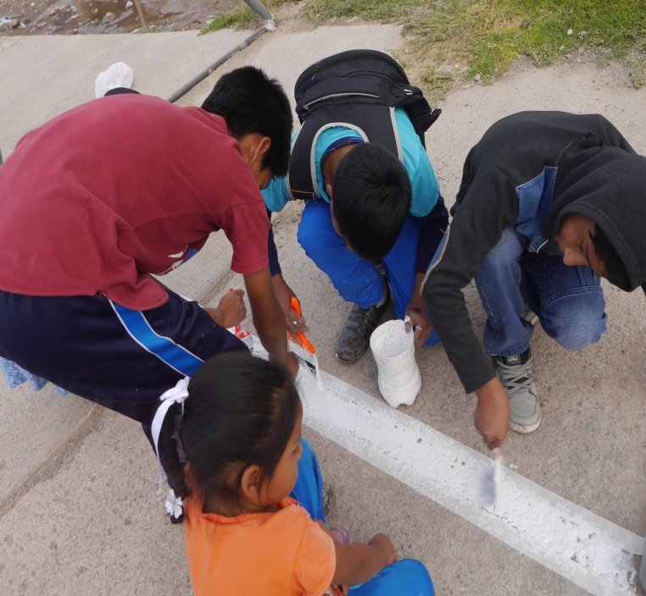

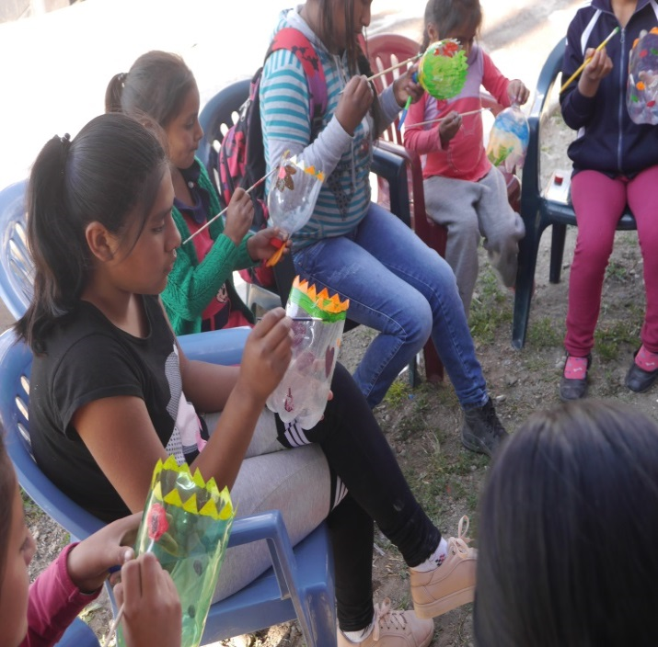

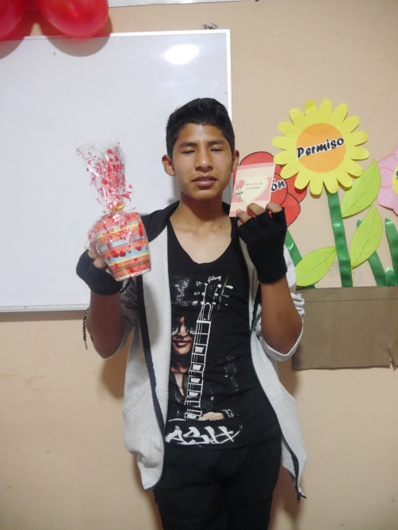**SHARE FOR MOTHER'S DAY**

In the month of May, a session was held to "share" for Mother's Day in the Alternative Youth Space of the Quinuapata area, with the active participation of mothers of adolescents.

The purpose of this sharing was to provide a space for confraternity between mothers and children, where adolescents expressed emotions and feelings towards their mothers, each adolescent handed a small present to their respective mothers or guardians.

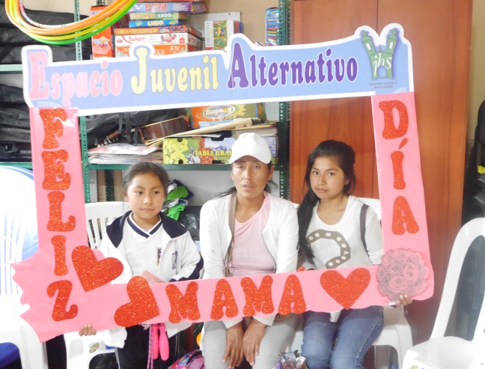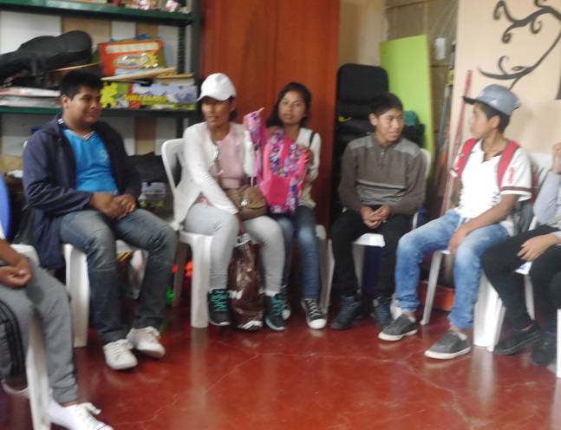

**¡¡¡Gracias!!!**