**Project activities report**

**Prevention of youth violence in Ayacucho – Peru**

**Project #: 30423**

**(1) Mapping of actors**

In January, the actors' mapping was started, which consists in locating in the intervention area the people, institutions and organizations that can be allied to work in a coordinated manner.

We are mapping the actors in the three intervention areas: Covadonga, Quinuapata and Quicapata, so we get to know better the people, institutions and allied organizations with which we can count on for an articulated work for the good of adolescents at risk and the community.

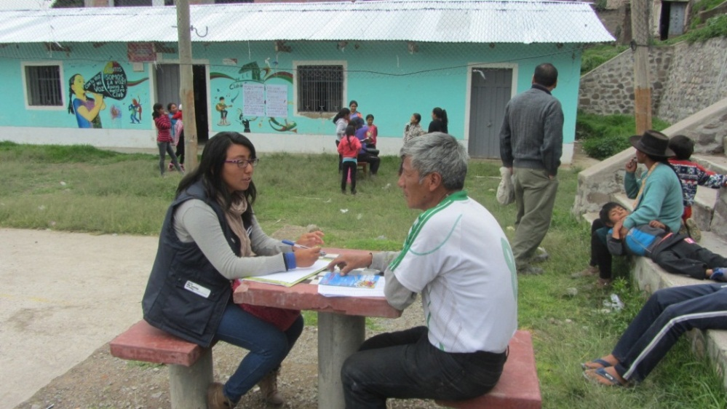

**Interview with a leader of the Quinuapata area**

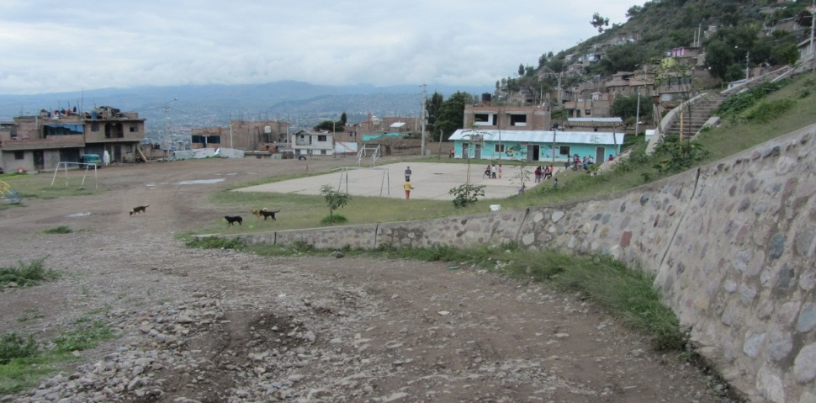

**Recognizing the area of intervention of Quinuapata**

**(2) Start of work with adolescents in the intervention areas**

This year 2018 the Alternative Youth Spaces will continue to operate in three areas of the city: Quicapata Zone in the Carmen Alto District, Quinuapata Zone and the Covadonga Zone both in the District of Ayacucho.

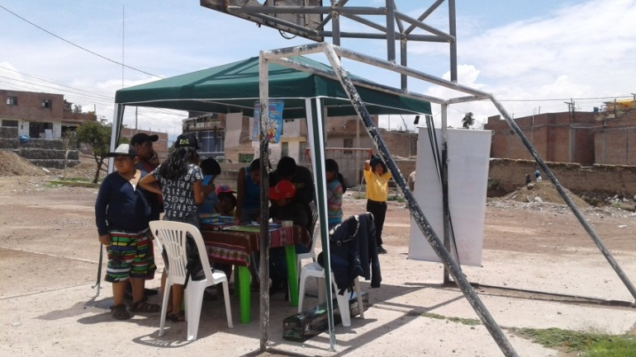For this reason, during the months of January and February various actions have been carried out, inviting the adolescents of the past year to register in the different intervention zones, and also so that new adolescents can be included to participate in the project.

The call was made with various materials such as posters, flyers, personal information, among others.

The various activities that will be offered in the Alternative Youth Space will help adolescents and young people to develop their skills, abilities, to find opportunities for change and a meaning to their lives. It also includes the participation of adolescents by carrying out positive activities in their neighborhood, such as cultural, recreational, recreational and social activities.

**(3) Signature of interinstitutional agreement**

The signing of the inter-institutional agreement of the Loyola Ayacucho Center with the Educational Institutions Francisco Bolognesi and Carlos Montes de Oca was carried out, in this way it will be possible to work jointly and in coordination with the adolescents and the area where they live.

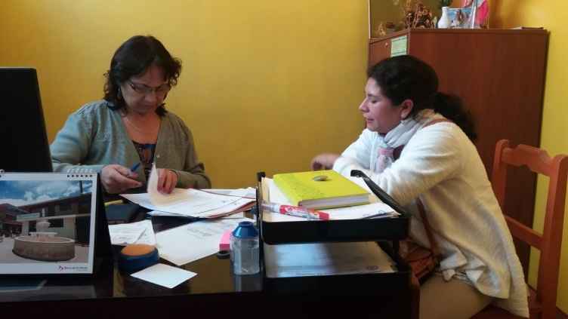

**Director of the I.E. Francisco Bolognesi and coordinator of the Loyola Center Area**

**They sign a work agreement**

**(4) Campaign to raise awareness of the good start of the school year**

The awareness campaign was held on 16 and 17 January, 20 and 21 February in the area of Covadonga, where they have been working with teenagers.

The activities of the school awareness campaign aim to guarantee the basic conditions for a good start of the school year for all the young people and adolescents of public schools in the intervention zones.

During the four days that the campaign was carried out, it was possible to sensitize the tutors and parents about the importance of the timely registration of their children so that they can access the right to education and in this way they do not leave the school year.

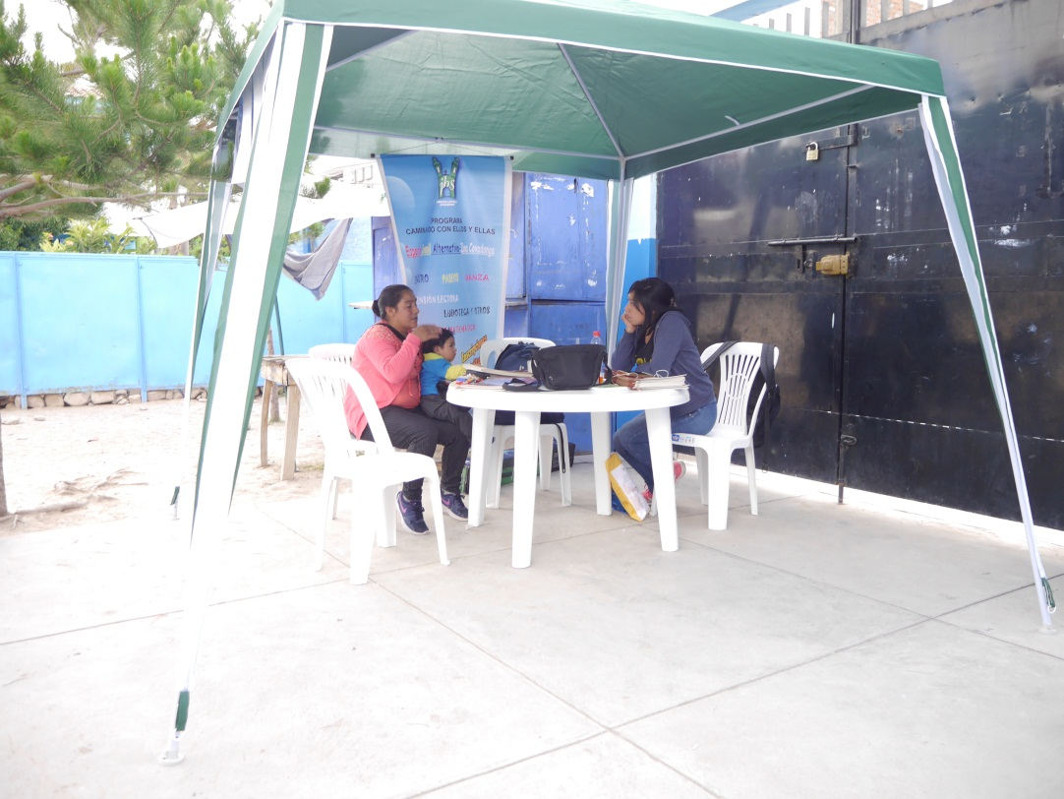

**Personal accompaniment to a mother for the timely enrollment of her son**