The People First Winter Warmth Appeal

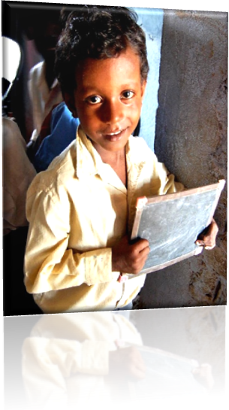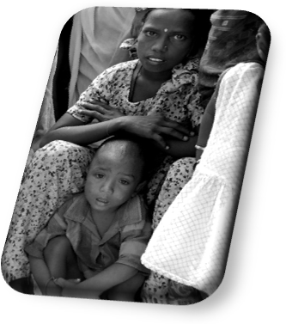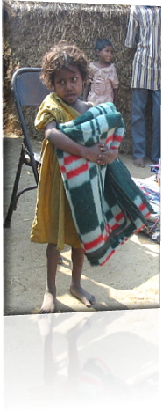

Gaya district of Bihar and the adjoining District of Chatra in the Forested Area of Jharkhand are two of India poorest Districts. It is difficult to imagine in the blazing heat of summer, just how cold it can get here. For an eight-week period in December to January the temperature can go down to near freezing point. For the poor, particularly children without blankets and any warm clothing this dangerous damp cold claims lives every year. The appeal was started following the death of a young girl in the night from the cold in her simple village dwelling and the appeal was started in the Hope this would never happen again in the villages and communities in which we work. The Trust has developed quiet and effective methods of getting blankets and warm clothing to those children most in need, ensuring effective distribution by local teachers and staff. There is no Doubt this Annual Appeal saves many lives.

