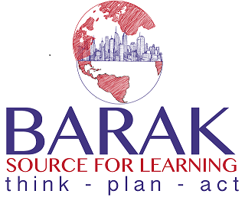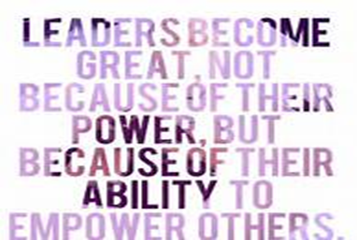

Greetings All, I hope you are all doing well.
This is an official invitation and welcome to the program and a brief introduction of what the program would like to achieve. Bull City Leadership is a mentoring program but it is not intended to recreate or copy other programs. Although several components will seem similar or familiar we hope to add a uniqueness that can only come from its participants. This program is a mental health based program (DSM 5 Axis 4 Psychosocial and Environmental Stressors it will also use Maslow’s Hierarchy of needs in its thesis statement) (thesis statement why we are doing this program).
In all there are three components to this program they can be looked at in different ways for inclusive reasons either as Physical, Mental and Spiritual or healthy body, healthy mind and healthy actions. The component goals will be met through lessons, outings and companionship with a mentor or mentoring agency (Mentoring agency means company or affiliate of program).
The program will start with serving young men in the RTP and Triad areas but these components are not exclusive to males. Throughout the months different types of events will be scheduled from group volunteer events to outings. There will also be times available for one to one mentoring once relationships are built between mentors and mentees.
What will be asked of you as a partner/mentor?
Time: either as one to one mentor/group or during volunteer outings.
Presenter: some may be called upon to be a speaker or presenter of relative topics.
Donations: if able donations to the program that will offset outings/ activities or supplies.
Promotion: if you know anyone else that is looking for a program to donate to or you wish to publicize the group’s action in anyway or just post what you are doing with the group.
Ideas: Any ideas that will help us accomplish the goal of mentoring properly. This is an inclusive group meaning your participation and ideas are welcome at all times!
The first event will be November 12th from 3:30 until 6:00pm it will be a mixer type event (with food) I hope it doesn’t interfere you’re your football and Sunday rest schedules. Most events will be Saturday or Sunday unless otherwise notified.

In Closing I would like to thank you for your time and consideration in these endeavors and I look forward to serving alongside of you in the near future.
With regards
Barry S Archer Sr.
barry@baraksourceforlearning.org or 919-695-7095
http://www.baraksfl.org https://www.gofundme.com/bull-city-leadership
The Internal Revenue Service recognizes Barak Source For Learning (Baraksfl) as a Section 501(c)(3) public charity. Gifts to Baraksfl are tax deductible in the U.S.A. Our Federal Tax ID # is 47-4234059. No goods or services were forwarded or offered in exchange for this contribution.

