Dear Friend,

You subscribed to email updates from Empower Local Refugees to Thrive by PRERNA4REFUGEES, a project on GlobalGiving. Here’s the unedited update from the field :

Quarterly Report : Stabilizing lives of new Refugees with Housing Support & Culturally Integrating them for a stronger future

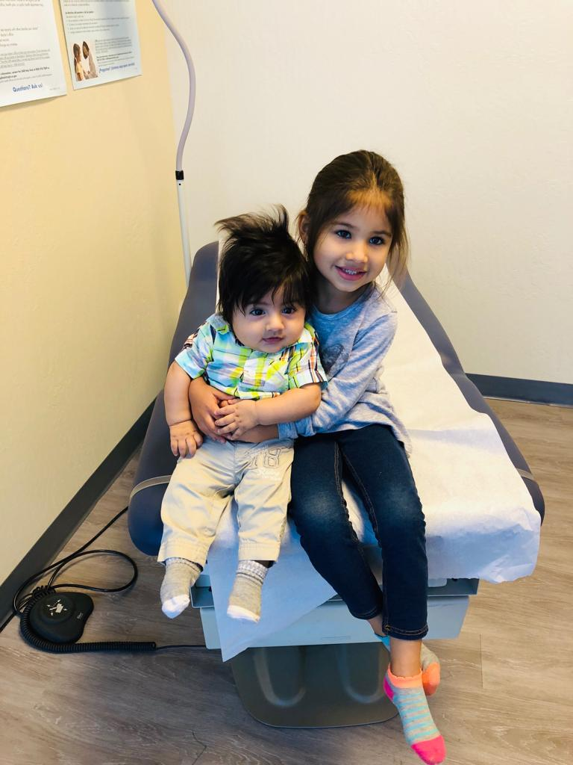

PRERNA has had a busy first quarter! We welcomed 2 new families of 11 new refugee members to our existing group of supported families in the San Francisco Bay Area. The Okubay family of 4 is from Eritrea. The 2nd family of 7 is originally from Egypt and consist of 6 children from the age of 10 to 24 years old and their single refugee mother. Both the families speak Arabic, so will bond well together. They were provided the welcome gift baskets and backpacks to get them started. Our team leads are helping them move into their new home, provide them with all the basic furniture and taking note of their immediate needs, enrolling their children into school and getting the family upto speed with all paperwork and medical checkups. The Okubay family moved into their new home on March 17th and are looking forward to an exciting chapter of their new life!

In January, our cultural assimilation lead organised a bowling event in Fremont which was a big success. Over 20 people showed up and they enjoyed learning how to bowl (they had never bowled before), eating pizza and having a good time making strikes and winning games. The Wardak family made a day trip to the Tech Museum in San Jose in March. They watched an IMAX film and also had the opportunity to see the museum with our assimilation lead.

On the financial side, we received generously over $12K in-kind donations through supplies.We won our first grant from Walmart! Looking forward to having more fundraising events and growth to help support more families and dedicated resources to help PRERNA scale!

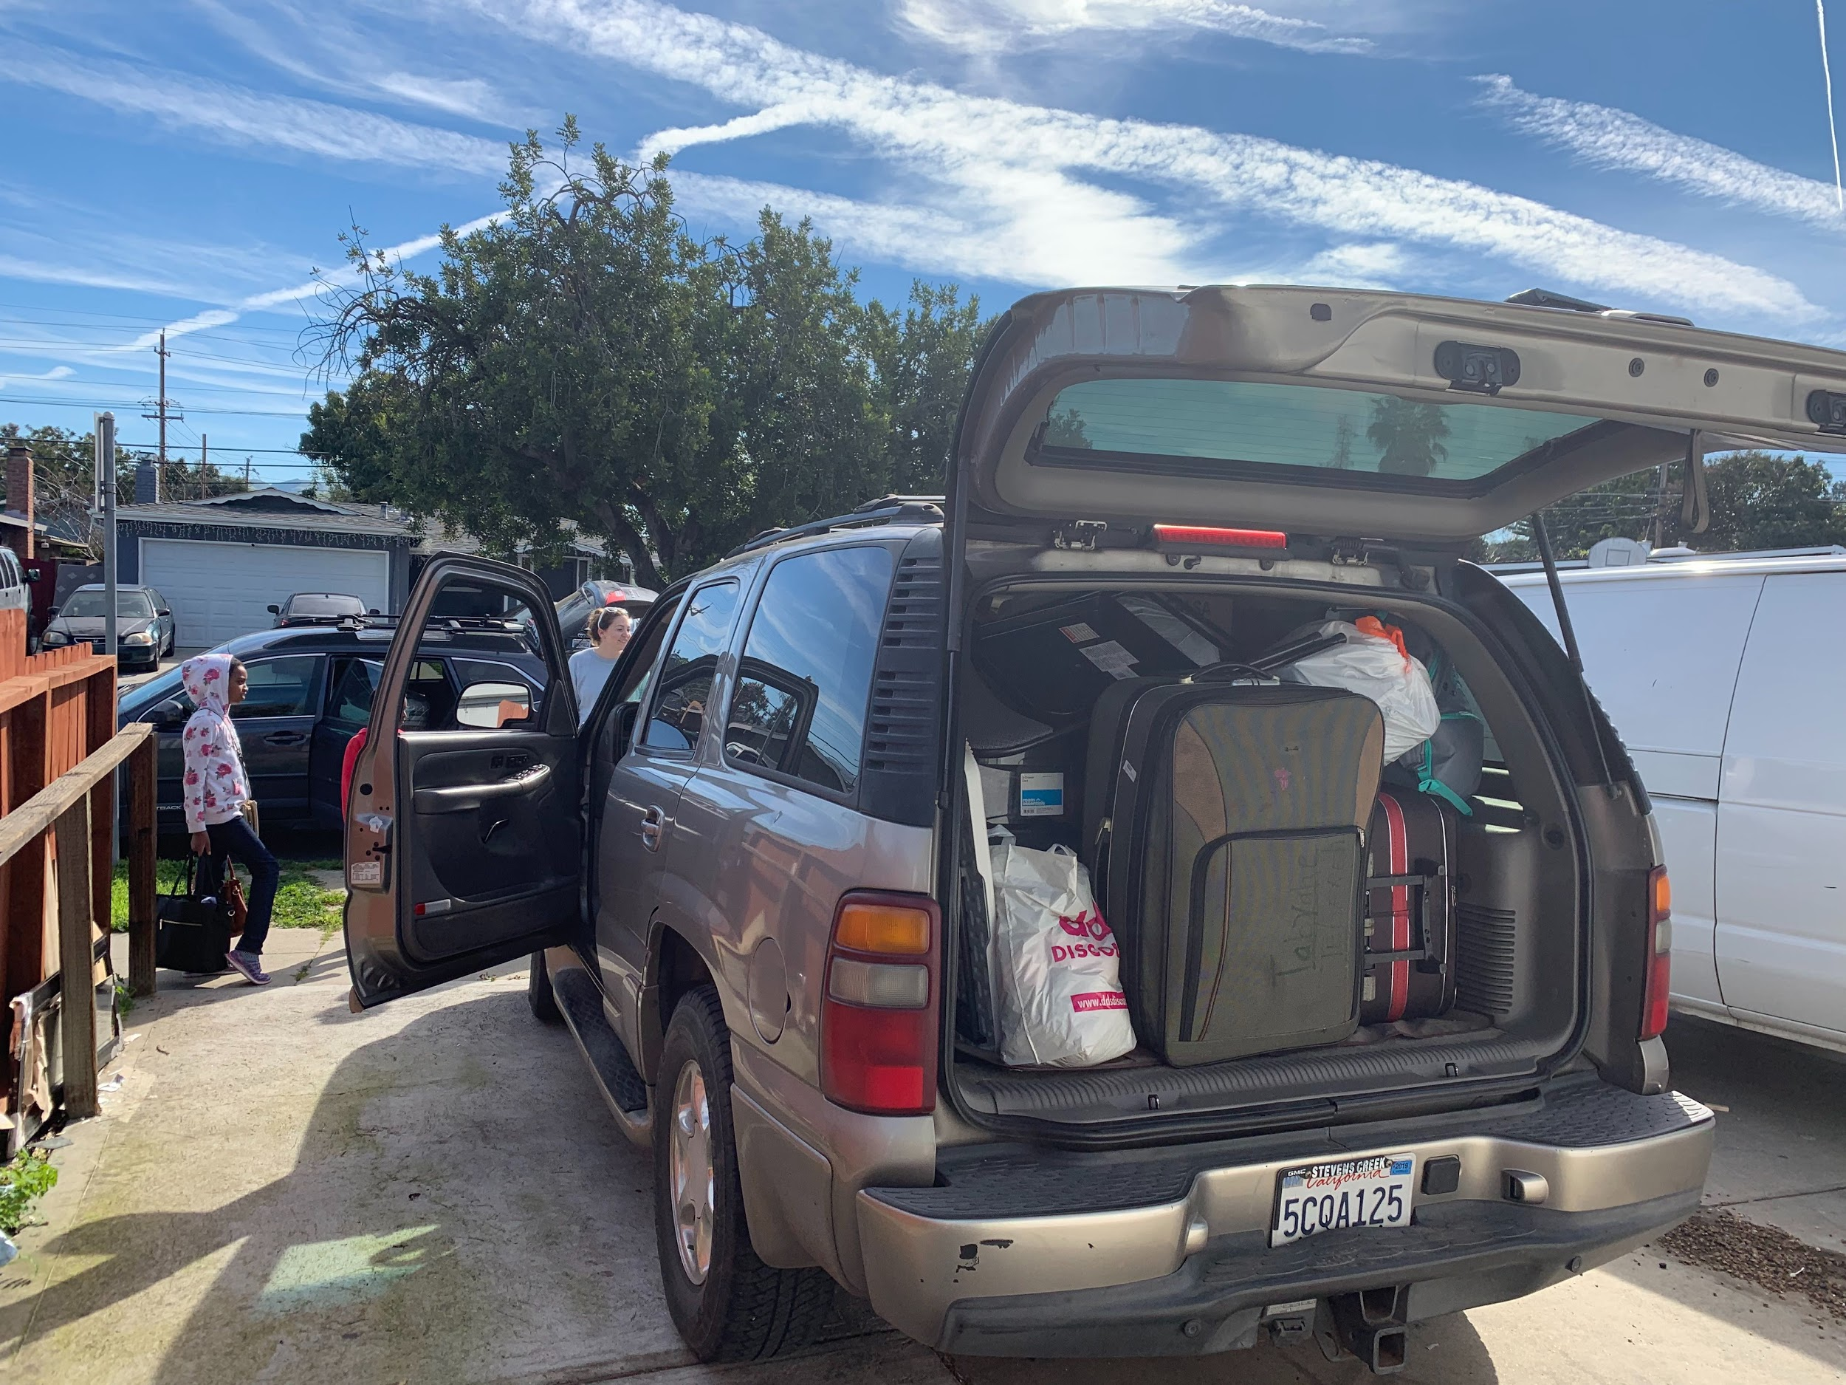

TheWardak family children came to the Tech Museum in San Jose for the Youth Climate Action Summit for the day! Malaina, our cultural assimilation team lead on the extreme left, had the opportunity to show them around the museum in the afternoon. The event itself was a huge success with 560 students attending from all over the bay area.

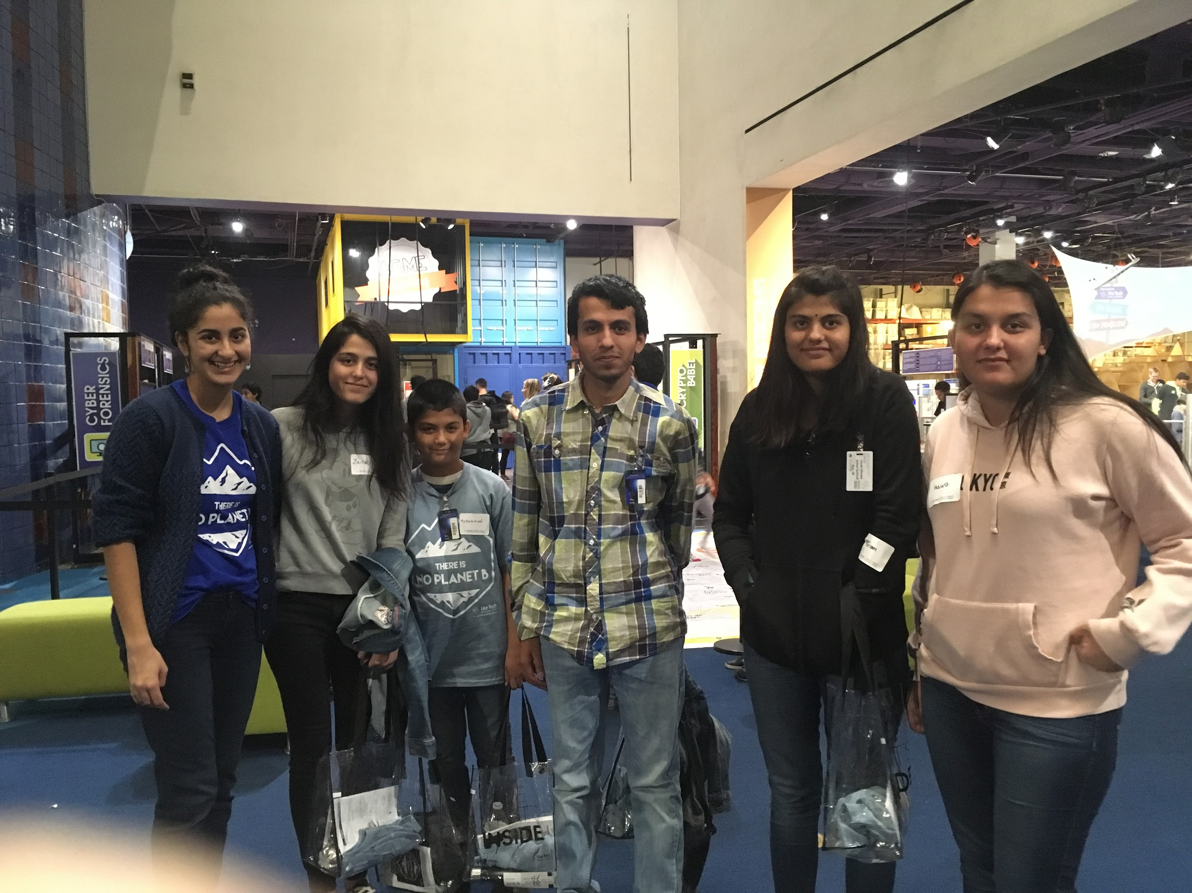
The bowling event at Cloverleaf Family Bowl, Fremont in January.

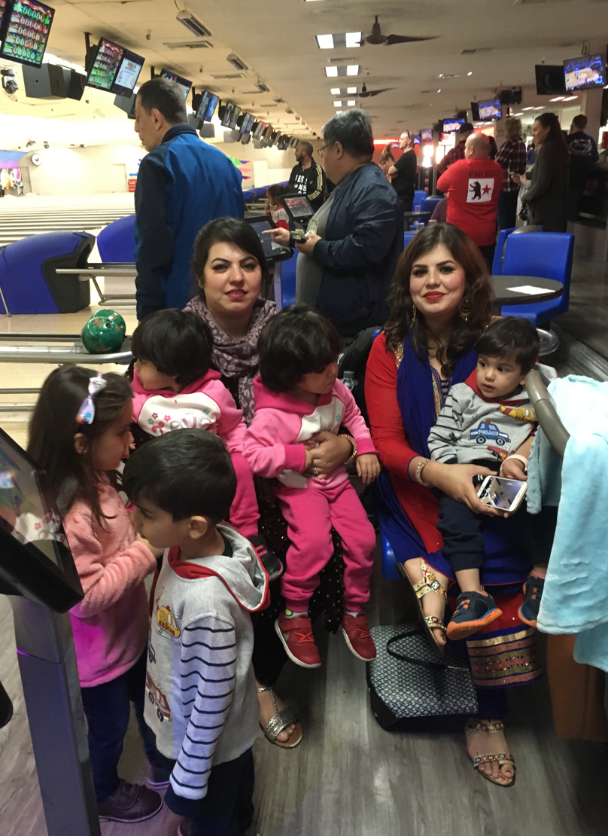
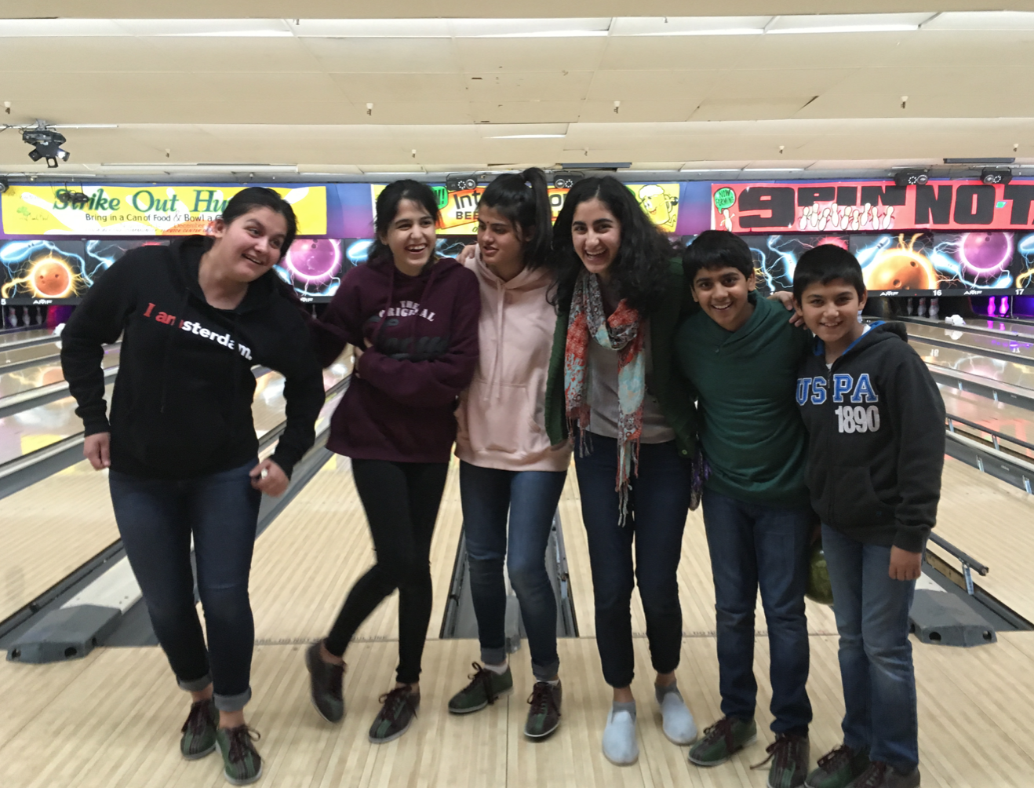

Holiday gift basket event - our team buzzing to get those incredible gift baskets to the refugee families…

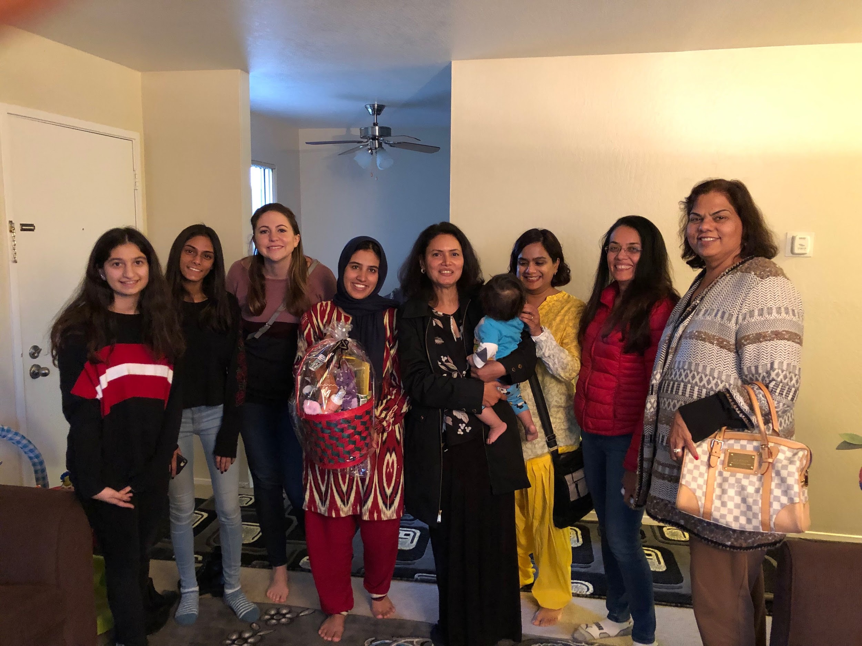

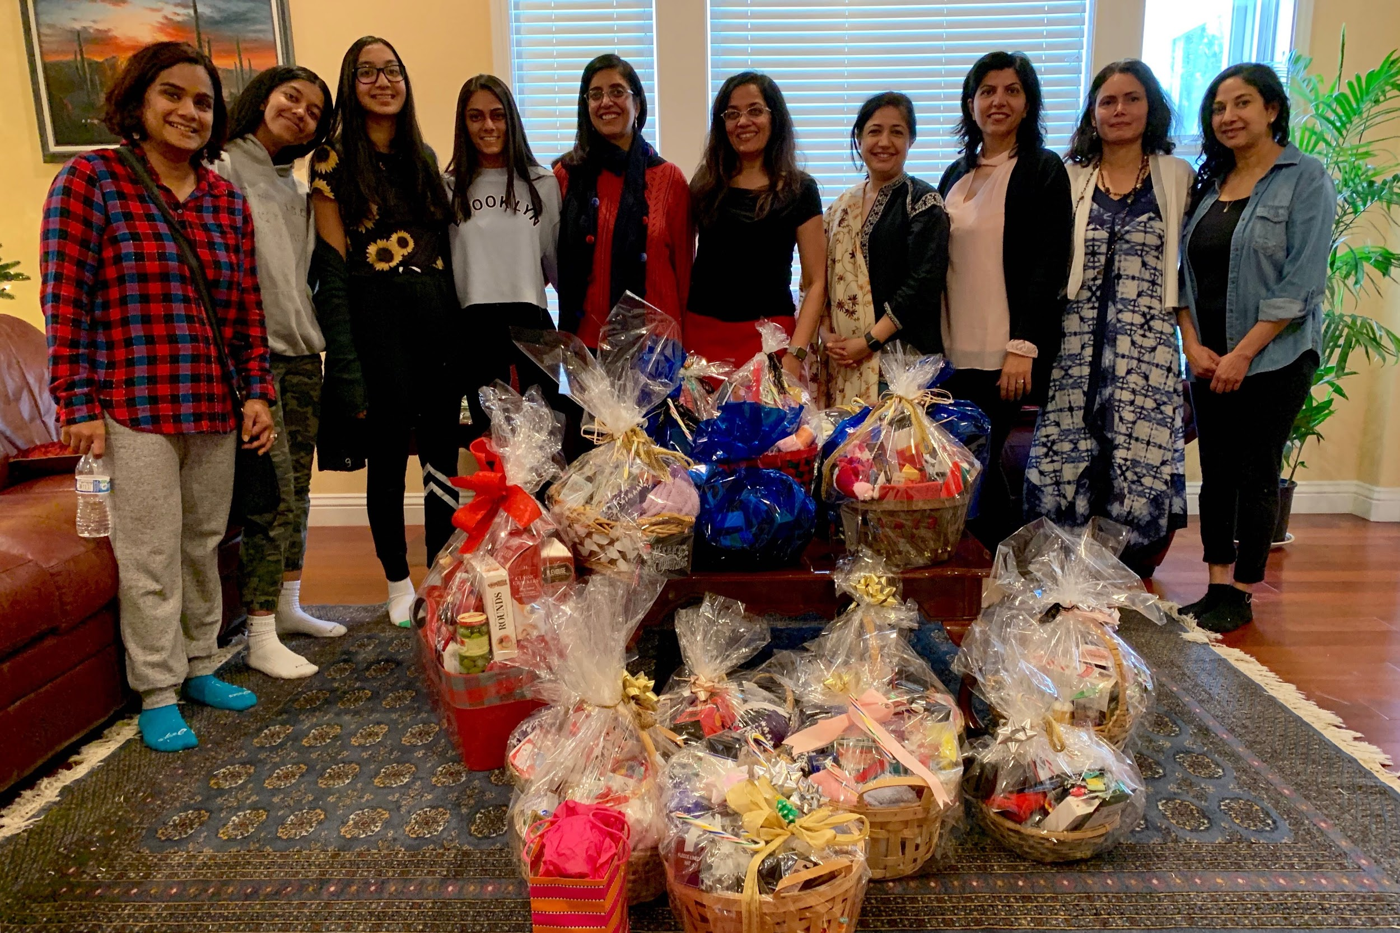

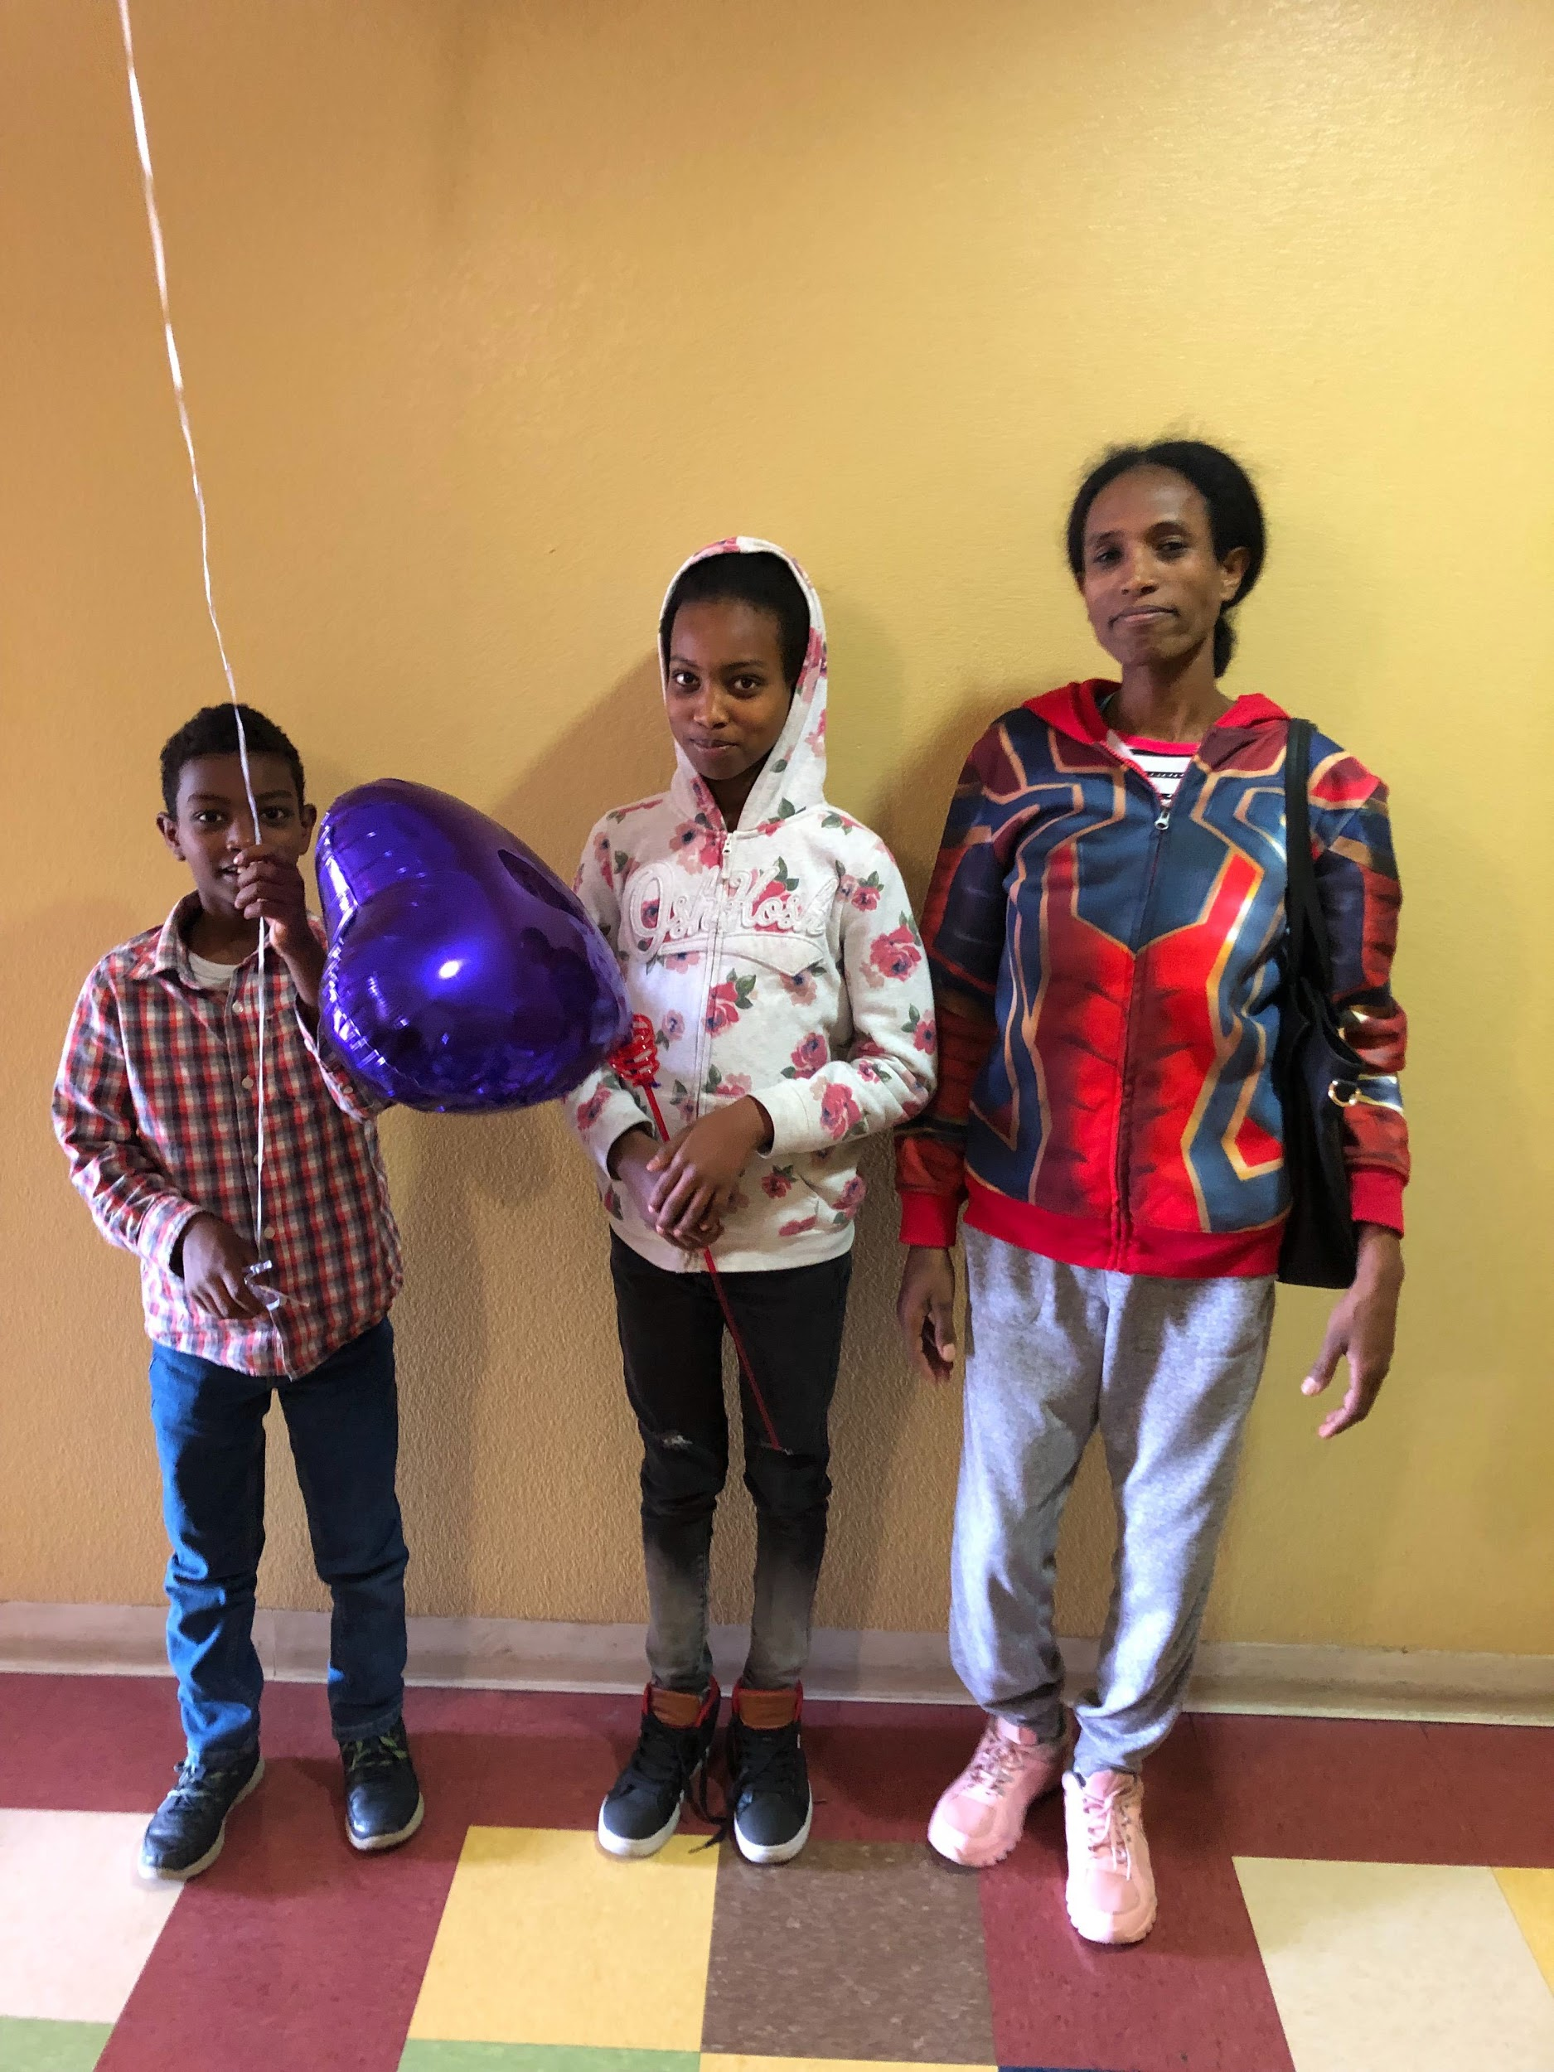
Okubay family - enjoying a grocery trip after moving into their home in San Jose

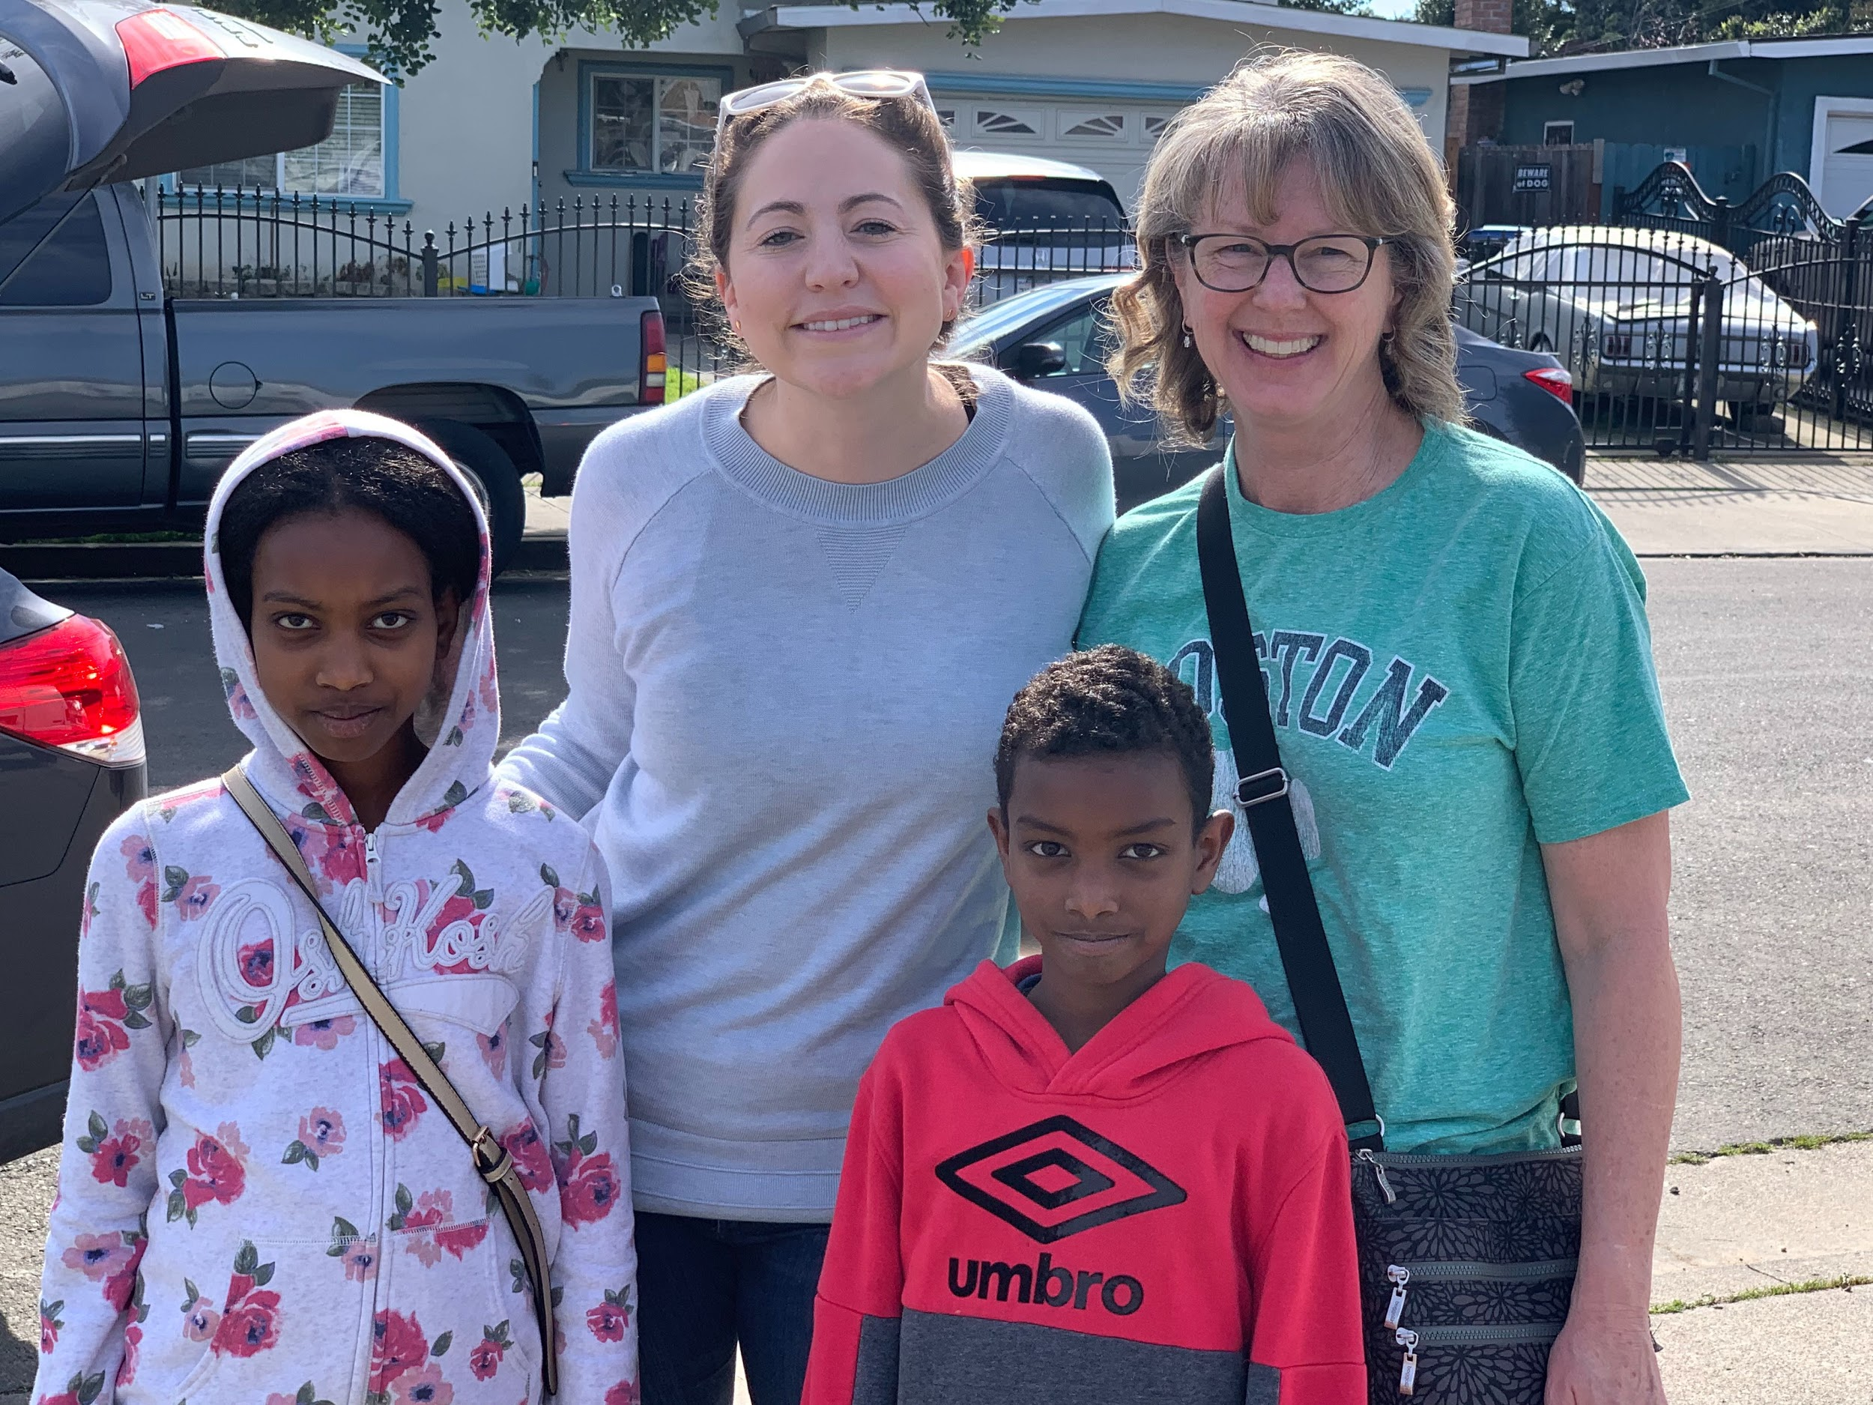

HP Community Fair in Palo Alto - March 21st. Spreading awareness about what Prerna does to empower the refugees.

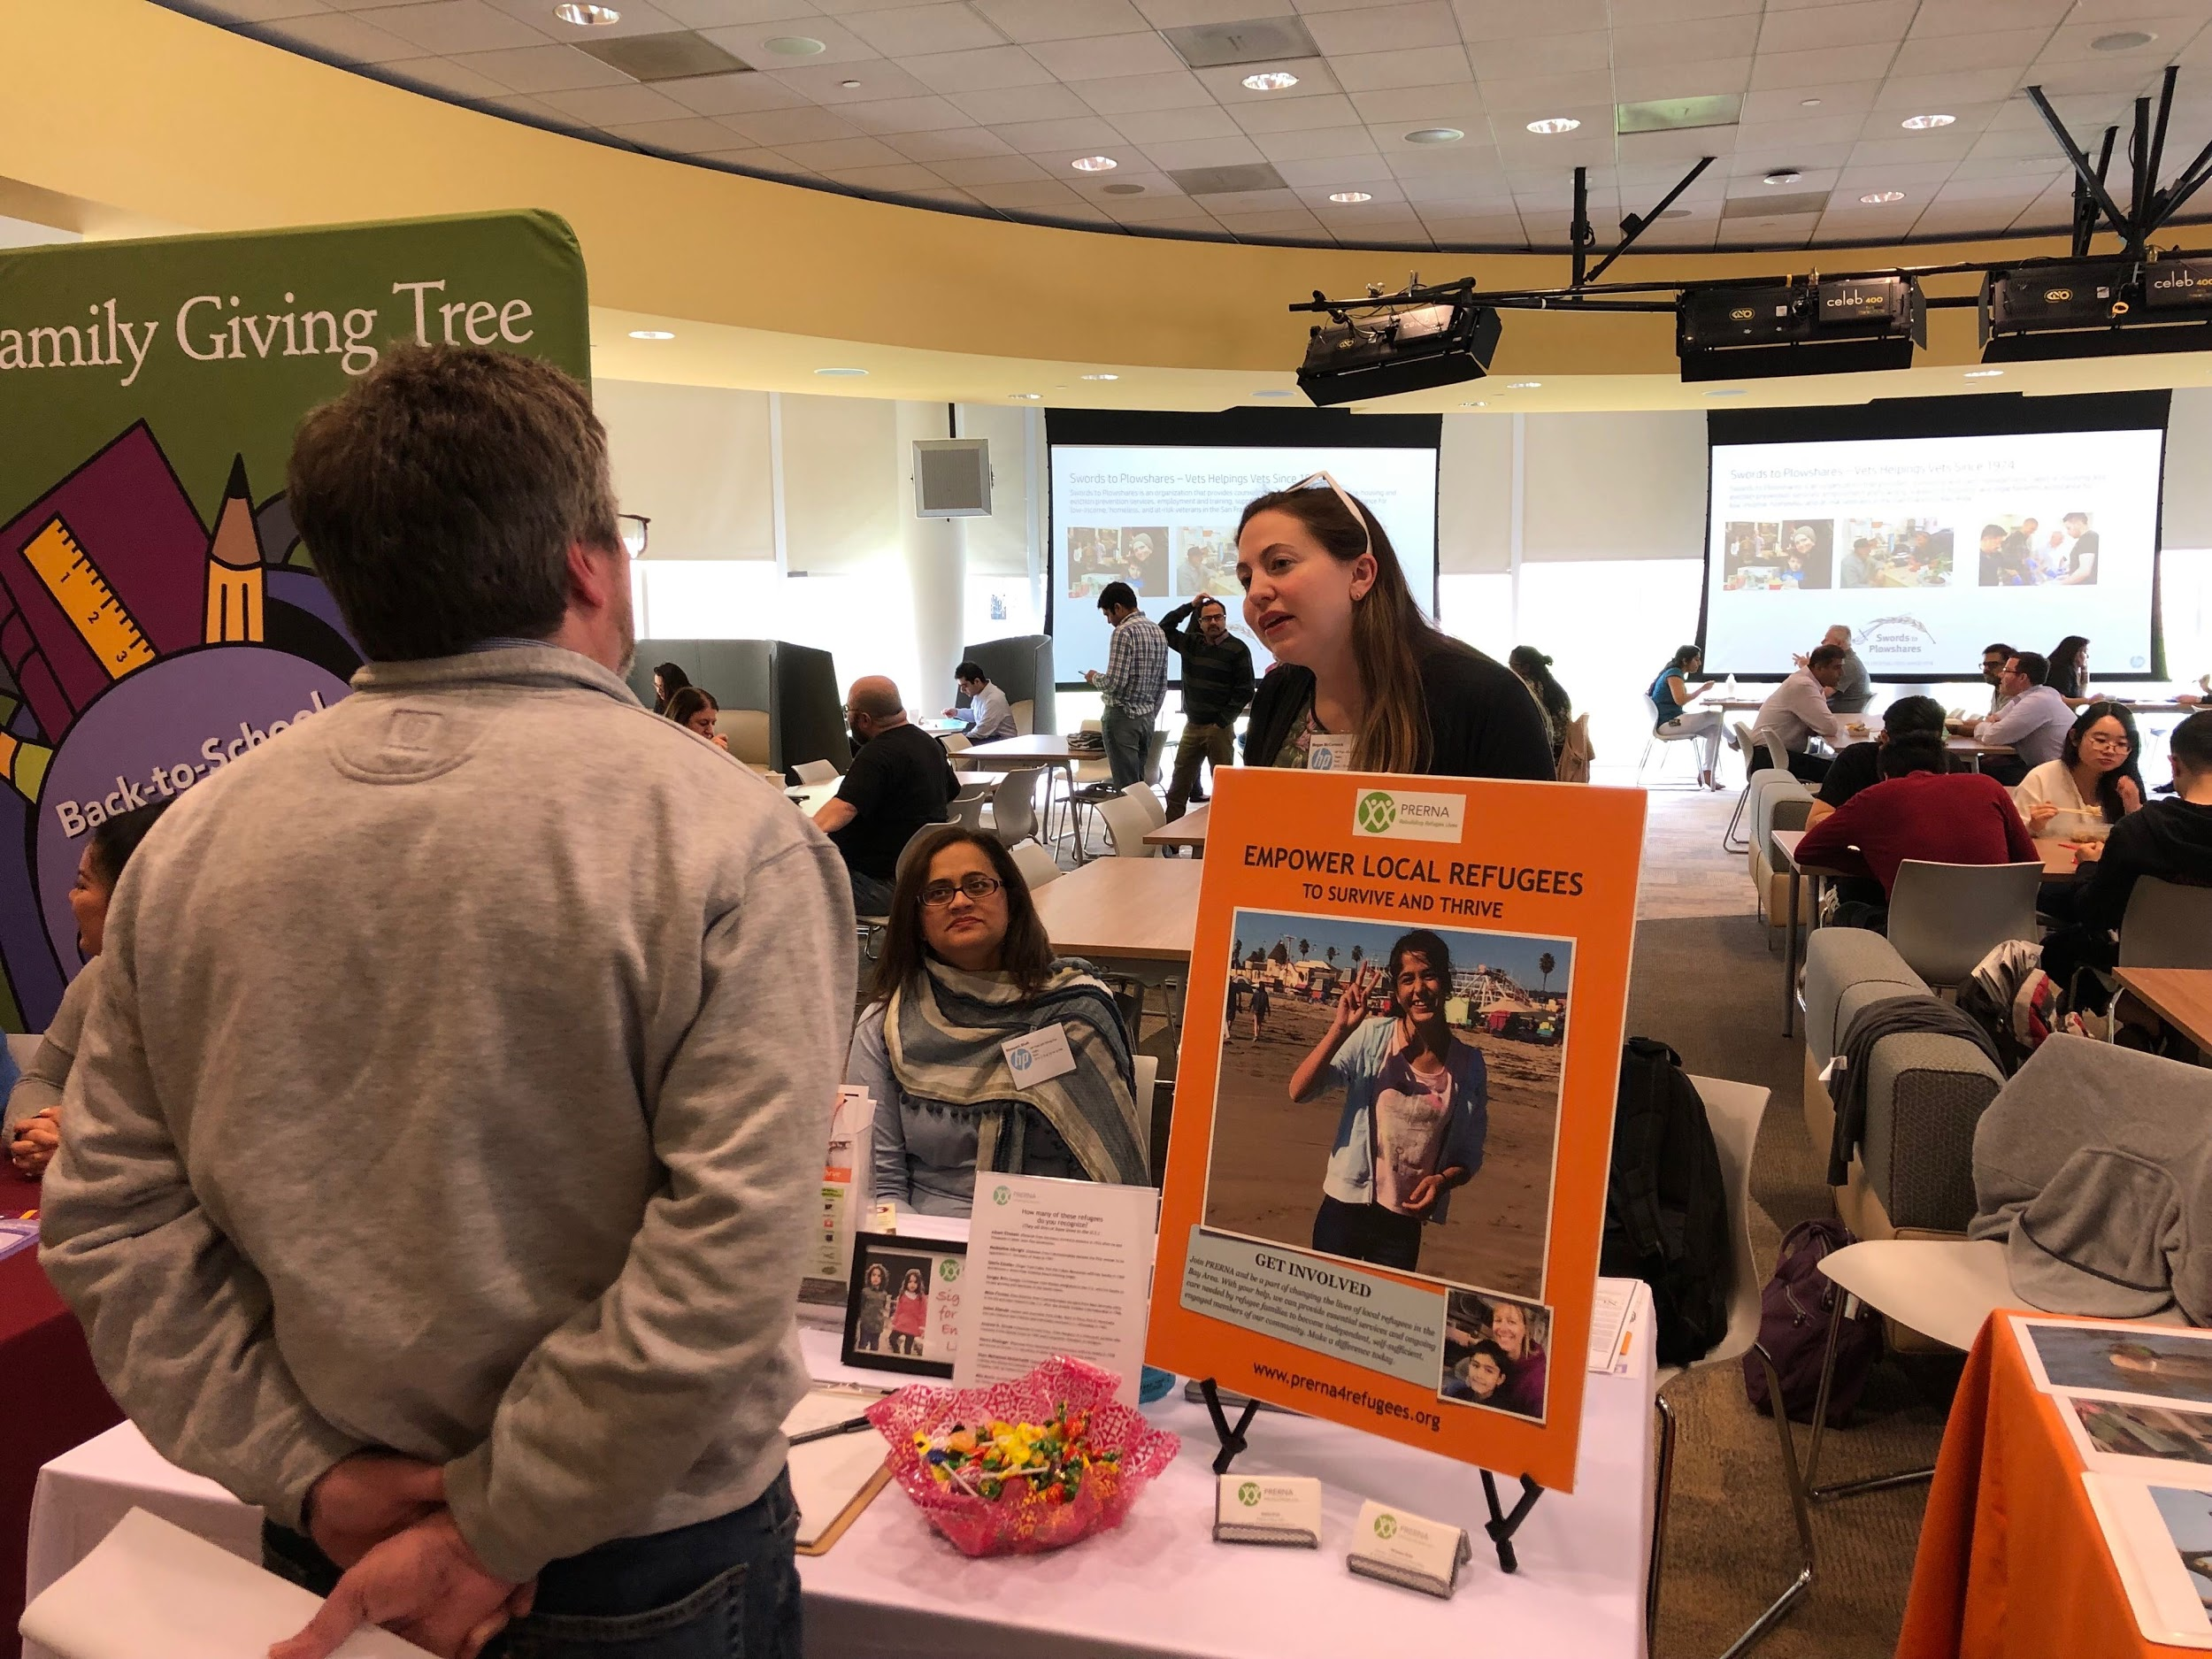

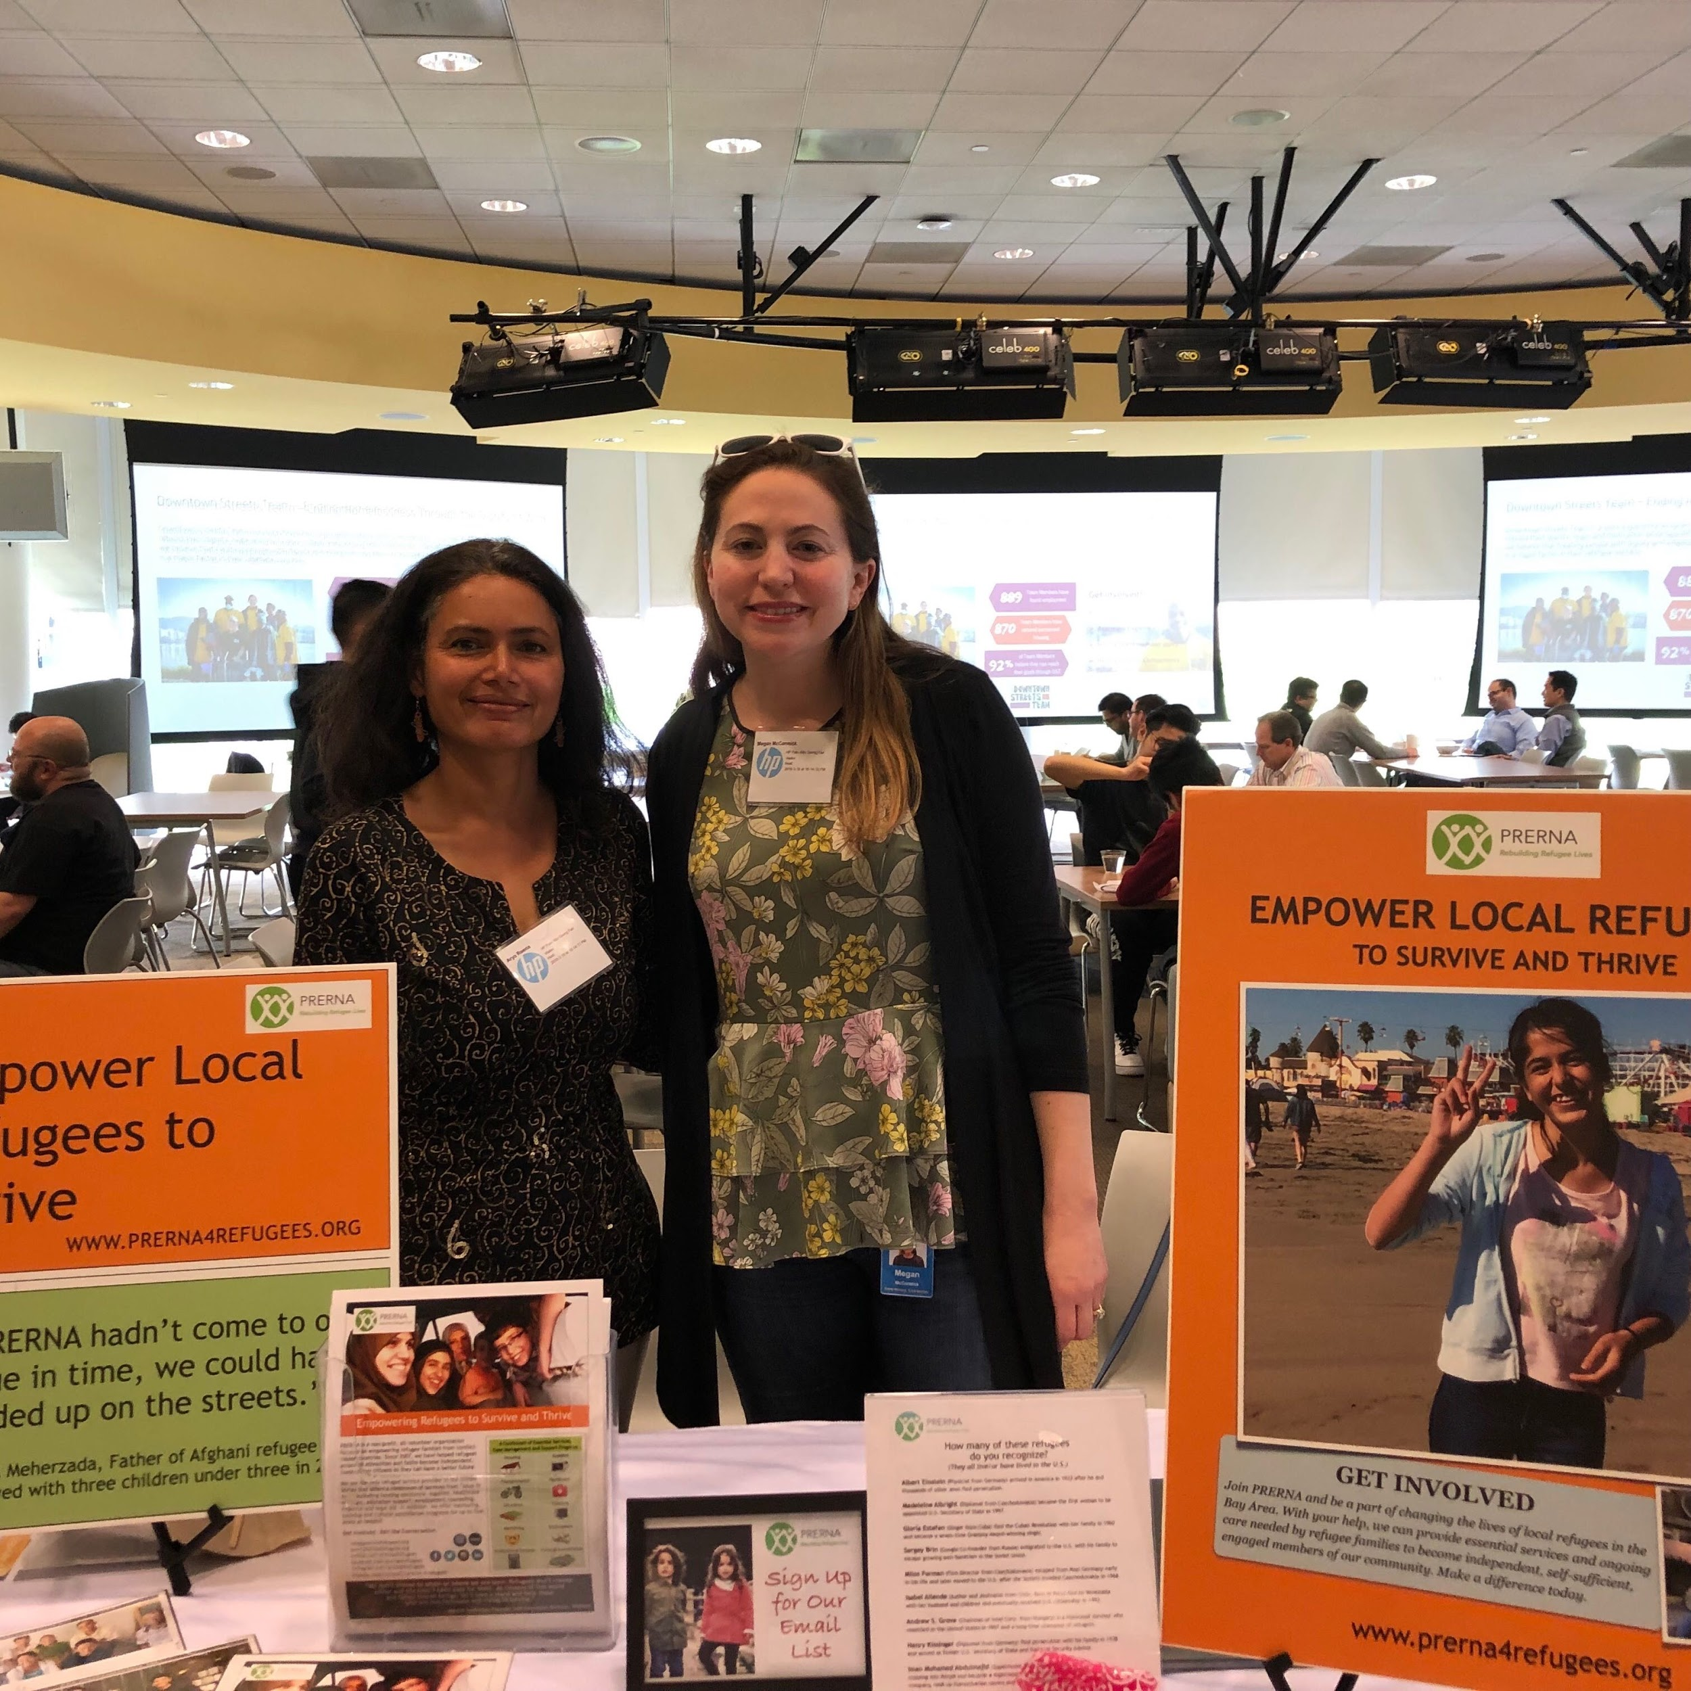

We give a huge thanks to our all-volunteer team members who contributed their time and muscle to make this happen. If you are interested in joining PRERNA to help local refugees in the U.S., please contact us at volunteering@prerna4refugees.org.
Learn more about PRERNA and sign up for our mailing list for monthly updates. Stay connected with us on Facebook, Twitter, Instagram, YouTube, and Linkedin.

Thank you again for empowering refugee families to thrive in the U.S.

With gratitude,
Meena Sankaran
Founder and Executive Director
PRERNA
www.prerna4refugees.org

